Supplemental Figure S1: Choline and Water-soluble Choline Metabolite Plasma Concentrations

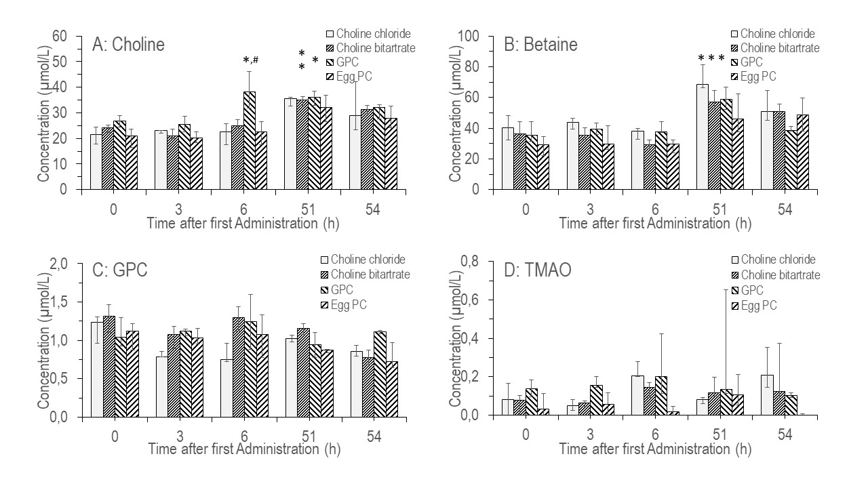
Choline and water-soluble choline metabolite concentrations in plasma by choline supplement and timing of blood samples (before start of supplementation (0h), as well as 3h, 6h, 51h and 54h after start of supplementation). Values are median (quartile 1 – quartile 3). Abbreviations: PC: phosphatidylcholine. GPC: glycerophosphocholine. TMAO: trimethylamineoxide. * p <0.05 vs. 0h; ** p<0.01 vs. 0h, # p<0.05 vs. all other supplements

Supplemental Figure S2: Further Water-soluble Choline-Related Metabolite Plasma Concentrations

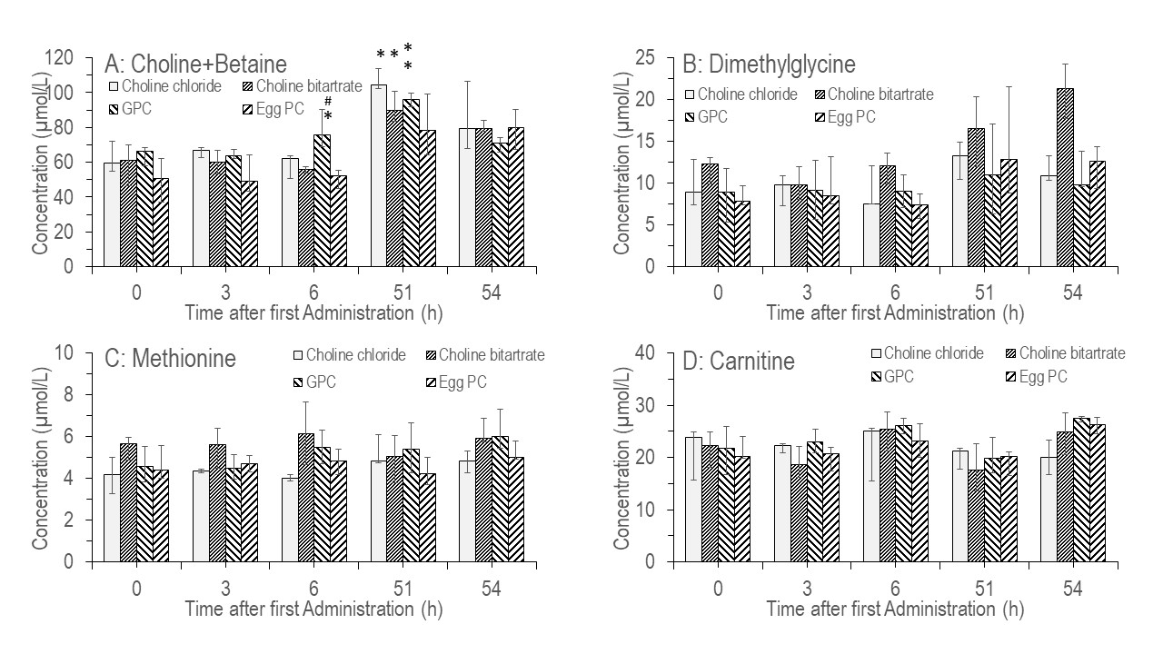

Further choline-related metabolite concentrations in plasma by choline supplement and timing of blood samples (before start of supplementation (0h), as well as 3h, 6h, 51h and 54h after start of supplementation). Data represent median (quartile 1 – quartile 3). Abbreviations: PC: phosphatidylcholine. GPC: glycerophosphocholine. * p <0.05 vs. 0h; ** p<0.01 vs. 0h, # p<0.05 vs. all other supplements

Supplemental Figure S3: Molecular Composition of Plasma Phosphatidylcholine

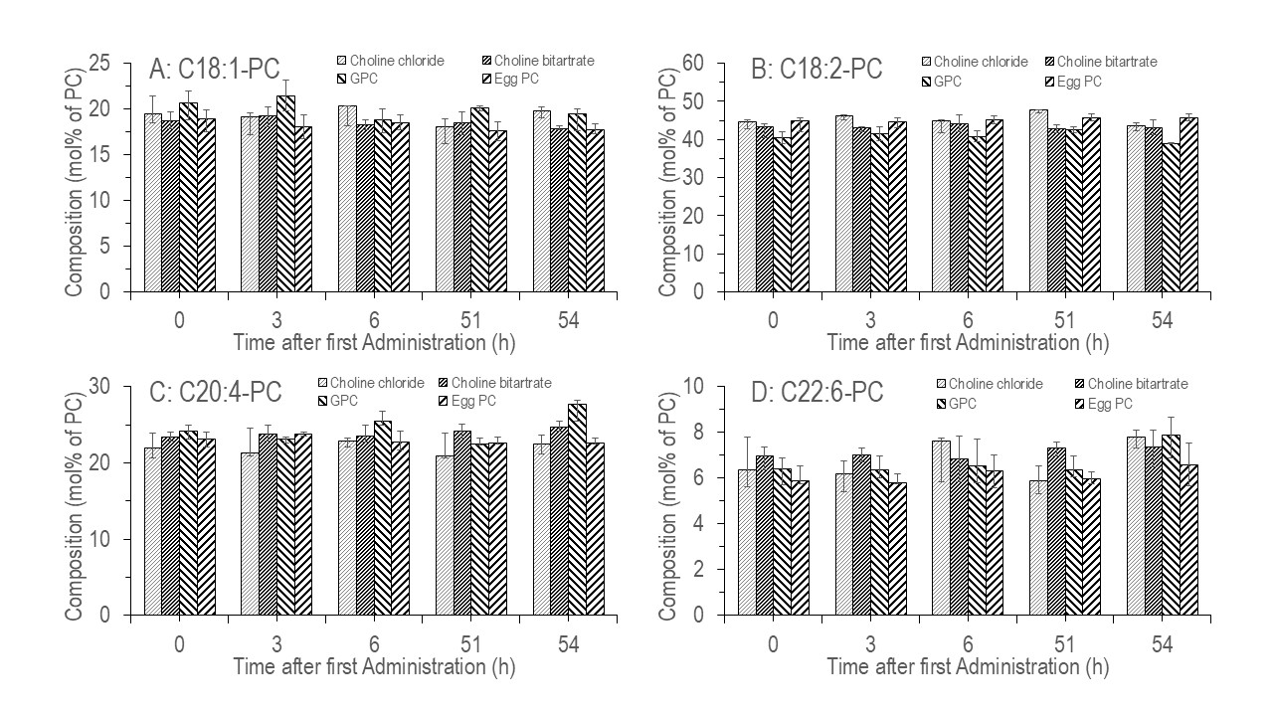
Fractions of major plasma phosphatidylcholine PC species, containing mono-unsaturated oleic acid (C18:1-PC), or poly-unsaturated linoleic acid (C18:2-PC), arachidonic acid (C20:4-PC) or docosahexaenoic acid (C22:6-PC) acid residue. Data are shown from start (0h) to 6h after end of supplementation (54h) across different supplement groups. Data represent median (quartile 1 – quartile 3). Abbreviations: PC: phosphatidylcholine. GPC: glycerophosphocholine

