Supplemental material

High plant protein intake decreases all-cause mortality in the “Seguimiento Universidad de Navarra” (SUN) cohort
European Journal of Nutrition
Ainara Martínez-Tabar ^{1,2}, Miguel Ruiz-Canela ^{1,2,3}, Vanessa Bullón-Vela ^{1,2}, Carmen de la Fuente-Arrillaga ^{1,2,3}, Carmen Sayón-Orea ^{1,2,3}, Miguel Ángel Martínez-González ^{1,2,3}, Maira Bes-Rastrollo ^{1,2,3,*}

¹University of Navarra, Department of Preventive Medicine and Public Health, Pamplona, Spain
²IdiSNA (Navarra Medical Research Institute), Pamplona, Spain
³CIBER Physiopathology of Obesity and Nutrition (CIBEROBN), Madrid, Spain

*Maira Bes Rastrollo
mbes@unav.es

Supplemental Figure 1. Flow-chart of the study participants in the SUN cohort study.
n=1,379
Lost to follow-up
(Retention rate: 93%)
n=220
Participants with no answer in > = 70 items of the FFQ
n=1,188
Participants with prevalent CVD, cancer and T2DM at baseline
n=2,123
Outside of predefined limits for total energy intake
n=234
Participants with insufficient follow-up time
Participants recruited before May 2022
n=23,133
Abbreviations: T2DM: Type 2 diabetes.

n=22,899
Participants
n= 17,989
Participants
n= 19,368
Participants
n= 19,588
Participants
n= 20,776
Participants

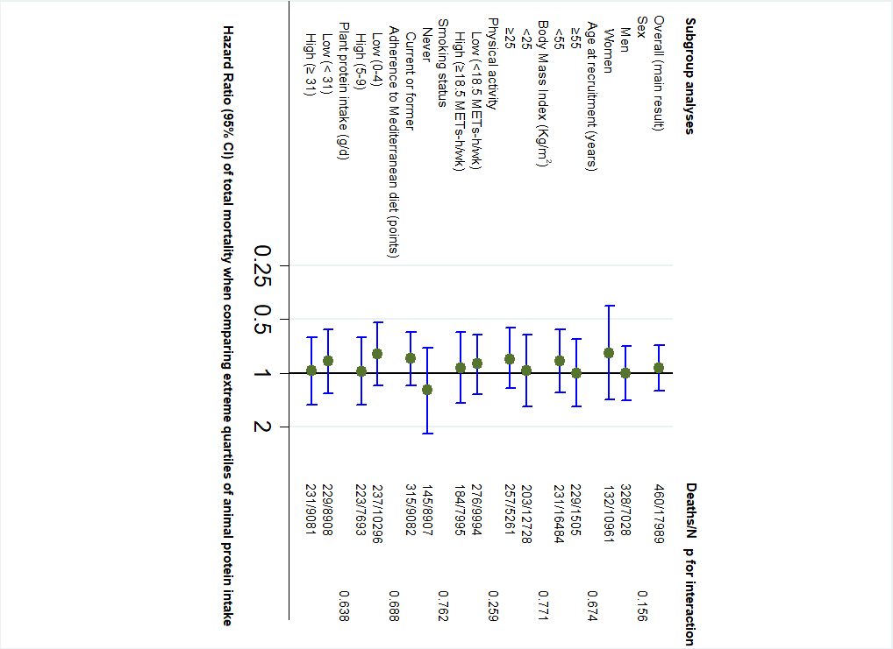
Supplemental Figure 2. Subgroup analysis for association between animal protein intake and all-cause mortality (highest versus lowest quartile of intake). Adjusted for age (underlying variable) and sex (dichotomous) stratified by deciles of age and recruitment period (5 categories). Additionally adjusted for alcohol intake (g/d, continuous), BMI (kg/m² , linear and quadratic terms, continuous), years of university education (three categories), marital status (married, others), smoking status (three categories), cumulative smoking habit (packs-years, four categories), physical activity (continuous), total energy intake (five categories), following a special diet (dichotomous), snacking (dichotomous), Trichopoulou MeDiet score (three categories), prevalent hypertension (dichotomous), prevalent hypercholesterolemia (dichotomous), plant protein (g/d, continuous), monounsaturated fatty acids (g/d, continuous), polyunsaturated fatty acids (g/d, continuous), saturated fatty acids (g/d, continuous) and trans fatty acids (g/d, continuous).

Supplemental Figure 3. Sensitivity analyses for the association between animal protein intake and all-cause mortality (highest versus lowest quartile of intake). Adjusted for age (underlying variable) and sex (dichotomous) stratified by deciles of age and recruitment period (3 categories). Additionally adjusted for alcohol intake (g/d, continuous), BMI (kg/m² , linear and quadratic terms, continuous), years of university education (three categories), marital status (married, others), smoking status (three categories), cumulative smoking habit (packs-years, four categories), physical activity (continuous), total energy intake (five categories), following a special diet (dichotomous), snacking (dichotomous), Trichopoulou MeDiet score (three categories), prevalent hypertension (dichotomous), prevalent hypercholesterolemia (dichotomous), plant protein (g/d, continuous), monounsaturated fatty acids (g/d, continuous), polyunsaturated fatty acids (g/d, continuous), saturated fatty acids (g/d, continuous) and trans fatty acids (g/d, continuous).

Supplemental Table 1. Subgroup analyses for association between plant protein intake and all-cause mortality according to quartiles of plant protein intake.
 | Hazard ratio (95% CI) | p for interaction
Overall | Q1: 1.00 (ref.)  Q2: 0.99 (0.75-1.31)  Q3: 0.81 (0.60-1.11)  Q4: 0.65 (0.45-0.93)
Subgroup analyses
Sex |  | p=0.011
Men | Q1: 1.00 (ref.)  Q2: 0.77 (0.54-1.08)  Q3: 0.81 (0.56-1.17)  Q4: 0.66 (0.42-1.03)
Women | Q1: 1.00 (ref.)  Q2: 1.57 (0.95-2.58)  Q3: 0.82 (0.45-1.49)  Q4: 0.56 (0.28-1.15)
Age at recruitment(years) |  | p=0.925
≥ 55 | Q1: 1.00 (ref.)  Q2: 1.11 (0.73-1.71)  Q3: 0.88 (0.54-1.41)  Q4: 0.73 (0.42-1.27)
<55 | Q1: 1.00 (ref.)  Q2: 0.89 (0.61-1.30)  Q3: 0.75 (0.49-1.15)  Q4: 0.57 (0.34-0.94)
Body mass index (kg/m²) |  | p=0.734
<25 | Q1: 1.00 (ref.)  Q2: 1.15 (0.74-1.79)  Q3: 0.80 (0.47-1.35)  Q4: 0.69 (0.38-1.26)
≥ 25 | Q1: 1.00 (ref.)  Q2: 0.87 (0.60-1.25)  Q3: 0.84 (0.56-1.26)  Q4: 0.68 (0.42-1.10)
Physical activity |  | p=0.287
Low (<18.5 METs-h/wk) | Q1: 1.00 (ref.)  Q2: 0.94 (0.66-1.35)  Q3: 0.84 (0.56-1.26)  Q4: 0.54 (0.33-0.89)
High (≥18.5 METs-h/wk) | Q1: 1.00 (ref.)  Q2: 1.22 (0.76-1.94)  Q3: 0.84 (0.50-1.40)  Q4: 0.80 (0.46-1.38)
Smoking status |  | p= 0.493
Never | Q1: 1.00 (ref.)  Q2: 1.16 (0.67-2.01)  Q3: 0.70 (0.38-1.27)  Q4: 0.77 (0.39-1.52)
Current or former | Q1: 1.00 (ref.)  Q2: 0.96 (0.70-1.33)  Q3: 0.89 (0.61-1.29)  Q4: 0.63 (0.40-0.97)
Mediterranean diet (points) |  | p=0.770
High adherence (5-9) | Q1: 1.00 (ref.)  Q2: 0.84 (0.48-1.46)  Q3: 0.76 (0.44-1.29)  Q4: 0.61 (0.35-1.08)
Low adherence (0-4) | Q1: 1.00 (ref.)  Q2: 0.95 (0.69-1.31)  Q3: 0.71 (0.47-1.06)  Q4: 0.51 (0.29-0.89)
Animal protein intake (g/d) |  | p=0.791
high (≥ 73) | Q1: 1.00 (ref.)  Q2: 1.05 (0.73-1.51)  Q3: 0.80 (0.50-1.28)  Q4: 0.63 (0.36-1.10)
low (< 73) | Q1: 1.00 (ref.)  Q2: 0.82 (0.53-1.27)  Q3: 0.69 (0.44-1.09)  Q4: 0.57 (0.36-0.92)

Adjusted for age (underlying variable) and sex (dichotomous) stratified by deciles of age and recruitment period (5 categories). Additionally adjusted alcohol intake (g/d, continuous), BMI (kg/m², linear and quadratic terms, continuous), years of university education (three categories), marital status (married, others), smoking status (three categories), cumulative smoking habit (packs-years, four categories), physical activity (continuous), total energy intake (five categories), following a special diet (dichotomous), snacking (dichotomous), Trichopoulou MeDiet score (three categories), prevalent hypertension (dichotomous), prevalent hypercholesterolemia (dichotomous), animal protein (g/d, continuous), monounsaturated fatty acids (g/d, continuous), polyunsaturated fatty acids (g/d, continuous), saturated fatty acids (g/d, continuous) and trans fatty acids (g/d, continuous).

Supplemental Table 2. Subgroup analyses for association between animal protein intake and all-cause mortality according to quartiles of animal protein intake.
 | Hazard ratio (95% CI) | p for interaction
Overall | Q1: 1.00 (ref.)  Q2: 0.93 (0.71-1.22)  Q3: 0.82 (0.61-1.09)  Q4: 0.94 (0.70-1.26)
Subgroup analyses
Sex |  | p=0.156
Men | Q1: 1.00 (ref.)  Q2: 0.84 (0.60-1.18)  Q3: 0.77 (0.55-1.10)  Q4: 1.00 (0.71-1.42)
Women | Q1: 1.00 (ref.)  Q2: 1.09 (0.67-1.78)  Q3: 0.87 (0.50-1.51)  Q4: 0.77 (0.42-1.41)
Age at recruitment (years) |  | p=0.674
≥ 55 | Q1: 1.00 (ref.)  Q2: 0.97 (0.65-1.45)  Q3: 0.72 (0.47-1.12)  Q4: 1.00 (0.65-1.54)
<55 | Q1: 1.00 (ref.)  Q2: 0.86 (0.59-1.24)  Q3: 0.87 (0.59-1.28)  Q4: 0.86 (0.57-1.29)
Body mass index (kg/m²) |  | p=0.771
<25 | Q1: 1.00 (ref.)  Q2: 0.92 (0.62-1.38)  Q3: 0.99 (0.64-1.54)  Q4: 0.97 (0.61-1.54)
≥ 25 | Q1: 1.00 (ref.)  Q2: 0.87 (0.61-1.28)  Q3: 0.69 (0.46-1.02)  Q4: 0.84 (0.56-1.22)
Physical activity |  | p=0.259
Low (<18.5 METs-h/wk) | Q1: 1.00 (ref.)  Q2: 0.99 (0.71-1.38)  Q3: 0.71 (0.48-1.05)  Q4: 0.89 (0.61-1.32)
High (≥18.5 METs-h/wk) | Q1: 1.00 (ref.)  Q2: 0.81 (0.50-1.30)  Q3: 0.94 (0.58-1.52)  Q4: 0.94 (0.59-1.48)
Smoking status |  | P= 0.762
Never | Q1: 1.00 (ref.)  Q2: 1.32 (0.82-2.13)  Q3: 0.93 (0.54-1.61)  Q4: 1.25 (0.72-2.18)
Current or former | Q1: 1.00 (ref.)  Q2: 0.82 (0.60-1.14)  Q3: 0.80 (0.57-1.13)  Q4: 0.83 (0.59-1.18)
Mediterranean diet (points) |  | p=0.688
High adherence (5-9) | Q1: 1.00 (ref.)  Q2: 1.05 (0.73-1.52)  Q3: 0.83 (0.54-1.27)  Q4: 0.98 (0.63-1.51)
Low adherence (0-4) | Q1: 1.00 (ref.)  Q2: 0.78 (0.53-1.14)  Q3: 0.73 (0.49-1.09)  Q4: 0.78 (0.52-1.17)
Plant protein intake (g/d) |  | p=0.638
High (≥ 31) | Q1: 1.00 (ref.)  Q2: 0.90 (0.62-1.30)  Q3: 0.96 (0.65-1.41)  Q4: 0.97 (0.63-1.50)
low (< 31) | Q1: 1.00 (ref.)  Q2: 0.94 (0.61-1.46)  Q3: 0.74 (0.48-1.15)  Q4: 0.86 (0.57-1.30)
Adjusted for age (underlying variable) and sex (dichotomous) stratified by deciles of age and recruitment period (5 categories). Additionally adjusted alcohol intake (g/d, continuous), BMI (kg/m², linear and quadratic terms, continuous), years of university education (three categories), marital status (married, others), smoking status (three categories), cumulative smoking habit (packs-years, four categories), physical activity (continuous), total energy intake (five categories), following a special diet (dichotomous), snacking (dichotomous), Trichopoulou MeDiet score (three categories), prevalent hypertension (dichotomous), prevalent hypercholesterolemia (dichotomous), plant protein (g/d, continuous), monounsaturated fatty acids (g/d, continuous), polyunsaturated fatty acids (g/d, continuous), saturated fatty acids (g/d, continuous) and trans fatty acids (g/d, continuous).

Supplementary Table 3. Cox proportional hazard ratios (HRs) and 95% confidence intervals (CIs) for all-cause mortality according to animal protein intake, stratified by food sources.
 | Q1 |  | Q2 | Q3 | Q4
 |  |  | Hazard ratio (95% CI)
Protein from red meat
Age and sex adjusted | 1.00 (Ref.) |  | 1.26  (0.98-1.62) | 1.25  (0.97-1.62) | 1.09  (0.83-1.43)
Model 1 | 1.00 (Ref.) |  | 1.18  (0.91-1.54) | 1.21  (0.92-1.60) | 0.97  (0.73-1.28)
Model 2 | 1.00 (Ref.) |  | 1.13  (0.86-1.48) | 1.12  (0.85-1.49) | 0.84  (0.62-1.15)
Protein from white meat
Age and sex adjusted |  | 1.00 (Ref.) | 1.15  (0.89-1.48) | 1.01  (0.77-1.33) | 1.11  (0.86-1.44)
Model 1 | 1.00 (Ref.) |  | 1.22  (0.93-1.59) | 1.07  (0.80-1.42) | 1.07  (0.82-1.40)
Model 2 | 1.00 (Ref.) |  | 1.20  (0.92-1.56) | 1.06  (0.80-1.40) | 1.05  (0.81-1.37)
Protein from fish and seafood
Age and sex adjusted |  | 1.00 (Ref.) | 0.86  (0.64-1.14) | 0.87  (0.65-1.16) | 0.93  (0.71-1.22)
Model 1 | 1.00 (Ref.) |  | 0.82  (0.61-1.10) | 0.90  (0.67-1.23) | 0.91  (0.76-1.34)
Model 2 | 1.00 (Ref.) |  | 0.81  (0.60 -1.09) | 0.87  (0.64-1.18) | 0.95  (0.71-1.27)
Protein from eggs
Age and sex adjusted |  | 1.00 (Ref.) | 0.89  (0.69-1.16) | 0.83  (0.64-1.07) | 0.89  (0.70-1.14)
Model 1 | 1.00 (Ref.) |  | 1.01  (0.74-1.38) | 0.87  (0.65-1.16) | 0.92  (0.71-1.20)
Model 2 | 1.00 (Ref.) |  | 0.98  ( 0.72-1.34) | 0.83  (0.62-1.12 | 0.87  (0.67-1.14)
Protein from dairy products |  |  | 0.97  (0.75-1.26) | 0.94  (0.73-1.22) | 1.01  (0.78-1.30)
Model 1 | 1.00 (Ref.) |  | 0.97  (0.74-1.27) | 0.97  (0.74-1.27) | 0.94  (0.78-1.37)
Model 2 | 1.00 (Ref.) |  | 0.94  (0.72-1.24) | 0.91  (0.69-1.21) | 0.92  (0.67-1.26)
Adjusted for age (underlying variable) and sex (dichotomous) stratified by deciles of age and recruitment period (5 categories). Model 1: additionally adjusted for alcohol intake (g/d, continuous), BMI (kg/m² , linear and quadratic terms, continuous), years of university education (three categories), marital status (married, others), smoking status (three categories), cumulative smoking habit (packs-years, four categories), physical activity (continuous), total energy intake (five categories), following a special diet (dichotomous), snacking (dichotomous), Trichopoulou MeDiet score (three categories), prevalent hypertension (dichotomous) and prevalent hypercholesterolemia (dichotomous). Model 2: additionally adjusted for animal protein (g/d, continuous) when the assessed exposure was plant protein, plant protein (g/d, continuous) when the assessed exposure was animal protein, monounsaturated fatty acids (g/d, continuous), polyunsaturated fatty acids (g/d, continuous), saturated fatty acids (g/d, continuous) and trans fatty acids (g/d, continuous). All models were additionally adjusted for all other protein sources except the exposure variable.

