Supplementary Material
Title
Compliance with the Netherlands’ vitamin D supplementation recommendation for three at-risk groups: young children, women over 50 years, and elderly
Authors
M.R. Verbakel¹, M.H. de Jong¹, J. Verkaik-Kloosterman¹
Affiliations
¹National Institute for Public Health and the Environment (RIVM), Bilthoven, The Netherlands.
Correspondence
Marieke R. Verbakel, marieke.verbakel@rivm.nl

Supplementary Tables
Supplementary Table 1. P-values from chi-square tests for differences in demographic variables for the proportion of supplement users.
Source | Variable | % totalª | %1^{b} | %2^{c} | P-value | BH threshold^{d} | P-value<  BH threshold
Young children 1-3 years
General Questionnaire | Age | 80 |  |  | 0.6547 | 0.0375
 | Sex | 80 |  |  | 0.7001 | 0.05
 | Educational level | 80 |  |  | <0.0001 | 0.0125 | *
 | Low vs. middle |  | 44 | 78 | 0.0587 | 0.05
 | Low vs. high |  | 44 | 83 | 0.0043 | 0.0167 | *
 | Middle vs. high |  | 78 | 83 | 0.0402 | 0.0333
 | Region | 80 |  |  | 0.001 | 0.025 | *
 | North vs. East |  | 63 | 87 | 0.011 | 0.0083
 | West vs. North |  | 83 | 63 | 0.022 | 0.0167
 | East vs. South |  | 87 | 73 | 0.0225 | 0.025 | *
 | West vs. South |  | 83 | 73 | 0.0448 | 0.0333
 | West vs. East |  | 83 | 87 | 0.5243 | 0.0417
 | North vs. South |  | 63 | 73 | 0.5778 | 0.05
24-hour recall day 1 | Age | 72 |  |  | <0.0001 | 0.0125 | *
 | 1 yr vs. 2 yrs |  | 84 | 75 | 0.0912 | 0.05
 | 1 yr vs. 3 yrs |  | 84 | 62 | <0.0001 | 0.0167 | *
 | 2 yrs vs. 3 yrs |  | 75 | 62 | 0.0155 | 0.0333 | *
 | Sex | 72 |  |  | 0.5799 | 0.05
 | Educational level | 72 |  |  | 0.5614 | 0.0375
 | Region | 72 |  |  | 0.2814 | 0.025
24-hour recall day 2 | Age | 70 |  |  | <0.0001 | 0.0125 | *
 | 1 yr vs. 2 yrs |  | 80 | 74 | 0.2355 | 0.05
 | 1 yr vs. 3 yrs |  | 80 | 60 | <0.0001 | 0.0167 | *
 | 2 yrs vs. 3 yrs |  | 74 | 60 | 0.0031 | 0.0333 | *
 | Sex | 70 |  |  | 0.8793 | 0.05
 | Educational level | 70 |  |  | 0.1128 | 0.0375
 | Region | 70 |  |  | 0.0333 | 0.025
Women 50-69 years
General Questionnaire | Age^{e} | 55 |  |  | 0.6144 | 0.0167
 | Educational level | 55 |  |  | 0.4293 | 0.0333
 | Region | 55 |  |  | 0.1578 | 0.05
24-hour recall day 1 | Age^{e} | 37 |  |  | 0.0049 | 0.0167 | *
 | Educational level | 37 |  |  | 0.0164 | 0.0333 | *
 | Region | 37 |  |  | 0.5203 | 0.05
24-hour recall day 2 | Age^{e} | 38 |  |  | 0.1848 | 0.0167
 | Educational level | 38 |  |  | 0.4683 | 0.0333
 | Region | 38 |  |  | 0.5916 | 0.05
Elderly 70-79 years
General Questionnaire | Age^{e} | 50 |  |  | 0.0959 | 0.0125
 | Sex | 50 |  |  | 0.0028 | 0.025 | *
 | Educational level | 50 |  |  | 0.2525 | 0.0375
 | Region | 50 |  |  | 0.2533 | 0.05
24-hour recall day 1 | Age^{e} | 41 |  |  | 0.3661 | 0.0125
 | Sex | 41 |  |  | 0.0383 | 0.025
 | Educational level | 41 |  |  | 0.4387 | 0.0375
 | Region | 41 |  |  | 0.5121 | 0.05
24-hour recall day 2 | Age^{e} | 39 |  |  | 0.4912 | 0.0125
 | Sex | 39 |  |  | 0.0176 | 0.025 | *
 | Educational level | 39 |  |  | 0.7289 | 0.0375
 | Region | 39 |  |  | 0.7930 | 0.05
ª Represents the percentage of participants who are a vitamin D-containing supplement user for the total subgroup (young children 1-3 yrs, women 50-69 yrs, or elderly 70-79 yrs old.
^{b} Represents the percentage of participants who are a vitamin D-containing supplement user in the first group of the post-hoc comparison test.
^{c} Represents the percentage of participants who are a vitamin D-containing supplement user in the second group of the post-hoc comparison test.
^{d} All p-values were adjusted for multiple comparisons using the Benjamini-Hochberg procedure [1]. The Benjamini-Hochberg procedure is a statistical method used to control the false discovery rate (FDR) when performing multiple comparisons. The FDR is the expected proportion of false positives among all significant findings. The procedure involves ranking the p-values as a result of tests in ascending order and comparing each to a calculated threshold based on the desired FDR. In this way, the significance level for individual tests is adjusted, limiting false positives while maintaining statistical power. This correction was applied independently for the main analyses and for the subsequent post hoc tests. Significance was determined at a FDR of 5%.
^{e} For women 50-69 yrs and elderly 70-79 yrs, two age groups were created to compare the younger people in the subgroup with the older people in the subgroup. For women these groups were: 50-59 yrs, 60-69 yrs. For elderly these groups were: 70-74 yrs, 75-79 yrs.

Supplementary Table 2. Percentage of vitamin D supplement use on 24-h recall days among participants reporting (almost) daily use in the GQ. Weighted for socio-demographic factors, season and day of the week (DNFCS 2019-2021).
Nr. of recall days | Young children  1-3 yrs  n=467 | Women  50-69 yrs n=201 | Elderly  70-79 yrs  n=139
0 | 6% | 19% | 21%
1 | 12% | 16% | 13%
2 | 82% | 66% | 66%
Abbreviations: GQ = general questionnaire, DNFCS = Dutch national food consumption survey, yrs = years
Supplementary Table 3. Causes for a vitamin D-containing supplement intake higher than the recommended vitamin D supplement dosage.
 | Young children 1-3 yrs  n=210 | Women  50-69 yrs  n=284 | Elderly  70-79 yrs  n=115
Single dosage above recommended | 18% | 55% | 63%
Quantity >1 portionª | 57% | 7% | 2%
Type of supplement >1 | 24% | 7% | 6%
Single dosage above recommended + quantity >1 portionª | 0% | 7% | 4%
Single dosage above recommended + Type of supplement >1 | 1% | 23% | 21%
Quantity >1 portionª + Type of supplement >1 | 0% | 3% | 2%
Single dosage above recommended + quantity >1 portionª + Type of supplement >1 | 0% | 0% | 2%
ª For young children, one portion is often defined as one droplet, since most children receive vitamin D supplements in droplet form. Multiple portions are usually required to reach the recommended dosage on the packaging. For example, four droplets equal the recommended dosage of 10 µg. For women and the elderly, one portion typically corresponds to one tablet and is usually equal to the recommended dosage on the packaging.

Supplementary Figures
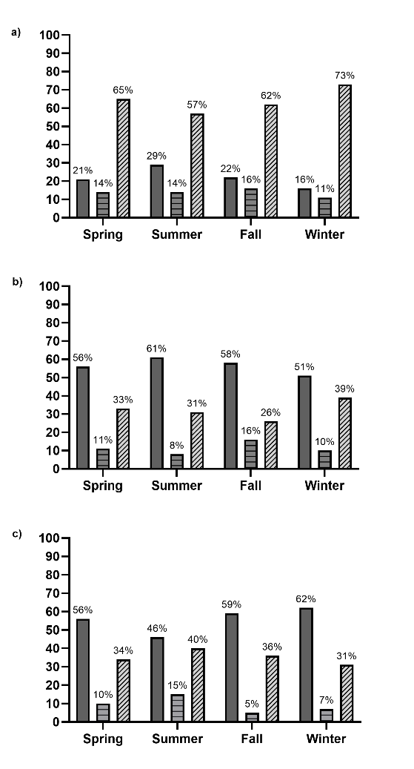
Supplemental Fig. 1. Proportion of a) young children 1-3 years old, b) women 50-69 years old, and c) elderly 70-79 years old with an intake of a vitamin D (containing) supplement on none (left and dark grey bar), one (middle and horizontally striped grey bar) or two (right and diagonal striped light grey bar) recall days shown per season. Weighted for socio-demographic factors, season and day of the week (DNFCS 2019-2021). Data from the 24-hour dietary recall.

References
1. Benjamini Y, Hochberg Y (1995) Controlling the false discovery rate: a practical and powerful approach to multiple testing. Journal of the Royal statistical society: series B (Methodological) 57 (1):289–300

