Deletion of Sirt3 does not affect atherosclerosis but accelerates weight gain and impairs rapid metabolic adaptation in LDL receptor knockout mice – Implications for cardiovascular risk factor development

Stephan Winnik^{1, 2}, Daniel S. Gaul¹, Frédéric Preitner³, Christine Lohmann¹, Julien Weber¹, Melroy X. Miranda^{1,6}, Yilei Liu¹, Lambertus J. van Tits¹, José María Mateos⁴, Chad E. Brokopp⁵, Johan Auwerx⁶, Bernard Thorens³, Thomas F. Lüscher^{1,7}, and Christian M. Matter^{1,7}

- Division of Cardiology, Dept. of Medicine, University Hospital Zurich, Zurich, Switzerland and Cardiovascular Research, Institute of Physiology, University of Zurich, Zurich, Switzerland
- Division of Cardiology and Department of Medicine, GZO – Regional Health Centre Wetzikon, Wetzikon, Switzerland
- Center for Integrative Genomics, University of Lausanne, Lausanne, Switzerland
- Center for Microscopy and Image Analysis, University of Zurich, Zurich, Switzerland
- Swiss Center for Regenerative Medicine, University Hospital Zurich, Zurich, Switzerland;
- Laboratory of Integrative Systems Physiology, School of Life Science, Ecole Polytechnique Fédérale de Lausanne, Lausanne, Switzerland
- Zurich Center for Integrative Human Physiology, University of Zurich, Zurich, Switzerland

Running title: Sirt3 in Atherosclerosis & Metabolism

Key words: Sirtuins; Sirtuin 3; atherosclerosis; metabolism; oxidative stress

SUPPLEMENTAL MATERIAL
Figure S1: Loss of Sirt3 does not increase aortic oxidative DNA damage.

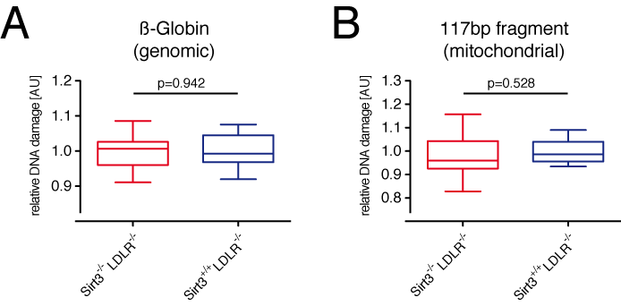

Figure S1: Eight-week old male LDLR^{-/-} and LDLR^{-/-}Sirt3^{-/-} mice were fed a high-cholesterol diet (1.25% w/w) for 12 weeks before aortae were harvested. Aortic DNA was isolated and relative oxidative damage of genomic (A) and mitochondrial DNA (B) was assessed using quantitative PCR. (A) Lesion frequency and the resulting copy number of ß-Globin served as surrogate for genomic DNA damage. (B) Lesion frequency and the resulting copy number of a 117bp mitochondrial DNA fragment served as surrogate for mitochondrial DNA damage. Box plots show interquartile ranges, whiskers indicate minima and maxima.
Figure S2: Loss of Sirt3 does not affect aortic expression levels of major NADPH regenerating enzymes.

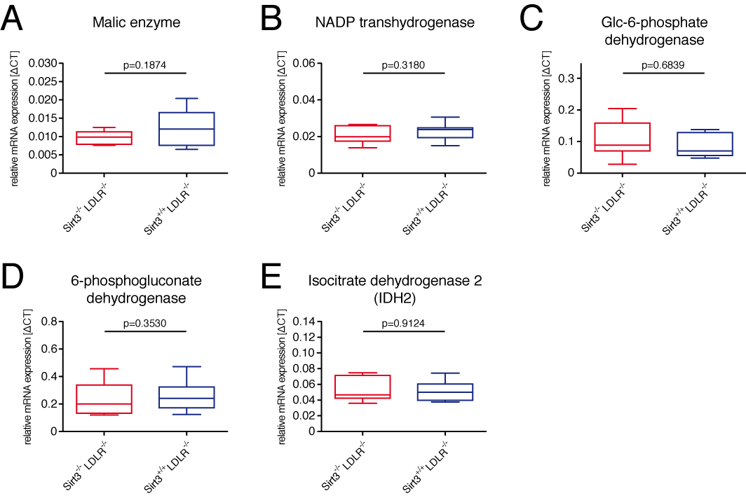

Figure S2: Eight-week old male LDLR^{-/-} and LDLR^{-/-} Sirt3^{-/-} mice were fed a high-cholesterol diet (1.25% w/w) for 12 weeks before mice were harvested and mRNA was isolated. Aortic expression analyses of the key NADPH regenerating enzymes were assessed using quantitative PCR. (A) Malic enzyme. (B) NADPH transhydrogenase. (C) Glucose-6-phosphate dehydrogenase (Glc-6-phosphate dehydrogenase). (D) 6-Phosphogluconate dehydrogenase. (E) Isocitrate dehydrogenase 2 (IDH2). Box plots show interquartile ranges, whiskers indicate minima and maxima.
Figure S3: Sirt3 deficiency leads to hepatic global mitochondrial hyperacetylation both after high-cholesterol diet and normal chow.

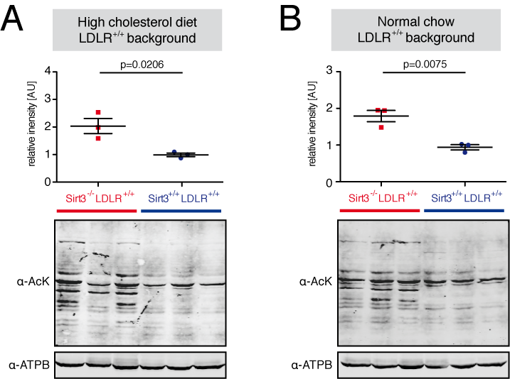

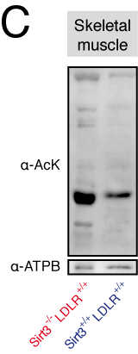

Figure S3: Eight-week old male Sirt3^{-/-}, Sirt3^{-/-} LDLR^{-/-}, and wiltdtype mice, respectively, were fed a high-cholesterol diet (1.25% w/w) or normal chow for 12 weeks before mice were harvested. Mitochondrial protein was isolated from livers (A & B) and gastrocnemius muscle, respectively, electrophoretically separated and probed with anti-acetyl lysine (α-AcK). (A) Hepatic mitochondrial protein acetylation after 12 weeks of high-cholesterol diet. (B) Hepatic mitochondrial protein acetylation after 12 weeks of normal chow. (C) Gastrocnemic mitochondrial protein acetylation after 12 weeks of high-cholesterol diet. ATP-synthase subunit ß (ATPB) served as loading control. Data are presented as means ± SEM with superimposition of individual data points.
Figure S4: Loss of Sirt3 does not affect epididymal white adipose tissue, liver or spleen mass in LDLR^{-/-} mice.

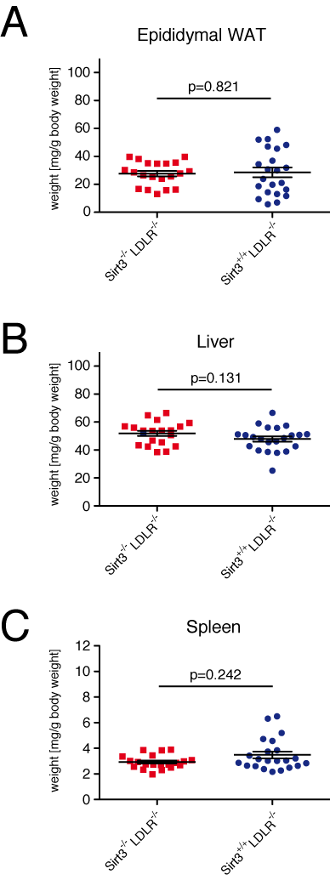

Figure S4: Eight-week old male LDLR^{-/-} and LDLR^{-/-}Sirt3^{-/-} mice were fed a high-cholesterol diet (1.25% w/w) for 12 weeks before mice were harvested. (A) Epididymal white adipose tissue (WAT) mass. (B) Liver mass. (C) Spleen mass. Data are presented as means ± SEM with superimposition of individual data points.

Figure S5: Loss of Sirt3 does not affect metabolic substrate preference or food intake.

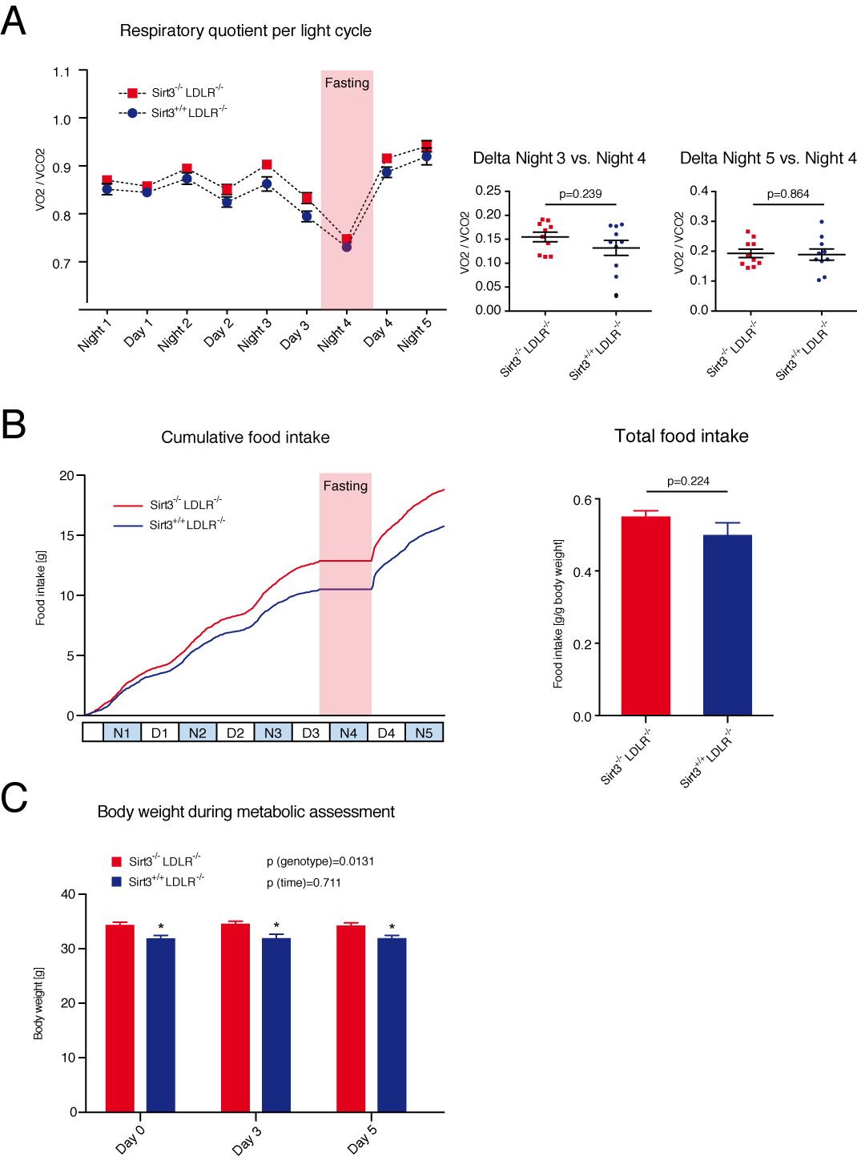
Figure S5: After a 12-week high-cholesterol diet (1.25% w/w) different metabolic parameters were assessed in individually-caged LDLR^{-/-} and LDLR^{-/-}Sirt3^{-/-} mice during five light cycles. (A) Respiratory quotient averaged per day/night (left panel); respiratory quotient drop during fasting, determined by subtracting the individual, fed (Night 3) to fasted (Night 4) averages (center panel, « Delta N3 vs. N4 ») and respiratory quotient rebound upon refeeding, determined by subtracting refed (Night 5) to fasted (Night 4) averages (right panel, « Delta N4 vs. N5 »). (B) Cumulative, real-time feeding (left panel) and total feeding (right panel) over the whole experiment. (C) Body weights before (Day 0), during (Day 3) and after (Day 5) the experiment. Data are presented as means ± SEM, with superimposition of individual data points in « Delta » panels. N=Night, D=Day. *) p<0.05 compared with LDLR^{-/-}Sirt3^{-/-} mice.
SUPPLEMENTARY METHODS

Tissue harvesting and processing
Mice were anesthetized using isoflurane. After medial thoraco- and laparotomy the left ventricle was punctured and blood was drawn. Thereafter, the right atrium was incised and the vascular system was rinsed briefly with cold normal saline (0.9% w/v) before organs were explanted. For histological examination, tissue was embedded in OCT (optimal cutting temperature) compound (Tissue-Tek) and immediately frozen on dry ice; for biochemical analyses samples were snap frozen in liquid nitrogen. All samples were stored at -80°C until analysis.

