Supplemental Figures

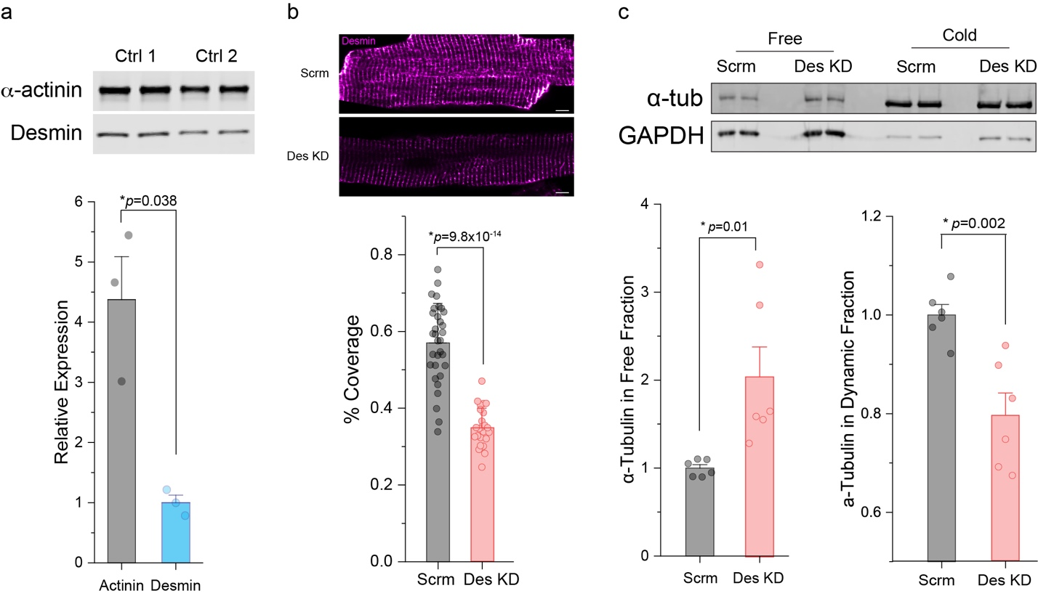

Supplemental Fig. 1 (a) Representative western blot images (top) and quantification (bottom) of α-actinin and desmin using whole cell lysates from adult rat cardiomyocytes; the blots were immunostained using the same α-actinin and desmin antibodies and concentration as used in Figure 1e (N=3 rats, n=3 averaged-values from 2 WB technical lanes per rat). (b) Representative immunofluorescent images (top) and quantification of coverage area (bottom) for desmin in scramble shRNA (Scrm) and Desmin Knock-Down shRNA (Des KD) adult rat cardiomyocytes (N=3 rats, n=~10 cells per rat). (c) Representative western blot (top) and quantification (bottom) of α-tubulin and GAPDH in free and cold-sensitive fractions from rat cardiomyocytes infected with adenovirus containing Scrm and Des KD (N=3 rats, n=6 WB technical lanes). The bar represents mean ±1 SEM; statistical significance is determined with Two-sample Student’s T-test.

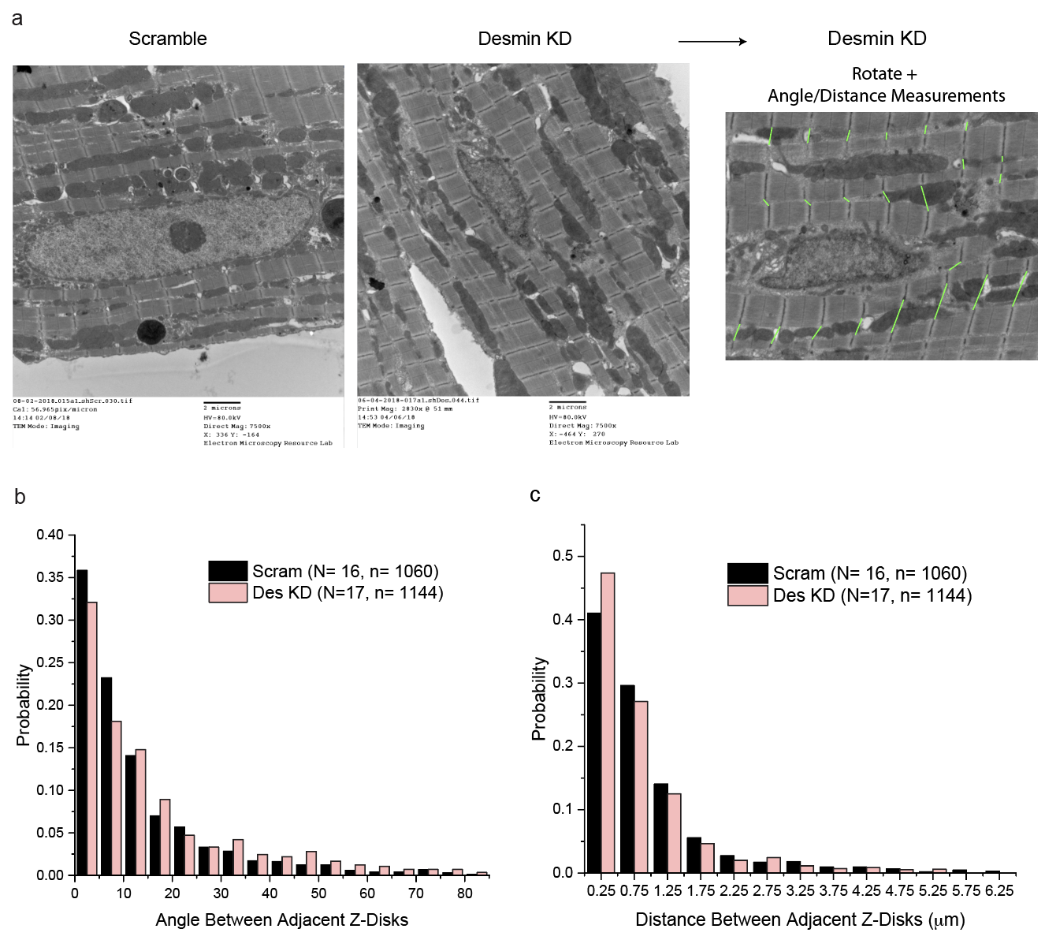

Supplemental Fig. 2 (a) Representative electron microscopy images of isolated rat cardiomyocytes with or without desmin knockdown. (b) Histograms of angle and (c) distance between adjacent Z-discs with or without desmin knockdown (N=cells, n=events).

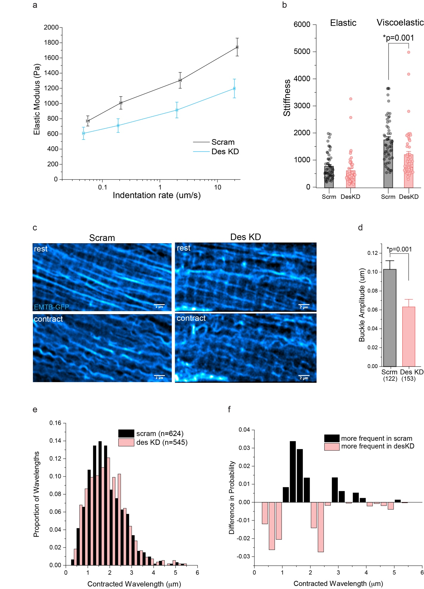

Supplemental Fig. 3 (a) Nanoindentation measurement of cardiomyocyte viscoelasticity displayed as stiffness (elastic modulus) as a function of probe indentation velocity with or without desmin KD. (b) Quantification of rate-dependent (viscoelastic) and independent (elastic) stiffness; the height of bar graphs denotes mean and error bar ±1 SE. (c) Representative images of microtubules in a cardiomyocyte at rest (top) and the peak of contraction (bottom) with or without desmin KD. (d) Quantification of microtubule buckle amplitude; the bar represents mean ± 1 SEM (n=cells). (e) Histogram of the wavelength distribution of individual microtubule buckles. (f) distribution difference (Scram – des KD from E). Statistical significance was determined using Two-sample Student’s T-test.

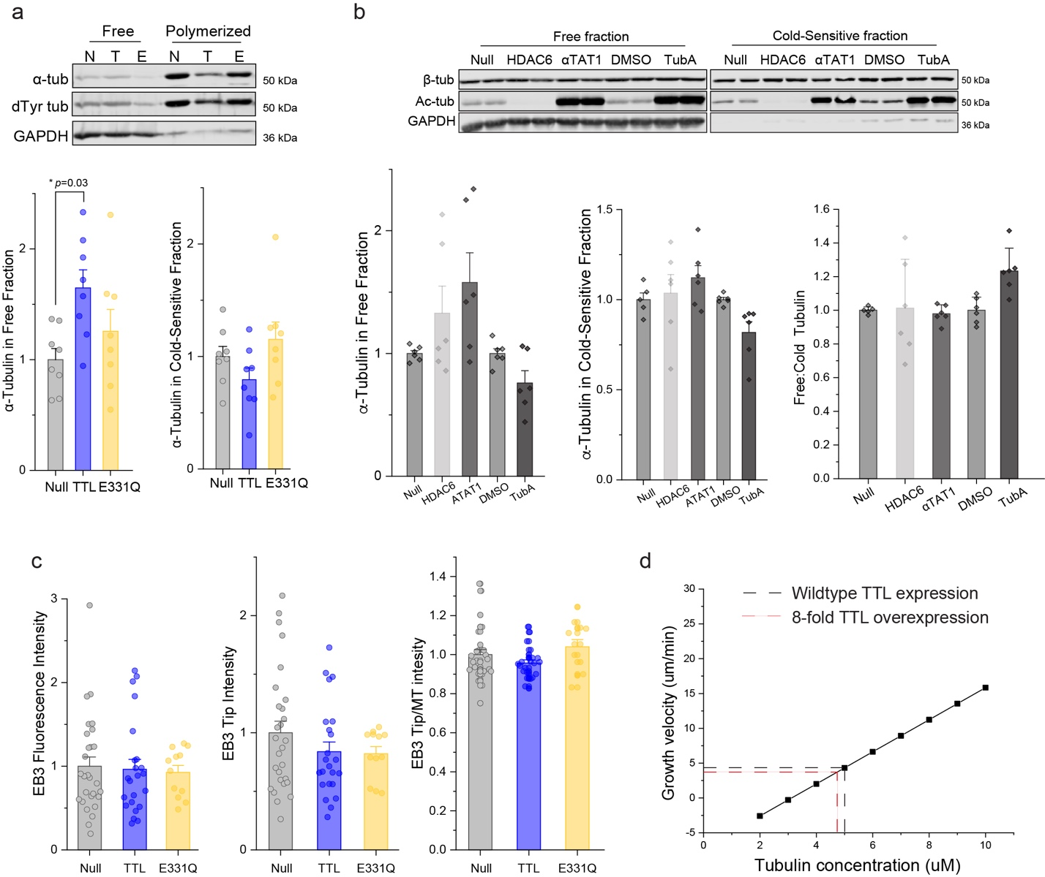

Supplemental Fig. 4 (a) Representative western blot (top) and quantification (bottom) of a-tubulin in free and cold-sensitive fractions from adult rat cardiomyocytes infected with null, TTL, or E331Q adenovirus (N=4 rats, n=8 WB technical lanes). (b) Representative western blot (top) and quantification (bottom) of β-tubulin and acetyl tubulin in free and cold-sensitive fractions from adult rat cardiomyocytes infected with either null, HDAC, or ATAT1 adenovirus, or treated with DMSO or TubA (N=3 rats, n=6 WB technical lanes). (c) Background (left) EB3-GFP fluorescence intensity, EB3 tip fluorescence intensity (middle), and the ratio of EB3 tip fluorescence intensity to microtubule EB3 intensity (right) in adult rat cardiomyocytes co-infected with EB3-GFP and either Null, TTL, or E331Q adenoviruses. The bar represents mean ± 1 SEM; statistical significance was determined using one-way ANOVA with post hoc test. (d) To reduce levels of detyrosination in this study we relied on overexpression of TTL, which is known to associate with the free α/β tubulin heterodimer in a 1:1 complex with a K_{d} of 1 μM[38]. Due to the nature of this interaction, TTL overexpression can decrease the amount of “polymerization-competent” tubulin, leading to a decrease in in vitro microtubule polymerization[38]. The relationship between free tubulin concentration and microtubule polymerization is described as a simple 1D model below, where ν_{g} is the velocity of microtubule growth, d is the dimer length (assumed to be 8 nm), k_{on} is the tubulin dimer association constant per protofilament (assumed to be 4.8 μM⁻¹s⁻¹ )[24], k_{off} is the tubulin dissociation rate constant per protofilament (assumed to be 15s⁻¹ )[24], and [Tb] is the concentration of free tubulin[4].
$$ν_{g}=d\left(k_{on}\left[Tb\right]- k_{off}\right).$$
Solving the equation of the line at a physiologic tubulin concentration of 5μM provides a theoretical value of 4.32 μm s⁻¹ for growth velocity. Using the K_{d} value for TTL-tubulin interaction at a tubulin concentration of 5μM suggests that an 8-fold overexpression of TTL[9] will produce 0.2 μM of TTL-tubulin complex. If we assume that tubulin bound to TTL cannot be polymerized, then only 4.8 μM of free tubulin is polymerization-competent at any time. This change in polymerization-competent tubulin would lead to a ~10% decrease in growth velocity. We did not observe an effect of E331Q on microtubule growth kinetics or on event frequency suggesting that the local tubulin concentration at the microtubule plus-tip is unaffected by the sequestration activity of TTL. The bar represents mean ± 1SEM; statistical significance for (a) and (c) was determined using one-way ANOVA with post hoc test and for (b) was using Two-sample Student’s T-test.

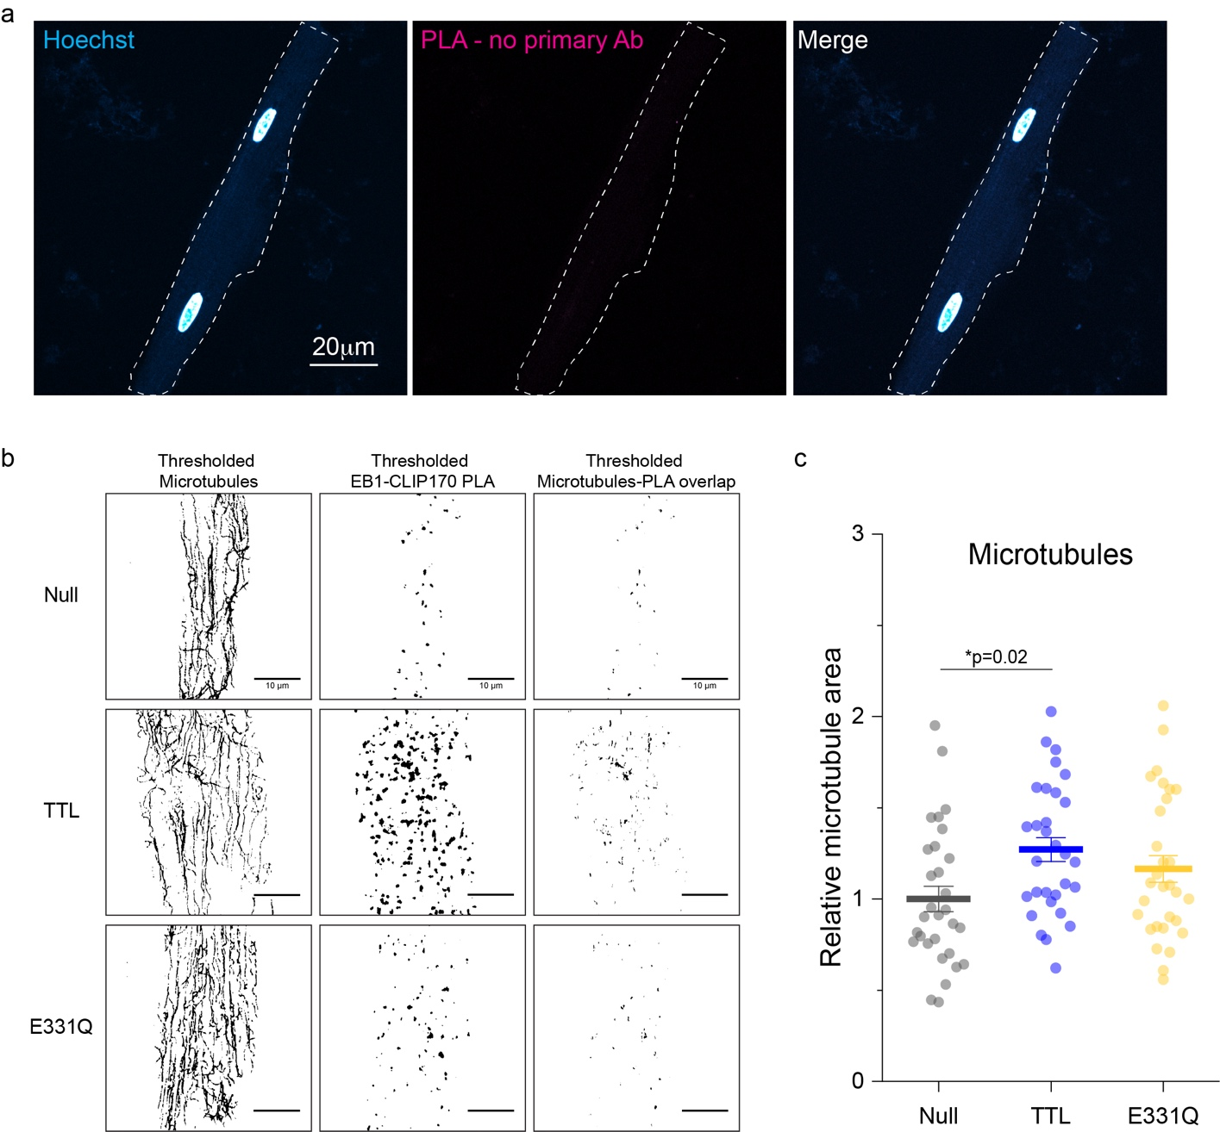

Supplemental Fig. 5 (a) Representative negative control immunofluorescent images after PLA in adult rat cardiomyocytes without EB1 or CLIP170 primary antibodies. (b) Representative thresholded immunofluorescent images used in the analysis and quantification of EB1-CLIP170 in Figure 5d. (c) Quantification of microtubule area in adult rat cardiomyocytes treated with Null, TTL, or E331Q adenovirus for 48h (N=3 rats, n=10 cells per rat). Bar
represents mean ±1 SEM; statistical significance determined with one-way ANOVA with post hoc test.

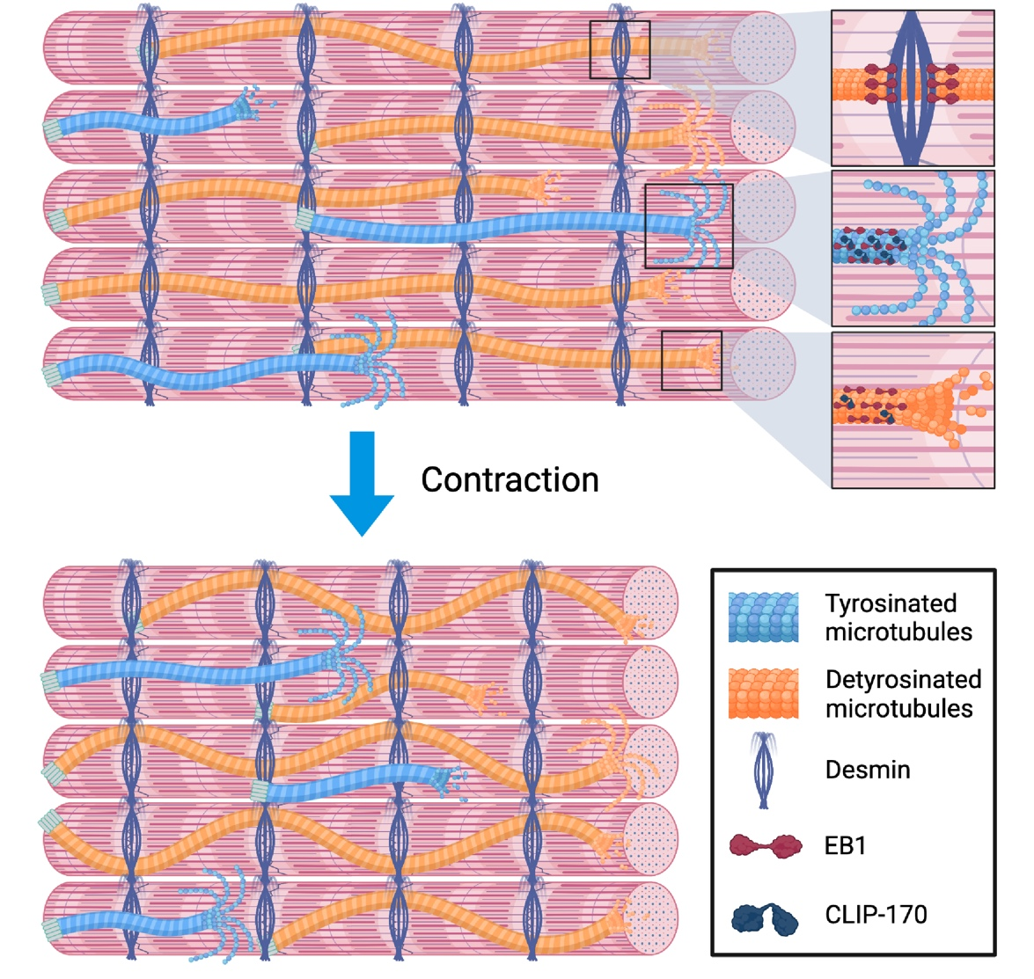

Supplemental Fig. 6 Cartoon summary of the results: Desmin intermediate filaments and tubulin detyrosination stabilize growing microtubules in the cardiomyocyte

