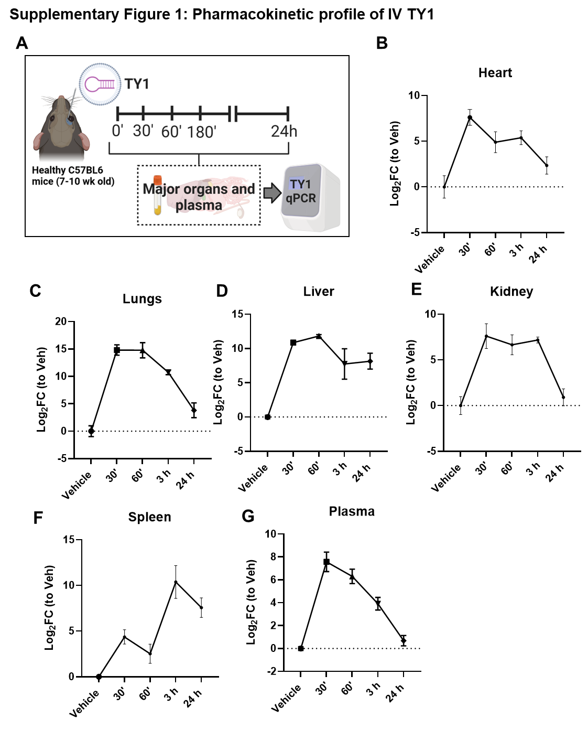
Supplementary Figures

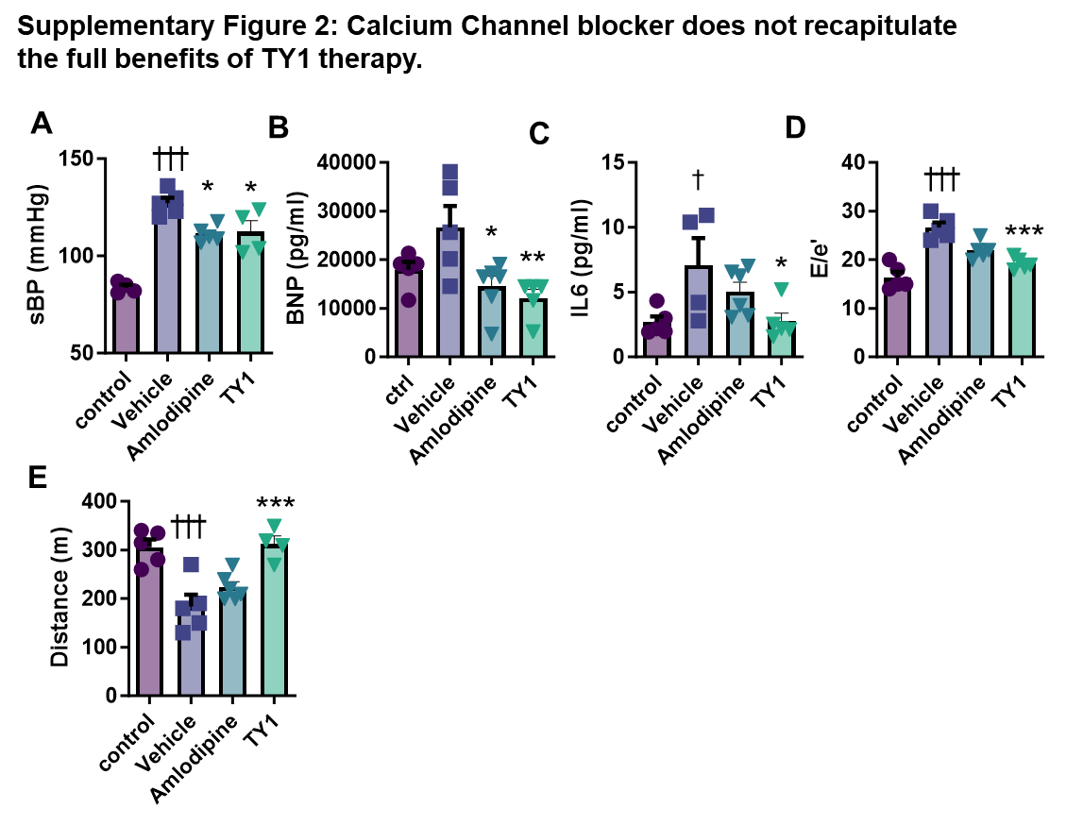
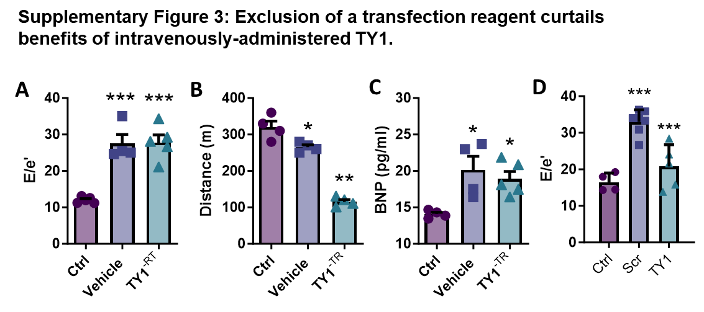
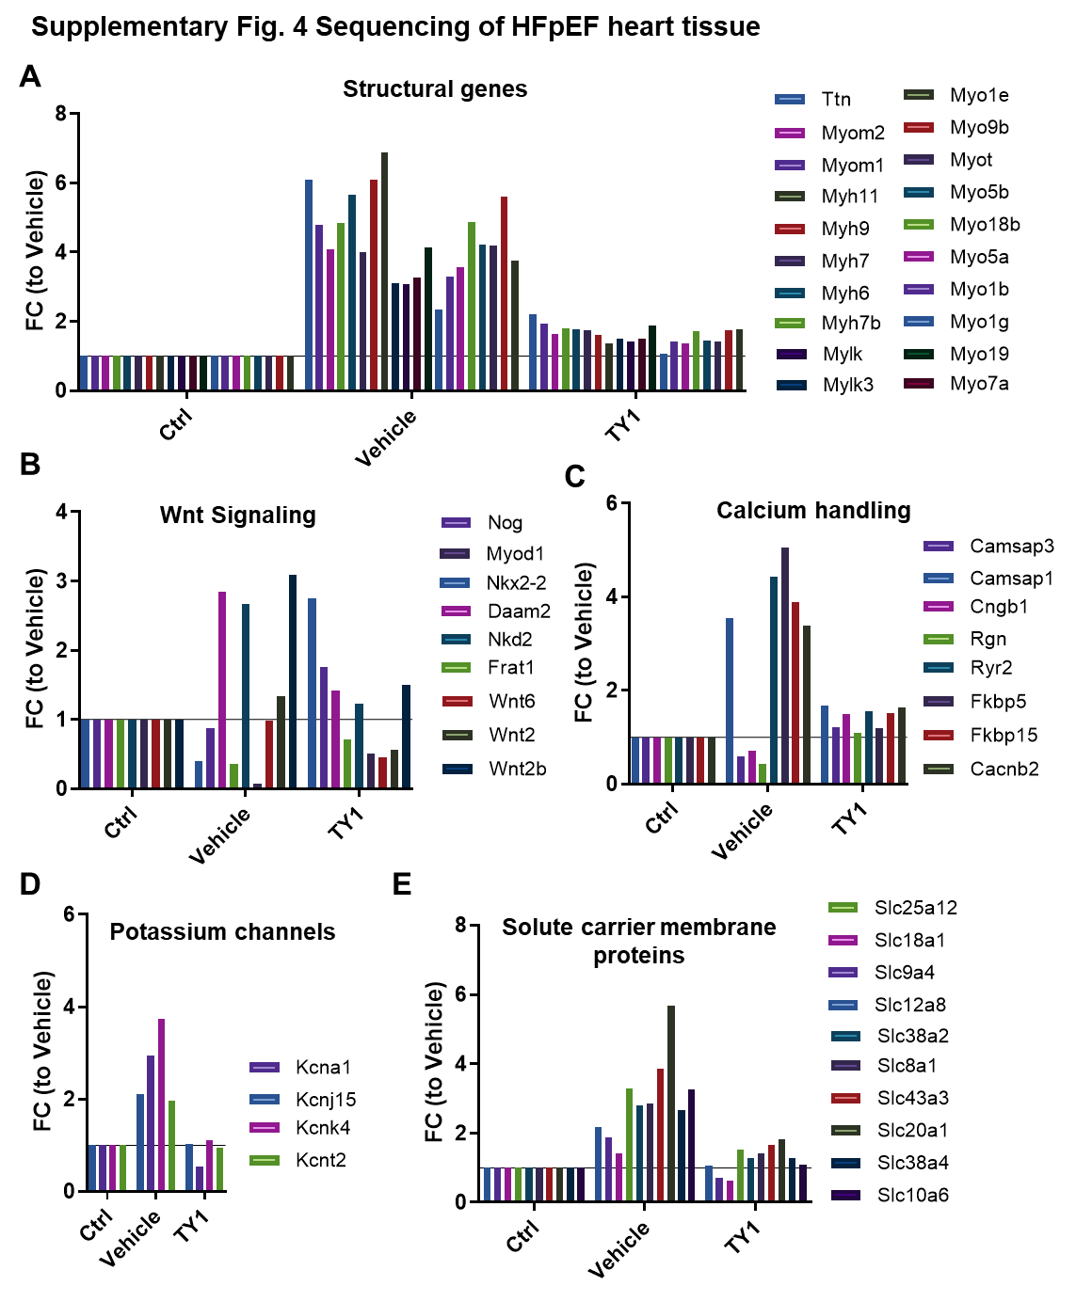
Supplementary Fig. 1: Pharmacokinetic profile of IV TY1 in healthy mice
A, Schematic of IV TY1 pharmacokinetic study. Healthy C57BL6 mice were given a single IV infusion of TY1 and animals (n=4-5 animals per timepoint per group) were sacrificed at various time points to collect heart, lung, liver, kidney, spleen and plasma to assess TY1 abundance by qPCR (as compared to a vehicle control). B-G, abundance of TY1 in various tissue at multiple time points expressed as log2 fold change compared to vehicle animals. Points reperesent group means and error bars represent SEM.

Supplementary Fig. 2: Therapeutic effects of TY1 in HFpEF are not entirely attributable to anti-hypertensive effects. A, B, HFpeF mice receiving daily oral administration of the calcium channel blocker amlodipine (4 mg/kg) had anti-hypertensive effects comparable to mice receiving twice-weekly intravenous infusions of TY1. However, unlike the amlodipine group, animals given TY1 has significantly less circulating BNP and IL6 (B and C, respectively), diastolic dysfunction (though a trend towards lower E/e’ was evident in the amlodipine group. D), and exercise endurance, E. N=4-5 animals per group. Bars represent group means and error bards represent s.d. *,†P<0.05; **, ††P<0.01; ***, †††P<0.001. *; denotes comparison between groups and vehicle, †; denotes comparison between groups and control.

Supplementary Fig. 3 Salutary effects of TY1 in HFpEF is not due non-specific effects
Loss of TY1 therapeutic bioactivity on diastolic dysfunction in HFpEF animals receiving TY1 without transfection reagent (-TR) as shown by exercise endurance, A, diastolic dysfunction, B, and circulating BNP levels, C. Lack of therapeutic bioactivity of a scramble sequence compared to TY1 in HFpEF animals as shown by lack of improvement in diastolic dysfunction in HFpEF animals (n=5 animals per group). D, Significance was determined by one-way ANOVA; *,†P<0.05; **, ††P<0.01; ***, †††P<0.001. *; denotes comparison between groups and vehicle, †; denotes comparison between groups and control.

Supplementary Fig. 4 Sequencing of HFpEF heart tissue Sequencing results showing TY1-induced normalization of HFpEF-dysregulated genes (compared to vehicle) including structural, (A), developmental (B), calcium handling (C), potassium channels (D), and solute carrier membrane proteins (E) (n=5 hearts per group).

