SUPPLEMENTARY MATERIAL

Necrosis-like cell death modes in heart failure: the influence of aetiology and the effects of RIP3 inhibition

Izabela Jarabicová¹, Csaba Horváth¹, Jaroslav Hrdlička², Almos Boroš², Veronika Olejníčková^{2,3}, Eva Zábrodská³, Soňa Štemberková Hubáčková^{4,5}, Hana Mauer Šutovská⁶, Ľuboš Molčan⁶, Libor Kopkan⁴, Martin Chudý⁷, Branislav Kura⁸, Barbora Kaločayová⁸, Eva Goncalvesová⁷, Jan Neckář², Michal Zeman⁶, František Kolář², Adriana Adameová^{1,8}

1 Faculty of Pharmacy, Department of Pharmacology and Toxicology, Comenius University, Bratislava, Slovak Republic
2 Institute of Physiology of the Czech Academy of Sciences, Prague, Czech Republic
3 Institute of Anatomy, First Faculty of Medicine, Charles University, Prague, Czech Republic
4 Institute for Clinical and Experimental Medicine, Prague, Czech Republic
5 Institute of Biotechnology, Czech Academy of Sciences, Prague, Czech Republic
6 Faculty of Natural Sciences, Department of Animal Physiology and Ethology, Comenius University, Bratislava, Slovak Republic
7 Department of Cardiology, Faculty of Medicine, Comenius University and National Cardiovascular Institute, Bratislava, Slovak Republic
8 Centre of Experimental Medicine, Institute for Heart Research, Slovak Academy of Sciences, Bratislava, Slovak Republic

Correspondence: prof. PharmDr. Adriana Duriš Adameová, PhD., FIACS; Faculty of Pharmacy, Department of Pharmacology and Toxicology, Comenius University, Odbojárov 10, 832 32 Bratislava, Slovak Republic; email: adameova@fpharm.uniba.sk; Tel. +421 2 50117 366; Fax +421 2 50 117 100

Supplementary figures
Fig. S1 mRNA levels of NLRP3 and GSDMD and the effect of RIP3 inhibition. (A) RT-qPCR analysis of NLRP3 in non-infarcted heart failure (HFni), infarcted HF (HFi), treated HFni (HFni+GSK´872) and treated HFi (HFi+GSK´872) group, n=4-6, data are presented as mean±SEM, two-way ANOVA; (B) RT-qPCR analysis of GSDMD in non-infarcted HF (HFni), infarcted HF (HFi), treated HFni (HFni+GSK´872) and treated HFi (HFi+GSK´872) group, n=4-6, data are presented as mean±SEM, two-way ANOVA, *P<0.05
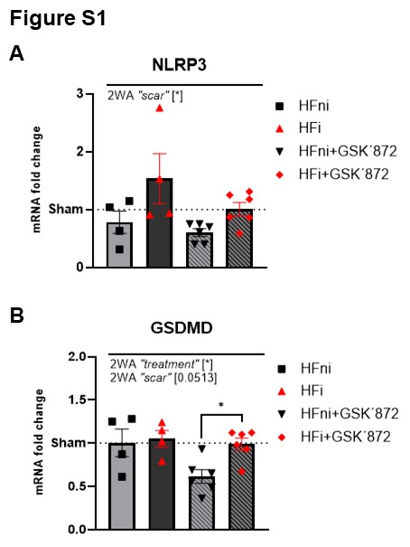

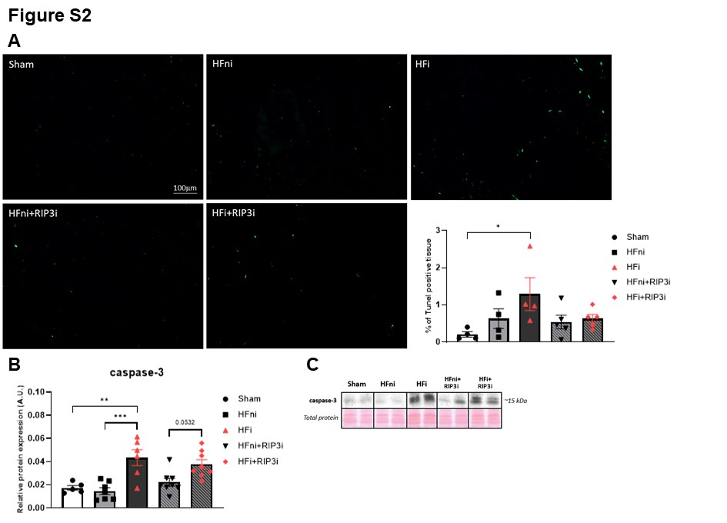
Fig. S2 Assessment of apoptosis in post-myocardial infarction heart failure (HF) and the effects of RIP3 inhibition. (A) TUNEL staining and percentage expression of TUNEL-positive cells in Sham, non-infarcted HF (HFni), infarcted HF (HFi), treated HFni (HFni+GSK´872) and treated HFi (HFi+GSK´872) group, n=4-5, data are presented as mean±SEM, one-way ANOVA, *P<0.05; (B) Western blot analysis of proapoptotic caspase-3 in Sham, non-infarcted HF (HFni), infarcted HF (HFi), treated HFni (HFni+GSK´872) and treated HFi (HFi+GSK´872) group, n=5-8, data are presented as mean±SEM, one-way ANOVA, **P<0.01, ***P<0.001; (C) Representative immunoblot and total protein staining

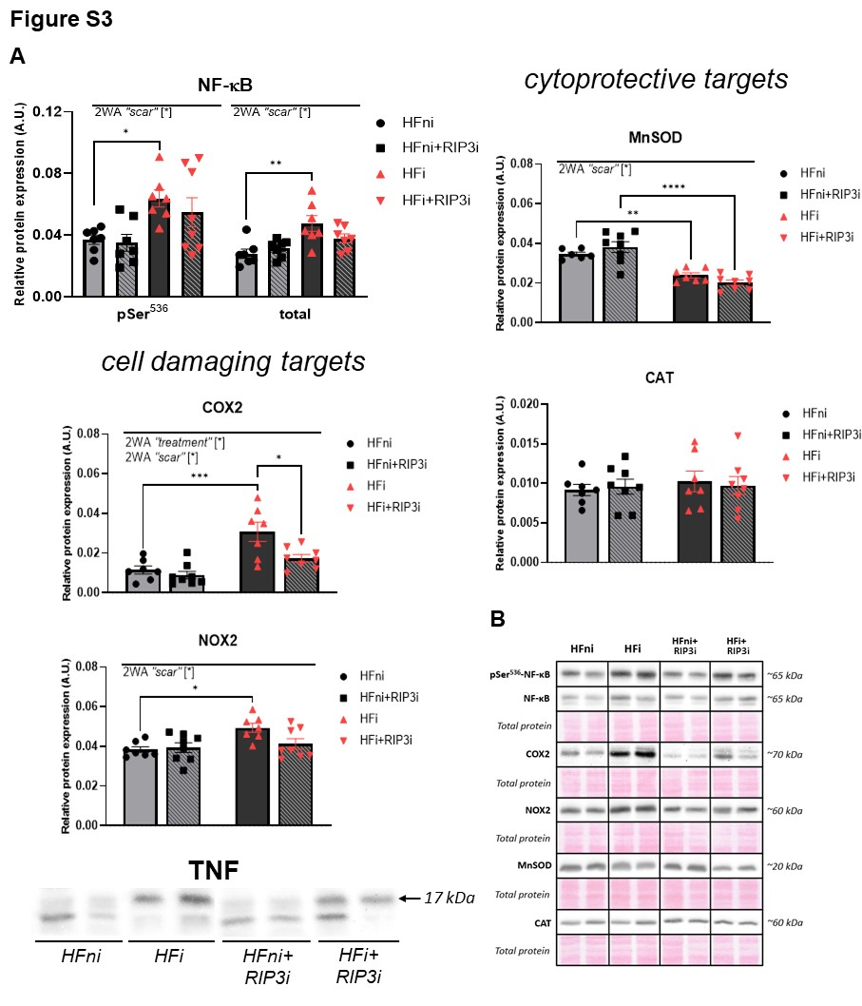
Fig. S3 Effect of RIP3 inhibition on the expression of NF-κB and its cell damaging and cytoprotective targets. (A) Western blot analysis of pSer⁵³⁶-NF-κB, NF-κB, COX2, NOX2, TNF, MnSOD and CAT in non-infarcted heart failure (HFni), treated HFni (HFni+GSK´872), infarcted HF (HFi) and treated HFi (HFi+GSK´872) group, n=6-8, data are presented as mean±SEM, two-way ANOVA, *P<0.05, **P<0.01, ***P<0.001, ****P<0.0001; (B) Representative immunoblots and total protein staining

Supplementary tables
Table S1 Primary antibodies used for the detection of proteins presented in the main text of the manuscript
1° antibody | Catalogue number | Manufacturer
α-SMA | M0851 | Dako, USA
AIF | #4642 | Cell Signaling Technology, USA
ASC | #67824 | Cell Signaling Technology, USA
BNIP3 | #3769 | Cell Signaling Technology, USA
CaMKII | ab181052 | Abcam, UK
caspase-1 | ab179515 | Abcam, UK
caspase-3 | #9662 | Cell Signaling Technology, USA
caspase-11 | #14340 | Cell Signaling Technology, USA
CAT | #14097 | Cell Signaling Technology, USA
COX2 | #12282, | Cell Signaling Technology, USA
CypD | #78247 | Cell Signaling Technology, USA
Drp1 | #5391 | Cell Signaling Technology, USA
GSDMD | #46451 | Cell Signaling Technology, USA
HMGB1 | ab18256 | Abcam, UK
Hsp70 | #4872 | Cell Signaling Technology, USA
Hsp90 | #4877 | Cell Signaling Technology, USA
Iba1 | ab108539 | Abcam, UK
IL-1β | ab9722 | Abcam, UK
JNK | #9252 | Cell Signaling Technology, USA
MLKL | ab243142 | Abcam, UK
MyD88 | #4283 | Cell Signaling Technology, USA
NF-κB | #8242 | Cell Signaling Technology, USA
NLRP3 | ab263899 | Abcam, UK
NOX2 | ab129068 | Abcam, UK
PGAM5 | ab244218 | Abcam, UK
pSer637-Drp1 | #4867 | Cell Signaling Technology, USA
pSer345-MLKL | MABC-1158 | Merck, Germany
pSer536-NF-κB | #3033 | Cell Signaling Technology, USA
pThr286-CaMKII | ab171095 | Abcam, UK
pThr138/Tyr185-JNK | #9255 | Cell Signaling Technology, USA
pThr231/Ser232-RIP3 | #91702 | Cell Signaling Technology, USA
RIP3 | #15828 | Cell Signaling Technology, USA
SOD2 (MnSOD) | #13141 | Cell Signaling Technology, USA
TGF-β | ab179695 | Abcam, UK
TLR2 | ab209217 | Abcam, UK
TLR3 | ab13915 | Abcam, UK
TLR4 | ab217274 | Abcam, UK
TNF | ab66579 | Abcam, UK
TRIF | #PA5-23467 | Invitrogen, Waltham, USA

Table S2 Thermal programme for miRCURY LNA SYBR Green PCR used for miRCURY LNA miRNA PCR Assay panel
Step | Temperature | Time | Cycles
PCR initial heat activation | 95 °C | 2 min.
Denaturation | 95 °C | 10 s. | 40x
Annelation | 56 °C | 60 s. | 40x

Table S3 Thermal programme for RT-qPCR miRNA analysis used for analysing of miRNA-140-5p and miRNA-142-3p
Step | Temperature | Time | Cycles
Polymerase activation | 95 °C | 20 s.
Denaturation | 95 °C | 3 s. | 40x
Annelation | 60 °C | 30 s. | 40x

Table S4 List of measured miRNAs and their mature sequences
miRNA name | Species | Mature sequence
miRNA-140-5p | Rattus norvegicus | CAGUGGUUUUACCCUAUGGUAG
miRNA-142-3p | Rattus norvegicus | UGUAGUGUUUCCUACUUUAUGGA
miRNA-103a-3p | Rattus norvegicus | AGCAGCAUUGUACAGGGCUAUGA

Table S5 List of primers for RT-qPCR
rCol1a_F | TGACTGGAAGAGCGGAGAGTA
rCol1a_R | GGGGTTTGGGCTGATGTACC
rFN1_F | ATGAGAAGCCTGGATCCCCT
rFN1_R | CAGTTGGGGAAGCTCATCTGT
rTNC_F | GTGAGGGACGCTCATTCACT
rTNC_R | GGGGCAAGGCCTCTGTAATG
rACTB_F | CCGCGAGTACAACCTTCTTGC
rACTB_R | TATCGTCATCCATGGCGAACTGG
rNLRP3_F | CTGCAGAGCCTACAGTTGGG
rNLRP3_R | GTCCTGCTTCCACACCTACC
rGSDMD_F | CCCTTCCCACAACATCTTCAT
rGSDMD_R | TTGGCTTTCCTAGAGGCTGGA

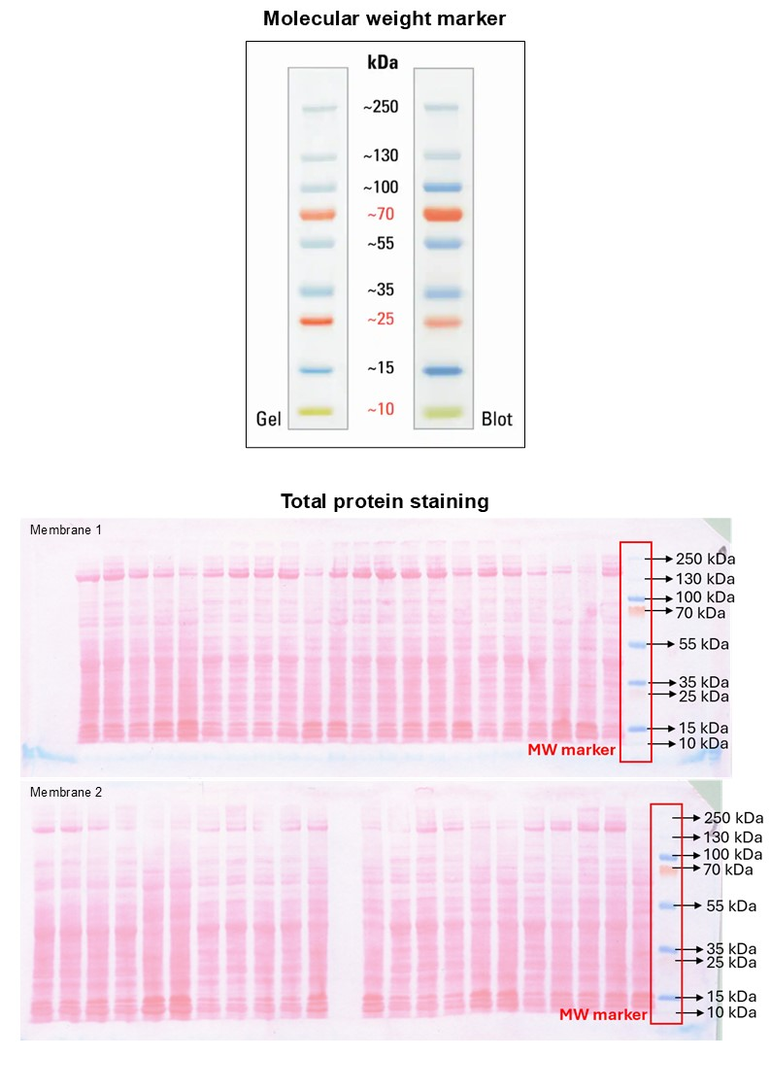
Supportive material to Western Blot data

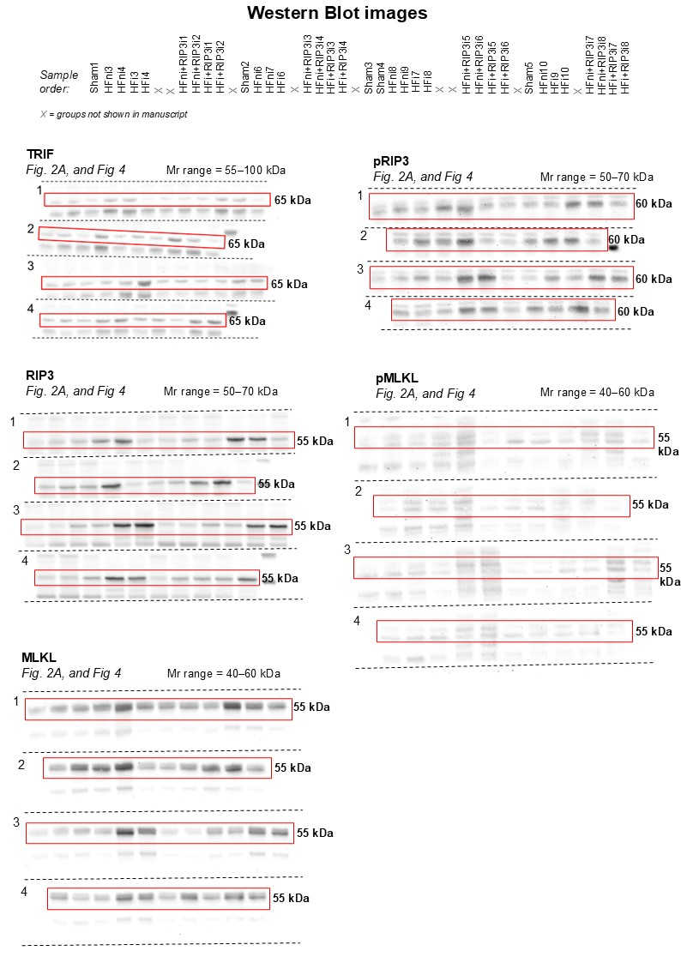

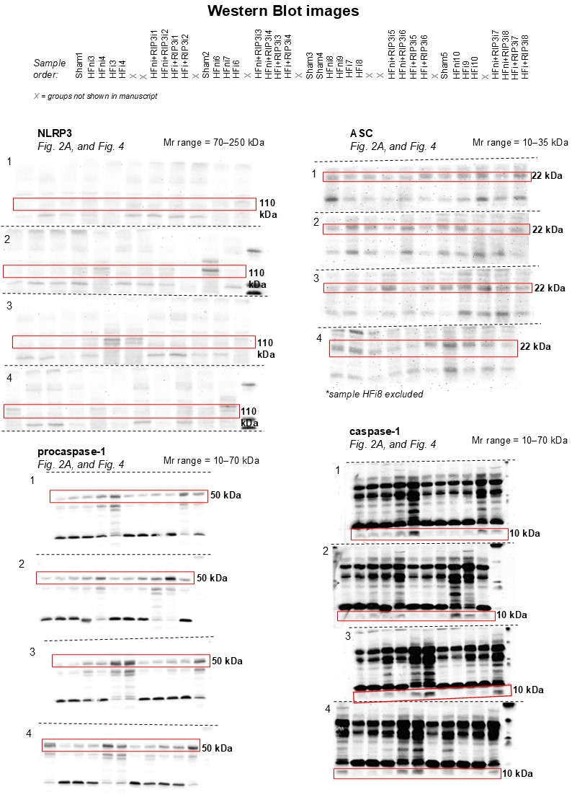

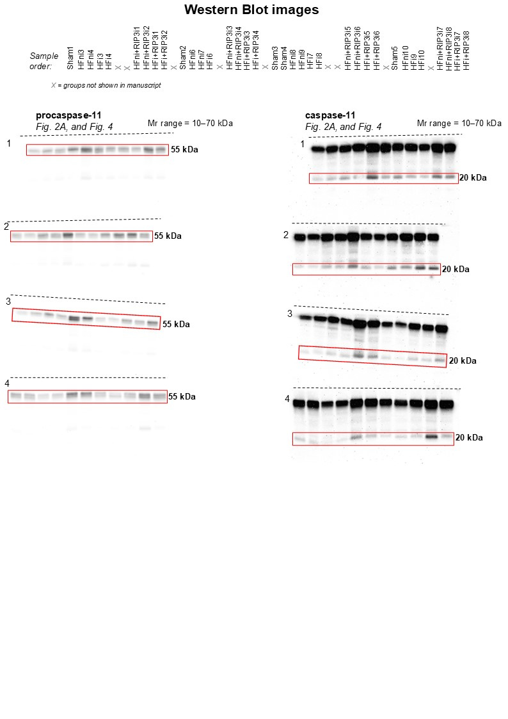

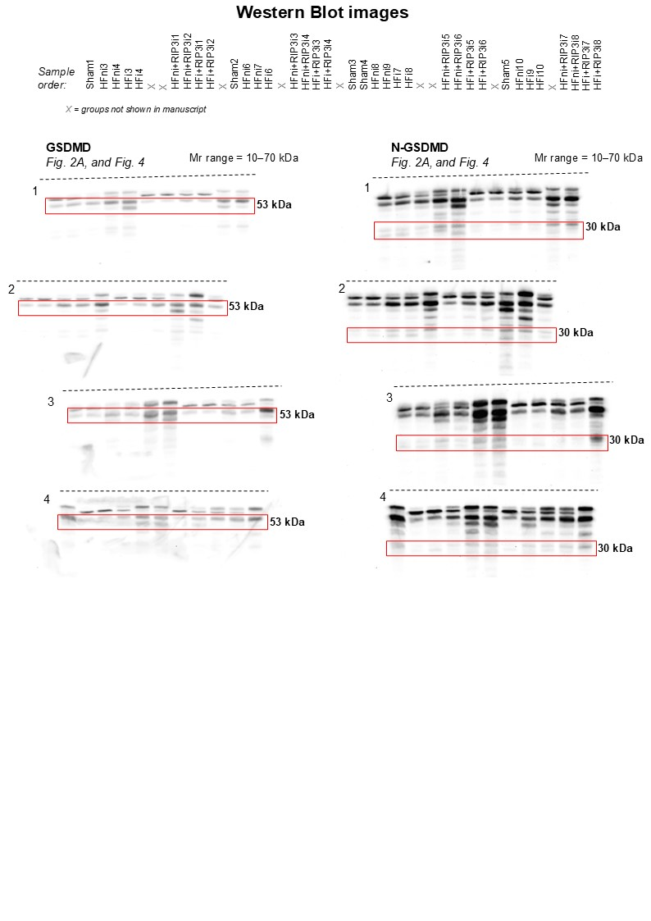

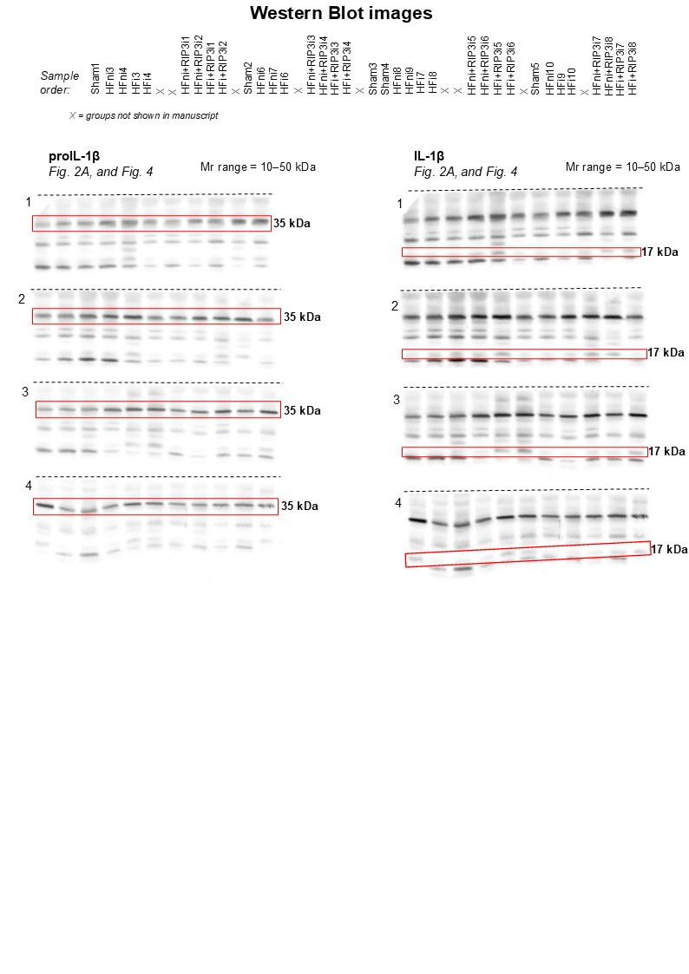

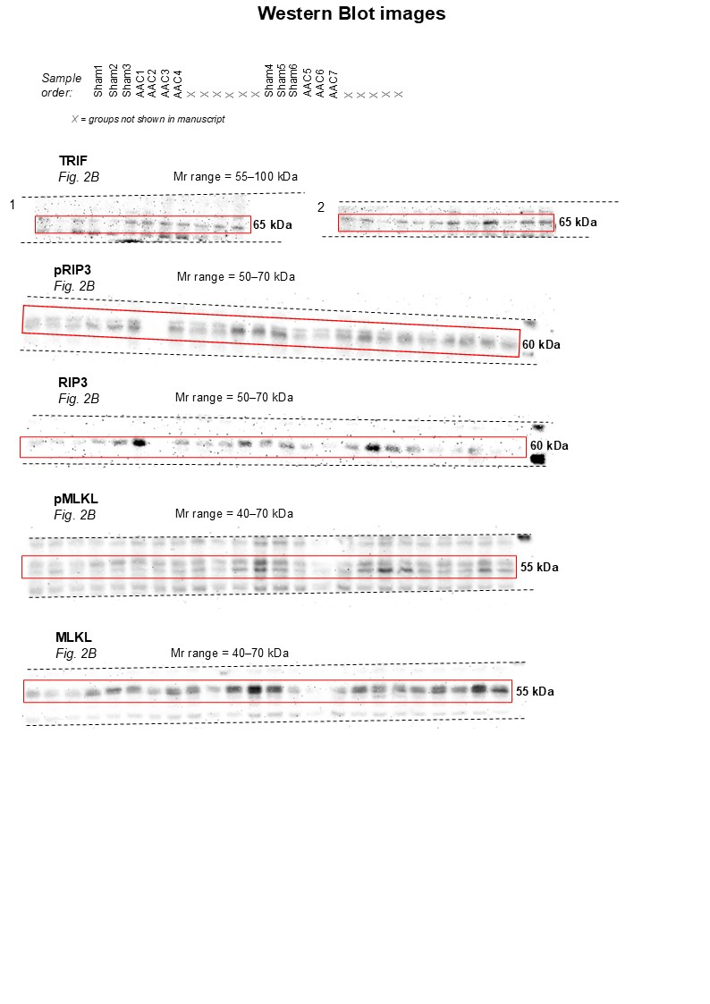

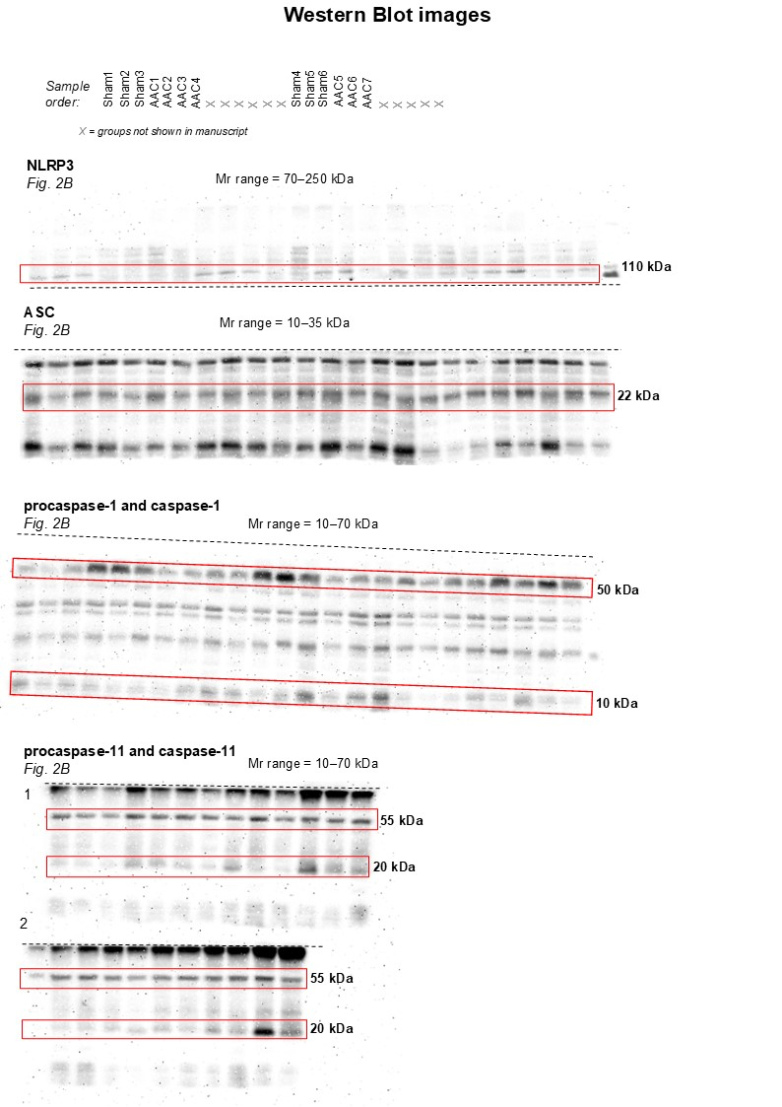

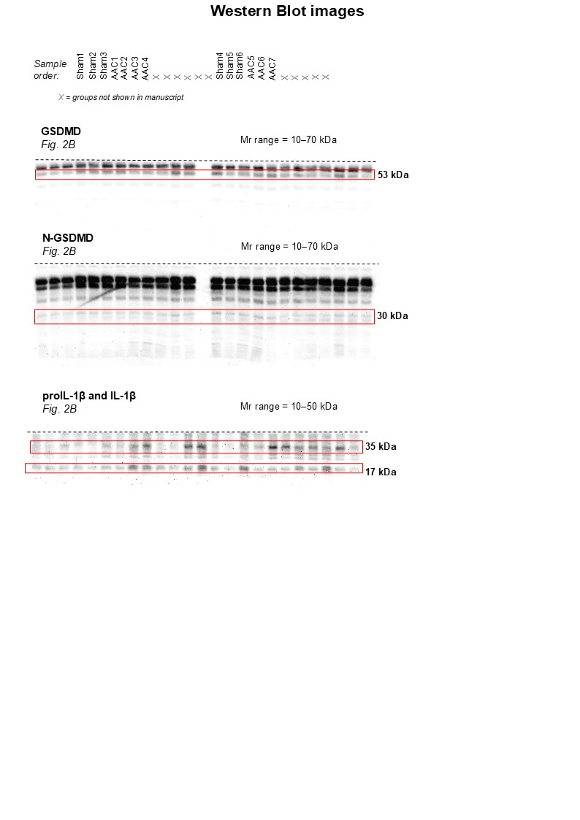

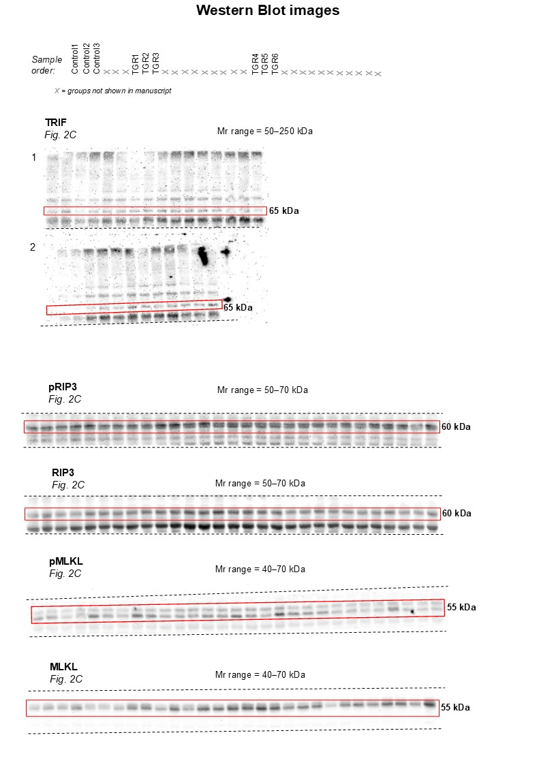

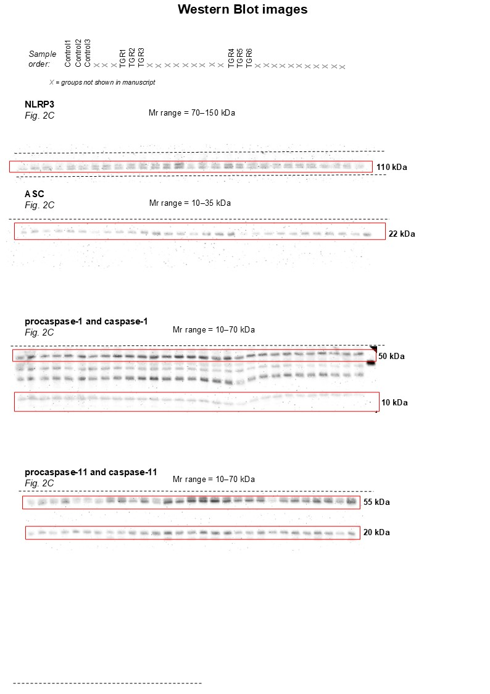

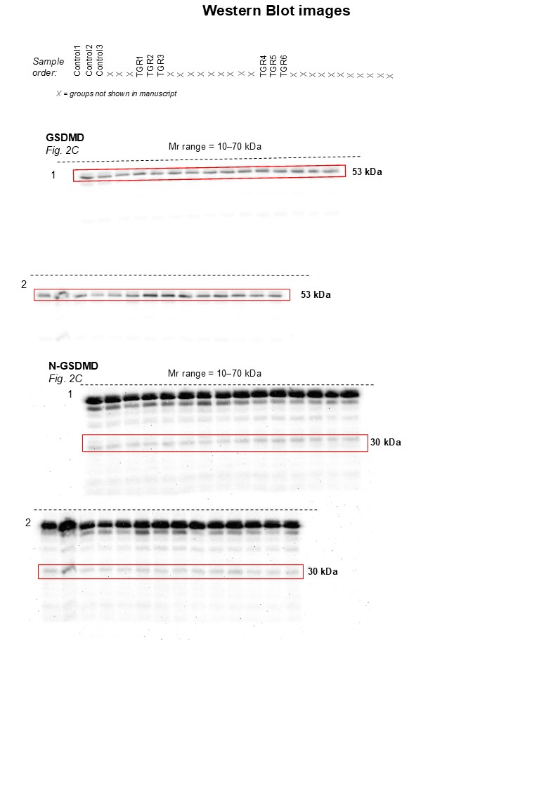

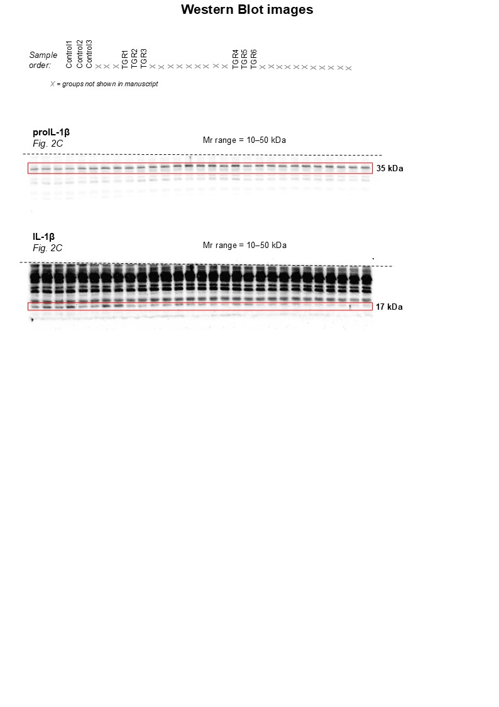

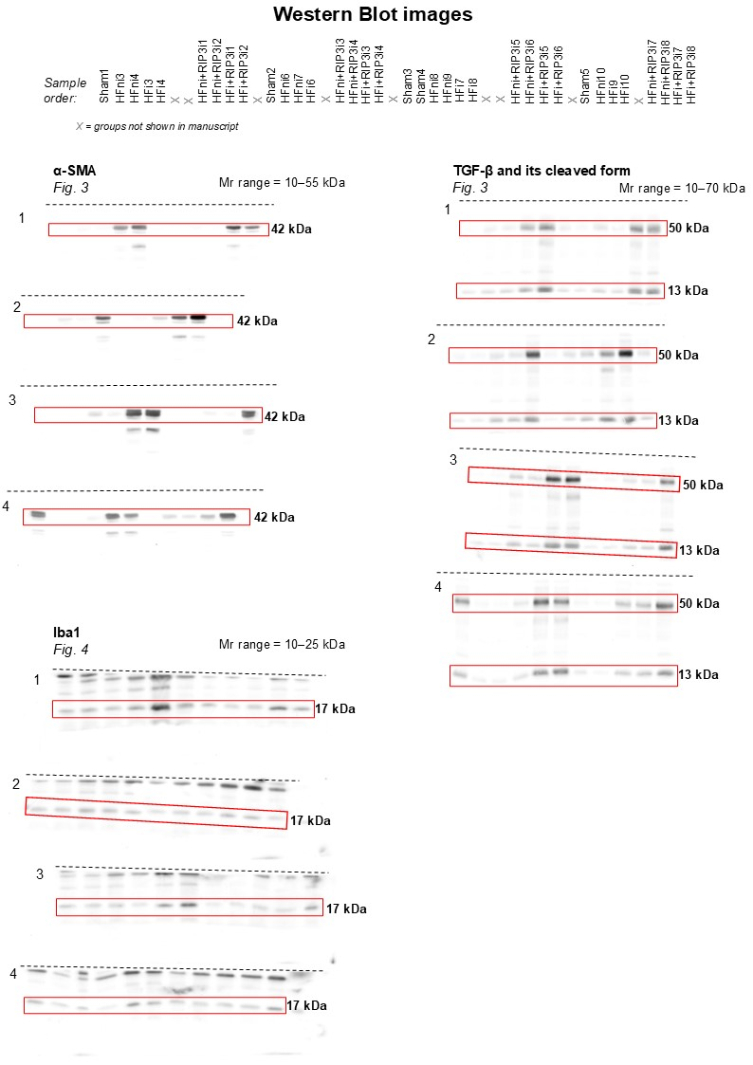

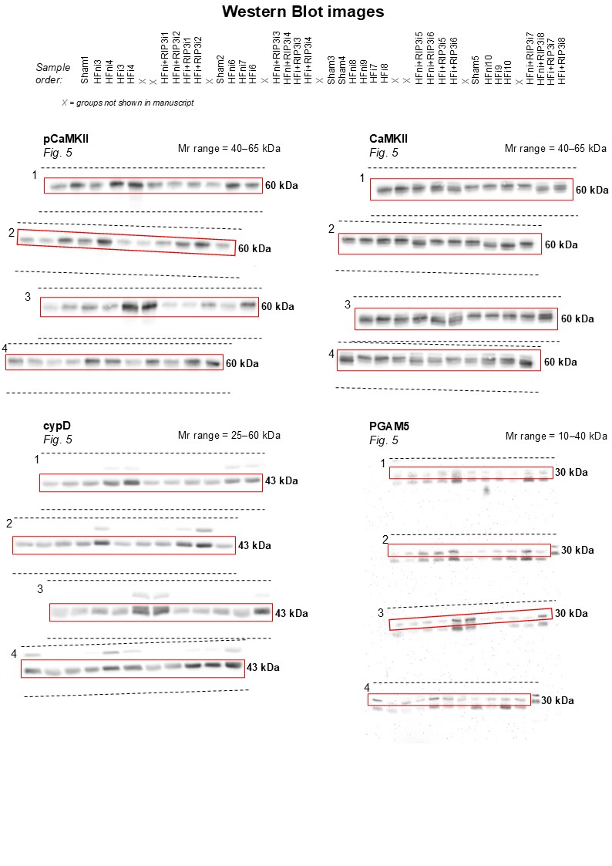

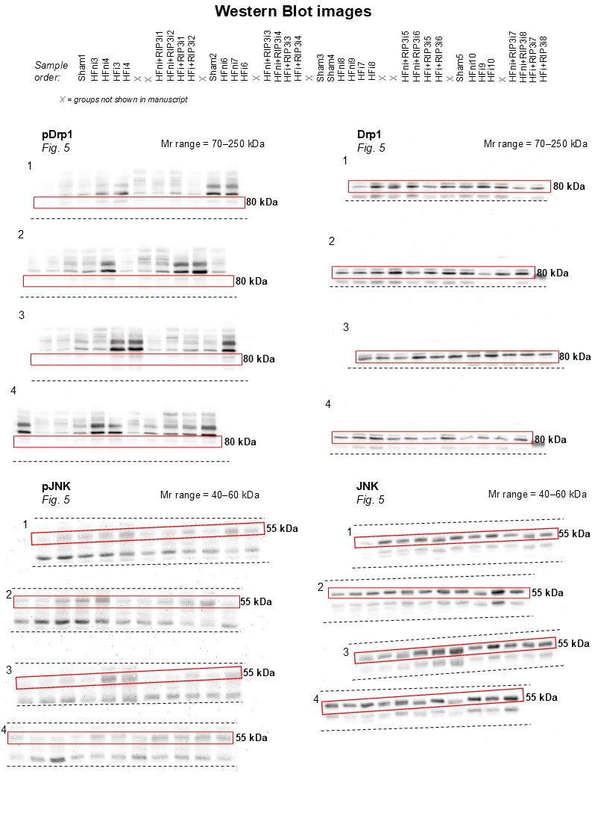

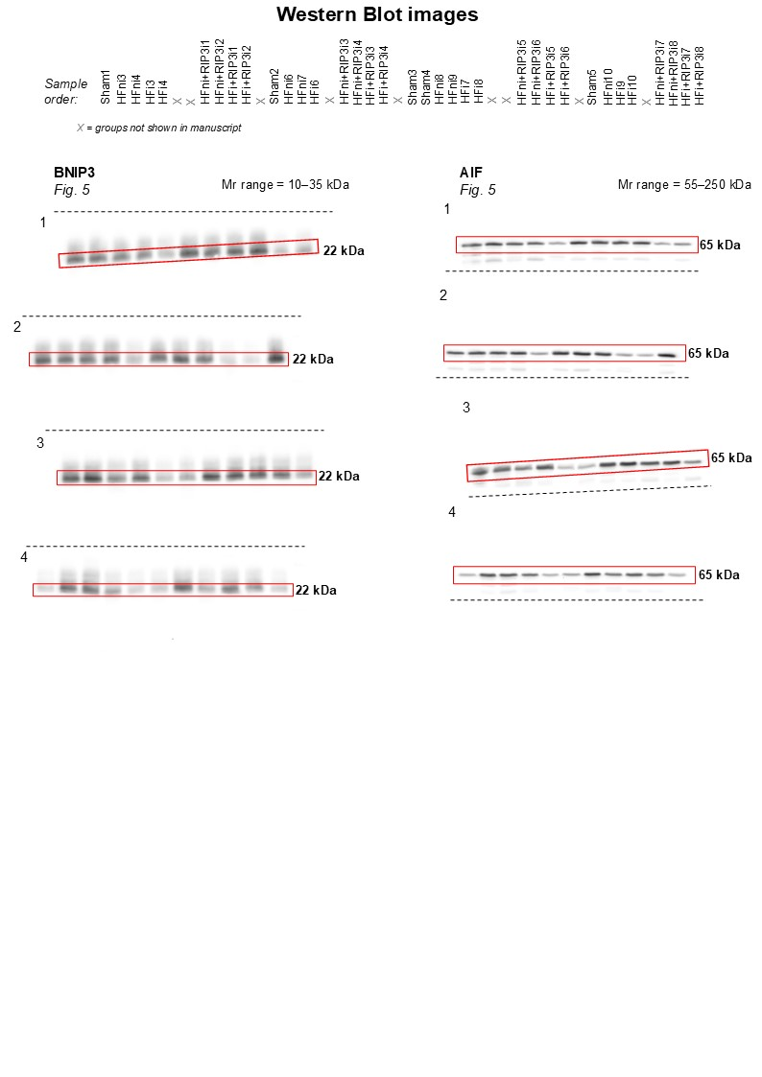

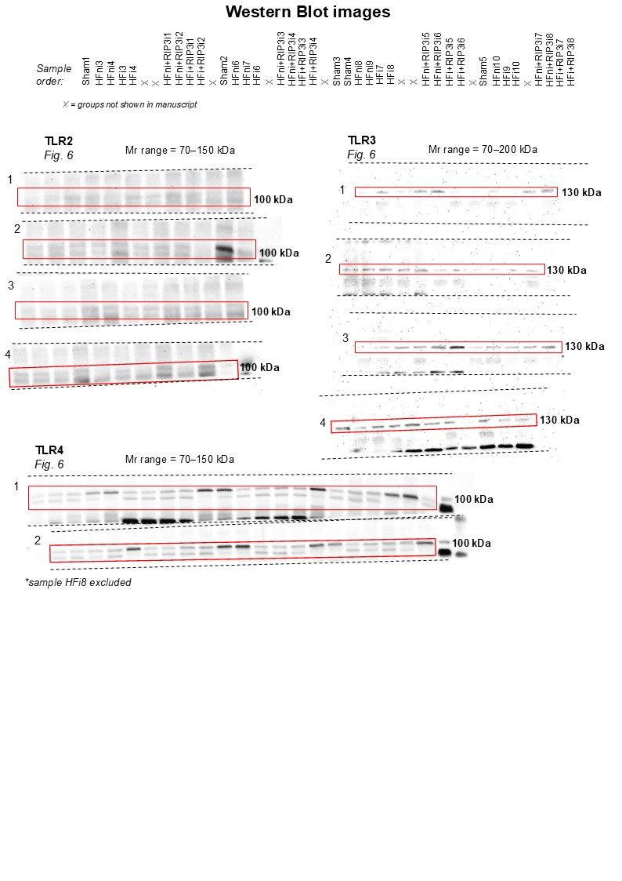

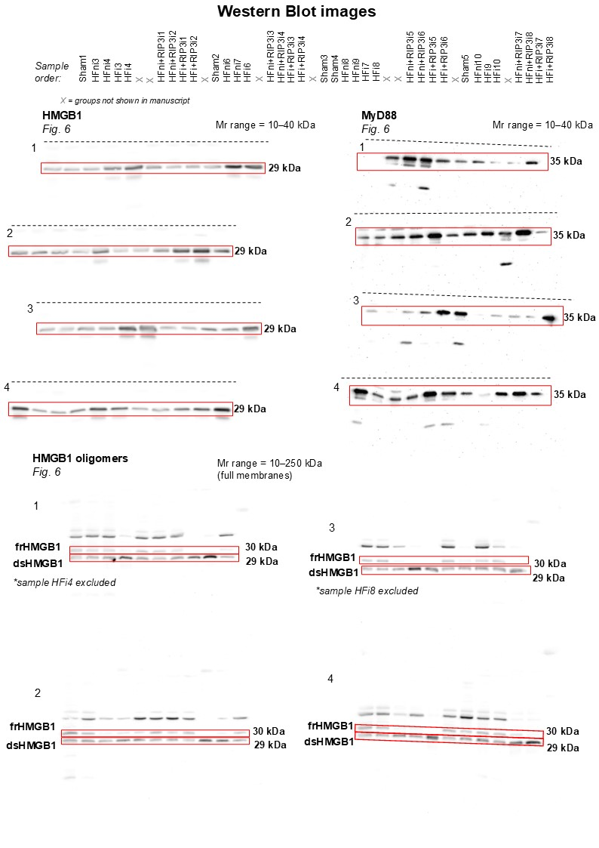

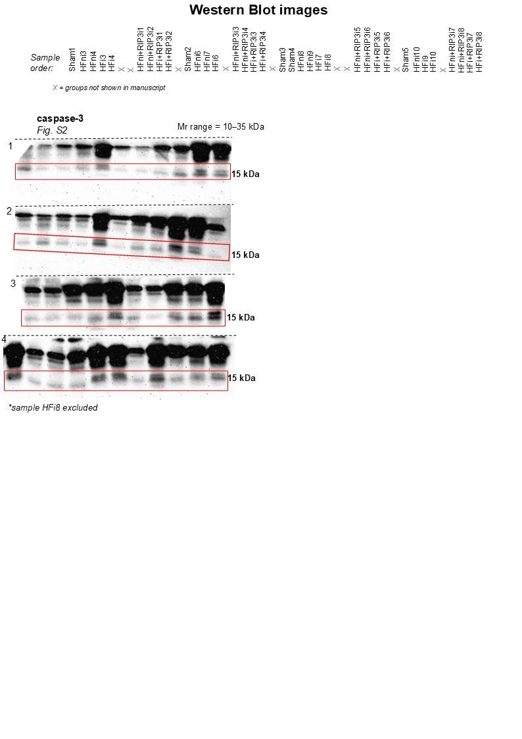

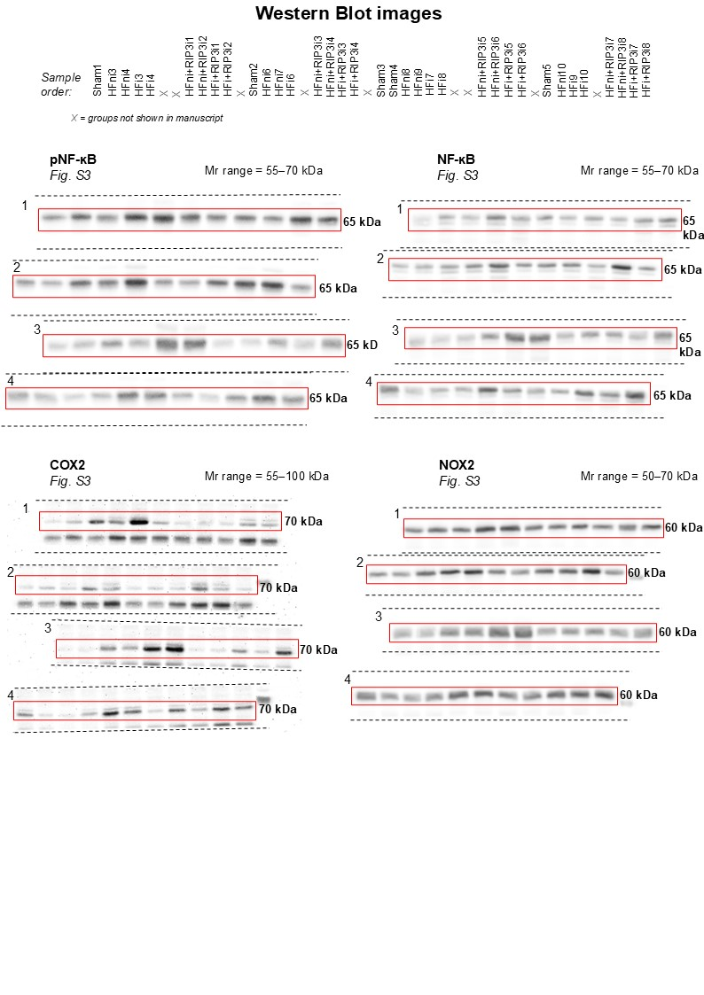

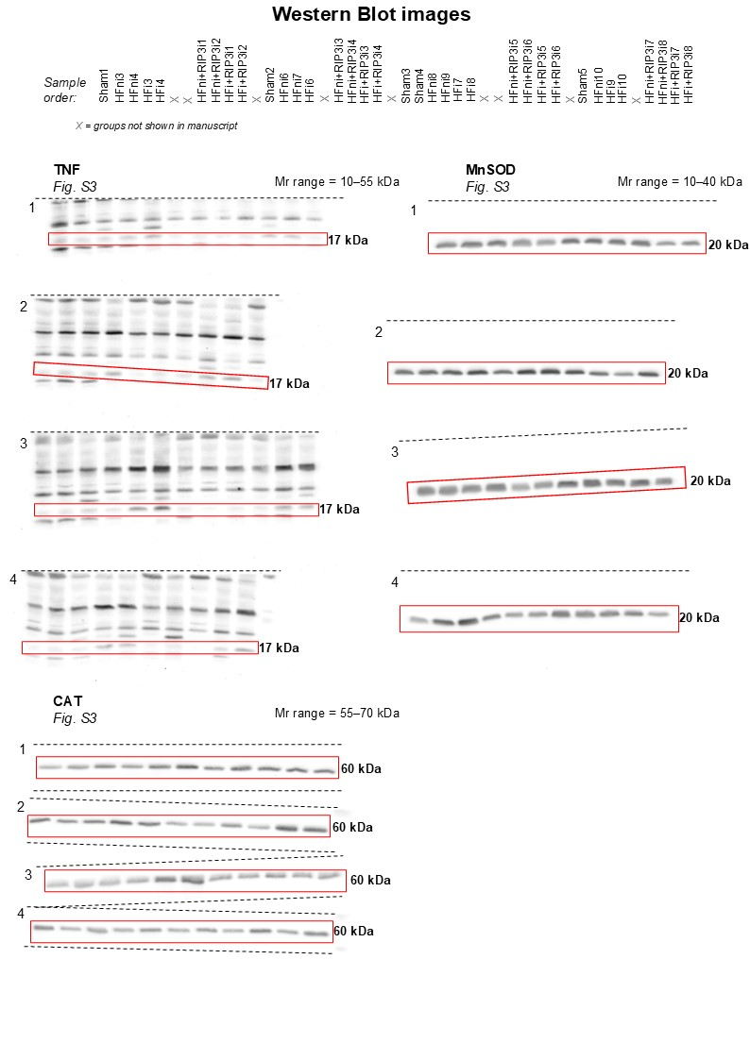
Summary Fig. The regulated necrosis-like cell death forms in heart failure due to myocardial infarction or pressure overload, the potential consequences of the plasma membrane rupture and the effect of RIP3 inhibition

