Supplementary material

AAV-mediated overexpression of CPT1B protects from cardiac hypertrophy and heart failure in a murine pressure overload model

Anca Remes^{,1,2†}, Theresa Ruf^{3,4†}, Tinatin Zurashvili^{1,5}, Lin Ding^{3,6}, Moritz Meyer-Jens^{2,7}, Dominic M. Schwab³, Susanne Hille^{1,2}, Andrea Matzen^{2,6}, Sabine Michalewski^{1,2}, Lucia Kilian^{2,6}, Prithviraj Manohar Vijaya Shetty^{1,2}, Marie-Christin Fuchs³, Matthias Eden^{3,4,6}, Hermann-Josef Gröne⁸, Kleopatra Rapti³, Andreas Jungmann³, Hendrik Milting⁹, Hugo A. Katus^{3,4}, Lucie Carrier^{2,7}, Derk Frank^{2,6}, Norbert Frey^{3,4}, Oliver J. Müller^{1,2}

¹ Department of Internal Medicine V, University of Kiel, Kiel, Germany
² German Centre for Cardiovascular Research, Partner Site Hamburg/Kiel/Lübeck, Kiel, Germany
³ Internal Medicine III, University Hospital Heidelberg, Heidelberg, Germany
⁴ German Centre for Cardiovascular Research, Partner Site Heidelberg/Mannheim, Heidelberg, Germany
⁵ David Tvildiani Medical University, Tbilisi, Georgia
⁶ Department of Internal Medicine III, University of Kiel, Kiel, Germany
⁷ Department of Experimental Pharmacology and Toxicology, University Medical Center Hamburg Eppendorf, Hamburg, Germany
⁸ Department for Cellular and Molecular Pathology, DKFZ Heidelberg, Germany
⁹ Erich & Hanna Klessmann-Institut, Ruhr-Universität Bochum, Herz & Diabeteszentrum NRW, Bad Oeynhausen, Germany
† These authors contributed equally to this work.
Corresponding author: Oliver J. Müller, Department of Internal Medicine V, University of Kiel and University Hospital Schleswig-Holstein, Arnold-Heller-Str. 3, 24105 Kiel, Germany. Tel. +49 431 50022950; Fax +49 431 50023204; e-mail: oliver.mueller@uksh.de
ORCHID ID 0000-0001-8223-263

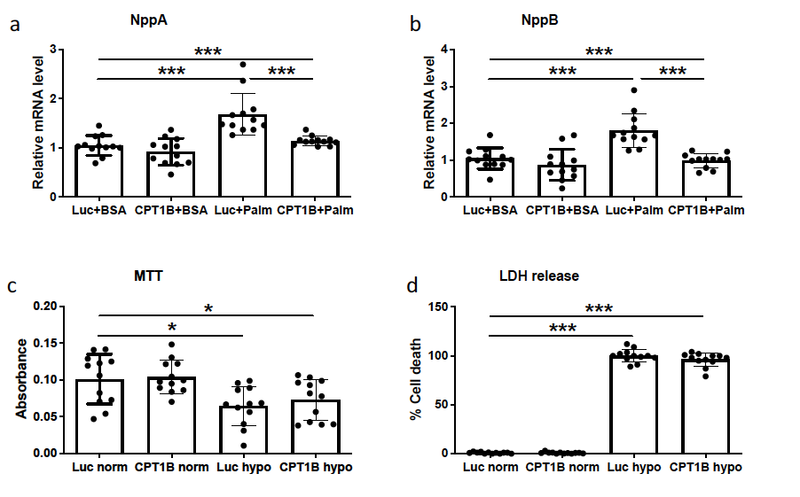

Supplementary Fig. 1. CPT1B overexpression decreases palmitate-induced cardiomyocyte hypertrophy and does not affect hypoxia-induced dysfunction. Statistical quantification of mRN levels of NppA (a) and NppB (b) as markers of pro-hypertrophic response in NRVCMs. RPL32 served as a housekeeping gene and values were normalized to Luc-BSA treated cells. (c) Assessment of total metabolic rate of NRVCMs in the depicted treatment groups, measured by MTT assay. (d) Quantification of LDH release in the supernatant in NRVCMs subjected to hypoxia. AAV6-Luc treated cells in hypoxia conditions were considered as control (100% LDH release). (*p<0.05, ***p<0.001, quantitative data are presented as means±SD, n=3).

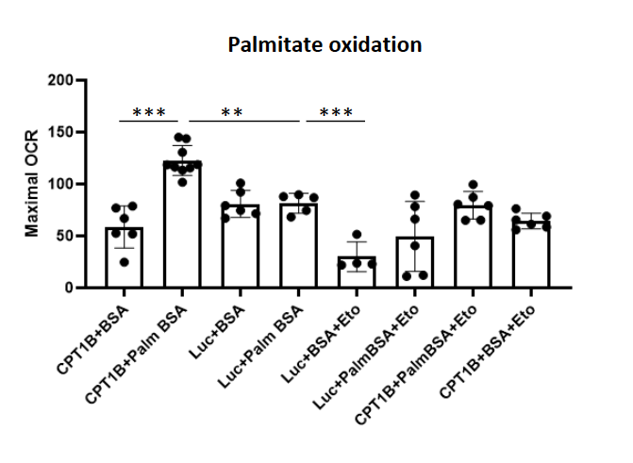
Supplementary Fig. 2. CPT1B overexpression leads to increased palmitate oxidation in hiPSC-CM. Shown is maximal oxygen consumption rate (OCR) in the depicted treatment groups, 3 days after AAV transduction. (**p<0.01, ***p<0.001, quantitative data are presented as means±SD, n=1 biological replicate and 6 technical replicates)

Suppl. Table 1. Echocardiographic measurements of mice subjected to TAC
Heart function prior to TAC (Baseline)
 | Sham  (n=14) | AAV9-LUC  (n=12) | AAV9-CPT1B  (n=8) | ANOVA-Multiple-Comparison
Echo-Parameter | Mean ± SV | Mean ± SV | Mean ± SV | LUC vs. CPT1B | LUC vs. Sham
EF (%) | 53,79 ± 7,43 | 56,17 ± 7,42 | 54,2 ± 7,2 | ns | ns
FS (%) | 15,83 ± 2,82 | 21,4 ±2,48 | 21,87 ± 6,3 | ns | ns
LV Mass (mg) | 134,4 ± 6,65 | 117,9 ± 5,14 | 117,7 ± 4,12 | ns | ns
LVPW;d (mm) | 0,72 ± 0,029 | 0,70 ± 0,032 | 0,69 ± 0,039 | ns | ns
LVDD (mm) | 4,34 ± 0,095 | 4,39 ± 0,056 | 4,25 ± 0,12 | ns | ns
Heart rate | 447,15 ± 32,74 | 454,14 ± 48,91 | 423,15 ± 14,66 | ns | ns
Heart function 2 weeks after TAC
 | Sham  (n=14) | AAV9-LUC  (n=12) | AAV9-CPT1B  (n=8) | ANOVA-Multiple-Comparison
Echo-Parameter | Mean ± SV | Mean ± SV | Mean ± SV | LUC vs. CPT1B | LUC vs. Sham
EF (%) | 51,59 ± 9,75 | 42,82 ± 7,87 | 53,24 ± 9,29 | ns | **
FS (%) | 26,53 ± 6,35 | 15,83 ± 2,82 | 23,44 ± 5,8 | ns | ***
LV Mass (mg) | 128,8 ± 5,54 | 164,6 ± 7,87 | 167,7 ± 8,92 | ns | ***
LVPW;d (mm) | 0,67 ± 0,018 | 0,87 ± 0,025 | 0,84 ± 0,045 | ns | ***
LVDD (mm) | 4,37 ± 0,070 | 4,54 ± 0,070 | 4,46 ± 0,060 | ns | ns
Heart rate | 484,88 ± 67,51 | 454,73 ± 27,62 | 484,26 ± 47,23 | ns | ns
Heart function 4 weeks after TAC
 | Sham  (n=14) | AAV9-LUC  (n=12) | AAV9-CPT1B  (n=8) | ANOVA-Multiple-Comparison
Echo-Parameter | Mean ± SV | Mean ± SV | Mean ± SV | LUC vs. CPT1B | LUC vs. Sham
EF (%) | 53,42 ± 7,99 | 34,42 ± 11,01 | 48,44 ± 17,95 | ** | ***
FS (%) | 23,93 ±5,19 | 23,93 ± 5,19 | 26,88 ± 8,1 | ** | ***
LV Mass (mg) | 124,7 ± 4,13 | 201,3 ± 20,01 | 189,0 ± 14,18 | ns | ***
LVPW;d (mm) | 0,70 ± 0,024 | 0,92 ± 0,051 | 1,01 ± 0,082 | ns | **
LVDD (mm) | 4,34 ± 0,033 | 4,62 ± 0,11 | 4,23 ± 0,21 | ns | ns
Heart rate | 425,34 ± 33,01 | 428,13 ± 31,50 | 424,50 ± 35,31 | ns | ns
Heart function 6 weeks after TAC
 | Sham  (n=14) | AAV9-LUC  (n=12) | AAV9-CPT1B  (n=8) | ANOVA-Multiple-Comparison
Echo-Parameter | Mean ± SV | Mean ± SV | Mean ± SV | LUC vs. CPT1B | LUC vs. Sham
EF (%) | 47,40 ± 6,14 | 40,95 ± 11,85 | 51,55 ± 7,78 | * | ***
FS (%) | 25,4 ± 4,73 | 25,4 ± 4,73 | 20,59 ± 5,36 | * | ***
LV Mass (mg) | 126,1 ± 3,64 | 221,6 ± 14,14 | 207,2 ± 19,88 | ns | ***
LVPW;d (mm) | 0,65 ± 0,022 | 1,01 ± 0,048 | 0,98 ± 0,068 | ns | ***
LVDD (mm) | 4,31 ± 0,066 | 4,91 ± 0,15 | 4,61 ± 0,16 | ns | **
Heart rate | 427,16 ± 24,7 | 421,31 ± 28,35 | 415,38 ± 21,53 | ns | ns

