Supplemental table S01: Primer sequences
Gene | sequence [5'--3'] | species
ATAD2_sense | AGT CAT CTG AAG AGG GTG AAG A | human
ATAD2_antisense | CGC TTC TGA TTC TCT TCT TCT CC | human
TCF19_sense | ATC TCT ACA CCT TCC ACC CC | human
TCF19_antisense | CTT GGC TGC TGT GGT CTT C | human
TFDP1_sense | CCA CGA TGA CAT AGA AGT GCT G | human
TFDP1_antisense | TGT CAC GTA TGG CTC CAG AG | human
RPS29_sense | GGT TCT CGC TCT TGT CGT GTC | human
RPS29_antisense | ATA TCC TTC GCG TAC TGA CGG | human
VEGFR2_sense | GAA CAT TTG GGA AAT CTC TTG C | human
VEGFR2_antisense | CGG GAA GAA CAA TGT AGT CTT TGC | human
Hif1a_sense | TCT GGA TGC CGG TGG TCT AGA CAG T | mouse
Hif1a_antisense | GTT AGC ACC ATC ACA AAG CCA TCT AG | mouse
Rps29_sense | ATG GGT CAC CAG CAG CTC TA | mouse
Rps29_antisense | AGC CTA TGT CCT TCG CGT ACT | mouse
Vegfa_sense | AGA GCA ACA TCA CCA TGC AG | mouse
Vegfa_antisense | CGC CTT GGC TTG TCA CAT | mouse

Supplemental table S10: Patient characteristics
Male / female sex (n) | 5 / 4 | n = 9
Age (years, mean ± SEM) | 60.6 ± 4.9 | n = 9
Ejection fraction (%, mean ± SEM) | 51.3 ± 5.3 | n = 8
Coronary artery disease (%) | 55.6 | n = 9
Hypertension (%) | 55.6 | n = 9
Kidney disease (%) | 11.1 | n = 9
Obesity (%) | 44.4 | n = 9

Supplemental Figure S01:
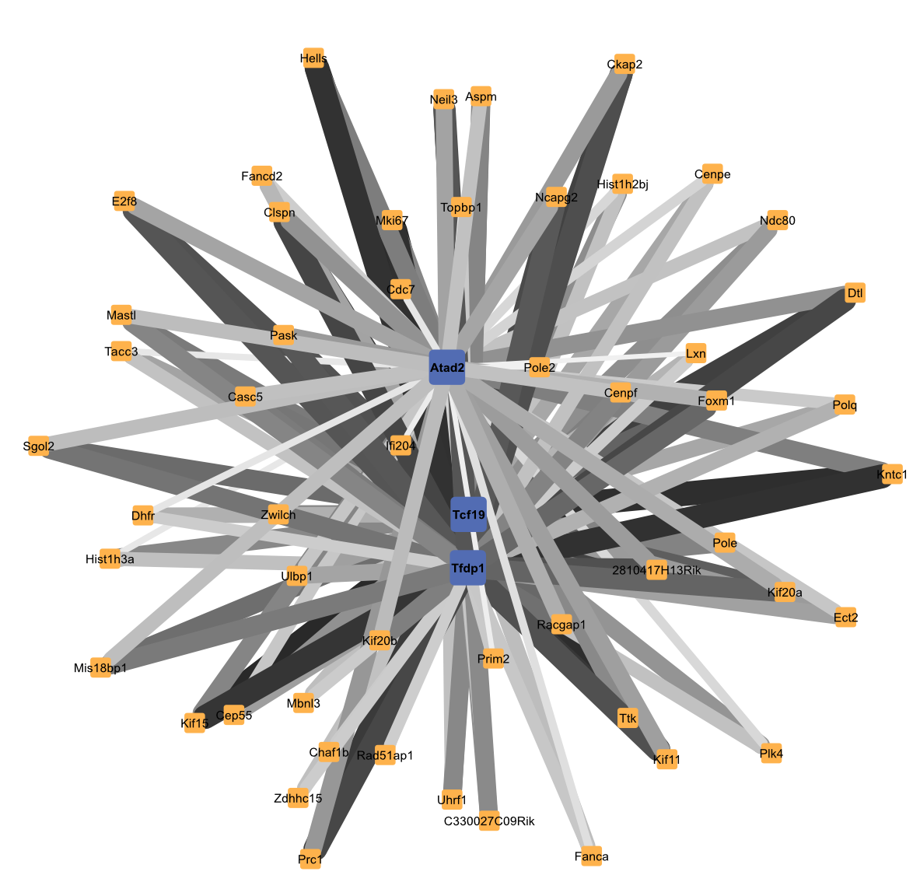
Network regulation by hub genes in module orange. TOM-based subnetworks of the top 50 interaction partners of Tcf19, Atad2 and Tfdp1 within the orange module. Edge thickness and color intensity represent the strength of topological overlap between genes.

Supplemental Figure S02:
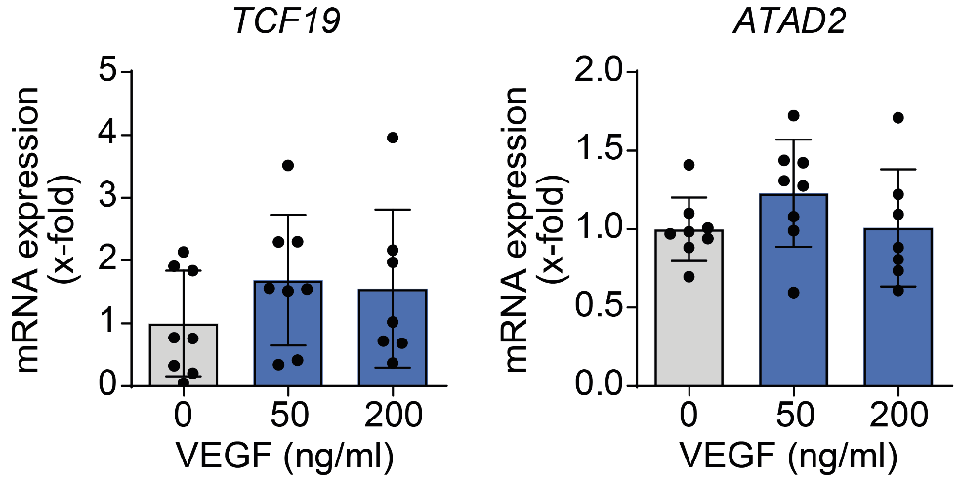
VEGF-dependent gene expression in HUVECs. mRNA expression of TCF19 and ATAD2 in HUVECs 72 hours after treatment with VEGF was assessed by qRT-PCR.

Supplemental Figure S03:
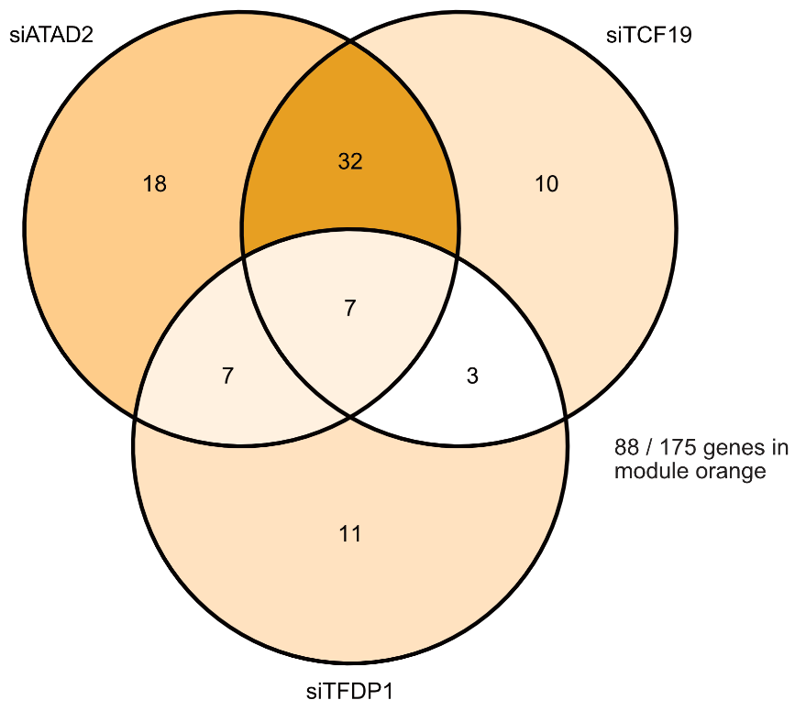
Gene expression after knock-down of hub genes. Venn diagram showing genes within module orange that were differentially expressed after siRNA knockdown of ATAD2, TCF19, or TFDP1.

