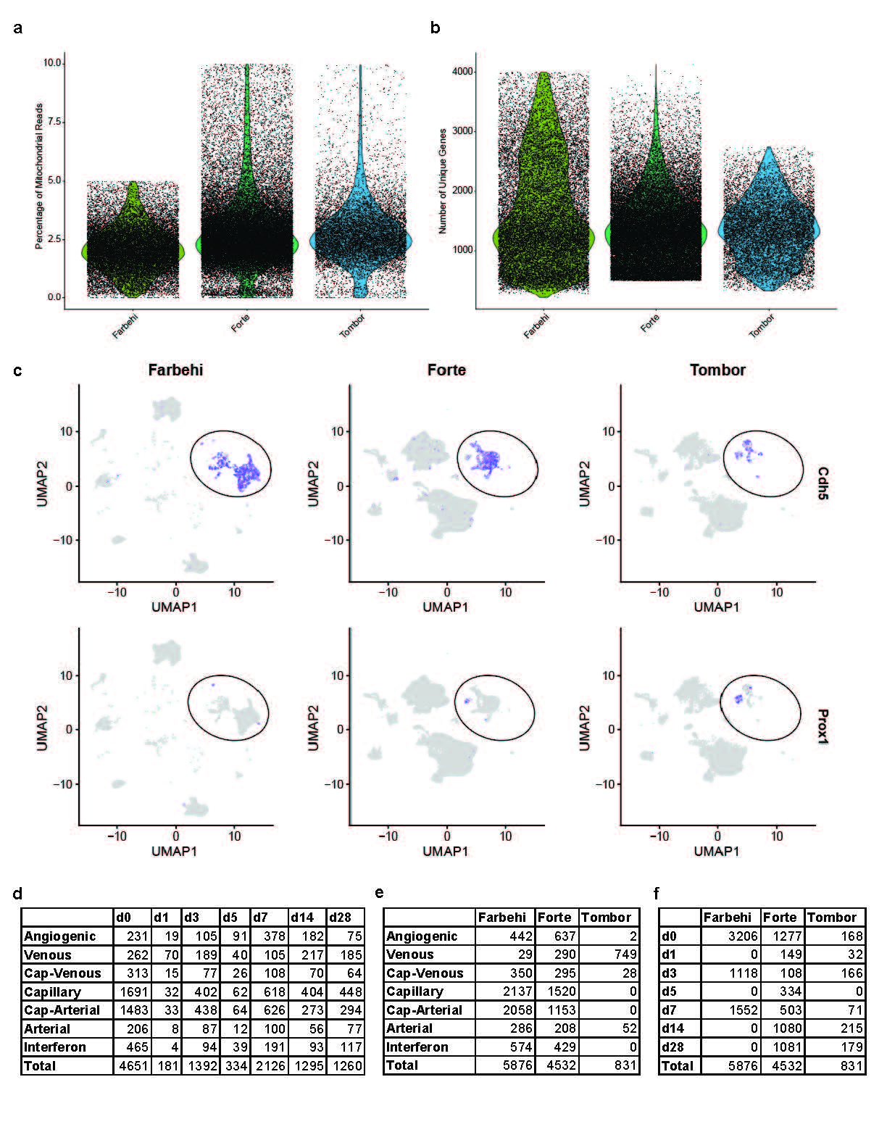
Fig S1. Quality control metrics and coronary endothelial cell distribution. a. Percentage of mitochondrial reads by original identity after filtering. b. Feature numbers by original identity after filtering. c. Uniform manifold and projection plots of Cdh5 and Prox1 counts, circle around population identified as coronary endothelial cells. d. Coronary endothelial subpopulation cell numbers by day. e. Coronary endothelial subpopulation cell numbers by original identity. f. Coronary endothelial original identity cell numbers by day.
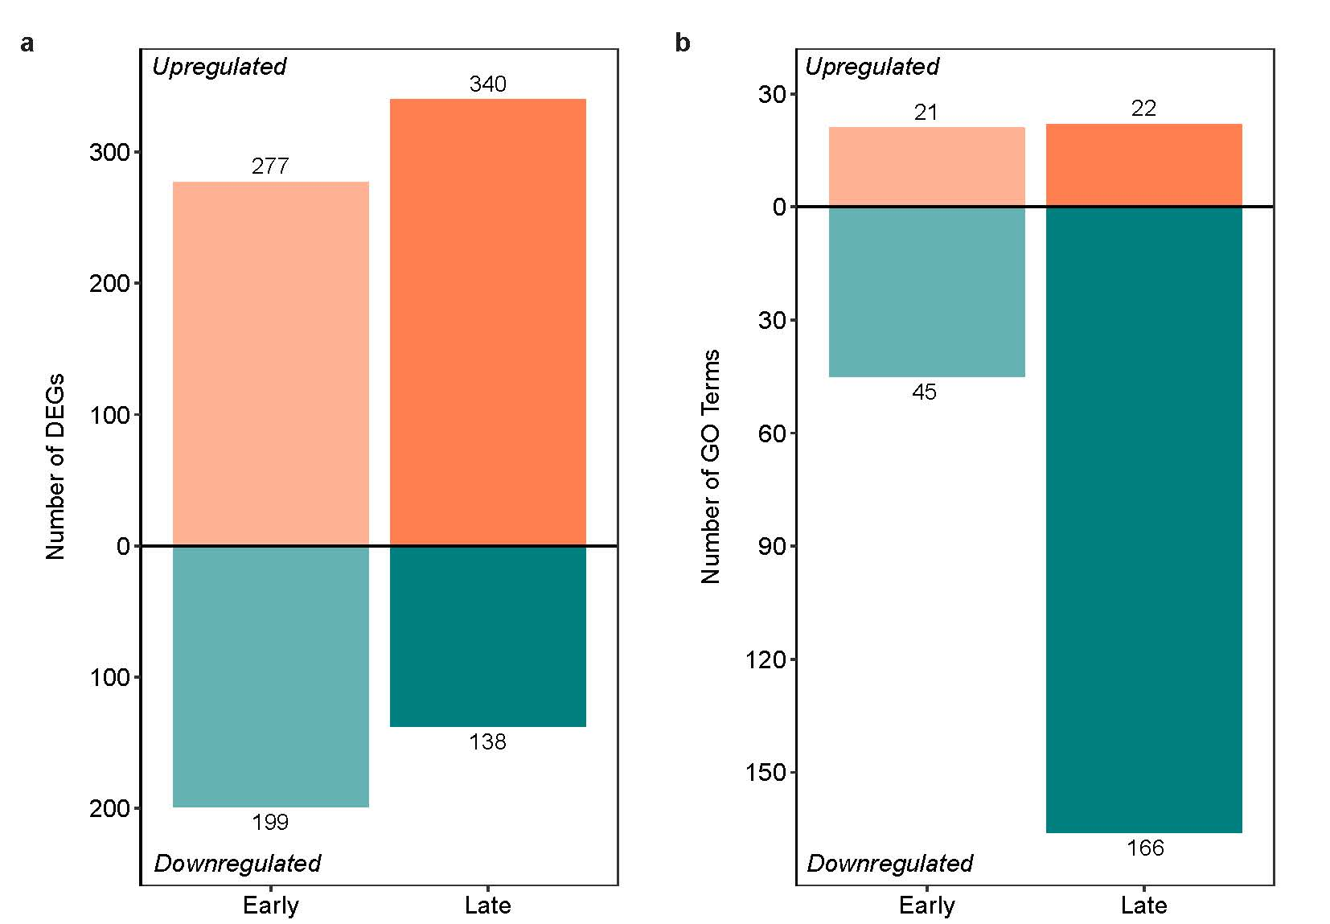
Fig S2. Differentially expressed genes and gene ontology terms at early and late timepoints. a. Upregulated differentially expressed genes (DEGs, orange), and downregulated DEGs (teal) unique to early (days 3 and/or 7) or late (days 14 and/or 28) timepoints, adjusted p-value < 0.05. b. Distribution of upregulated and downregulated gene ontology (GO) terms from gene lists unique to early or late timepoints.

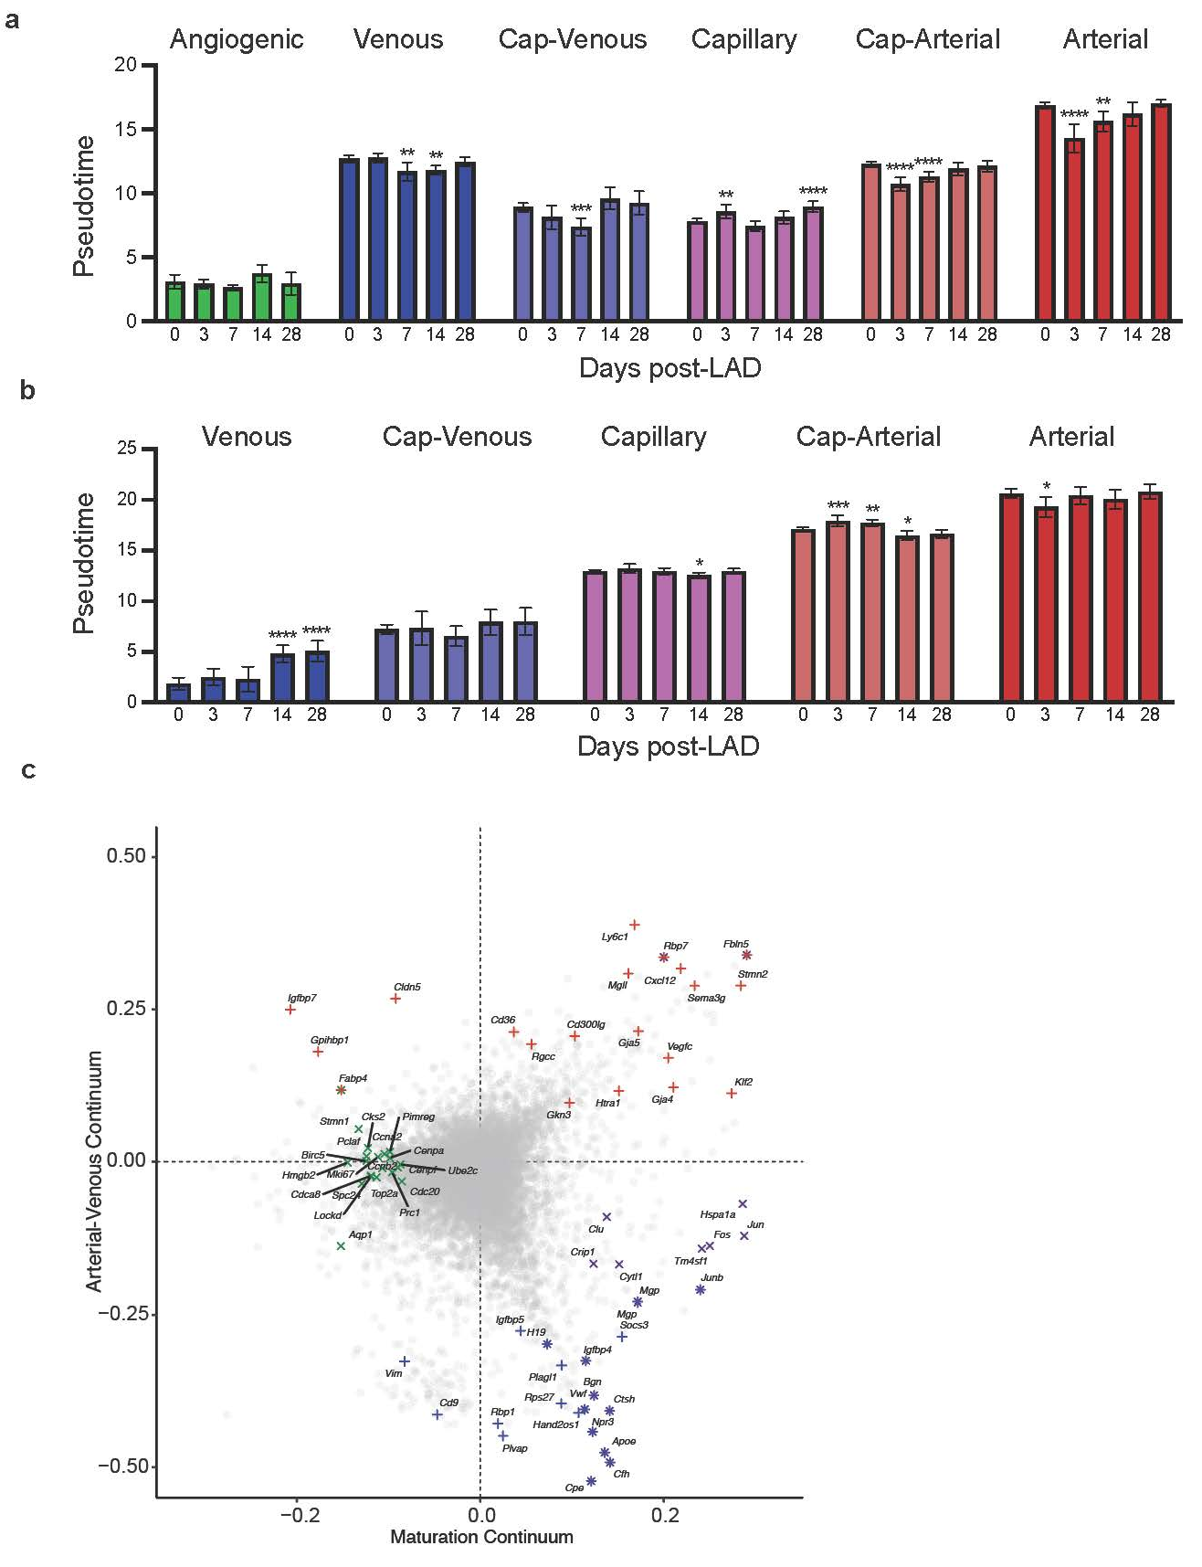
Fig S3. Trajectory analysis with Monocle. a. Maturation pseudotime values within each subpopulation by day after left anterior descending artery (LAD) ligation (bar = mean, whiskers = 95% confidence intervals, statistics = one-way ANOVA with Dunnett’s post-hoc test). b. Arterial-venous pseudotime values within each subpopulation day after LAD ligation (bar = mean, whiskers = 95% confidence intervals, statistics = one-way ANOVA with Dunnett’s post-hoc test). c. Dot plot of maturation and arterial-venous pseudotime expression correlations with top genes associated with each fate highlighted.

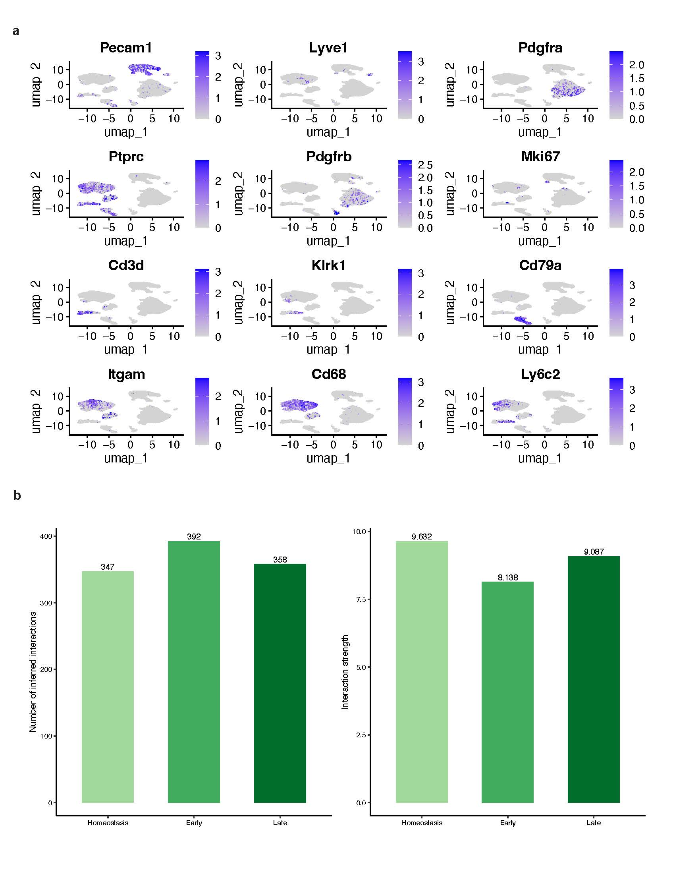
Fig S4. Interstitial cell communication analysis with CellChat. a. Uniform manifold and projection plots of marker gene counts used to annotate cardiac interstitial populations. b. Number of inferred interactions and interaction strength at homeostasis (day 0), early (days 3 and/or 7) or late (days 14 and/or 28).

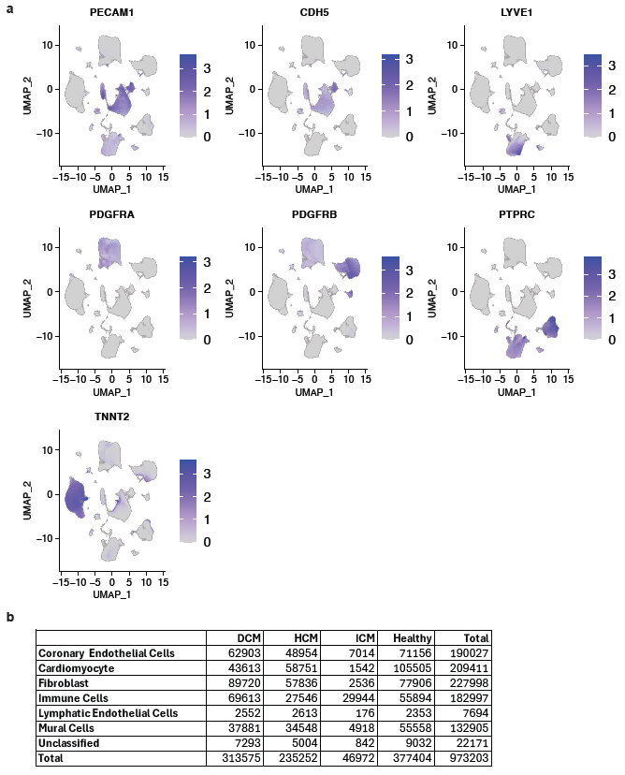
Fig S5. Human cardiomyopathy quality control metrics and cell type distribution. a. Uniform manifold and projection plots of marker gene counts used to annotate cardiac populations. b. Cell numbers by condition (DCM: dilated cardiomyopathy, HCM: hypertrophic cardiomyopathy, ICM: ischemic cardiomyopathy).

Supplementary Table 1. Primers for qPCR
Gene | Forward (5’-3’) | Reverse (5’-3’)
ACTB | TCACCCACACTGTGCCCATCTACGA | CAGCGGAACCGCTCATTGCCAATGG
EFNB2 | TATGCAGAACTGCGATTTCCAA | TGGGTATAGTACCAGTCCTTGTC
GJA4 | ACACCCACCCTGGTCTACC | CACTGGCGACATAGGTGCC
GJA5 | CCGTGGTAGGCAAGGTCTG | ATCACACCGGAAATCAGCCTG
EPHB4 | CGCACCTACGAAGTGTGTGA | GTCCGCATCGCTCTCATAGTA
NR2F2 | GGACCACATACGGATCTTCCAA | ACATCAGACAGACCACAGGCAT
NRP2 | GTGGTTCATCTTGACCTTGT | ATTCTTCTTCTGCAACCTCA

Supplementary Table 2. Statistical Tests
Figure | Statistical Test
Fig. 1d | Two-way ANOVA with post-hoc Sidak
Fig. 1f | One-way ANOVA with post-hoc Dunnett
Fig. 2a | Wilcoxon Rank Sum with Bonferroni correction
Fig. 2d | Gene ontology over-representation test with Benjamini & Hochberg correction
Fig. 2e | One sample t and Wilcoxon test
Fig. 3c | One-way ANOVA with post-hoc Tukey
Fig. 3d | One-way ANOVA with post-hoc Dunnett
Fig. 3f | Gene ontology over-representation test with Benjamini & Hochberg correction
Fig. 3i | One-way ANOVA with post-hoc Tukey
Fig. 3j | One-way ANOVA with post-hoc Dunnett
Fig. 3l | Gene ontology over-representation test with Benjamini & Hochberg correction
Fig. 5b | Mixed effects model with condition as a fixed effect and Benjamini & Hochberg correction
Fig. 5c | Fisher’s Exact test
Fig. 5d | One sample t test
Fig. 5f | Two-way ANOVA with post-hoc Dunnett
Fig. 6e | One-way ANOVA with post-hoc Dunnett
Fig. 6g | Pearson correlation
Fig. 6h | One-way ANOVA with post-hoc Dunnett
Supplementary Fig. 3a | One-way ANOVA with post-hoc Dunnett
Supplementary Fig. 3b | One-way ANOVA with post-hoc Dunnett

Supplementary Table 3. Intersection between Transcriptomic and Proteomic Differences
 | Transcriptomics
 | Early |  | Late
 | Upregulated | Downregulated | Upregulated | Downregulated
Upregulated Proteomics | NDUS8, CALR, G5E902, NDUB6, CAD13, CALU, MYDGF, SSRD, D3Z569, PSMD7, COX7B, Q9CXU4 | H10, RS24, RS15, B1ARA5, G5E850, RS17, RS10, IIGP1, RL21, RL18, LYRIC, RL12, RL31 | HSPB1, NDUAD, NACAM, RS7, H10, NDUB4, RL13, RS9, B1ARA5, NID1, DJB11, G5E850, NDUA7, YBOX1, QCR9, IIGP1, RL14, NDUA3, RL18, RL6, PFD2, TSPO | CAD13, E9Q9C4
Downregulated Proteomics | VDAC3, ACTB, NDUS2, SDHB, FABP5, G3BP1 |  | J3QP71, NDUS7, NDUS5, PEA15,  D3YUG3, DDX3X | ACTB

Supplementary File 1. Differentially expressed genes across all endothelial cell subpopulations at days 3, 7, 14 and 28 using the Wilcoxon Rank Sum test with a minimum percentage of 0.25. Differential expression relative to homeostasis (day 0).

Supplementary File 2. Lists of significantly differentially expressed genes unique to early (days 3 and/or 7) or late (days 14 and/or 28) timepoints. Separated by upregulated and downregulated. Adjusted p-value < 0.05.

Supplementary File 3. Gene ontology results for unique early (days 3 and/or 7) or late (days 14 and/or 28) timepoints. Separated by upregulated and downregulated. Enrichment relative to all expressed genes at early or late timepoints. Benjamini-Hochberg corrected p-value < 0.05.

Supplementary File 4. Graph autocorrelation results for maturation and arteriovenous pseudotime trajectories.

Supplementary File 5. Pearson correlations of pseudotime (maturation and arteriovenous) and normalized gene expression counts.

Supplementary File 6. Gene ontology results for the top and bottom tenth percentiles of maturation and arteriovenous gene expression and pseudotime correlations. Enrichment relative to all genes in the dataset. Benjamini-Hochberg corrected p-value < 0.05.

Supplementary File 7. Genes in the bottom and top tenth percentiles of maturation and arteriovenous correlation continuums with the largest Moran’s I values, associated with angiogenic, mature, venous and arterial identities.

Supplementary File 8. Inferred intercellular communication network of ligand-receptor pairs and signaling pathways at homeostatic (day 0), early (days 3 and 7) and late (days 14 and 28) timepoints.

Supplementary File 9. Signaling pathway probabilities from and to coronary endothelial cells at homeostatic (day 0), early (days 3 and 7) and late (days 14 and 28) timepoints, separated by cell type.

