Supplementary information

Self-aggregation of cationic gemini surfactants with amide groups in the spacer and variable alkyl chain length

Martin Pisárčik ª, Martin Bajcuraª , Miloš Lukáč ª, Ferdinand Devínsky ^{b}, Andrea Bilková ^{c}, František Bilka ^{c} ,
Branislav Horváth ^{d}

ª Department of Chemical Theory of Drugs, Faculty of Pharmacy, Comenius University, Bratislava, SK-83232 Slovakia
^{b} Faculty of Pharmacy, Comenius University, Bratislava, SK-83232 Slovakia
^{c} Department of Cell and Molecular Biology of Drugs, Faculty of Pharmacy, Comenius University, Bratislava, SK-83232 Slovakia
^{d} NMR Laboratory, Faculty of Pharmacy, Comenius University, Bratislava, SK-83232 Slovakia

Contents

- Dynamic light scattering measurements, data analysis, particle size distributions
- Angular dependence of scattered light, calculation of radius of gyration
- 2. Zeta potential data

1. Dynamic light scattering measurements and data analysis

Screenshots from DLS measurements were obtained using Brookhaven BIC analysis software ver. 6.3 for BI 9000AT digital correlator (DOS version). For each AM(m) gemini surfactant, the screenshots show the data analysis resulting from the time correlation function fits for all repeated correlation function recordings at each m value. The hydrodynamic diameter that is shown in the plots in the main article, is the Eff.Diam. value in the data analysis screenshots. This value is calculated from the Taylor series expansion of logarithm of time correlation function g⁽¹⁾(t) in terms of cumulants as follows:
ln(g⁽¹⁾(t)) = -t + μ₂ t² + .....
μ₂ is the second cumulant (2nd Mom. in the screenshots) which would be near zero for a perfect single exponential decay. The decay rate was calculated from the expansion of the logarithm of time correlation function up to the second term using the first linear term in the series for the calculation (Gam.Ave. in the screenshots). The diffusion coefficient D was determined from the decay rate ( = D q²) and the hydrodynamic diameter of AuNPs (Eff.Diam. in the screenshots) was calculated from the diffusion coefficient using the Stokes–Einstein formula

Eff.Diam = kT / (3πηD)

η is solvent viscosity, k is the Boltzmann constant, and T is absolute temperature. Five independent recordings of time correlation function and calculations of Gam.Ave., 2nd Mom., Eff.Diam were carried out for each AM(m) gemini surfactant. The average value and standard deviation of Eff.Diam were calculated from the set of 5 recordings after the elimination of recordings with large experimental error and plotted in the graphs in the main article. The intensity time fluctuations of the scattered light were detected at a scattering angle of 90° and a temperature 25°C. The screenshots show the set of repeated recordings of the time correlation function after the elimination of recordings with large experimental error and the calculated data of Gam.Ave., 2nd Mom., Eff.Diam for each AM(m) gemini surfactant.

Screenshots of DLS data analysis

AM12, 10 x cmc
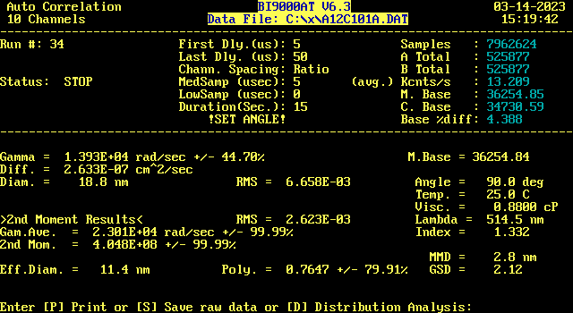

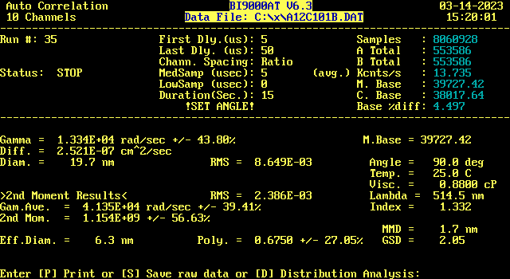

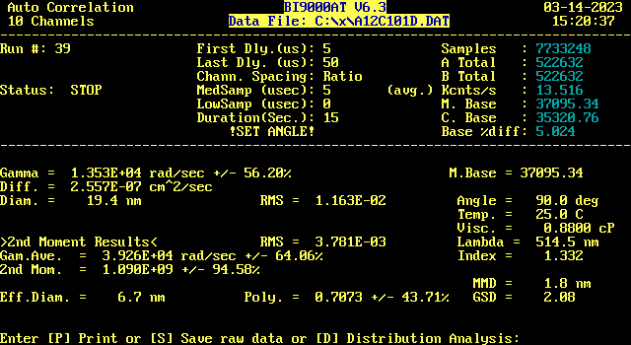
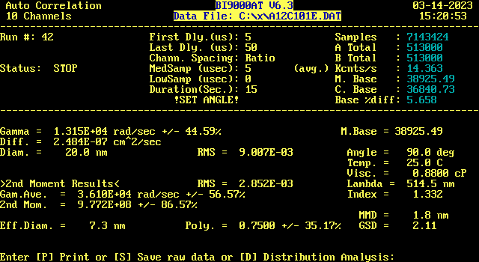

AM13, 10 x cmc
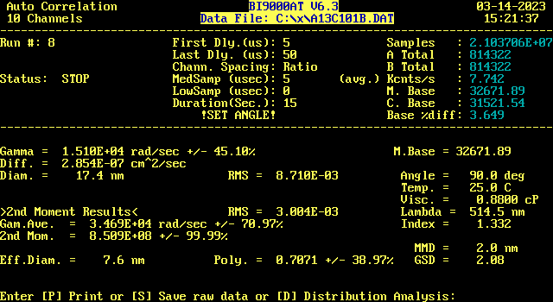

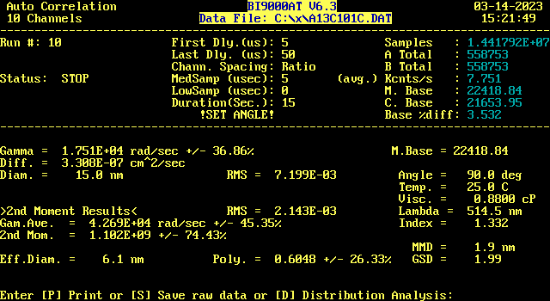

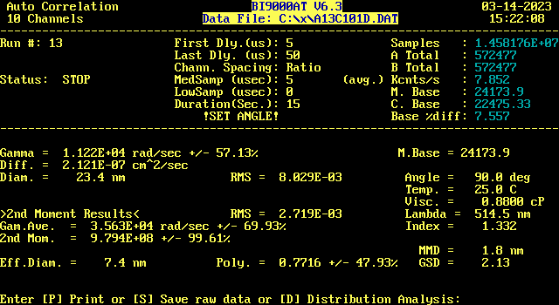

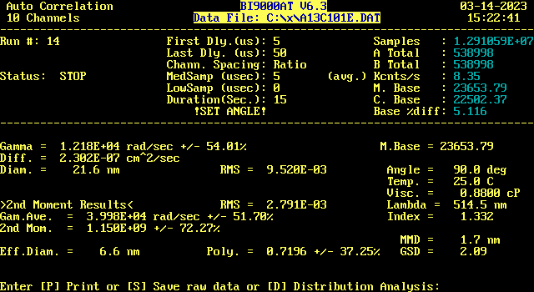

AM14, 10 x cmc
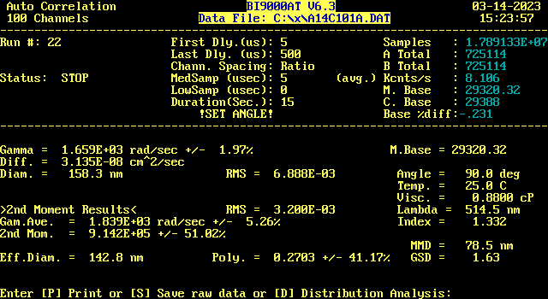

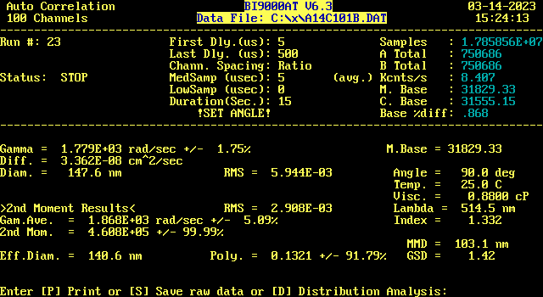

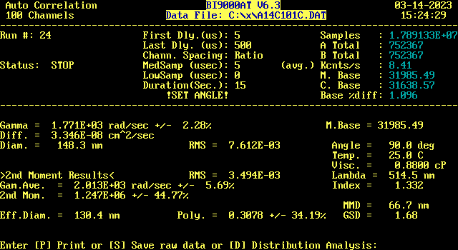

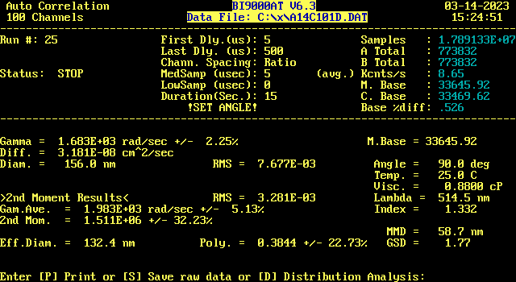
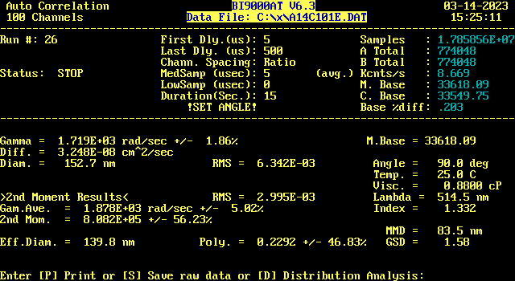

AM15, 10 x cmc
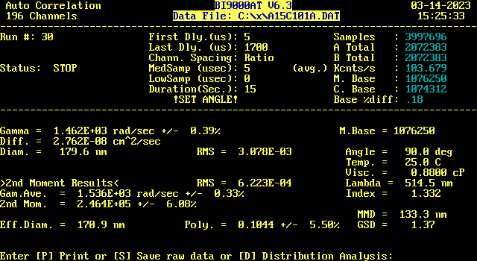

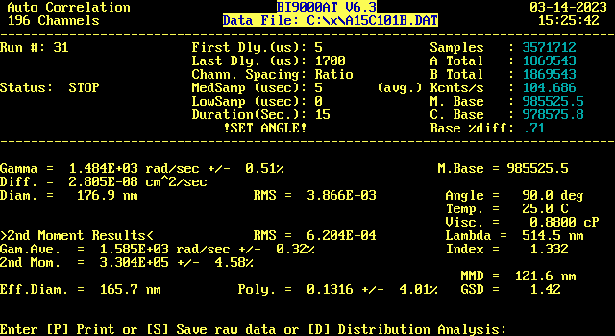

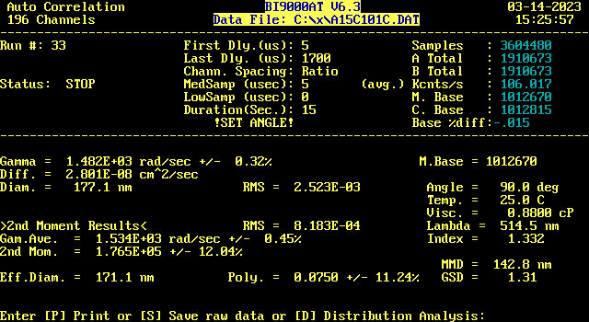

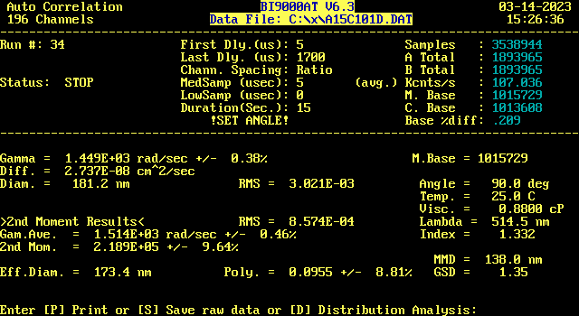

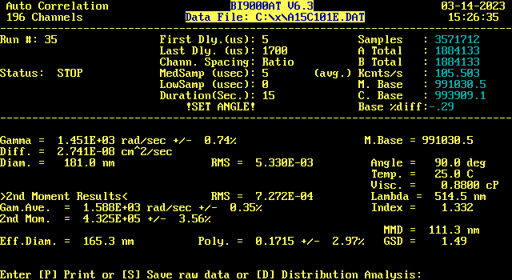
Particle size distributions
Brookhaven software library for the CONTIN numerical algorithm, written in Fortran language, was used for the construction of particle size distributions. The rejection probability parameter was set to 0.5. The following screenshots provide the plots of the particle size distributions for each AM(m) surfactant, as obtained by the BIC analysis software ver. 6.3.

AM12
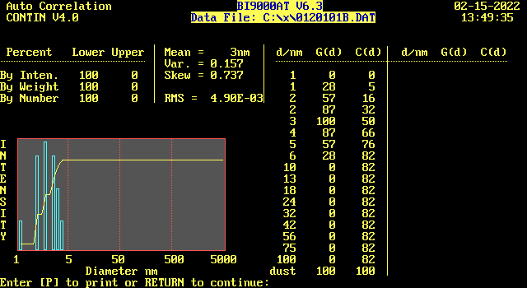

AM13
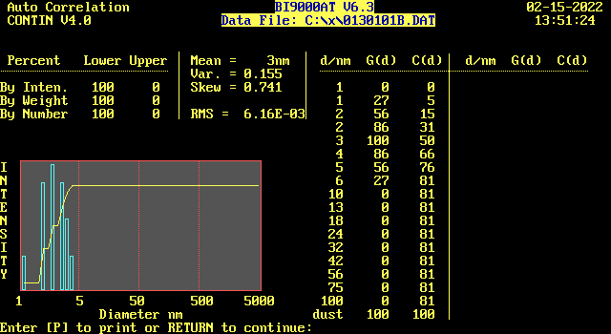

AM14
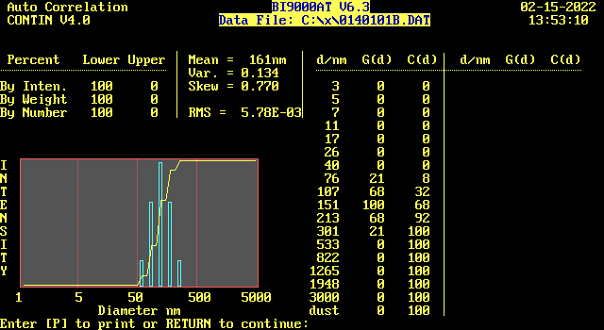

AM15

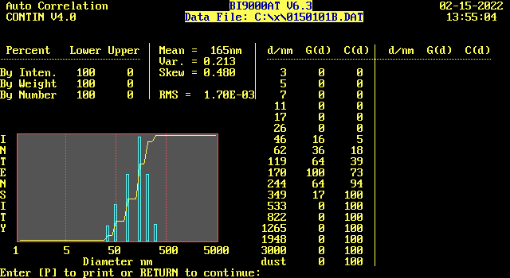

2. Angular dependence of scattered light, calculation of radius of gyration

The slope of the exponential autocorrelation curve at the zero correlation time is Γ = D q². Γ has the meaning of the first cumulant of the time expansion of log autocorrelation function into the Taylor series. D is the translational diffusion coefficient. The scattering vector q is defined as follows.

$q^{2} ​= ​{\left(4 π\text{ n / }λ\right)}^{2} ​\sin^{2}\left(θ / ​2\right)$

θ - scattering angle, λ - wavelength of the incident laser beam, n – refractive index of solvent. The diffusion coefficient extrapolated to zero scattering angle D₀ is given by

$D_{0} ​= \lim_{q→0} Γ​​/​​q^{2}$

The hydrodynamic radius R_{h0} at zero scattering angle is calculated by the Stokes-Einstein formula:

$R_{​h0} ​= ​\frac{k T}{6 ​π η D_{0}}$

η is solvent viscosity. The quantity Γ/q² can be expanded into the series with the increasing q² the and the linear term is proportional to the square of the radius of gyration R_{g}

$\frac{}{ q^{2}} = D_{0} + D_{0} c^{'} R_{g}^{2} q^{2} +…$

For small q² values, the constant c’ is equal to 13/75 [1]. By neglecting higher q² terms in the equation above, R_{g} can be expressed as follows

${R_{g}={\left(\frac{1}{D_{o} c' } \frac{d /q^{2}}{dq^{2}}\right)}^{0.5}= {\left(\frac{b}{D_{0} c’}\right)}^{0.5}}_{}$

where b is the slope of the Γ/q² vs. q² dependence obtained as a fit parameter using linear regression.

The ratio R_{g} / R_{h0} where R_{h0} is the hydrodynamic diameter at zero scattering angle, reflects the aggregate geometry of colloidal structures. The ratio value for spheres is equal to (3/5)^{0.5} = 0.78 and approx. 1.3 -4.0 for elongated micelles [2,3]

As results from the angle-dependent light scattering data analysis, the Γ/q² vs. q² plot indicates the linear dependence
for both AM14 and AM15 surfactants.

The calculated values of D₀ , R_{h0} , b, R_{g} , and R_{g} / R_{h0} are shown in the following table.
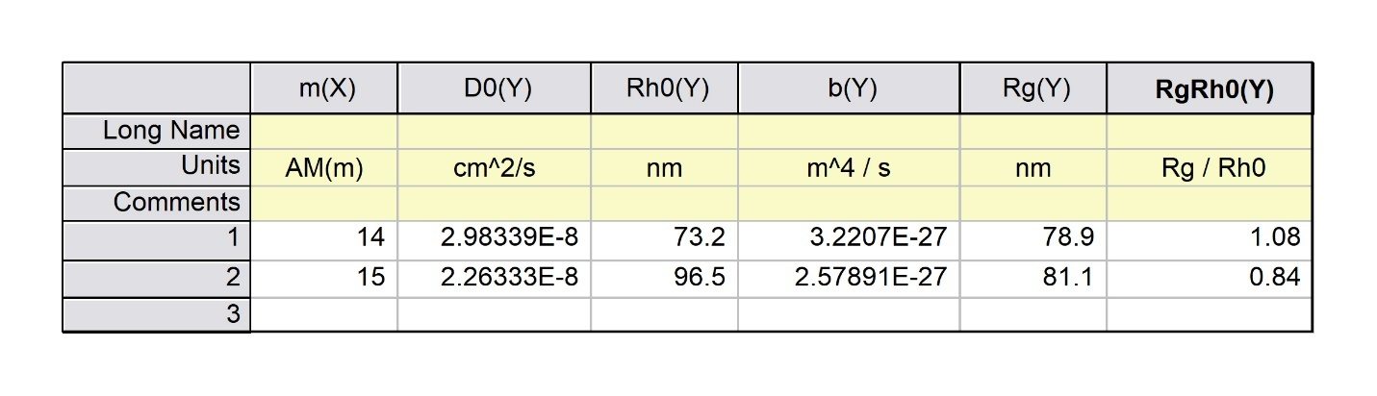
As the data indicate, AM15 aggregate geometry with the ratio value 0.84 is close to the ideal hard sphere ratio equal to 0.78.
The ratio for AM14 is higher but still not in the region for non-spherical, elongated micelles. We assume that both surfactants
form spherical or close to spherical aggregates at the investigated concentration 10 x cmc.

References
[1] Burchard W. et al. Macromolecules 13 (1980) 580-587.
[2] Chu B.: Laser Light Scattering: Basic Principles and Practice, Academic Press: Boston 1991.
[3] Brown W., Ed. Light Scattering: Principles and Development; Clarendon Press: Oxford 1996 Chapter 1.

3. Zeta potential data

The table shows the zeta potential data sets for AM12 – AM15 gemini surfactants at the specified surfactant concentration after the elimination of data recordings with large experimental error.

Surfactant |  | AM12 |  |  |  | AM13 |  |  |  | AM14 |  |  |  | AM15
Concentration |  | 30 x cmc |  |  |  | 50 x cmc |  |  |  | 10 x cmc |  |  |  | 10 x cmc
 |  | 31.83 |  |  |  | 65.78 |  |  |  | 64.67 |  |  |  | 91.34
 |  | 37.81 |  |  |  | 52.85 |  |  |  | 65.49 |  |  |  | 92.15
 |  | 41.44 |  |  |  | 67.58 |  |  |  | 73.1 |  |  |  | 75.76
 |  | 36.34 |  |  |  | 56.21 |  |  |  | 64.28 |  |  |  | 78.71
 |  | 36.83 |  |  |  | 61.3 |  |  |  | 60.35 |  |  |  | 78.62
 |  | 36.73 |  |  |  | 68.76 |  |  |  | 75.2 |  |  |  | 80.69
 |  | 38.35 |  |  |  | 67.67 |  |  |  | 57.43 |  |  |  | 82.14
 |  | 29 |  |  |  | 56.29 |  |  |  | 66.83 |  |  |  | 87.25
 |  | 29.37 |  |  |  | 65.52 |  |  |  | 61.34 |  |  |  | 81.99
 |  | 35.64 |  |  |  | 62.62 |  |  |  | 75.43 |  |  |  | 90.65
 |  | 37.28 |  |  |  | 66.11 |  |  |  | 66.83 |  |  |  | 82.71
 |  | 39.76 |  |  |  | 69.4 |  |  |  | 56.86
 |  | 31.54 |  |  |  | 64.6 |  |  |  | 63.66
 |  | 37.98 |  |  |  | 64.49 |  |  |  | 72.98
 |  | 33.27
 |  | 28.35
 |  | 36.51
 |  | 28.69
 |  | 38.57
 |  | 31.21
Zeta mean, mV |  | 34.98 | ± | 3.99 |  | 63.34 | ± | 5.06 |  | 66.14 | ± | 6.16 |  | 83.07 | ± | 5.07

