Supplementary Information (SI) of

The effect of pre-shear protocols on the rheological characterization of epoxy nanocomposites
Yu-Min Wang¹, Sean Sutyak¹, Didun Oladeji¹, Simon A. Rogers², Daniel V. Krogstad^{1, 3}
¹Illinois Applied Research Institute, Grainger College of Engineering, University of Illinois Urbana-Champaign, 2100 S Oak St., Champaign, IL 61820, USA
²Department of Chemical and Biomolecular Engineering, University of Illinois Urbana-Champaign, 600 S. Matthews Ave., Urbana, IL 61801, USA
³Department of Material Science and Engineering, Grainger College of Engineering, University of Illinois Urbana-Champaign, 21304 W. Green St., Urbana, IL 61801, USA

Supporting Information
In this study, we employed a detailed rheological approach to determine optimal pre-shear conditions, incorporating transient, oscillatory, stress relaxation, and/or creep steps for various epoxy/BCP resins with nanoclay rheology modifiers before conducting transient creep tests for yield stress identification. Ten epoxy resins were formulated, as described in Table 1 in the main publication. Prior to initiation of the pre-shear tests described in the publication, the basic rheological properties of the resins, including those obtainable from oscillatory strain amplitude and frequency sweeps, were characterized and are presented in this supplemental information document.
Oscillatory amplitude strain sweep experiments were performed on each resin (R1-R10) across a strain range of 0.01% to 400% at an angular frequency of 5.0 rad·s⁻¹ and the results are presented in Figure S1. The amplitude sweep data from all the resins had similar profiles. R1, which had twice the concentrations of nanoclay compared to R2-R10 (10 wt% instead of 5 wt% nanoclay), had the highest storage modulus. R9 and R10 had the next largest storage moduli. Interestingly, these resins were two in which the block copolymers (BCPs) self-assembled into cylindrical micelles (Figure 6). The moduli of all other resins were very similar to one another. All the resins demonstrated a yield stress.
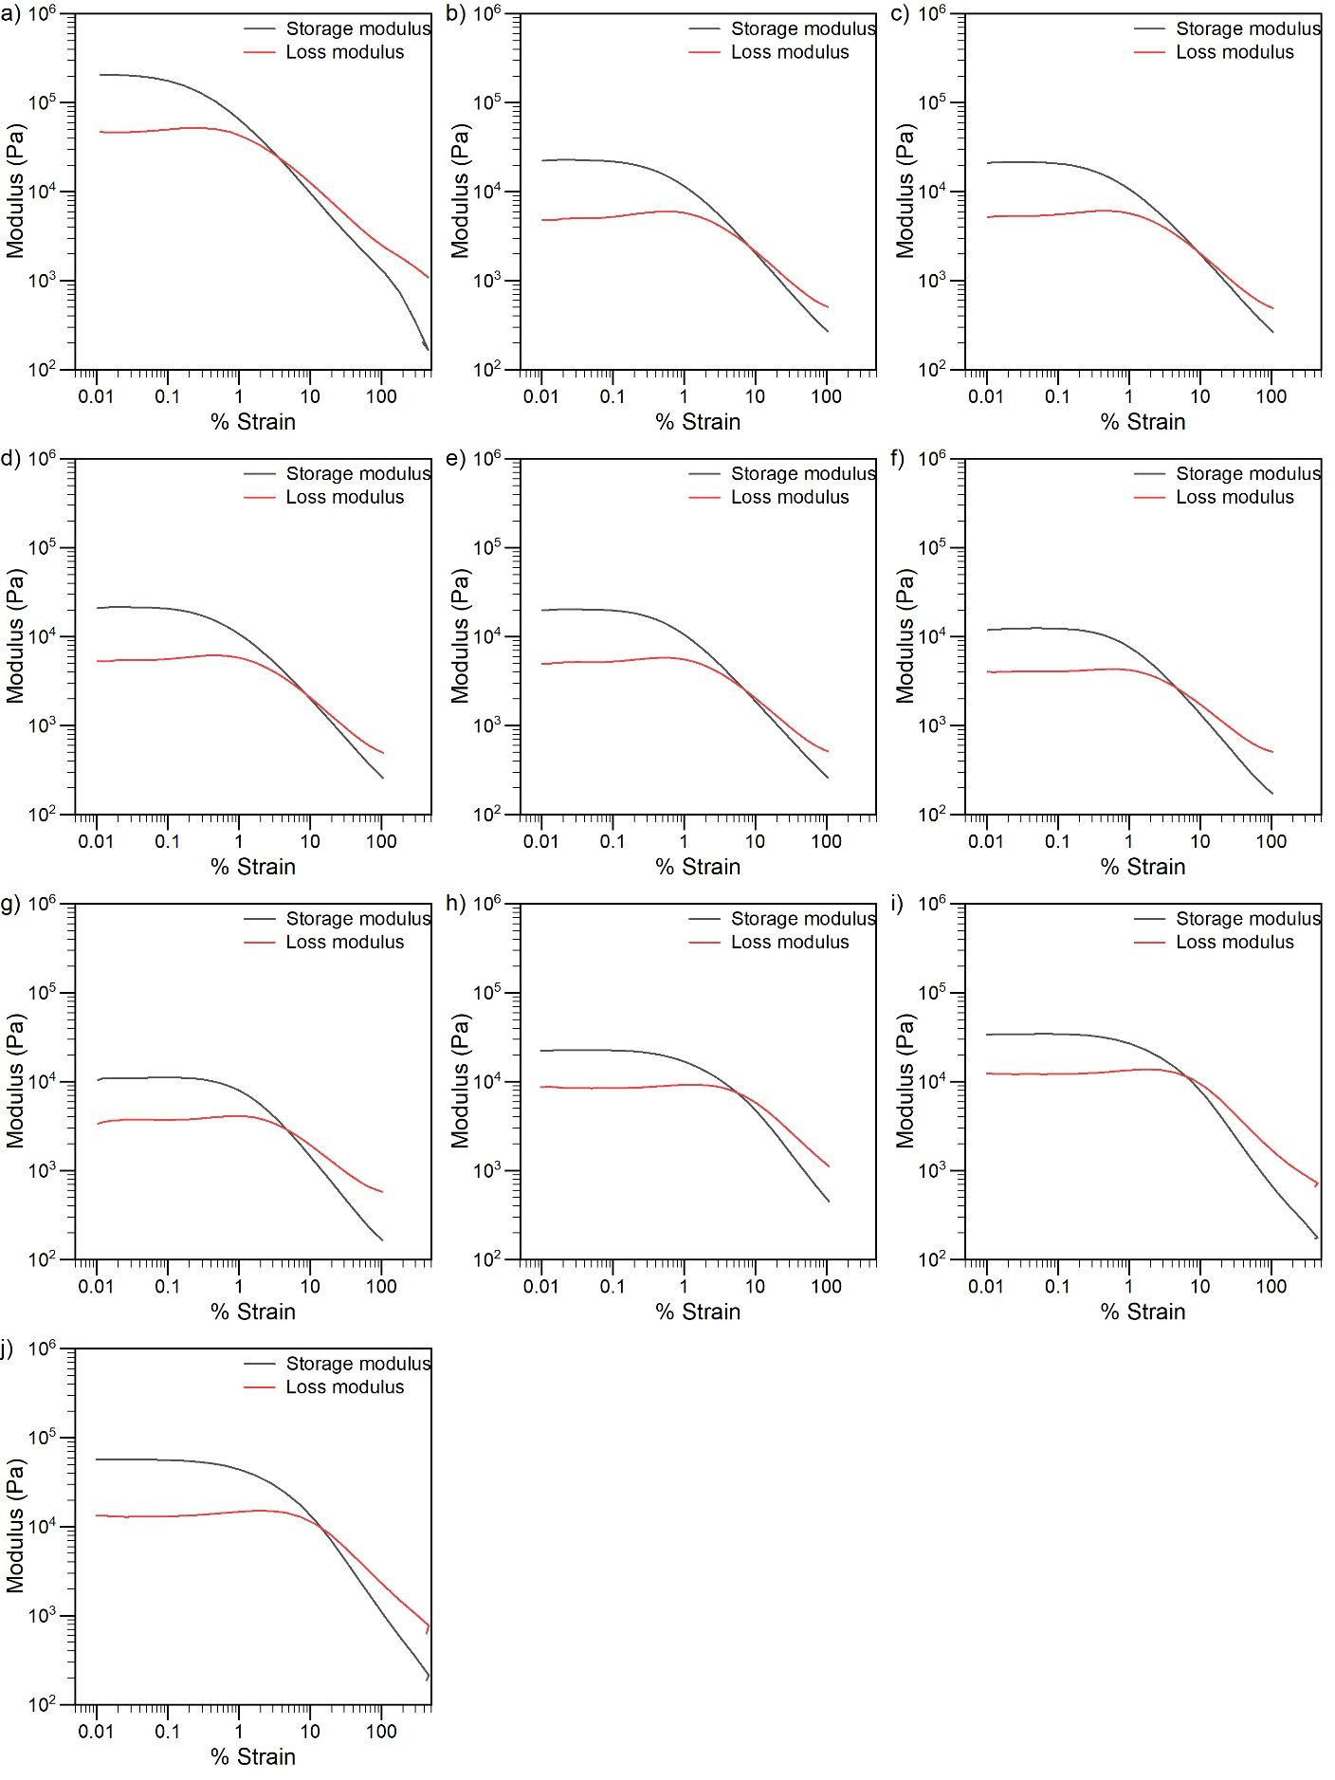
Figure S1: Oscillatory amplitude strain sweep tests for a) R1, b) R2, c) R3, d) R4, e) R5, f) R6, g) R7, h) R8, i) R9, and j) R10.
Three representative compositions of R1, R3, and R9 were selected for oscillatory frequency sweeps over a wider frequency range (0.5 to 500 rad·s⁻¹) with 0.01% strain without pre-shearing, as shown in Figure S2. These were chosen to represent key structural types: dissolved polymer coils (R1), disordered spherical micelles (R3), and cylindrical micelles (R9). In all cases, the storage modulus was larger than the loss modulus over the entire frequency range.
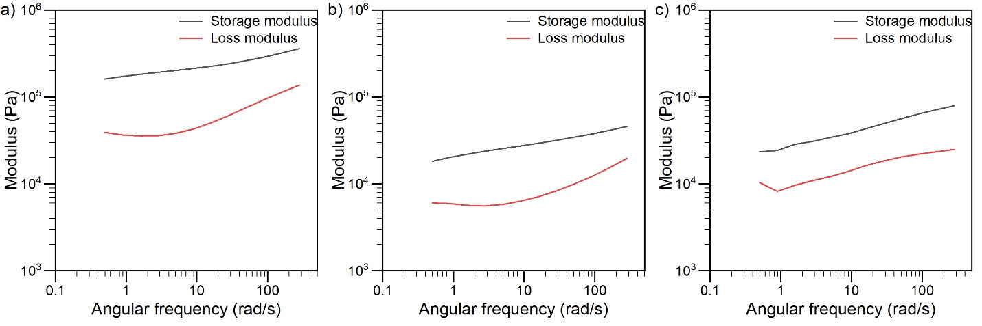
Figure S2: Representative rheological behavior from oscillatory frequency sweeps for (a) R1, (b) R3, and (c) R9.

Oscillatory frequency sweeps were also conducted on all resins following LAOS pre-shear (50–100% strain, depending on the resin composition). These results are provided in Figure S3.
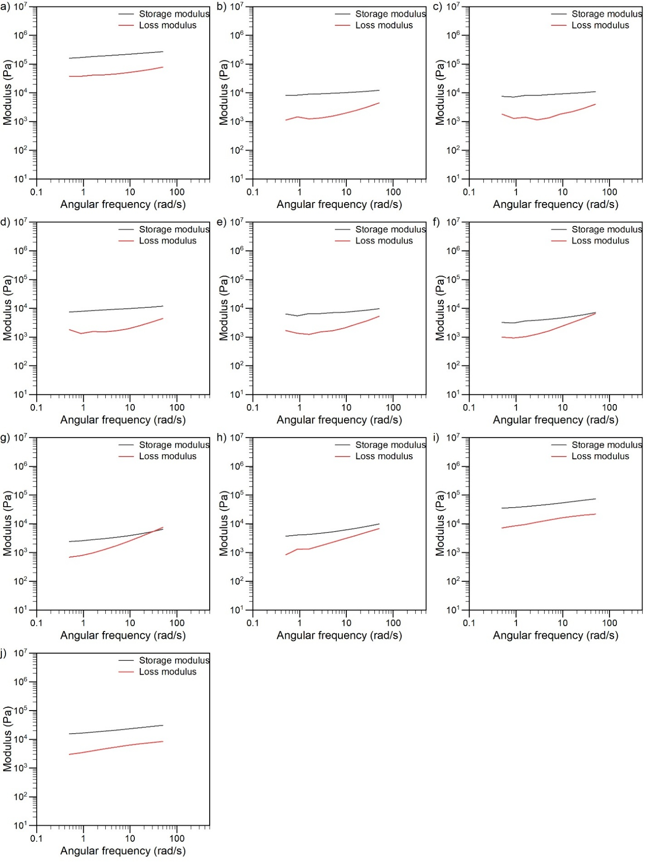
Figure S3: Oscillatory frequency sweep tests after pre-shearing for a) R1, b) R2, c) R3, d) R4, e) R5, f) R6, g) R7, h) R8, i) R9, and j) R10.

