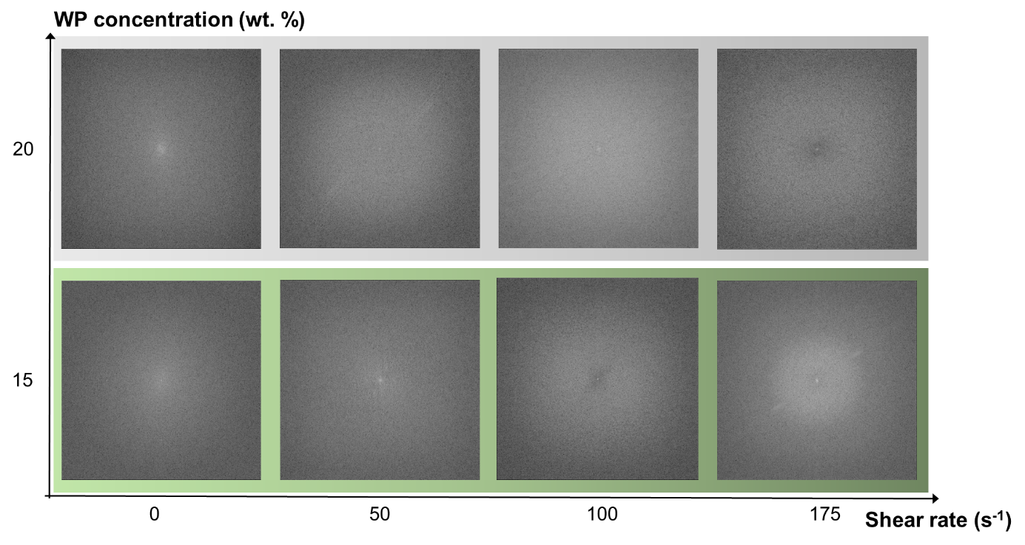
Figure S1: Fast Fourier Transform analysis performed on images of WP gels after shear treatment of solutions with 15 and 20 wt.% protein concentrations at 65°C.

