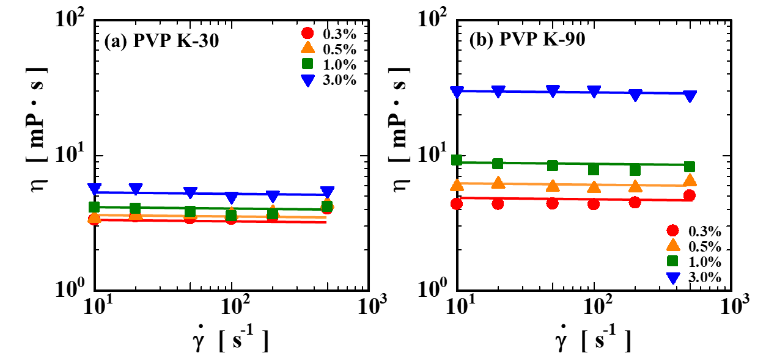
Fig. S1 Viscosity behavior of PVP-NMP solutions.

The viscosities of the KB-free PVP-NMP solutions (K30 and K90) were measured as a function of the shear rate. Both K30 and K90 solutions exhibited Newtonian behavior, showing no dependence of viscosity on the shear rate.

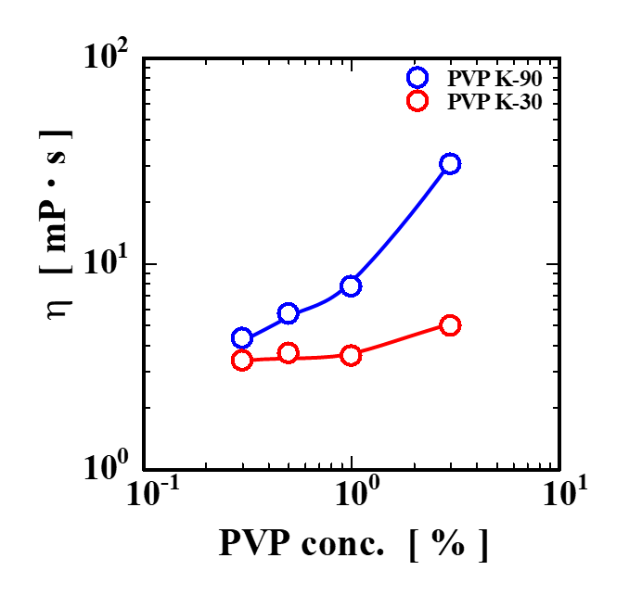
Fig. S2 Concentration dependence of viscosity in PVP-NMP solutions.

The concentration dependence of the viscosity in the PVP-NMP solutions was evaluated. For both K30 and K90 systems, the viscosity increased with increasing PVP concentration. The concentration dependence was more pronounced for the higher-molecular-weight K90 dispersant.

The impedance measurements of the KB-free PVP-NMP dispersant solutions revealed significantly larger impedance values compared with those of the KB-containing slurry samples. In particular, a large semicircular response attributed to electrode polarization was observed in the low-frequency region.

It should be noted that the PVP used in this study was cosmetic grade rather than analytical reagent grade and may contain trace amounts of water and ionic impurities (ash content). As the PVP concentration increases, the amount of ions introduced into the solution may increase, leading to a reduction in the apparent resistance associated with interfacial polarization at the electrode-solution interface.

The treatment of electrode polarization responses and series resistance in polymer solutions and composite electrode systems has been widely reported in impedance analyses. In such cases, the series resistance component is generally regarded as a baseline term originating from the solvent and the measurement setup rather than from the structural features of the particle networks (Takeno et al. 2017a; Patey et al. 2009; Lasia 2014; Wang et al. 2021).

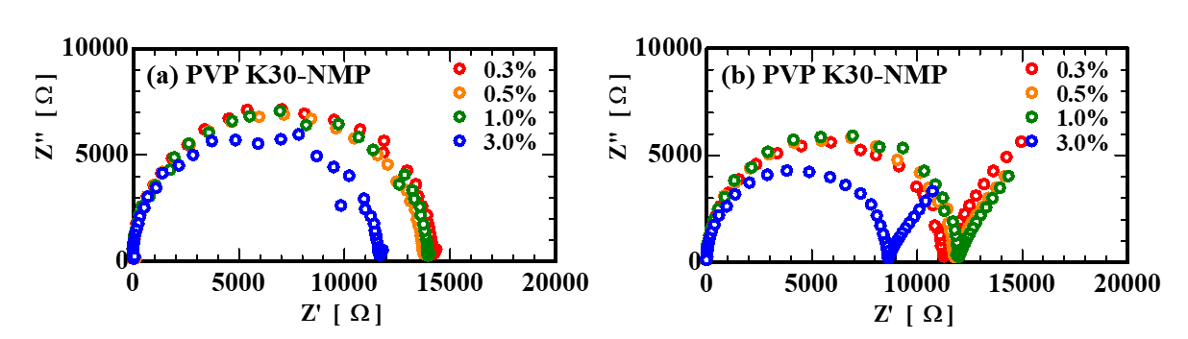

Fig. S3 Nyquist plot of PVP–NMP dispersant solutions without KB. A large semicircle attributed to the electrode polarization is observed, indicating that the impedance response is dominated by interfacial polarization rather than particle-network effects.

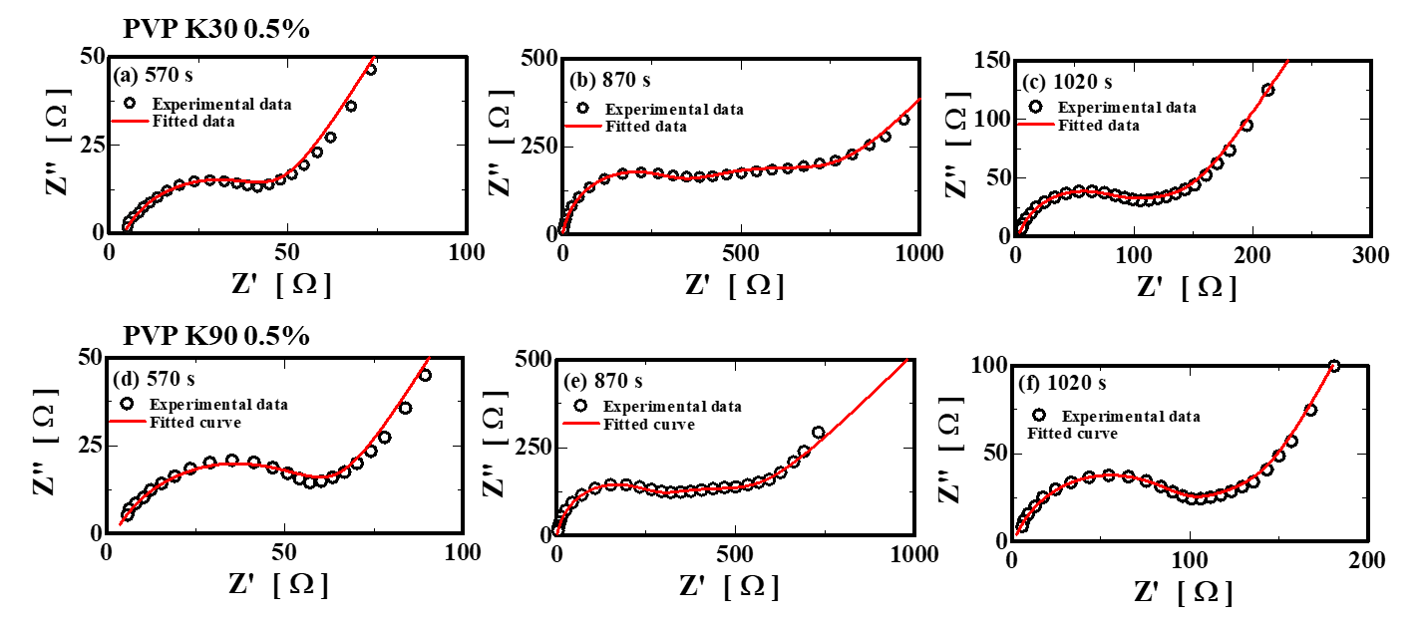

Fig. S4. Comparison between experimental impedance spectra and fitted curves for representative Ketjen Black slurries at a PVP concentration of 0.5 wt%. Panels (a)–(c) correspond to the PVP K30 system, and panels (d)–(f) correspond to the PVP K90 system. The spectra were taken at selected times during the step shearing test: (a) and (d) at 570 s (Region I), (b) and (e) at 870 s (Region II), and (c) and (f) at 1020 s (Region III). Symbols represent experimental data, and solid lines represent fitted curves obtained using the equivalent circuit shown in Fig. 8.

Representative examples of the fitting results are shown in Fig. S4 for the PVP K30 (panels (a)–(c)) and PVP K90 (panels (d)–(f)) systems at a PVP concentration of 0.5 wt%. The spectra correspond to selected times during the step shearing test: 570 s (Region I), 870 s (Region II), and 1020 s (Region III). The fitted curves reproduce the experimental Nyquist plots well over the entire frequency range, confirming the validity of the selected equivalent circuit model. In particular, the evolution of the semicircle structure during the step shearing test, including the transition from one semicircle to two semicircles and the subsequent recovery behavior, is well captured by the fitting. These results demonstrate that the adopted equivalent circuit consistently describes the impedance response associated with structural changes in the carbon black suspensions. The reliability of the fitting is further supported by the low χ² values reported in Table S1.

Table S1. Fitting parameters obtained from impedance spectra of Ketjen Black slurries using the equivalent circuit shown in Fig. 8.

(“−” indicates that the element was not included in the equivalent circuit for that condition.)

PVP K30 0.3%
Region | Time (s) | R₁ (Ω) | R₂ (Ω) | Q₂ (S·sⁿ) | n₂ (-) | R₃ (Ω) | Q₃ (S·sⁿ) | n₃ (-) | Q₄ (S·sⁿ) | n₄ (-) | χ²
Ⅰ | 570 | 1.4 ± 0.05 | 11.4 ± 0.2 | (1.91 ± 0.26) × 10⁻⁷ | 0.973 ± 0.010 | − | − | − | (4.89 ± 0.24) × 10⁻⁵ | 0.706 ± 0.006 | 2.11× 10⁻³
Ⅱ | 870 | 3.9 ± 0.2 | 40.4 ± 0.4 | (5.11 ± 0.45) × 10⁻⁷ | 0.742 ± 0.006 | − | − | − | (4.19 ± 0.13) × 10⁻⁵ | 0.710 ± 0.004 | 6.41 × 10⁻⁴
Ⅲ | 910 | 3.8 ± 0.1 | 9.3 ± 0.2 | (4.97 ± 1.03) × 10⁻⁷ | 0.922 ± 0.016 | − | − | − | (2.66 ± 0.01) × 10⁻⁵ | 0.785 ± 0.004 | 2.09 × 10⁻³
Ⅲ | 1020 | 2.3 ± 0.1 | 12.2 ± 0.2 | (4.23 ± 0.67) × 10⁻⁷ | 0.912 ± 0.012 | − | − | − | (4.18 ± 0.15) × 10⁻⁵ | 0.734 ± 0.005 | 1.78 × 10⁻³
Ⅲ | 1500 | 1.7 ± 0.1 | 13.8 ± 0.3 | (5.72 ± 0.90) × 10⁻⁷ | 0.885 ± 0.012 | − | − | − | (5.35 ± 0.20) × 10⁻⁵ | 0.706 ± 0.005 | 1.83 × 10⁻³

PVP K30 0.5%
Region | Time (s) | R₁ (Ω) | R₂ (Ω) | Q₂ (S·sⁿ) | n₂ (-) | R₃ (Ω) | Q₃ (S·sⁿ) | n₃ (-) | Q₄ (S·sⁿ) | n₄ (-) | χ²
Ⅰ | 570 | 4.1 ± 0.1 | 41.5 ± 0.5 | 1.96 ± 0.13 × 10⁻⁶ | 0.707 ± 0.005 | − | − | − | (6.47 ± 0.27) × 10⁻⁵ | 0.658 ± 0.005 | 5.06 × 10⁻⁴
Ⅱ | 870 | 0 (fixed) | 278.1 ± 6.9 | 7.26 ± 0.44 × 10⁻⁹ | 0.968 ± 0.005 | 415.0 ± 33.1 | (1.66 ± 0.30) × 10⁻⁶ | 0.705 ± 0.023 | (6.34 ± 0.89) × 10⁻⁵ | 0.540 ± 0.028 | 1.40 × 10⁻⁴
Ⅲ | 910 | 1.5 ± 0.2 | 171.7 ± 8.2 | 1.25 ± 0.12 × 10⁻⁸ | 0.944 ± 0.009 | 168.2 ± 25.7 | (2.70 ± 1.08) × 10⁻⁶ | 0.713 ± 0.005 | (9.41 ± 1.25) × 10⁻⁵ | 0.506 ± 0.025 | 2.80 × 10⁻⁴
Ⅲ | 1020 | 2.6 ± 0.1 | 80.8 ± 5.9 | 1.04 ± 0.13 × 10⁻⁷ | 0.828 ± 0.012 | 55.1 ± 10.4 | (1.04 ± 0.50) × 10⁻⁵ | 0.670 ± 0.064 | (6.06 ± 0.45) × 10⁻⁵ | 0.640 ± 0.013 | 2.16 × 10⁻⁴
Ⅲ | 1500 | 3.1 ± 0.1 | 52.6 ± 0.6 | 2.24 ± 0.14 × 10⁻⁶ | 0.671 ± 0.005 | − | − | − | (9.66 ± 0.42) × 10⁻⁵ | 0.602 ± 0.006 | 3.98 × 10⁻⁴

PVP K30 1.0%
Region | Time (s) | R₁ (Ω) | R₂ (Ω) | Q₂ (S·sⁿ) | n₂ (-) | R₃ (Ω) | Q₃ (S·sⁿ) | n₃ (-) | Q₄ (S·sⁿ) | n₄ (-) | χ²
Ⅰ | 570 | 0 (fixed) | 415.3 ± 5.1 | (4.37 ± 0.17) × 10⁻⁹ | 0.974 ± 0.003 | 644.9 ± 16.8 | (9.00 ± 0.51) × 10⁻⁷ | 0.708 ± 0.007 | (3.24 ± 0.26) × 10⁻⁵ | 0.591 ± 0.014 | 7.33 × 10⁻⁵
Ⅱ | 870 | 0 (fixed) | 508.3 ± 9.4 | (2.86 ± 0.14) × 10⁻⁹ | 0.994 ± 0.004 | 786.1 ± 37.3 | (5.84 ± 0.68) × 10⁻⁷ | 0.732 ± 0.014 | (3.73 ± 0.53) × 10⁻⁵ | 0.567 ± 0.026 | 1.28 × 10⁻⁴
Ⅲ | 910 | 0 (fixed) | 465.3 ± 8.5 | (3.03 ± 0.15) × 10⁻⁹ | 0.995 ± 0.004 | 775.2 ± 36.4 | (6.39 ± 0.72) × 10⁻⁷ | 0.728 ± 0.014 | (3.85 ± 0.54) × 10⁻⁵ | 0.565 ± 0.026 | 1.21 × 10⁻⁴
Ⅲ | 1020 | 0 (fixed) | 407.8 ± 5.9 | (4.23 ± 0.18) × 10⁻⁹ | 0.977 ± 0.004 | 634.4 ± 23.9 | (9.23 ± 0.77) × 10⁻⁷ | 0.708 ± 0.010 | (4.35 ± 0.46) × 10⁻⁵ | 0.562 ± 0.019 | 8.15 × 10⁻⁵
Ⅲ | 1500 | 0 (fixed) | 345.7 ± 3.5 | (6.72 ± 0.21) × 10⁻⁹ | 0.952 ± 0.003 | 514.8 ± 10.3 | (1.42 ± 0.06) × 10⁻⁶ | 0.683 ± 0.005 | (3.92 ± 0.23) × 10⁻⁵ | 0.589 ± 0.010 | 4.62 × 10⁻⁵

PVP K30 3.0%
Region | Time (s) | R₁ (Ω) | R₂ (Ω) | Q₂ (S·sⁿ) | n₂ (-) | R₃ (Ω) | Q₃ (S·sⁿ) | n₃ (-) | Q₄ (S·sⁿ) | n₄ (-) | χ²
Ⅰ | 570 | 0 (fixed) | 542.2 ± 12.7 | (3.83 ± 0.22) × 10⁻⁹ | 0.979 ± 0.005 | 890.5 ± 48.3 | (4.94 ± 0.68) × 10⁻⁷ | 0.749 ± 0.017 | (4.05 ± 0.93) × 10⁻⁵ | 0.590 ± 0.042 | 1.77 × 10⁻⁴
Ⅱ | 870 | 0 (fixed) | 598.7 ± 14.4 | (3.14 ± 0.19) × 10⁻⁹ | 0.988 ± 0.005 | 985.2 ± 55.3 | (4.20 ± 0.61) × 10⁻⁷ | 0.756 ± 0.018 | (3.89 ± 0.99) × 10⁻⁵ | 0.591 ± 0.047 | 2.00 × 10⁻⁴
Ⅲ | 910 | 0 (fixed) | 568.7 ± 14.1 | (3.26 ± 0.20) × 10⁻⁹ | 0.990 ± 0.005 | 981.5 ± 55.7 | (4.27 ± 0.62) × 10⁻⁷ | 0.756 ± 0.012 | (3.86 ± 1.00) × 10⁻⁵ | 0.592 ± 0.047 | 2.12 × 10⁻⁴
Ⅲ | 1020 | 0 (fixed) | 533.3 ± 12.8 | (3.82 ± 0.22) × 10⁻⁹ | 0.981 ± 0.005 | 889.8 ± 50.0 | (5.05 ± 0.72) × 10⁻⁷ | 0.748 ± 0.018 | (4.33 ± 1.05) × 10⁻⁵ | 0.586 ± 0.045 | 1.84 × 10⁻⁴
Ⅲ | 1500 | 0 (fixed) | 466.7 ± 10.2 | (5.58 ± 0.29) × 10⁻⁹ | 0.959 ± 0.005 | 713.4 ± 37.1 | (6.92 ± 0.89) × 10⁻⁷ | 0.736 ± 0.016 | (5.29 ± 1.07) × 10⁻⁵ | 0.579 ± 0.037 | 1.28 × 10⁻⁴

PVP K90 0.3%
Region | Time (s) | R₁ (Ω) | R₂ (Ω) | Q₂ (S·sⁿ) | n₂ (-) | R₃ (Ω) | Q₃ (S·sⁿ) | n₃ (-) | Q₄ (S·sⁿ) | n₄ (-) | χ²
Ⅰ | 570 | 2.4 ± 0.02 | 24.8 ± 0.18 | (6.35 ± 0.32) × 10⁻⁸ | 0.994 ± 0.004 | − | − | − | (3.02 ± 0.06) × 10⁻⁵ | 0.690 ± 0.003 | 5.12 × 10⁻⁴
Ⅱ | 870 | 0 (fixed) | 164.1 ± 1.66 | (3.03 ± 0.18) × 10⁻⁸ | 0.892 ± 0.004 | − | − | − | (1.08 ± 0.03) × 10⁻⁴ | 0.444 ± 0.004 | 4.19 × 10⁻⁴
Ⅲ | 910 | 4.0 ± 0.2 | 37.2 ± 0.52 | (2.58 ± 0.25) × 10⁻⁶ | 0.669 ± 0.007 | − | − | − | (4.26 ± 0.13) × 10⁻⁵ | 0.675 ± 0.004 | 5.06 × 10⁻⁴
Ⅲ | 1020 | 4.5 ± 0.04 | 24.5 ± 0.20 | (3.04 ± 0.18) × 10⁻⁷ | 0.877 ± 0.004 | − | − | − | (4.40 ± 0.09) × 10⁻⁵ | 0.673 ± 0.003 | 3.80 × 10⁻⁴
Ⅲ | 1500 | 3.1 ± 0.02 | 21.5 ± 0.17 | (1.14 ± 0.06) × 10⁻⁷ | 0.962 ± 0.004 | − | − | − | (8.00 ± 0.18) × 10⁻⁵ | 0.619 ± 0.003 | 3.98 × 10⁻⁴

PVP K90 0.5%
Region | Time (s) | R₁ (Ω) | R₂ (Ω) | Q₂ (S·sⁿ) | n₂ (-) | R₃ (Ω) | Q₃ (S·sⁿ) | n₃ (-) | Q₄ (S·sⁿ) | n₄ (-) | χ²
Ⅰ | 570 | 2.3 ± 0.1 | 60.0 ± 0.35 | (1.27 ± 0.05) × 10⁻⁶ | 0.694 ± 0.003 | − | − | − | (6.69 ± 0.15) × 10⁻⁵ | 0.658 ± 0.003 | 2.58 × 10⁻⁴
Ⅱ | 870 | 0 (fixed) | 227.9 ± 6.11 | (7.72 ± 0.46) × 10⁻⁹ | 0.971 ± 0.006 | 267.0 ± 23.1 | (2.17 ± 0.44) × 10⁻⁶ | 0.700 ± 0.026 | (8.99 ± 0.86) × 10⁻⁵ | 0.504 ± 0.019 | 1.13 × 10⁻⁴
Ⅲ | 910 | 1.8 ± 0.1 | 148.2 ± 3.84 | (3.08 ± 0.18) × 10⁻⁹ | 0.886 ± 0.005 | 106.0 ± 10.2 | (7.17 ± 2.02) × 10⁻⁶ | 0.686 ± 0.035 | (6.22 ± 0.47) × 10⁻⁵ | 0.629 ± 0.014 | 1.28 × 10⁻⁴
Ⅲ | 1020 | 1.3 ± 0.1 | 97.4 ± 1.28 | (1.59 ± 0.07) × 10⁻⁷ | 0.790 ± 0.003 | 35.7 ± 3.2 | (1.35 ± 0.39) × 10⁻⁵ | 0.744 ± 0.035 | (5.00 ± 0.22) × 10⁻⁵ | 0.705 ± 0.008 | 9.84 × 10⁻⁵
Ⅲ | 1500 | 1.5 ± 0.1 | 77.0 ± 0.71 | (9.56 ± 0.50) × 10⁻⁷ | 0.694 ± 0.004 | 16.2 ± 2.1 | (7.59 ± 3.08) × 10⁻⁶ | 0.931 ± 0.050 | (5.49 ± 0.31) × 10⁻⁵ | 0.723 ± 0.009 | 1.99 × 10⁻⁴

PVP K90 1.0%
Region | Time (s) | R₁ (Ω) | R₂ (Ω) | Q₂ (S·sⁿ) | n₂ (-) | R₃ (Ω) | Q₃ (S·sⁿ) | n₃ (-) | Q₄ (S·sⁿ) | n₄ (-) | χ²
Ⅰ | 570 | 1.8 ± 0.1 | 119.4 ± 1.21 | (3.88 ± 0.14) × 10⁻⁷ | 0.733 ± 0.002 | 37.4 ± 2.9 | (4.66 ± 1.11) × 10⁻⁶ | 0.849 ± 0.029 | (7.84 ± 0.34) × 10⁻⁵ | 0.634 ± 0.007 | 8.18 × 10⁻⁵
Ⅱ | 870 | 1.0 ± 0.2 | 348.0 ± 17.88 | (1.48 ± 0.20) × 10⁻⁶ | 0.712 ± 0.017 | 253.2 ± 6.6 | (8.03 ± 0.48) × 10⁻⁹ | 0.962 ± 0.005 | (8.60 ± 0.78) × 10⁻⁵ | 0.536 ± 0.017 | 8.17 × 10⁻⁵
Ⅲ | 910 | 2.2 ± 0.1 | 130.6 ± 4.38 | (4.87 ± 0.31) × 10⁻⁸ | 0.855 ± 0.006 | 102.3 ± 8.6 | (7.48 ± 1.74) × 10⁻⁶ | 0.666 ± 0.032 | (7.55 ± 0.48) × 10⁻⁵ | 0.635 ± 0.011 | 8.42 × 10⁻⁵
Ⅲ | 1020 | 1.8 ± 0.1 | 110.9 ± 3.02 | (1.54 ± 0.08) × 10⁻⁷ | 0.785 ± 0.005 | 68.6 ± 6.3 | (1.32 ± 0.3) × 10⁻⁵ | 0.664 ± 0.030 | (6.91 ± 0.39) × 10⁻⁵ | 0.663 ± 0.010 | 7.75 × 10⁻⁵
Ⅲ | 1500 | 1.7 ± 0.1 | 112.8 ± 11.46 | (4.45 ± 0.18) × 10⁻⁷ | 0.722 ± 0.003 | 39.0 ± 3.3 | (7.08 ± 1.78) × 10⁻⁶ | 0.802 ± 0.031 | (7.08 ± 0.32) × 10⁻⁵ | 0.653 ± 0.008 | 8.28 × 10⁻⁵

PVP K90 3.0%
Region | Time (s) | R₁ (Ω) | R₂ (Ω) | Q₂ (S·sⁿ) | n₂ (-) | R₃ (Ω) | Q₃ (S·sⁿ) | n₃ (-) | Q₄ (S·sⁿ) | n₄ (-) | χ²
Ⅰ | 570 | 0 (fixed) | 260.1 ± 9.95 | (9.81 ± 0.78) × 10⁻⁹ | 0.951 ± 0.007 | 482.3 ± 40.5 | (1.62 ± 0.33) × 10⁻⁶ | 0.691 ± 0.026 | (6.69 ± 0.64) × 10⁻⁵ | 0.502 ± 0.021 | 1.59 × 10⁻⁴
Ⅱ | 870 | 0 (fixed) | 432.5 ± 14.40 | (3.56 ± 0.27) × 10⁻⁹ | 0.995 ± 0.007 | 866.8 ± 58.3 | (5.72 ± 1.02) × 10⁻⁷ | 0.734 ± 0.002 | (5.05 ± 0.90) × 10⁻⁵ | 0.540 ± 0.034 | 2.51 × 10⁻⁴
Ⅲ | 910 | 0 (fixed) | 373.3 ± 13.25 | (4.42 ± 0.36) × 10⁻⁹ | 0.988 ± 0.007 | 774.2 ± 59.8 | (8.12 ± 1.59) × 10⁻⁷ | 0.719 ± 0.025 | (5.12 ± 0.83) × 10⁻⁵ | 0.533 ± 0.033 | 2.65 × 10⁻⁴
Ⅲ | 1020 | 0 (fixed) | 306.5 ± 10.74 | (6.52 ± 0.51) × 10⁻⁹ | 0.970 ± 0.007 | 590.5 ± 49.1 | (1.26 ± 0.25) × 10⁻⁷ | 0.700 ± 0.025 | (5.81 ± 0.75) × 10⁻⁵ | 0.519 ± 0.027 | 2.02 × 10⁻⁴
Ⅲ | 1500 | 0 (fixed) | 251.2 ± 9.37 | (1.14 ± 0.09) × 10⁻⁸ | 0.940 ± 0.007 | 459.1 ± 38.7 | (1.89 ± 0.37) × 10⁻⁶ | 0.683 ± 0.026 | (7.88 ± 0.78) × 10⁻⁵ | 0.497 ± 0.022 | 1.42 × 10⁻⁴

The impedance spectra were fitted using ZView software based on the equivalent circuit model shown in Fig. 8. R₁ was initially treated as a free parameter. When free fitting resulted in non-physical negative values of R₁, it was fixed at 0 Ω and the spectra were refitted. For spectra in which fixing R₁ led to a significant deterioration in fitting quality, R₁ was retained as a free parameter. For spectra exhibiting a single semicircle, the circuit element corresponding to R₃‖CPE₃ was omitted. For spectra with two semicircles, all elements in the equivalent circuit were included. Representative data points from Regions I–III were selected for clarity, while the overall trends were consistent across all datasets. The reported errors represent fitting uncertainties obtained from ZView, and χ² denotes the chi-squared goodness-of-fit parameter.

