Deep sequencing reveals persistence of cell-associated mumps vaccine virus in chronic encephalitis
Sofia Morfopoulou, Edward T Mee, Sarah M Connaughton, Julianne R Brown, Kimberly Gilmour, WK ‘Kling’ Chong, W Paul Duprex, Deborah Ferguson, Mike Hubank, Ciaran Hutchinson, Marios Kaliakatsos, Stephen McQuaid, Simon Paine, Vincent Plagnol, Chris Ruis, Alex Virasami, Hong Zhan, Thomas S Jacques, Silke Schepelmann, Waseem Qasim, Judith Breuer

Contents
Deep sequencing reveals persistence of cell-associated mumps vaccine virus in chronic encephalitis 1
Single nucleotide polymorphisms detection 2
Epitope prediction 2
Supplementary Tables 3
Supplementary Figures 10

Single nucleotide polymorphisms detection
Fifteen positions in the vaccine sequence were found to be polymorphic (MAF 5% or greater, Table S6b and S6c). These were all located in the N gene which codes for the nucleocapsid protein or in the untranslated region between the N and the V/P/I genes. The majority of the changes were T to C substitutions. Five of the changes coded for missense amino acid substitutions, five were synonymous while the remaining five changes were in non-coding regions. Twelve polymorphisms were present at frequencies of 10-24%.
Eighty one differences between the brain MuV data and the vaccine consensus genome were observed (MAF 5% or greater, Figure S3, Table S6a) with an excess of T to C changes (51/81). Fifty five of these differences had become fixed in the brain MuV consensus sequence (Table S3, MAF 75% or greater) while twenty six were minority variants (Table S5) and clustered at the 3’ends of the N and large (L) genes (Figure S3). Twelve changes were identical to the pre-existing minority variants identified at 10-24% frequency in or near to the N gene, now fixed in the brain virus. These were all T to C changes, four of them predicted to result in non-synonymous changes, three in synonymous and five was located in a non-coding region (Table S6b, Figure S3).

Epitope prediction
We made use of data on the donor’s HLA genotype to predict specific CTL cell epitopes. We used the IEDB epitope prediction tool and the recommended percentile rank cutoff <= 1%. Five of the fixed missense changes in the M, HN, L proteins (2, 1 and 2 changes respectively) occurred within predicted CTL epitopes while none were found in N, P and F proteins. 4 out of the 5 epitopes are considered as peptide binders according to IEDB standards (IC50 score less than 500nM). A low IC50 value signifies a high binding affinity. In 4/5 cases the substitution present in the MuV^{JL5}-London is predicted to reduce CTL binding affinity (Table S8). We repeated the analysis using four randomly selected HLA alleles. 4/6 of the predicted epitopes would not be regarded as peptide binders (Table S8). The mutations increased the binding affinity in half of the epitopes, while decreased it in the other half, without modifying their peptide binder status (Table S8). No loss of predicted T cell binding affinity seen in mutated peptides from two predicted epitopes based on four randomly selected HLA A and B alleles.

Supplementary Tables
Supplementary Table 1: Summary of real-time PCR assays undertaken on the CSF at the first signs of CNS infection (patient was approximately 34 months old). All assays listed were negative.
Supplementary Table 2: Summary of real-time PCR assays undertaken on the brain biopsy, CSF, blood and urine samples (patient was approximately 67 months old). All assays listed were negative except for the mumps virus PCR assay for the brain biopsy which was positive as well as the JC virus PCR assay for one blood and one urine sample.
*Micropathology Laboratory Ltd., **Public Health England (PHE)
Supplementary Table 3: Summary of present species detected by metaMix. The only viral pathogen detected is MuV. Human sequences as well as environmental bacteria and kit contaminants were also detected. The posterior probability of the presence of the taxon in the sample is presented and the Bayes Factor to quantify the evidence in favor of the presence of each species to it being absent.
Supplementary Table 4: Summary of all 81 variants between the brain and the vaccine data consisting of 55 fixed and 26 minority variants.
Supplementary Table 5: 55 fixed mutations (frequency > 75%) between brain and vaccine data. Of these 50 occur in coding regions of the mumps virus genome, reported here per protein. The changes in the N gene present in the vaccine sequencing data as minority variants have a grey text background.
Supplementary Table 6: Goodness-of-Fit exact binomial test two-tailed p-value for significant deviation from the expected number of fixed missense changes per protein.
Supplementary Table 7: The 26 minority variants in the brain data consist of 17 changes in coding areas and 9 in non-coding. The table summarizes the former, reported per protein.
Supplementary Table 8: Epitope binding affinity scores (IC50) for the donor and random alleles. The asterisk (*) indicates peptide binders recognized by T cells (IC50<500nM).
Supplementary Table 1
CSF
Adenovirus
BK virus
JC virus
CMV
EBV
Enterovirus
Parechovirus
HHV6
HSV
Toxoplasma
16S (pan-bacterial)
18S (pan-fungal)
Mycobacteria

Supplementary Table 2
Brain biopsy | CSF | Blood | Urine
Adenovirus | Adenovirus | Adenovirus
BK virus | BK virus | BK virus | BK virus
CMV | CMV | CMV | CMV
HHV6* | HHV6*
HSV 1 and 2 | HSV 1 and 2
Human astrovirus | Human astrovirus
JC virus | JC virus | JC virus | JC virus
Measles** | Measles** |  | Measles**
Mumps** | Mumps** |  | Mumps**
Rubella** | Rubella**
EBV |  | EBV
Toxoplasma* |  | Toxoplasma*
Norovirus
Rotavirus
Sapovirus
 | Astrovirus VA1/HMO-C
 | Coronavirus*
 | Enterovirus*
 | Mycoplasma*
 | Parechovirus*
 | Rhinovirus*
 | RSV*
 | VZV

Supplementary Table 3
taxonID | scientName | Read count | poster.prob | log10BF
unknown | unknown | 348908 | 1 | NA
9606 | Homo sapiens | 101050 | 1 | 110573
11161 | Mumps virus | 77624 | 1 | 335240.4
1747 | Propionibacterium acnes | 2653 | 1 | 3339.266
10090 | Mus musculus | 1190 | 1 | 727.4473
374840 | Enterobacteria phage phiX174 sensu lato | 423 | 1 | 846.6118
584 | Proteus mirabilis | 421 | 1 | 624.2779
548476 | Corynebacterium aurimucosum ATCC 700975 | 350 | 1 | 442.3845
47229 | Massilia timonae | 316 | 1 | 497.8983
529507 | Proteus mirabilis HI4320 | 263 | 1 | 292.9151
158877 | Yokenella regensburgei | 256 | 1 | 241.8602
29388 | Staphylococcus capitis | 249 | 1 | 342.6923
33032 | Anaerococcus lactolyticus | 234 | 1 | 372.4314
469 | Acinetobacter | 232 | 1 | 326.9754
102862 | Proteus penneri | 223 | 1 | 201.0023
28037 | Streptococcus mitis | 223 | 1 | 314.1208
1282 | Staphylococcus epidermidis | 222 | 1 | 371.8281
40214 | Acinetobacter johnsonii | 206 | 1 | 308.6753
69218 | Enterobacter cancerogenus | 202 | 1 | 215.8242
225324 | Enhydrobacter aerosaccus | 198 | 1 | 466.9199
816 | Bacteroides | 178 | 1 | 407.5874
618 | Serratia odorifera | 175 | 1 | 268.8794
38303 | Corynebacterium pseudogenitalium | 171 | 1 | 268.9854
1303 | Streptococcus oralis | 169 | 1 | 285.8656
28090 | Acinetobacter lwoffii | 168 | 0.99 | 308.9395
1260 | Finegoldia magna | 164 | 1 | 355.4904
1270 | Micrococcus luteus | 161 | 1 | 371.4328
1833 | Rhodococcus erythropolis | 127 | 1 | 310.9948
38284 | Corynebacterium accolens | 126 | 0.93 | 84.55722
267747 | Propionibacterium acnes KPA171202 | 118 | 1 | 221.4295
33029 | Anaerococcus hydrogenalis | 116 | 0.94 | 40.6264
1305 | Streptococcus sanguinis | 107 | 1 | 296.4448
13690 | Sphingobium yanoikuyae | 107 | 0.97 | 170.1415
39791 | Corynebacterium glucuronolyticum | 102 | 0.99 | 72.87183
250 | Chryseobacterium gleum | 97 | 1 | 278.5301
82347 | Facklamia languida | 97 | 1 | 309.0609
40215 | Acinetobacter junii | 93 | 0.94 | 78.6702
553199 | Propionibacterium acnes SK137 | 80 | 0.96 | 123.512
186802 | Clostridiales | 75 | 0.98 | 45.65406
1656 | Actinomyces viscosus | 73 | 0.99 | 91.91713
28127 | Prevotella buccalis | 70 | 1 | 249.1014
1351 | Enterococcus faecalis | 69 | 1 | 234.7038
1155766 | Enterococcus faecium Aus0004 | 60 | 1 | 225.3758
43675 | Rothia mucilaginosa | 56 | 0.99 | 187.2995
Supplementary Table 4
4a. Brain data against vaccine consensus
Position | Ref | Reads1 | Var | Reads2 | VarFreq | Effect | Gene | Codon change | Amino acid change
512 | A | 3 | G | 1313 | 99.7 | missense | N | c.367A>G | p.Thr123Ala
1463 | G | 3363 | A | 378 | 10.1 | missense | N | c.1318G>A | p.Asp440Asn
1496 | T | 2 | C | 1866 | 99.89 | missense | N | c.1351T>C | p.Phe451Leu
1514 | T | 1 | C | 1354 | 99.93 | synonymous | N | c.1369T>C | p.Leu457Leu
1515 | T | 0 | C | 1352 | 100 | missense | N | c.1370T>C | p.Leu457Ser
1537 | T | 2 | C | 1171 | 99.74 | synonymous | N | c.1392T>C | p.Gly464Gly
1547 | T | 2 | C | 1238 | 99.84 | missense | N | c.1402T>C | p.Phe468Leu
1548 | T | 0 | C | 1372 | 99.93 | missense | N | c.1403T>C | p.Phe468Ser
1590 | T | 3146 | C | 223 | 6.62 | missense | N | c.1445T>C | p.Phe482Ser
1602 | A | 782 | G | 2641 | 77.15 | missense | N | c.1457A>G | p.Tyr486Cys
1647 | A | 3849 | C | 238 | 5.82 | missense | N | c.1502A>C | p.Asn501Thr
1731 | T | 2518 | C | 1975 | 43.96 | missense | N | c.1586T>C | p.Val529Ala
1769 | T | 1 | C | 4173 | 99.98 | synonymous | N | c.1624T>C | p.Leu542Leu
1801 | T | 2055 | C | 1442 | 41.22 | non-coding
1815 | T | 0 | C | 3025 | 100 | non-coding
1856 | T | 1 | C | 1113 | 99.91 | non-coding
1860 | T | 1 | C | 913 | 99.89 | non-coding
1873 | T | 1 | C | 280 | 99.64 | non-coding
1882 | T | 1 | C | 105 | 99.06 | non-coding
2306 | G | 0 | T | 1169 | 99.91 | missense | V/P/I | c.328G>T | p.Val110Phe
3213 | T | 120 | C | 19 | 13.67 | non-coding
3215 | T | 104 | C | 20 | 16.13 | non-coding
3220 | T | 95 | C | 19 | 16.67 | non-coding
3256 | T | 589 | C | 41 | 6.5 | non-coding
3273 | T | 726 | C | 52 | 6.68 | missense | M | c.10T>C | p.Ser4Pro
3373 | T | 51 | C | 917 | 94.73 | missense | M | c.110T>C | p.Leu37Pro
3577 | T | 28 | C | 799 | 96.61 | missense | M | c.314T>C | p.Met105Thr
3629 | T | 32 | C | 783 | 95.96 | synonymous | M | c.366T>C | p.Asp122Asp
3681 | T | 34 | C | 842 | 96.12 | missense | M | c.418T>C | p.Tyr140His
3771 | T | 18 | C | 479 | 96.38 | missense | M | c.508T>C | p.Tyr170His
3778 | T | 22 | C | 450 | 95.34 | missense | M | c.515T>C | p.Val172Ala
3786 | T | 16 | C | 415 | 96.29 | synonymous | M | c.523T>C | p.Leu175Leu
3806 | T | 16 | C | 421 | 96.34 | synonymous | M | c.543T>C | p.Ser181Ser
3823 | G | 0 | A | 475 | 100 | missense | M | c.560G>A | p.Arg187Gln
3841 | T | 18 | C | 589 | 97.03 | missense | M | c.578T>C | p.Leu193Pro
3911 | T | 26 | C | 594 | 95.65 | synonymous | M | c.648T>C | p.Asp216Asp
3912 | T | 27 | C | 511 | 94.98 | missense | M | c.649T>C | p.Ser217Pro
4020 | T | 28 | C | 590 | 95.47 | missense | M | c.757T>C | p.Tyr253His
4575 | C | 1 | T | 382 | 99.74 | synonymous | F | c.30C>T | p.Gly10Gly
4633 | T | 0 | C | 448 | 100 | missense | F | c.88T>C | p.Tyr30His
4718 | A | 1 | C | 494 | 99.8 | missense | F | c.173A>C | p.Gln58Pro
4991 | G | 1 | A | 410 | 99.76 | missense | F | c.446G>A | p.Arg149Gln
5540 | T | 0 | A | 577 | 100 | missense | F | c.995T>A | p.Phe332Tyr
5767 | A | 0 | G | 904 | 99.89 | missense | F | c.1222A>G | p.Thr408Ala
5933 | C | 2 | T | 850 | 99.77 | missense | F | c.1388C>T | p.Ala463Val
6642 | C | 0 | T | 234 | 100 | missense | HN | c.29C>T | p.Ser10Leu
6898 | A | 0 | G | 190 | 100 | synonymous | HN | c.285A>G | p.Gly95Gly
6944 | T | 228 | C | 28 | 10.94 | synonymous | HN | c.331T>C | p.Leu111Leu
6945 | T | 193 | C | 30 | 13.45 | missense | HN | c.332T>C | p.Leu111Ser
7228 | T | 1 | C | 285 | 99.65 | synonymous | HN | c.615T>C | p.His205His
7257 | G | 0 | A | 260 | 100 | missense | HN | c.644G>A | p.Gly215Glu
7372 | C | 0 | T | 292 | 100 | synonymous | HN | c.759C>T | p.Cys253Cys
7536 | T | 2 | C | 281 | 98.6 | missense | HN | c.923T>C | p.Val308Ala
7756 | C | 2 | T | 606 | 99.67 | synonymous | HN | c.1143C>T | p.Val381Val
8076 | C | 26 | T | 423 | 94.21 | missense | HN | c.1463C>T | p.Pro488Leu
8936 | T | 0 | C | 70 | 100 | missense | L | c.499T>C | p.Ser167Pro
10387 | T | 0 | C | 91 | 100 | synonymous | L | c.1950T>C | p.Asn650Asn
10405 | T | 0 | C | 62 | 100 | synonymous | L | c.1968T>C | p.Asp656Asp
10407 | A | 4 | T | 50 | 92.59 | missense | L | c.1970A>T | p.Asp657Val
10414 | T | 0 | C | 70 | 100 | synonymous | L | c.1977T>C | p.Phe659Phe
11431 | C | 0 | T | 118 | 100 | synonymous | L | c.2994C>T | p.Ser998Ser
12379 | C | 4 | A | 46 | 92 | synonymous | L | c.3942C>A | p.Ser1314Ser
13688 | A | 10 | G | 77 | 88.51 | missense | L | c.5251A>G | p.Ser1751Gly
13970 | C | 0 | T | 100 | 100 | missense | L | c.5533C>T | p.Pro1845Ser
14036 | C | 0 | G | 102 | 99.03 | missense | L | c.5599C>G | p.Gln1867Glu
14500 | T | 0 | C | 123 | 100 | synonymous | L | c.6063T>C | p.Phe2021Phe
14616 | T | 121 | C | 8 | 6.2 | missense | L | c.6179T>C | p.Leu2060Pro
14868 | T | 169 | C | 11 | 6.11 | missense | L | c.6431T>C | p.Leu2144Pro
14985 | T | 199 | C | 23 | 10.36 | missense | L | c.6548T>C | p.Leu2183Pro
15008 | T | 222 | C | 16 | 6.72 | missense | L | c.6571T>C | p.Tyr2191His
15012 | T | 237 | C | 16 | 6.32 | missense | L | c.6575T>C | p.Leu2192Pro
15023 | T | 213 | C | 24 | 10.13 | synonymous | L | c.6586T>C | p.Leu2196Leu
15157 | A | 363 | G | 37 | 9.25 | synonymous | L | c.6720A>G | p.Glu2240Glu
15163 | T | 363 | C | 28 | 7.16 | synonymous | L | c.6726T>C | p.Ser2242Ser
15174 | A | 362 | G | 21 | 5.48 | missense | L | c.6737A>G | p.Asp2246Gly
15190 | A | 294 | G | 85 | 22.43 | missense | L | c.6753A>G | p.Ile2251Met
15218 | A | 0 | C | 341 | 99.71 | missense | L | c.6781A>C | p.Ile2261Leu
15248 | T | 253 | C | 153 | 37.68 | non-coding
15314 | T | 173 | C | 58 | 25.11 | non-coding
15317 | T | 89 | C | 78 | 46.71 | non-coding
15318 | A | 154 | G | 49 | 24.14 | non-coding

4b. Variants prexisting in the vaccine data
Position | Ref | Reads1 | Var | Reads2 | Freq | Effect | Gene | Codon_change | Amino_acid change
1496 | T | 982 | C | 242 | 19.77% | missense | N | c.1351T>C | p.Phe451Leu
1514 | T | 913 | C | 212 | 18.84% | synonymous | N | c.1369T>C | p.Leu457Leu
1515 | T | 900 | C | 216 | 19.35% | missense | N | c.1370T>C | p.Leu457Ser
1537 | T | 783 | C | 192 | 19.63% | synonymous | N | c.1392T>C | p.Gly464Gly
1547 | T | 782 | C | 209 | 21.09% | missense | N | c.1402T>C | p.Phe468Leu
1548 | T | 750 | C | 238 | 24.09% | missense | N | c.1403T>C | p.Phe468Ser
1769 | T | 503 | C | 95 | 15.89% | synonymous | N | c.1624T>C | p.Leu542Leu
1815 | T | 413 | C | 91 | 18.06%
1856 | T | 373 | C | 37 | 9.02%
1860 | T | 368 | C | 41 | 10.02%
1873 | T | 367 | C | 42 | 10.27%
1882 | T | 325 | C | 50 | 13.33%

4c.Variants present only in the vaccine data
Position | Ref | Reads1 | Var | Reads2 | Freq | Effect | GENE | Codon_change | Amino_acid change
1627 | T | 780 | C | 50 | 6.02% | synonymous | N | c.1482T>C | p.Asn494Asn
2416 | A | 785 | C | 85 | 9.77% | synonymous | V/P/I | c.438A>C | p.Ser146Ser
10494 | C | 226 | T | 13 | 5.44% | missense | L | c.2057C>T | p.Ala686Val
Supplementary Table 5
N (dN/dS=6/3) |  |  | P |  |  | M (dN/dS=9/4)
Codon change | Amino acid change | % | Codon change | Amino acid change | % | Codon change | Amino acid change | %
c.367A>G | p.Thr123Ala | 100% | c.328G>T | p.Val110Phe | 99.91 | c.110T>C | p.Leu37Pro | 94.73
c.1351T>C | p.Phe451Leu | 99.7 |  |  |  | c.314T>C | p.Met105Thr | 96.61
c.1369T>C | p.Leu457Leu | 99.89 |  |  |  | c.366T>C | p.Asp122Asp | 95.96
c.1370T>C | p.Leu457Ser | 99.93 |  |  |  | c.418T>C | p.Tyr140His | 96.12
c.1392T>C | p.Gly464Gly | 100 |  |  |  | c.508T>C | p.Tyr170His | 96.38
c.1402T>C | p.Phe468Leu | 99.74 |  |  |  | c.515T>C | p.Val172Ala | 95.34
c.1403T>C | p.Phe468Ser | 99.84 |  |  |  | c.523T>C | p.Leu175Leu | 96.29
c.1457A>G | p.Tyr486Cys | 99.93 |  |  |  | c.543T>C | p.Ser181Ser | 96.34
c.1624T>C | p.Leu542Leu | 77.15 |  |  |  | c.560G>A | p.Arg187Gln | 100
 |  |  |  |  |  | c.578T>C | p.Leu193Pro | 97.03
 |  |  |  |  |  | c.648T>C | p.Asp216Asp | 95.65
 |  |  |  |  |  | c.649T>C | p.Ser217Pro | 94.98
 |  |  |  |  |  | c.757T>C | p.Tyr253His | 95.47

F (dN/dS=6/1) |  |  | HN (dN/dS=4:4) |  |  | L (dN/dS:6:6)
Codon change | Amino acid change | % | Codon change | Amino acid change | % | Codon change | Amino acid change | %
c.30C>T | p.Gly10Gly | 99.74 | c.29C>T | p.Ser10Leu | 100 | c.499T>C | p.Ser167Pro | 100
c.88T>C | p.Tyr30His | 100 | c.285A>G | p.Gly95Gly | 100 | c.1950T>C | p.Asn650Asn | 100
c.173A>C | p.Gln58Pro | 99.8 | c.615T>C | p.His205His | 99.65 | c.1968T>C | p.Asp656Asp | 100
c.446G>A | p.Arg149Gln | 99.76 | c.644G>A | p.Gly215Glu | 100 | c.1970A>T | p.Asp657Val | 92.59
c.995T>A | p.Phe332Tyr | 100 | c.759C>T | p.Cys253Cys | 100 | c.1977T>C | p.Phe659Phe | 100
c.1222A>G | p.Thr408Ala | 99.89 | c.923T>C | p.Val308Ala | 98.6 | c.2994C>T | p.Ser998Ser | 100
c.1388C>T | p.Ala463Val | 99.77 | c.1143C>T | p.Val381Val | 99.67 | c.3942C>A | p.Ser1314Ser | 92
 |  |  | c.1463C>T | p.Pro488Leu | 94.21 | c.5251A>G | p.Ser1751Gly | 88.51
 |  |  |  |  |  | c.5533C>T | p.Pro1845Ser | 100
 |  |  |  |  |  | c.5599C>G | p.Gln1867Glu | 99.03
 |  |  |  |  |  | c.6063T>C | p.Phe2021Phe | 100
 |  |  |  |  |  | c.6781A>C | p.Ile2261Leu | 99.71

Supplementary Table 6
Gene | significant deviation from expected number of fixed missense changes (p-value) | T to C hypermutation rate
N | 0.77 | 62% (8/13)
P | 0.73 | 0% (0/1)
M | 2.79x10⁻⁴ | 93% (13/14)
F | 0.08 | 14% (1/7)
HN | 0.57 | 40% (4/10)
L | 0.08 | 55% (12/22)
non-coding regions | NA | 93% (13/14)

Supplementary Table 7
NP |  |  | M |  |  | HN |  |  | L
Codon change | Amino acid change | % | Codon change | Amino acid change | % | Codon change | Amino acid change | % | Codon change | Amino acid change | %
c.1318G>A | p.Asp440Asn | 10.1 | c.10T>C | p.Ser4Pro | 6.7 | c.331T>C | p.Leu111Leu | 10.9 | c.6179T>C | p.Leu2060Pro | 6.2
c.1445T>C | p.Phe482Ser | 6.6 |  |  |  | c.332T>C | p.Leu111Ser | 13.5 | c.6431T>C | p.Leu2144Pro | 6.1
c.1502A>C | p.Asn501Thr | 5.8 |  |  |  |  |  |  | c.6548T>C | p.Leu2183Pro | 10.3
c.1586T>C | p.Val529Ala | 43.9 |  |  |  |  |  |  | c.6571T>C | p.Tyr2191His | 6.7
 |  |  |  |  |  |  |  |  | c.6575T>C | p.Leu2192Pro | 6.3
 |  |  |  |  |  |  |  |  | c.6586T>C | p.Leu2196Leu | 10.1
 |  |  |  |  |  |  |  |  | c.6720A>G | p.Glu2240Glu | 9.3
 |  |  |  |  |  |  |  |  | c.6726T>C | p.Ser2242Ser | 7.2
 |  |  |  |  |  |  |  |  | c.6737A>G | p.Asp2246Gly | 5.5
 |  |  |  |  |  |  |  |  | c.6753A>G | p.Ile2251Met | 22.4

Supplementary Table 8
Protein | Mutation | Predicted binding affinity (IC50) value  for wild type | Predicted binding affinity (IC50) value  for mutated type
Donor alleles
M protein* | p.Tyr170His | 91 | 240
M protein* | p.Val172Ala | 91 | 240
HN protein* | p.Ser10Leu | 55 | 81
L protein* | p.Asp657Val | 163 | 125
L protein | p.Pro1845Ser | 655 | 9891
Random alleles
M protein | p.Leu37Pro | 3179 | 2977
M protein | p.Tyr140His | 1297 | 1598
M protein* | p.Leu193Pro | 95 | 33
HN protein* | p.Pro488Leu | 73 | 38
L protein | p.Asp657Val | 1177 | 832
L protein | p.Gln1867Glu | 1515 | 2837

Supplementary Figures
Supplementary Figure 1
Read coverage (blue line) depth of the brain biopsy deep sequencing data mapped to the assembled sequence and is plotted across a genome schematic. (99.94% genome coverage, median coverage depth: 290, mean: 686, range: 1-5014). In green the read coverage depth of the NIBSC vaccine deep sequencing data mapped to a publicly available MuV^{JL5} reference (identifier: FJ211585) and is plotted across a genome schematic (100% genome coverage, median coverage depth: 706, mean: 818, range: 1-2369).
We observe a non-uniform coverage of the genome from the sequencing data, more specifically a decreasing gradient in the abundance of the transcripts produced for genes located further from the 3’ genome promoter. This is due to the fact that the RNA-dependent RNA polymerase (RdRp) recognises a single promoter at the 3’ end of the genome and can therefore only initiate there [1].
The difference in genome coverage between the brain and the vaccine virus may reflect the presence of mumps virus defective interfering particles[2].

Supplementary Figure 2
Full genome maximum likelihood phylogenetic tree of the viral sequence identified in the brain of the patient (in dark blue font) to all full mumps virus genomes found in GenBank (64 unique sequences, accession date 20 June 2015). The Jeryl Lynn strains are denoted in light blue color. The Bat Paramyxovirus was used as root.
Supplementary Figure 3
MuV^{JL5} strain (FJ211585) genomic structure and the single nucleotide polymorphisms observed in the brain virus genome. Missense polymorphisms are in red, synonymous are in green, non-coding in grey. The variants pre-existing in the vaccine sequence as minority variants are denoted with similar color coding but with dashed lines.

Supplementary Figure 4
Detection of mumps N protein in the CNS by immunohistochemistry. A & B. Low power photomicrographs showing abundant virus expression in neurons and neuropil in the grey matter. C. High power image of focal region from A demonstrating the presence of virus in neuron cell bodies and neuronal processes. D. Occasional virus positive cells were also detected in meningeal tissue on the surface of the brain.

Supplementary Figure 5: Minority variants in the MuV^{JL5-}London genome. The amino acid changes are plotted along the genome, color-coded for each protein. The magenta-colored changes are occurring in non-coding regions of the MuV genome. Information on whether the changes occurred in predicted CTL epitopes is also provided.

Supplementary Figure 6: Visualisation of the multiple sequence alignment for 52 M proteins found in GenBank and the translated sequence of the M gene from the brain virus. Tyr140His is noted with a red arrow, while the 8 fixed de novo substitutions are noted with a purple arrow. In each page 50 amino acids are visualised.

Figure 1

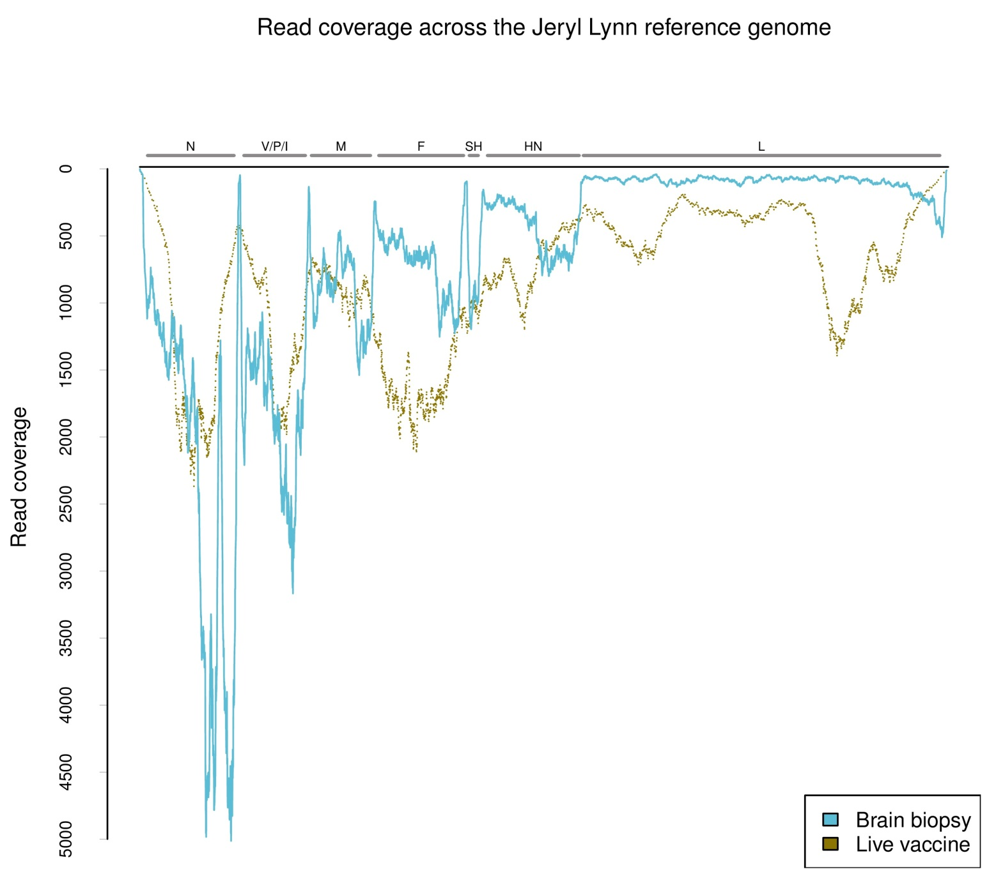

Figure 2

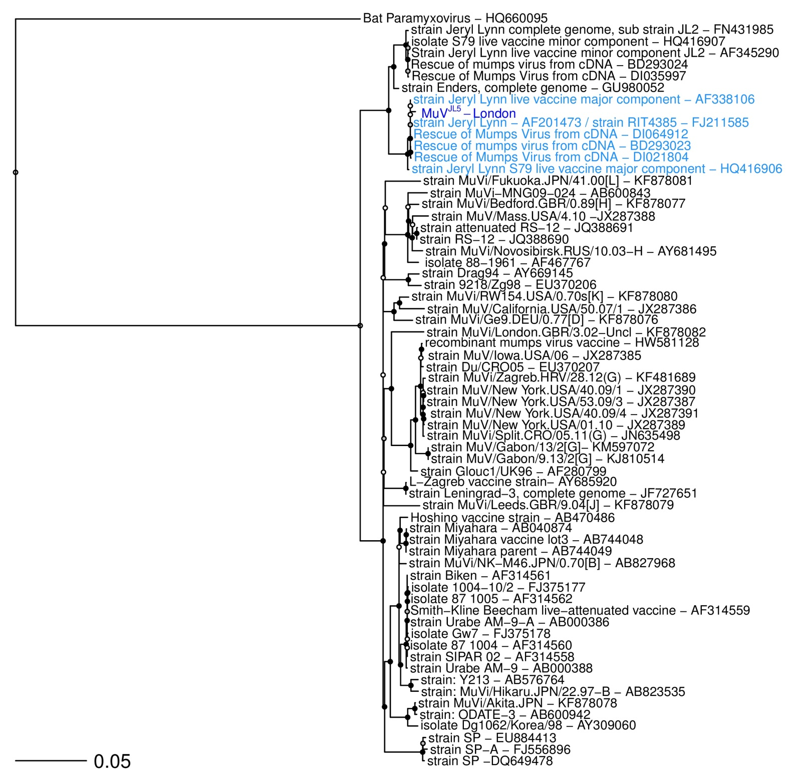

Figure 3

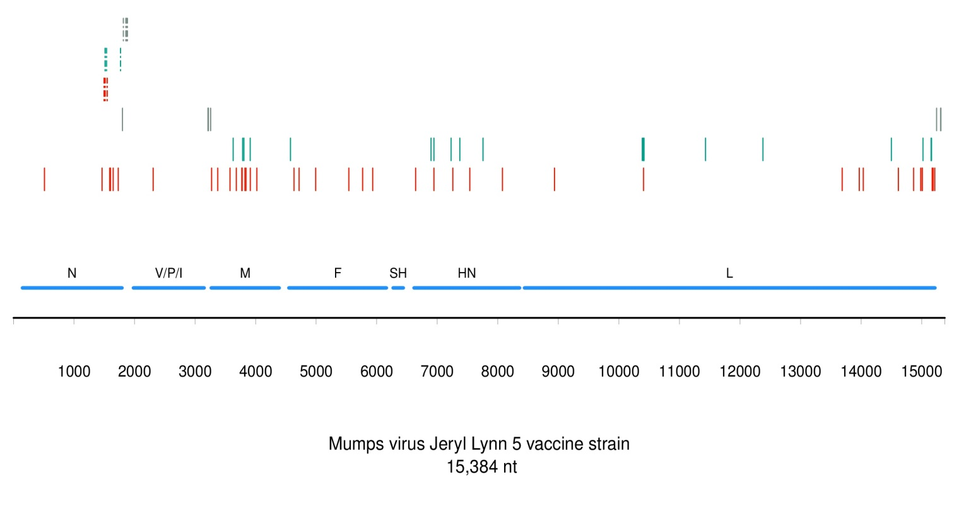

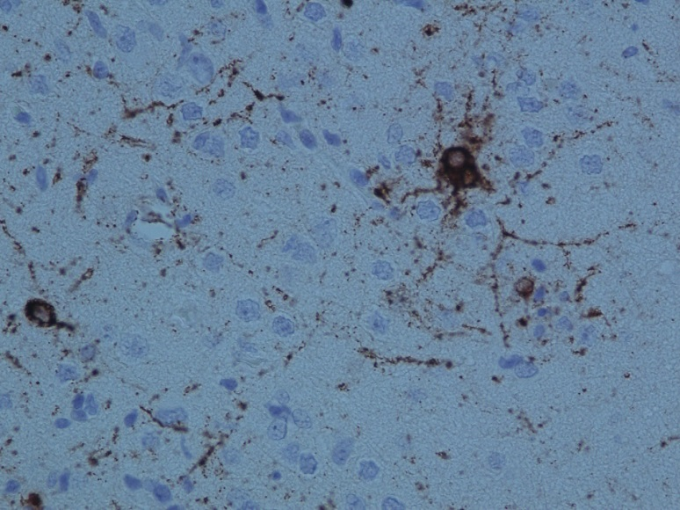
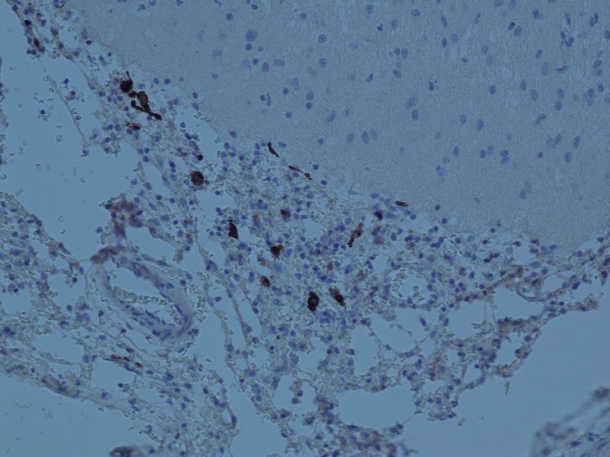
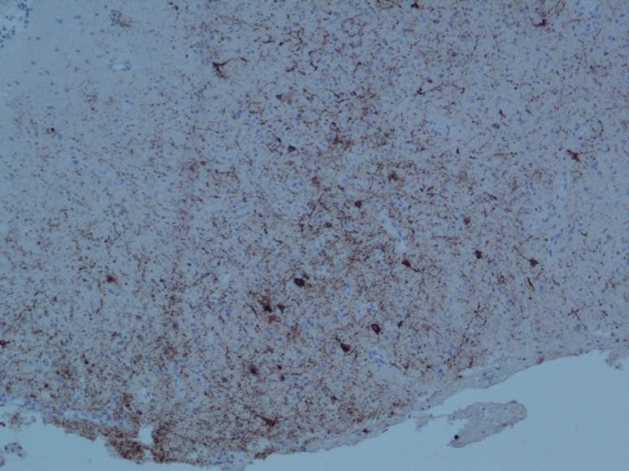
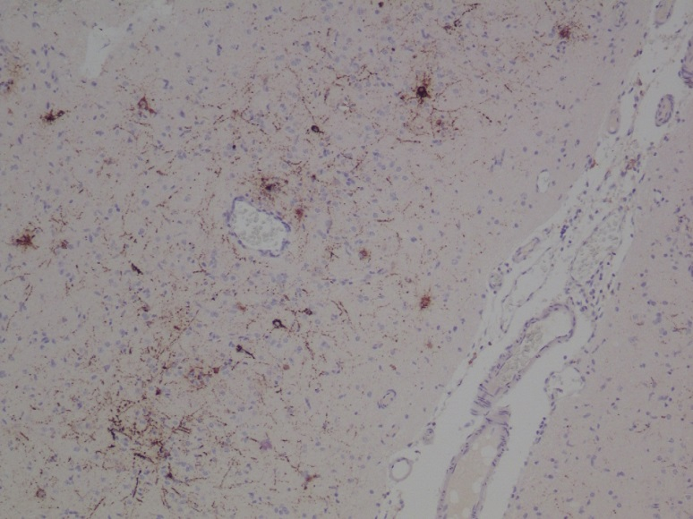
Figure 4
D
C
B
A

Figure 5

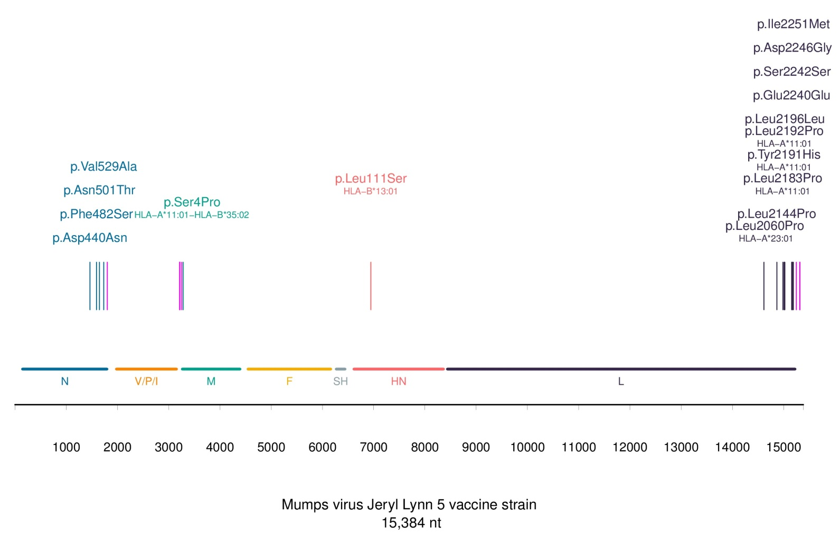

Figure 6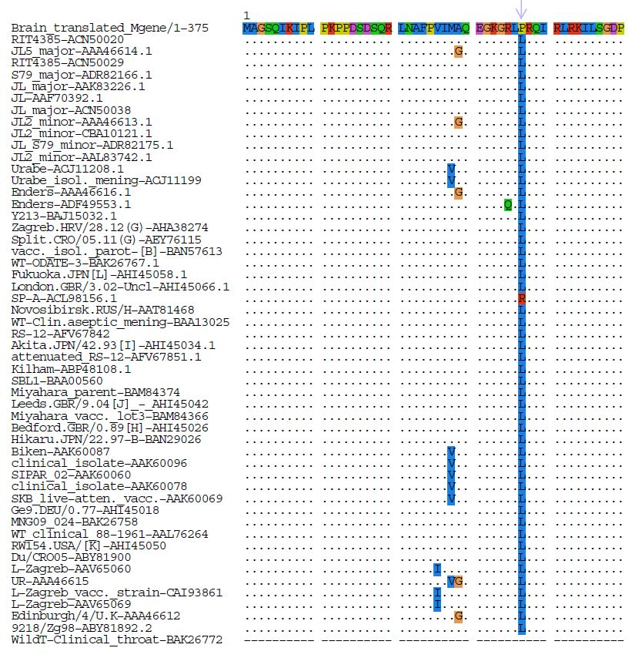

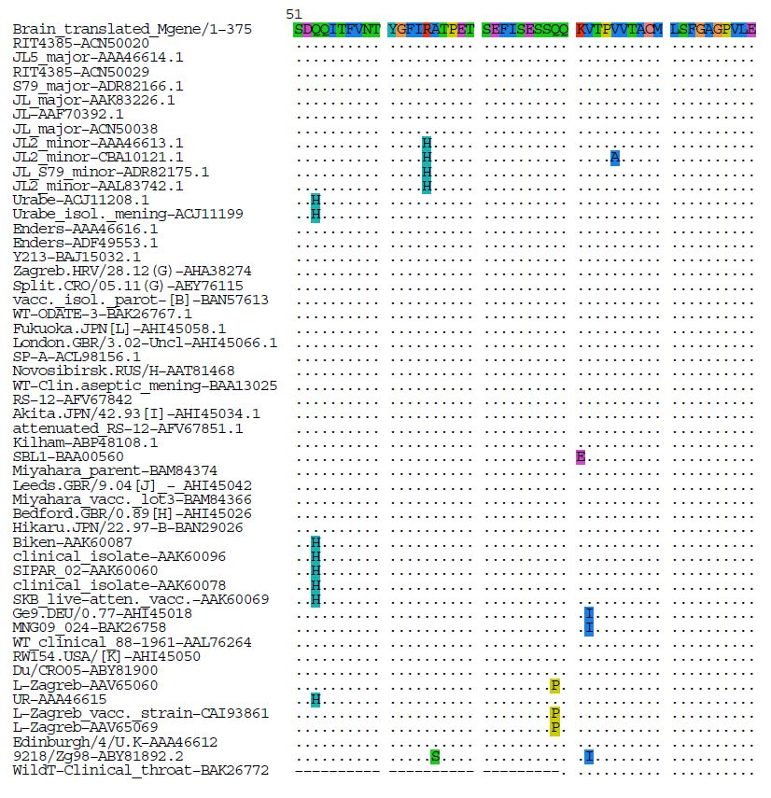

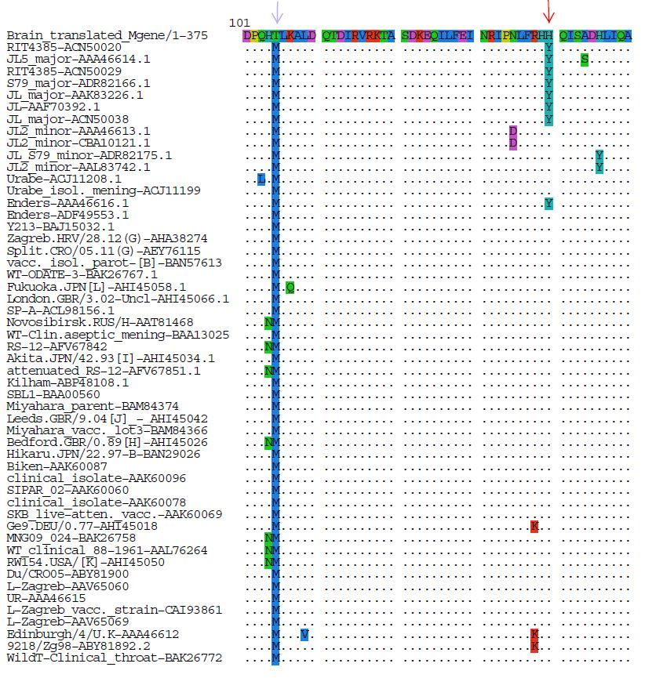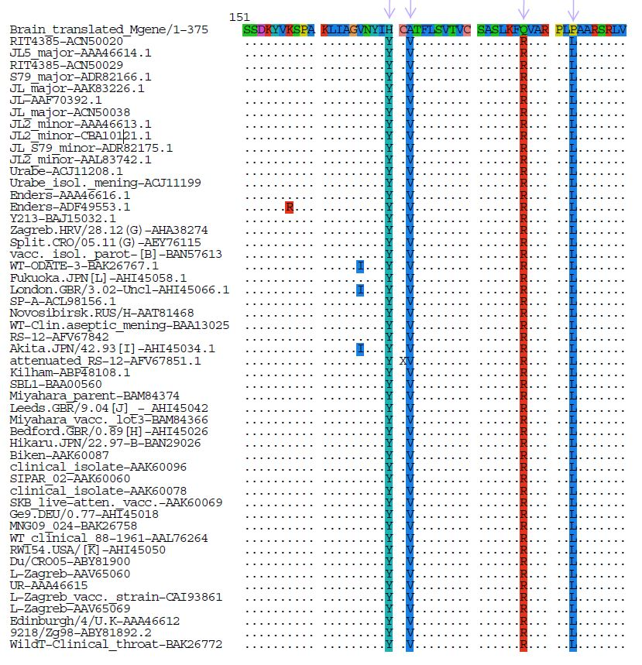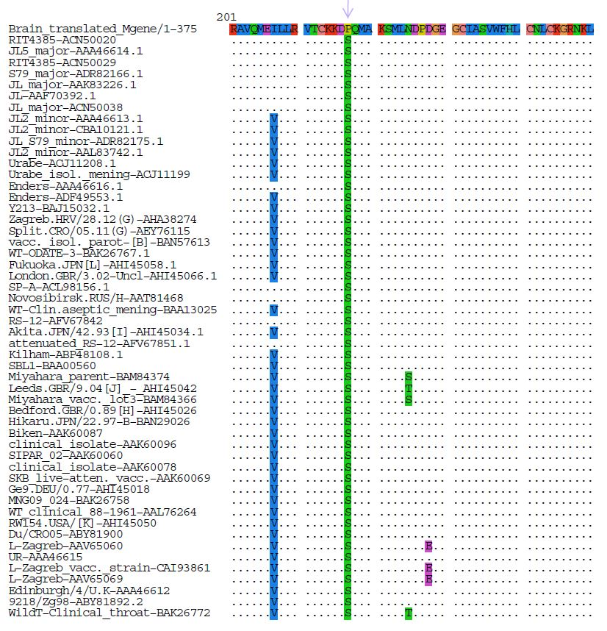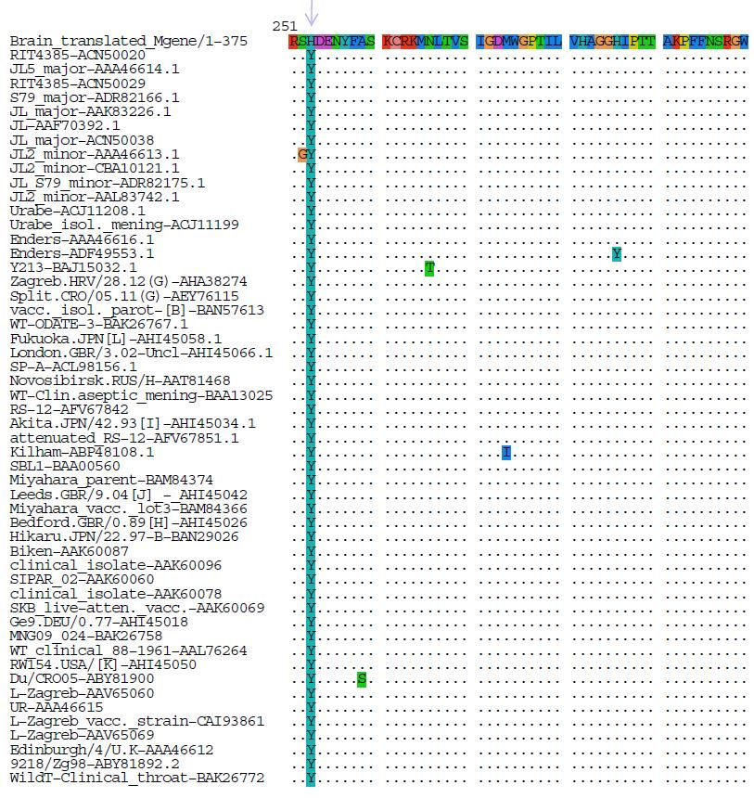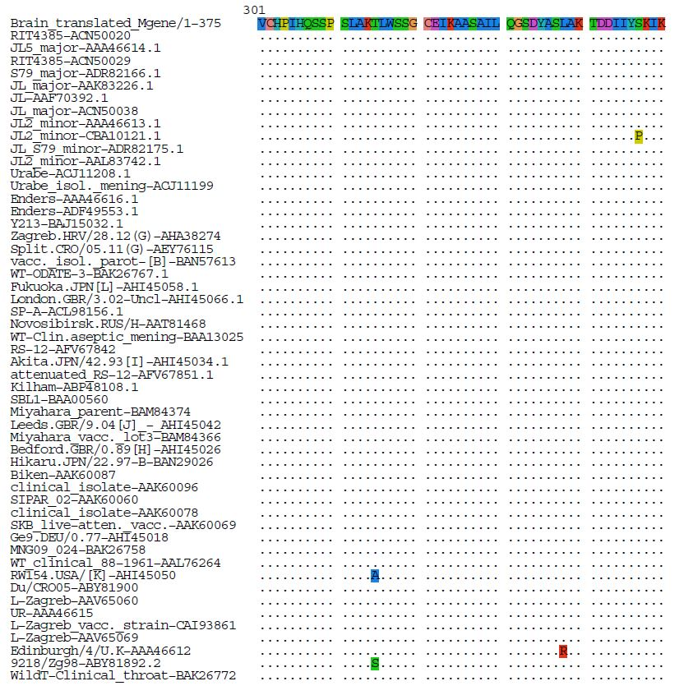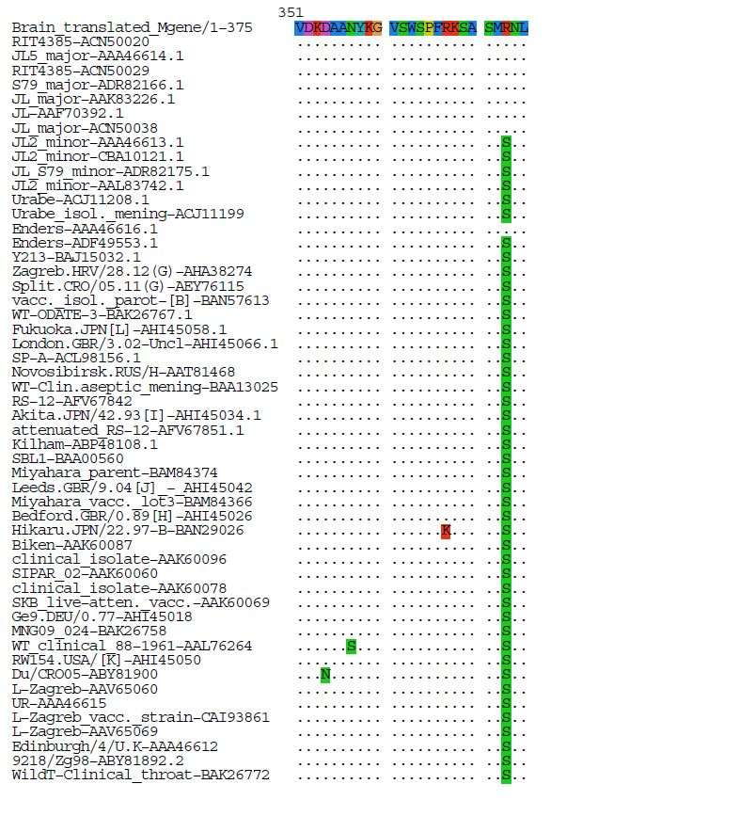

1. Rubin S, Vandermeulen C (2011) Mumps. In: Samal SK (ed) Biol. Paramyxoviruses. Caister Academic Press, pp 5–36
2. Šantak M, Markušić M, Balija ML, Kopač SK, Jug R, Örvell C, Tomac J, Forčić D (2015) Accumulation of defective interfering viral particles in only a few passages in Vero cells attenuates mumps virus neurovirulence. Microbes Infect 17:228–236. doi: http://dx.doi.org/10.1016/j.micinf.2014.11.006

