Supplementary Tables and Figures, On-line Resources

On-line Resource Table 1: Plasma Biomarkers at Last Blood Draw
 | Low Pathology | Intermediate ADNC | High ADNC | Other Pathology | Intermediate ADNC + Other | High ADNC  + Other
n | 29 | 19 | 124 | 45 | 29 | 66
Aβ42 | 14.2 ± 4.7 | 14.4 ± 5.8 | 12.1 ± 4.4 | 13.9 ± 4 | 13.1 ± 5.9 | 12 ± 3.5
Aβ40 | 247.7 ± 75.2 | 288.2 ± 83.6 | 216 ± 64.1 | 233.7 ± 66.5 | 219.5 ± 84.8 | 218.2 ± 56.8
Aβ42/Aβ40 | 0.058 ± 0.013 | 0.050 ± 0.014 | 0.057 ± 0.014 | 0.060 ± 0.012 | 0.062 ± 0.016 | 0.055 ± 0.011
T-tau | 2.2 ± 1.1 | 2.4 ± 1.2 | 2.3 ± 1.4 | 1.9 ± 1.1 | 1.7 ± 0.7 | 2.2 ± 1.1
P-tau181 | 3.3 ± 1.5 | 4.2 ± 2.9 | 5.4 ± 2.2 | 3.9 ± 1.8 | 3.9 ± 1.8 | 5.4 ± 2.3
P-tau231 | 8.9 ± 3.8 | 11.7 ± 5.3 | 13.3 ± 5.1 | 10.1 ± 4.9 | 11 ± 5.6 | 14 ± 5.1
NfL | 32.3 ± 13.8 | 44 ± 31.6 | 39.3 ± 24.5 | 67.3 ± 167.4 | 40.5 ± 41.4 | 37.3 ± 22.3

Values of biomarkers are in pg/mL. On-line Resource Supplementary Table 2 contains statistical comparisons

On-line Resource Table 2. Statistical comparisons for plasma biomarkers in different pathologically-defined groups
 | AB42/AB40 |  |  | T-tau |  |  | P-tau181 |  |  | P-tau231 |  |  | NfL
contrast | Estimate (SE) | Raw P value | Adj P  value | Estimate (SE) | Raw P value | Adj P  value | Estimate (SE) | Raw P value | Adj P  value | Estimate (SE) | Raw P value | Adj P  value | Estimate (SE) | Raw P value | Adj P  value
Low Path - Intermediate ADNC | 0.0077 (0.0037) | 0.042 | 0.320 | -0.31 (0.36) | 0.383 | 0.952 | -0.95 (0.63) | 0.136 | 0.669 | -2.67 (1.48) | 0.072 | 0.465 | -14.28 (19.74) | 0.470 | 0.979
Low Path - High ADNC | 0.0033 (0.0028) | 0.236 | 0.843 | -0.23 (0.27) | 0.388 | 0.955 | -2.22 (0.47) | 3.6 x 10⁻⁶ | 5.2 x 10⁻⁵ | -4.83 (1.1) | 1.5 x 10⁻⁵ | 2.2 x 10⁻⁴ | -13.02 (14.5) | 0.370 | 0.947
Low Path - Other Path | -0.0019 (0.0031) | 0.544 | 0.990 | 0.25 (0.31) | 0.411 | 0.963 | -0.54 (0.53) | 0.309 | 0.911 | -1.17 (1.23) | 0.344 | 0.934 | -40.31 (16.36) | 0.014 | 0.139
Low Path - (Intermediate ADNC + Other) | -0.0034 (0.0034) | 0.319 | 0.918 | 0.65 (0.33) | 0.052 | 0.372 | -0.58 (0.57) | 0.316 | 0.916 | -1.98 (1.34) | 0.141 | 0.679 | -5.69 (17.78) | 0.749 | 0.999
Low Path - (High ADNC + Other) | 0.004 (0.0029) | 0.171 | 0.743 | -0.14 (0.29) | 0.628 | 0.997 | -2.24 (0.5) | 9.9 x 10⁻⁶ | 1.4 x 10⁻⁴ | -5.33 (1.17) | 7.3 x 10⁻⁶ | 1.0 x 10⁻⁴ | -13.08 (15.4) | 0.397 | 0.958
Intermediate ADNC - High ADNC | -0.0044 (0.0033) | 0.182 | 0.763 | 0.08 (0.31) | 0.799 | 0.999 | -1.27 (0.55) | 0.022 | 0.198 | -2.16 (1.29) | 0.096 | 0.552 | 1.27 (17.28) | 0.942 | 0.999
Intermediate ADNC - Other Path | -0.0095 (0.0036) | 0.008 | 0.083 | 0.57 (0.34) | 0.096 | 0.552 | 0.41 (0.6) | 0.503 | 0.985 | 1.5 (1.4) | 0.284 | 0.892 | -26.02 (18.8) | 0.167 | 0.737
Intermediate ADNC - (Intermediate ADNC + Other) | -0.011 (0.0038) | 0.004 | 0.047 | 0.97 (0.37) | 0.009 | 0.091 | 0.37 (0.64) | 0.563 | 0.992 | 0.7 (1.5) | 0.642 | 0.997 | 8.59 (20.1) | 0.669 | 0.998
Intermediate ADNC - (High ADNC + Other) | -0.0036 (0.0034) | 0.286 | 0.893 | 0.18 (0.32) | 0.583 | 0.994 | -1.29 (0.57) | 0.025 | 0.220 | -2.65 (1.34) | 0.049 | 0.359 | 1.21 (17.97) | 0.946 | 0.999
High ADNC - Other Path | -0.0052 (0.0023) | 0.023 | 0.204 | 0.49 (0.22) | 0.027 | 0.232 | 1.68 (0.39) | 2.1 x 10⁻⁵ | 3.0 x 10⁻⁴ | 3.66 (0.89) | 5.3 x 10⁻⁵ | 0.001 | -27.29 (11.89) | 0.022 | 0.199
High ADNC - (Intermediate ADNC + Other) | -0.0066 (0.0027) | 0.014 | 0.138 | 0.89 (0.27) | 0.001 | 0.012 | 1.64 (0.45) | 3.5 x 10⁻⁴ | 0.005 | 2.86 (1.06) | 0.008 | 0.080 | 7.33 (14.18) | 0.606 | 0.996
High ADNC - (High ADNC + Other) | 0.0007 (0.0019) | 0.702 | 0.999 | 0.1 (0.18) | 0.600 | 0.995 | -0.02 (0.33) | 0.947 | 0.999 | -0.49 (0.78) | 0.526 | 0.988 | -0.06 (10.25) | 0.995 | 0.999
Other Path - (Intermediate ADNC + Other) | -0.0015 (0.003) | 0.627 | 0.997 | 0.4 (0.3) | 0.182 | 0.764 | -0.03 (0.52) | 0.949 | 0.999 | -0.81 (1.2) | 0.501 | 0.985 | 34.62 (16.06) | 0.032 | 0.262
Other Path - (High ADNC + Other) | 0.0059 (0.0025) | 0.018 | 0.164 | -0.39 (0.24) | 0.101 | 0.568 | -1.7 (0.42) | 7.8 x 10⁻⁵ | 0.001 | -4.16 (0.98) | 2.8 x 10⁻⁵ | 4.0 x 10⁻⁴ | 27.23 (13.02) | 0.037 | 0.295
(Intermediate ADNC + Other) - (High ADNC + Other) | 0.0074 (0.0029) | 0.011 | 0.111 | -0.79 (0.28) | 0.005 | 0.060 | -1.66 (0.49) | 0.001 | 0.009 | -3.35 (1.14) | 0.004 | 0.041 | -7.39 (15.21) | 0.628 | 0.997

Effect sizes and both raw and multiple-comparisons adjusted p-values for pairwise comparisons of plasma biomarkers between diagnostic groups. Statistics are corrected for multiple comparisons using Tukey’s method to maintain a family error rate of 0.05, with values reaching this significance threshold bolded. A graphical representation of this data is available in Figure 1.

On-line Resource Figure 1. Plasma biomarkers by diffuse plaque density and amyloid angiopathy
Boxplots of the distributions of the plasma biomarkers from the blood draw closest to death in individuals with various degrees of (a) diffuse amyloid plaques (b) amyloid angiopathy. One NfL value of 1154 in FTLD patient was removed from plots for visualization, but was retained in statistical analyses. Effect sizes and both raw and multiple-comparisons adjusted p-values are available in Supplementary Table 6, On-line Resource. Statistics for pairwise comparisons are corrected for multiple comparisons using Tukey’s method to maintain a family error rate of 0.05, and are graphically summarized as follows:
* p<.05, ** p<.01, *** p<.001

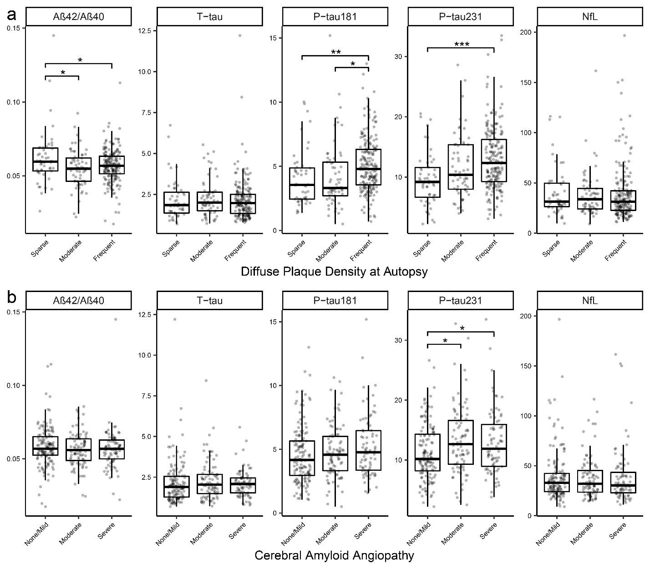

On-line resource Table 3. Statistical comparisons for plasma biomarkers in relation to diffuse amyloid plaques and amyloid angiopathy
- Diffuse Plaque Density
 | AB42/AB40 |  |  | T-tau |  |  | P-tau181 |  |  | P-tau231 |  |  | NfL
contrast | Estimate (SE) | Raw P value | Adj P  value | Estimate (SE) | Raw P value | Adj P  value | Estimate (SE) | Raw P value | Adj P  value | Estimate (SE) | Raw P value | Adj P  value | Estimate (SE) | Raw P value | Adj P  value
Sparse - Moderate | 0.0068 (0.0024) | 0.005 | 0.015 | -0.02 (0.24) | 0.941 | 0.997 | -0.17 (0.43) | 0.700 | 0.922 | -2.14 (0.98) | 0.031 | 0.078 | -9.4 (12.76) | 0.462 | 0.742
Sparse - Frequent | 0.0049 (0.002) | 0.017 | 0.044 | 0.04 (0.2) | 0.848 | 0.980 | -1.08 (0.36) | 0.003 | 0.008 | -3.49 (0.82) | 2.6 x 10⁻⁵ | 7.6 x 10⁻⁵ | 3.41 (10.69) | 0.75 | 0.945
Moderate - Frequent | -0.0019 (0.0019) | 0.299 | 0.552 | 0.06 (0.18) | 0.758 | 0.949 | -0.91 (0.33) | 0.006 | 0.015 | -1.36 (0.76) | 0.074 | 0.174 | 12.81 (9.71) | 0.188 | 0.385

- Cerebral Amyloid Angiopathy
 | AB42/AB40 |  |  | T-tau |  |  | P-tau181 |  |  | P-tau231 |  |  | NfL
contrast | Estimate (SE) | Raw P value | Adj P  value | Estimate (SE) | Raw P value | Adj P  value | Estimate (SE) | Raw P value | Adj P  value | Estimate (SE) | Raw P value | Adj P  value | Estimate (SE) | Raw P value | Adj P  value
None/Mild - Moderate | 0.0019 (0.0018) | 0.278 | 0.523 | -0.23 (0.17) | 0.184 | 0.378 | -0.22 (0.31) | 0.479 | 0.758 | -1.98 (0.72) | 0.007 | 0.018 | 4.08 (9.24) | 0.659 | 0.898
None/Mild - Severe | 0.0016 (0.0018) | 0.371 | 0.644 | -0.08 (0.18) | 0.637 | 0.884 | -0.69 (0.33) | 0.034 | 0.085 | -1.77 (0.75) | 0.018 | 0.048 | 2.22 (9.55) | 0.816 | 0.971
Moderate - Severe | -3e-04 (0.002) | 0.883 | 0.988 | 0.14 (0.19) | 0.460 | 0.74 | -0.47 (0.35) | 0.182 | 0.375 | 0.21 (0.82) | 0.799 | 0.965 | -1.85 (10.41) | 0.859 | 0.983

Effect sizes and both raw and multiple-comparisons adjusted p-values for pairwise comparisons of plasma biomarkers between pathologically-defined groups. Statistics are corrected for multiple comparisons using Tukey’s method to maintain a family error rate of 0.05, with values reaching this significance threshold bolded. A graphical representation of this data is available in Supplementary Figure 1, On-line Resource.

On line resource Table 4: Statistical comparisons of plasma biomarkers in groups defined by different staging approaches to ADNC
- CERAD Neuritic Plaque Density
 | AB42/AB40 |  |  |  |  |  | T-tau |  |  |  |  | P-tau181 |  |  |  |  |  | P-tau231 |  |  |  |  |  | NfL
contrast | Estimate (SE) |  |  | Raw P value | Adj P  value |  | Estimate (SE) |  | Raw P value | Adj P  value |  | Estimate (SE) |  | Raw P value |  | Adj P  value |  | Estimate (SE) |  | Raw P value |  | Adj P  value |  | Estimate (SE) |  | Raw P value | Adj P  value
Sparse - Moderate | 0.0064 (0.0023) |  |  | 0.005 | 0.014 |  | -0.1 (0.22) |  | 0.645 | 0.889 |  | -0.91 (0.39) |  | 0.021 |  | 0.054 |  | -3.25 (0.91) |  | 4.0 x 10⁻⁴ |  | 0.001 |  | -7.77 (11.92) |  | 0.515 | 0.792
Sparse - Frequent | 0.0054 (0.0022) |  |  | 0.018 | 0.046 |  | -0.3 (0.22) |  | 0.170 | 0.355 |  | -1.99 (0.39) |  | 6.1 x 10⁻⁷ |  | 1.8 x 10⁻⁶ |  | -4.14 (0.9) |  | 6.3 x 10⁻⁶ |  | 1.9 x 10⁻⁵ |  | 3.04 (11.83) |  | 0.797 | 0.964
Moderate - Frequent | -0.001 (0.0017) |  |  | 0.547 | 0.819 |  | -0.2 (0.17) |  | 0.227 | 0.448 |  | -1.07 (0.29) |  | 2.6 x 10⁻⁴ |  | 7.7 x 10⁻⁴ |  | -0.9 (0.69) |  | 0.192 |  | 0.393 |  | 10.81 (8.96) |  | 0.228 | 0.450
- Braak Stage
 | AB42/AB40 |  |  |  |  |  | T-tau |  |  |  |  | P-tau181 |  |  |  |  |  | P-tau231 |  |  |  |  |  | NfL
contrast | Estimate (SE) |  |  | Raw P value | Adj P  value |  | Estimate (SE) |  | Raw P value | Adj P  value |  | Estimate (SE) |  | Raw P value |  | Adj P  value |  | Estimate (SE) |  | Raw P value |  | Adj P  value |  | Estimate (SE) |  | Raw P value | Adj P  value
(0 - II) - (III - IV) | 9e-04 (0.0024) |  |  | 0.700 | 0.921 |  | 0.13 (0.23) |  | 0.576 | 0.841 |  | -0.55 (0.39) |  | 0.167 |  | 0.350 |  | -1.22 (0.92) |  | 0.185 |  | 0.380 |  | 15.83 (12.35) |  | 0.201 | 0.406
(0 - II) - (V - VI) | 0.0044 (0.0019) |  |  | 0.019 | 0.050 |  | -0.35 (0.18) |  | 0.061 | 0.146 |  | -1.98 (0.32) |  | 1.8 x 10⁻⁹ |  | 5.5 x 10⁻⁹ |  | -4.23 (0.74) |  | 2.6 x 10⁻⁸ |  | 7.7 x 10⁻⁸ |  | 13.46 (9.88) |  | 0.174 | 0.362
(III - IV) - (V - VI) | 0.0035 (0.0021) |  |  | 0.089 | 0.204 |  | -0.47 (0.2) |  | 0.018 | 0.047 |  | -1.43 (0.34) |  | 4.2 x 10⁻⁵ |  | 1.2 x 10⁻⁴ |  | -3.01 (0.81) |  | 2.5 x 10⁻⁴ |  | 6.9 x 10⁻⁴ |  | -2.36 (10.86) |  | 0.828 | 0.974
- NIA-Reagan Criteria for ADNC
 |  | AB42/AB40 |  |  |  |  |  | T-tau |  |  |  |  | P-tau181 |  |  |  |  |  | P-tau231 |  |  |  |  |  | NfL
contrast |  | Estimate (SE) | Raw P value |  |  | Adj P  value |  | Estimate (SE) | Raw P value |  | Adj P  value |  | Estimate (SE) |  | Raw P value |  | Adj P  value |  | Estimate (SE) |  | Raw P value |  | Adj P  value |  | Estimate (SE) | Raw P value | Adj P  value
Low ADNC - Intermediate ADNC |  | 0.0021 (0.0024) | 0.383 |  |  | 0.657 |  | 0.1 (0.23) | 0.677 |  | 0.909 |  | -0.4 (0.4) |  | 0.316 |  | 0.575 |  | -1.55 (0.93) |  | 0.096 |  | 0.219 |  | 14.83 (12.5) | 0.236 | 0.462
Low ADNC - High ADNC |  | 0.0048 (0.0018) | 0.008 |  |  | 0.022 |  | -0.37 (0.18) | 0.039 |  | 0.097 |  | -1.89 (0.31) |  | 2.6 x 10⁻⁹ |  | 7.8 x 10⁻⁹ |  | -4.28 (0.71) |  | 5.4 x 10⁻⁹ |  | 1.6 x 10⁻⁸ |  | 12.17 (9.55) | 0.203 | 0.410
Intermediate ADNC - High ADNC |  | 0.0028 (0.0022) | 0.206 |  |  | 0.414 |  | -0.46 (0.21) | 0.028 |  | 0.072 |  | -1.49 (0.36) |  | 5.0 x 10⁻⁵ |  | 1.5 x 10⁻⁴ |  | -2.73 (0.85) |  | 0.001 |  | 0.004 |  | -2.66 (11.4) | 0.816 | 0.970

Effect sizes and both raw and multiple-comparisons adjusted p-values for pairwise comparisons of plasma biomarkers between pathologically-defined groups. Statistics are corrected for multiple comparisons using Tukey’s method to maintain a family error rate of 0.05, with values reaching this significance threshold bolded. A graphical representation of this data is available in Figure 2.
On-line resource Table 5. Statistical comparisons for plasma biomarkers in relation to Hippocampal sclerosis (HS), Limbic Age-related TDP-43 Encephalopathy (LATE), Lewy Body Disease (LBD) and ADNC
- Hippocampal Sclerosis of Aging (HSA)
 | AB42/AB40 |  |  |  |  |  | T-tau |  |  |  |  | P-tau181 |  |  |  |  |  | P-tau231 |  |  |  |  |  | NfL
contrast | Estimate (SE) |  |  | Raw P value | Adj P  value |  | Estimate (SE) |  | Raw P value | Adj P  value |  | Estimate (SE) |  | Raw P value |  | Adj P  value |  | Estimate (SE) |  | Raw P value |  | Adj P  value |  | Estimate (SE) |  | Raw P value | Adj P  value
ADNC - (ADNC + HS) | -7e-04 (0.0025) |  |  | 0.776 | 0.956 |  | -0.15 (0.26) |  | 0.556 | 0.826 |  | 0.58 (0.46) |  | 0.210 |  | 0.421 |  | -0.11 (1.07) |  | 0.922 |  | 0.995 |  | -13.93 (5.26) |  | 0.018 | 0.050
ADNC - HS | -0.0038 (0.0028) |  |  | 0.173 | 0.360 |  | 0.15 (0.3) |  | 0.624 | 0.875 |  | 1.82 (0.5) |  | 3.6 x 10⁻⁴ |  | 0.001 |  | 3.33 (1.15) |  | 0.004 |  | 0.012 |  | -15.36 (4.43) |  | 0.001 | 0.002
(ADNC + HS) - HS | -0.0031 (0.0034) |  |  | 0.369 | 0.640 |  | 0.3 (0.36) |  | 0.409 | 0.686 |  | 1.24 (0.62) |  | 0.048 |  | 0.116 |  | 3.43 (1.44) |  | 0.018 |  | 0.048 |  | -2.83 (4.12) |  | 0.532 | 0.791
- Hippocampal TDP-43 Positivity (LATE)
 | AB42/AB40 |  |  |  |  |  | T-tau |  |  |  |  | P-tau181 |  |  |  |  |  | P-tau231 |  |  |  |  |  | NfL
contrast | Estimate (SE) |  |  | Raw P value | Adj P  value |  | Estimate (SE) |  | Raw P value | Adj P  value |  | Estimate (SE) |  | Raw P value |  | Adj P  value |  | Estimate (SE) |  | Raw P value |  | Adj P  value |  | Estimate (SE) |  | Raw P value | Adj P  value
ADNC - (ADNC + TDP-43) | -8e-04 (0.002) |  |  | 0.687 | 0.914 |  | 0.06 (0.33) |  | 0.862 | 0.983 |  | 0.48 (0.46) |  | 0.298 |  | 0.55 |  | -0.71 (1.04) |  | 0.495 |  | 0.773 |  | -2.22 (5.98) |  | 0.711 | 0.927
ADNC - (TDP-43) | -0.0016 (0.0026) |  |  | 0.549 | 0.819 |  | 0.3 (0.45) |  | 0.509 | 0.786 |  | 2.43 (0.59) |  | 7.5 x 10⁻⁵ |  | 0.0002 |  | 4.73 (1.3) |  | 4.1 x 10⁻⁴ |  | 0.001 |  | -7.09 (7.72) |  | 0.360 | 0.630
(ADNC + TDP-43) - (TDP-43) | -8e-04 (0.0029) |  |  | 0.795 | 0.963 |  | 0.24 (0.49) |  | 0.624 | 0.876 |  | 1.94 (0.66) |  | 0.004 |  | 0.011 |  | 5.44 (1.45) |  | 2.8 x 10⁻⁴ |  | 0.001 |  | -4.87 (8.56) |  | 0.571 | 0.837
- Lewy Body Disease (LBD)
 |  | AB42/AB40 |  |  |  |  |  | T-tau |  |  |  |  | P-tau181 |  |  |  |  |  | P-tau231 |  |  |  |  |  | NfL
contrast |  | Estimate (SE) | Raw P value |  |  | Adj P  value |  | Estimate (SE) | Raw P value |  | Adj P  value |  | Estimate (SE) |  | Raw P value |  | Adj P  value |  | Estimate (SE) |  | Raw P value |  | Adj P  value |  | Estimate (SE) | Raw P value | Adj P  value
ADNC - (ADNC + LBD) |  | 0.0011 (0.0023) | 0.65 |  |  | 0.893 |  | 0.19 (0.23) | 0.401 |  | 0.677 |  | -0.17 (0.4) |  | 0.679 |  | 0.910 |  | -0.23 (0.97) |  | 0.815 |  | 0.970 |  | 8.28 (3.97) | 0.038 | 0.095
ADNC - LBD |  | -0.0065 (0.0023) | 0.005 |  |  | 0.013 |  | 0.84 (0.23) | 3.4 x 10⁻⁴ |  | 0.001 |  | 1.33 (0.4) |  | 0.001 |  | 0.003 |  | 2.93 (0.94) |  | 0.002 |  | 0.006 |  | 11.51 (3.88) | 0.003 | 0.009
(ADNC + LBD) - LBD |  | -0.0075 (0.0028) | 0.009 |  |  | 0.024 |  | 0.66 (0.28) | 0.022 |  | 0.056 |  | 1.49 (0.5) |  | 0.003 |  | 0.009 |  | 3.16 (1.19) |  | 0.009 |  | 0.023 |  | 3.23 (4.87) | 0.508 | 0.785

Effect sizes and both raw and multiple-comparisons adjusted p-values for pairwise comparisons of plasma biomarkers between pathologically-defined groups. Statistics are corrected for multiple comparisons using Tukey’s method to maintain a family error rate of 0.05, with values reaching this significance threshold bolded. A graphical representation of this data is available in Figure 3.

On-line Resource Table 6. Cohorts with LATE-NC staged as present or absent in the hippocampus using TDP43 immunohistochemistry
variable | ADNC | ADNC + TDP-43 | TDP-43
n | 73 | 29 | 14
Age at Baseline | 74.7 ± 9.6 | 80.1 ± 5 | 80.3 ± 10.6
Age at Last Plasma | 77.4 ± 10.3 | 83 ± 5.2 | 82.5 ± 10.3
Age at Death | 79.8 ± 10.2 | 85.6 ± 5.5 | 84.5 ± 9.9
Last Plasma - Death (years) | 2.4 ± 1.2 | 2.6 ± 1.5 | 2 ± 1.1
Female | 30 (41%) | 7 (24%) | 5 (36%)
Hispanic | 4 (5%) | 1 (4%) | 1 (7%)
EDUC | 14.9 ± 3.4 | 16.2 ± 2 | 14.4 ± 3.5
APOE 0 e4 alleles | 33 (45%) | 10 (34%) | 9 (64%)
APOE 1 e4 allele | 30 (41%) | 18 (62%) | 4 (29%)
APOE 2 e4 alleles | 10 (14%) | 1 (3%) | 1 (7%)
Baseline MMSE | 22.3 ± 5.9 | 21.4 ± 5.4 | 20.9 ± 6.7
Baseline DRS | 109.5 ± 25.8 | 111.6 ± 16.9 | 109.1 ± 22.4
Baseline CDR-sob | 6.5 ± 4 | 6.1 ± 3.2 | 6 ± 5.2
Final MMSE | 15.6 ± 7.1 | 17.1 ± 6.2 | 19.1 ± 5.5
Final DRS | 86.5 ± 29.8 | 93.4 ± 23.9 | 97.6 ± 25.4
Final CDR-sob | 11.2 ± 4.5 | 10.4 ± 4.3 | 8.4 ± 5.8
Final Clinical DX: Normal | 1 (1%) | 0 (0%) | 0 (0%)
Final Clinical DX: MCI | 1 (1%) | 1 (3%) | 1 (7%)
Final Clinical Dx: AD | 63 (86%) | 26 (90%) | 10 (71%)
Final Clinical DX: DLB/PDD | 6 (8%) | 2 (7%) | 3 (21%)
Final Clinical DX: FTLD | 1 (1%) | 0 (0%) | 0 (0%)
Final Clinical DX: Other | 1 (1%) | 0 (0%) | 0 (0%)
# Blood Samples | 2.6 ± 1.5 | 2.4 ± 1.1 | 2.1 ± 1.5
# Clinical Visits | 4.6 ± 2.3 | 5.3 ± 2.3 | 6 ± 2.9
Final Plasma Aβ42 | 12.1 ± 4 | 12.3 ± 2.9 | 12.8 ± 3.3
Final Plasma Aβ40 | 223.1 ± 59.2 | 221.4 ± 57.9 | 229.2 ± 60.7
Final Plasma Aβ42/Aβ40 | 0.055 ± 0.009 | 0.057 ± 0.008 | 0.057 ± 0.008
Final Plasma T-tau | 2.4 ± 1.5 | 2.2 ± 1.4 | 2.2 ± 1.3
Final Plasma P-tau181 | 5.5 ± 2.2 | 5.1 ± 1.7 | 3.2 ± 1.2
Final Plasma P-tau231 | 13.5 ± 4.4 | 14.4 ± 4.6 | 8.9 ± 2.7
Final Plasma NfL | 38.2 ± 24.8 | 41.8 ± 26.6 | 49.5 ± 37.3

On-line resource Figure 2. Longitudinal changes of plasma biomarkers in relation to ADNC without concomitant pathologies
Longitudinal progression in biomarkers in the 10 years prior to death in study participants divided by their degree of ADNC after excluding concomitant neuropathologies including FTLD, HS, LBD, and other significant pathologies. Horizontal dashed lines represent the thresholds derived from ROC analyses presented in Figure 4. Thick lines represent predictions of the trajectories of the biomarkers for an demographically average participant, derived from mixed effects models with covariates added for age, sex, interval from last visit to death, as well as each variable’s interaction with time. All models included random intercepts and slopes by participant.

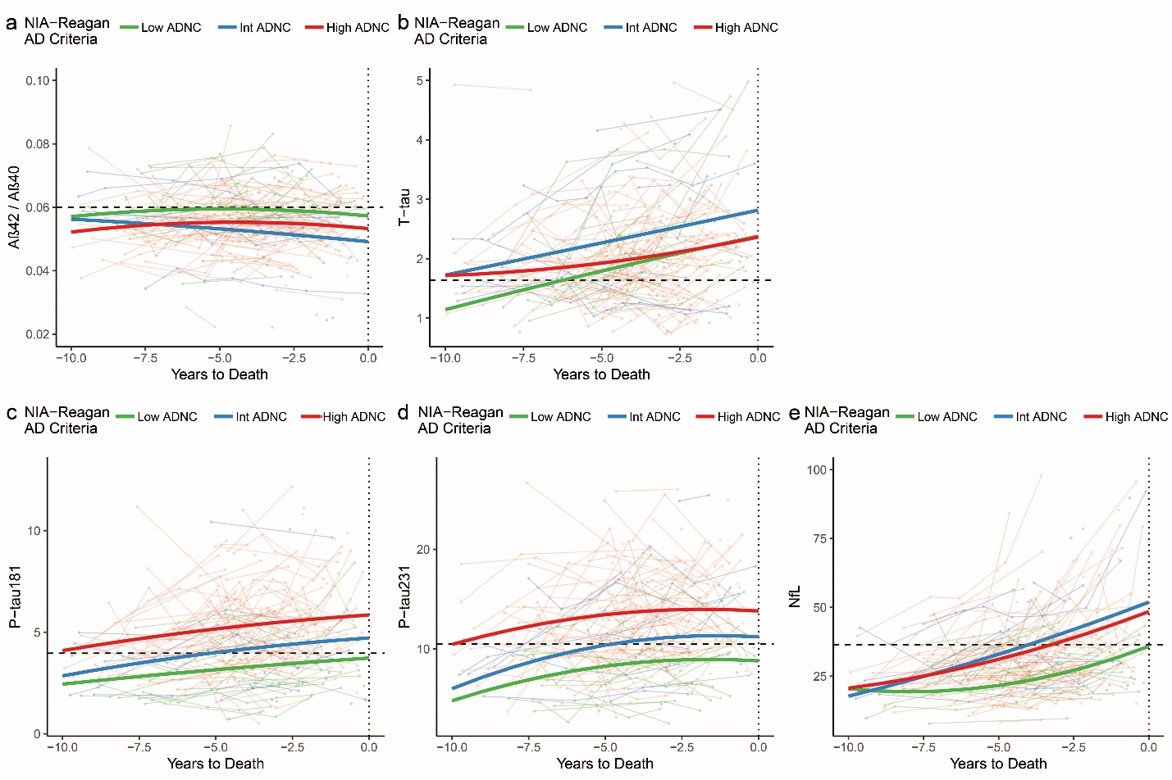
On-line Resource Figure 3: ROC analyses of a subset of cases with concurrent structural T1-weighted MRI.
ROC curves and associated thresholds, specificities, sensitivities, and areas under the curve (AUCs) for the use of each plasma biomarker, structural MRI measure, or their combination to distinguish patients who were classified as high ADNC at autopsy vs those that were not in a subset of 76 individuals with structural T1-weighted MRI obtained within 2 years of the plasma biomarker measurement. The average hippocampal volume was corrected for the estimated total intracranial volume (eTIV). When compared to the AUCs of the single variable curves using DeLong’s test, Model 1 (combining entorhinal thickness and P-tau181) performed better than entorhinal thickness alone (p=0.004), but comparable to P-tau181 alone (p=0.37).
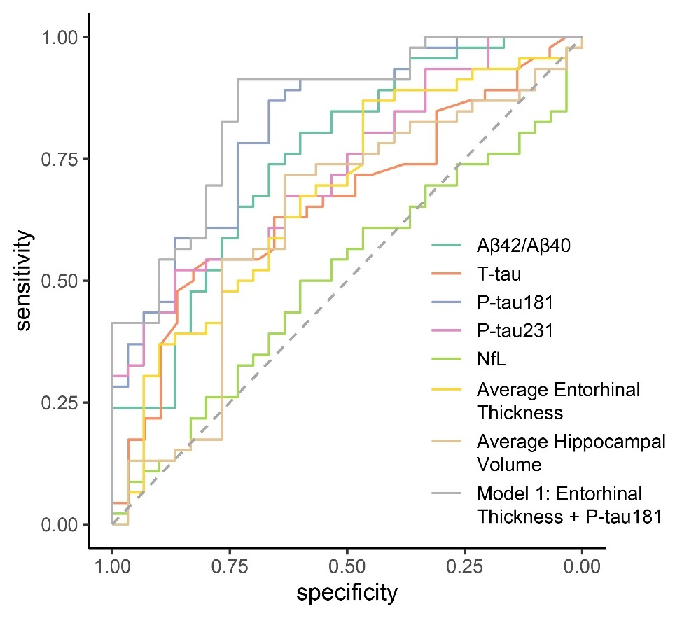
 | threshold | specificity | sensitivity | AUC
Aβ42/Aβ40 | 0.0583 | 0.6667 | 0.7391 | 0.7507
T-tau | 1.9650 | 0.8276 | 0.5217 | 0.6623
P-tau181 | 3.3042 | 0.6667 | 0.8696 | 0.8203
P-tau231 | 13.4179 | 0.8667 | 0.5217 | 0.7290
NfL | 28.6823 | 0.6000 | 0.5000 | 0.5058
Average Entorhinal Thickness | 3.0913 | 0.4667 | 0.8696 | 0.6772
Average Hippocampal Volume (eTIV corrected) | 2.0637 | 0.6333 | 0.7174 | 0.6261
Model 1: Entorhinal Thickness + P-tau181 | 0.4651 | 0.7333 | 0.9130 | 0.8493

