Supplementary Figures
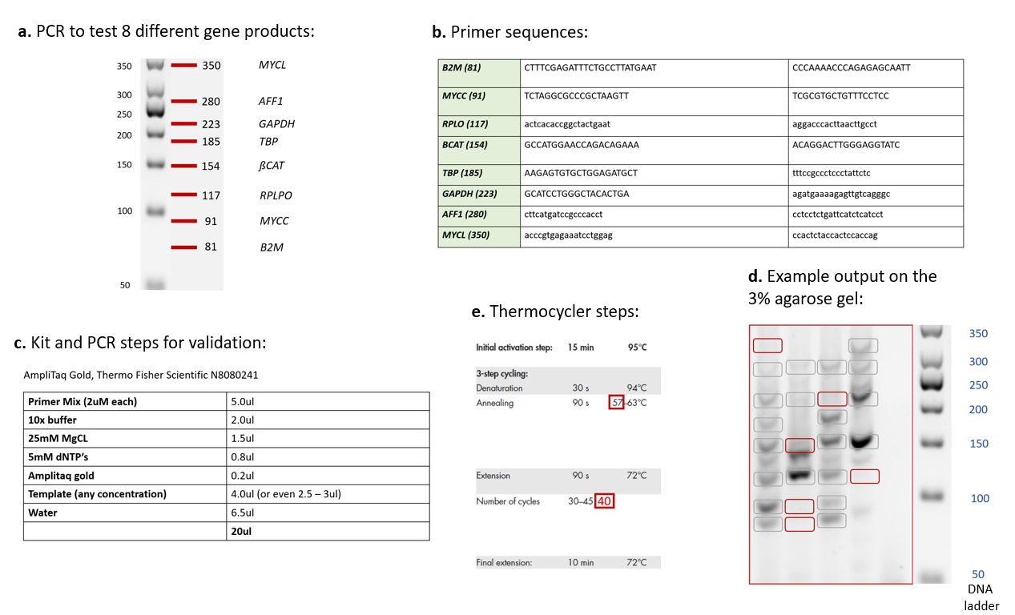
Supplementary Methods Fig. 1
Supplementary Methods Figure 1: Single-cell DNA quality control assessment protocol. Figure shows the steps of the quality control protocol. a) 8 key gene products of different size were selected for PCR validation. b) Primers for these products were designed and validated in the laboratory. c) PCR kit applied and components of the reaction. d) PCR reaction steps. e) An output example on an agarose gel. Grey boxes highlight the presence of the expected product, red boxes indicate that the expected product is absent.

Supplementary Fig. 1.
Supplementary Fig. 1: Bulk tumour copy number dataset 1 for each patient. Panels summarize the CNVs detected in each patient using DNA methylation arrays.

Supplementary Fig. 2.

Supplementary Fig. 2: Bulk tumour copy number dataset 2 for each patient. Panels summarize the CNVs detected in each patient using WES.

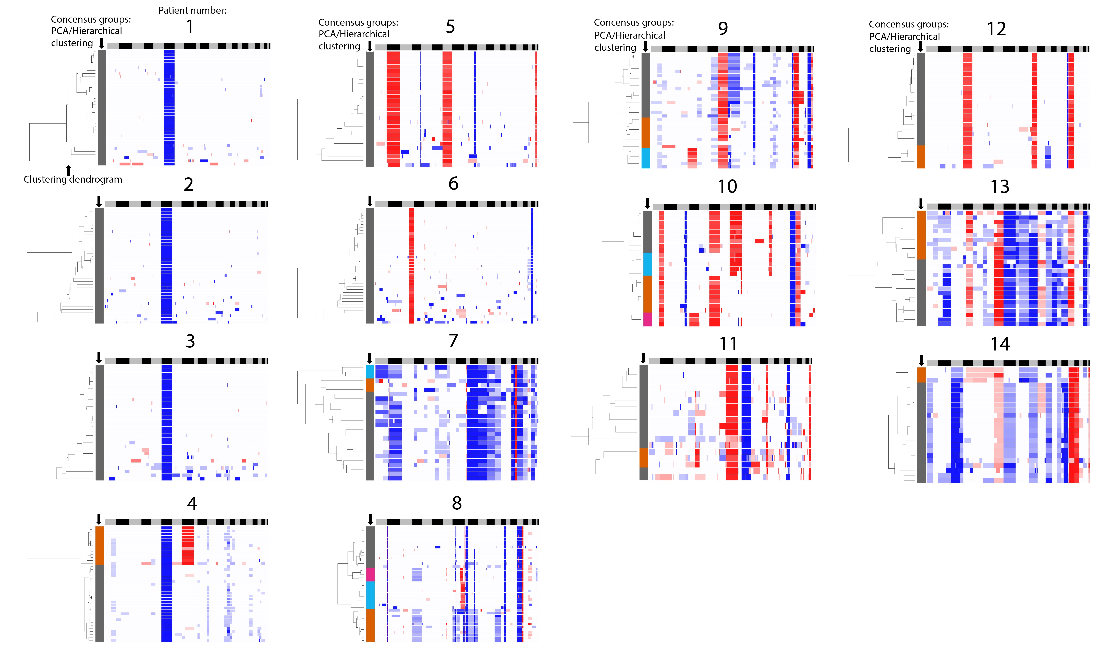
Supplementary Fig. 3.

Supplementary Fig. 3: Hierarchical clustering heatmaps with dendrograms. Panels summarize the consensus clusters based on PCA and Euclidean distances clustering.

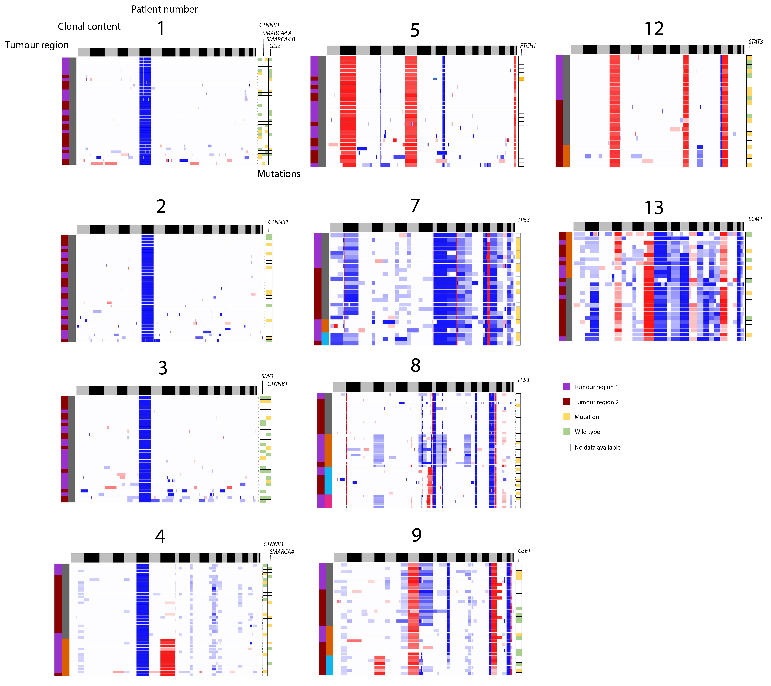
Supplementary Fig. 4.
Supplementary Fig. 4: Mutation validation in the dissected clones and two tumour regions samples. Figures summarize the information on mutations validated by Sanger sequencing in two regions of the tumour. Pink-purple and grey/orange/blue/pink columns on the left summarize the spatial origin (tumour region 1 or 2) and clonal content of individual cells, respectively. Each column on the right corresponds to a mutation, each square summarizes the status of a following mutation in a single cell. See key for colour affiliations.

