IL-10-providing B cells govern pro-inflammatory activity of macrophages and microglia in CNS autoimmunity
Anastasia Geladaris^{1,2#}, Silke Häusser-Kinzel^{1#}, Roxanne Pretzsch^{1,3}, Nitzan Nissimov^{1,4}, Klaus Lehmann-Horn⁵, Darius Häusler^{1,2#}, Martin S. Weber^{1,2,3#*}
¹Institute of Neuropathology, University Medical Centre, Göttingen, Germany; ²Fraunhofer-Institute for Translational Medicine and Pharmacology ITMP, Göttingen, Germany; ³Department of Neurology, University Medical Centre, Göttingen, Germany; ⁴Department of Neurosurgery, Charité-Universitätsmedizin Berlin Corporate Member of Freie Universität Berlin and Humboldt-Universität zu Berlin, Germany; ⁵Department of Neurology, School of Medicine, Technical University of Munich, Germany;
# Anastasia Geladaris and Silke Häusser-Kinzel are co-first, Darius Häusler and Martin S. Weber are co-last authors.

*Address correspondence to: Martin S. Weber, MD
Department of Neuropathology
Department of Neurology
University Medical Center, Georg August University
Robert-Koch-Str. 40, 37099 Göttingen, Germany
Phone +49-551 39-7706
Fax +49-551-39-10800
E-mail: martin.weber@med.uni-goettingen.de

Supplementary figures

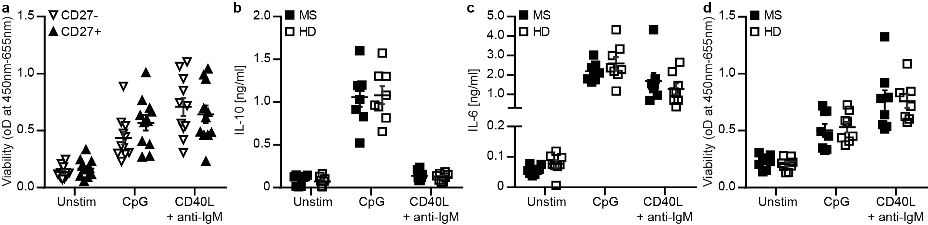
Supplementary Fig. 1: B cells isolated from patients with MS and healthy controls secrete comparable amounts of IL-10 and IL-6. a) CD27⁻ and CD27⁺ B cells isolated from peripheral blood mononuclear cells (PBMC) of healthy donors (n = 11) were cultured without stimulation (unstim), stimulated with CpG (4 µg/ml) or stimulated with CD40 ligand (CD40L; 1 µg/ml) and anti-IgM antibody (40 µg/ml) for 48 hours. Viability of the cells was determined using colorimetric WST-1 assay. b-d) B cells isolated from PBMC of patients with multiple sclerosis (MS; n = 8) and healthy donors (HD; n = 11) were cultured without stimulation (unstim), stimulated with CpG (4 µg/ml) or stimulated with CD40 ligand (CD40L; 1 µg/ml) and anti-IgM antibody (40 µg/ml) for 48 hours. Concentrations of secreted b) IL-10 and c) IL-6 were determined using ELISA and d) viability using colorimetric WST-1 assay. The mean ± standard error of the mean is indicated in all graphs.
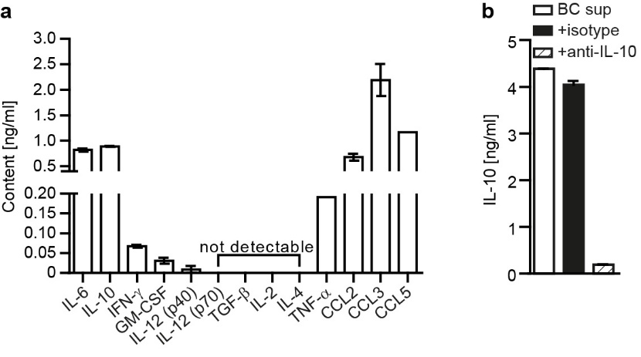 | Supplementary Fig. 2: B cell cytokine profile and neutralization of IL-10 via anti-IL-10 antibodies. Splenic B cells were isolated from C57BL/6J mice, stimulated with 5 µg/ml lipopolysaccharide and supernatants were collected after a) 24 or b) 48 hours. a) Indicated cytokines in the supernatant were determined using ELISA (n = 2) b) IL-10-neutralizing (anti-IL-10) or isotype control antibodies were added to the B cell supernatant for 20 minutes and IL-10 concentration was determined via ELISA. All data are shown as mean ± standard error of the mean.

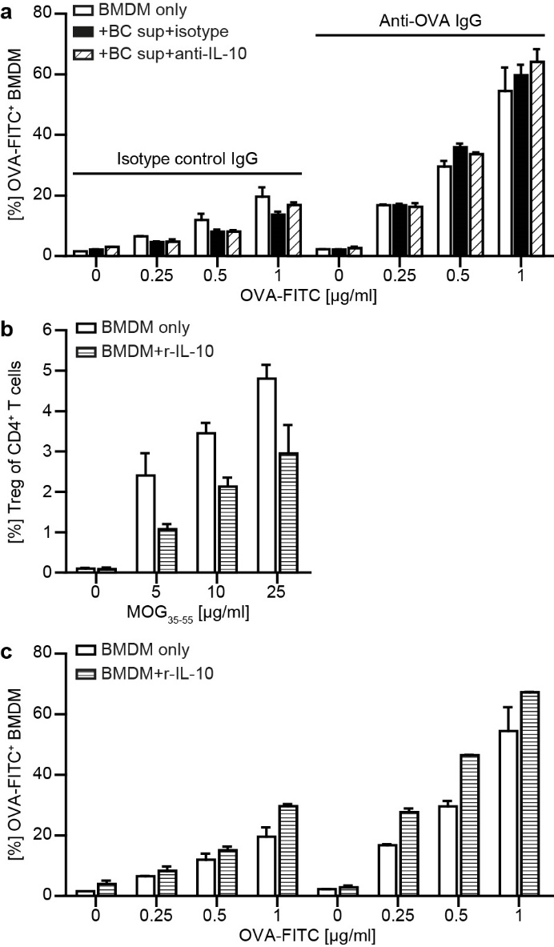 | Supplementary 3: IL-10 exposure of BMDM neither influences opsonization-mediated phagocytosis nor development of regulatory T cells. Activated bone marrow-derived myeloid cells (BMDM) were either cultured alone (BMDM only), a) with B cell supernatant (+BC sup+isotype), B cell supernatant neutralized for IL-10 using IL-10 blocking antibodies (+BC sup+anti-IL-10) or b, c) with 1 ng/ml recombinant (r)-IL-10 (BMDM+r-IL-10) for 48 hours. a, c) Following pre-incubation with BC sup or r-IL-10, BMDM were cultured with FITC-labelled ovalbumin (OVA-FITC) in the presence of anti-OVA antibody or an isotype control antibody (IgG) for 2.5 hours. Frequency of phagocytosing OVA-FITC⁺ cells (n = 2 wells/condition) was analysed via flow cytometry. b) After pre-incubation with r-IL-10, BMDM were co-cultured with carboxyfluorescein succinimidyl ester (CFSE)-stained MOG-specific T cells isolated from 2D2 mice in the presence of MOG peptide 35-55 for 72 hours. Frequency of CD25⁺ FoxP3⁺ regulatory T cells (Treg; n = 4 wells/condition) within CD4⁺ cells assessed via flow cytometry. All data are shown as mean ± standard error of the mean.

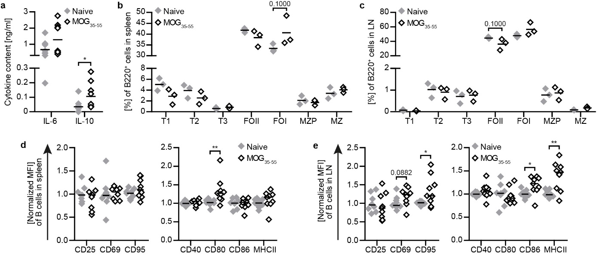
Supplementary Fig. 4: MOG p35-55 immunization increases IL-10 production by B cells. Naïve C57BL/6J mice or mice immunized with MOG peptide 35-55 (MOG₃₅₋₅₅) were analysed on day 10 post-immunization. a) Splenic B cells were purified and stimulated with LPS [5 µg/ml] for 24 hours. Cytokine concentrations in the supernatants were determined via ELISA (n = 9; pooled from three independent experiments). B cells (B220⁺) from b) spleen and c) lymph nodes were categorized into transitional (T1: B220⁺CD93⁺IgM⁺; T2: B220⁺CD93⁺IgM⁺CD23⁺; T3: B220⁺CD93⁺CD23⁺), follicular (FOI: B220⁺CD19⁺IgD⁺; FOII: B220⁺CD19⁺IgD⁺IgM⁺), marginal zone precursor (MZP: B220⁺CD19⁺CD21⁺IgM⁺IgD⁺CD23⁺) and marginal zone (MZ: B220⁺CD19⁺CD21⁺IgM⁺IgD⁺) cells. Mean B cells from d) spleen and e) lymph nodes were analysed for activation and expression of molecules involved in antigen presentation shown as mean fluorescence intensity (MFI) using flow cytometry (n = 9; pooled from three independent experiments). The median is indicated in all graphs. Asterisks indicate significant difference calculated using the unpaired two-tailed Mann Whitney U-test (*P ≤ 0.05, **P ≤ 0.01).
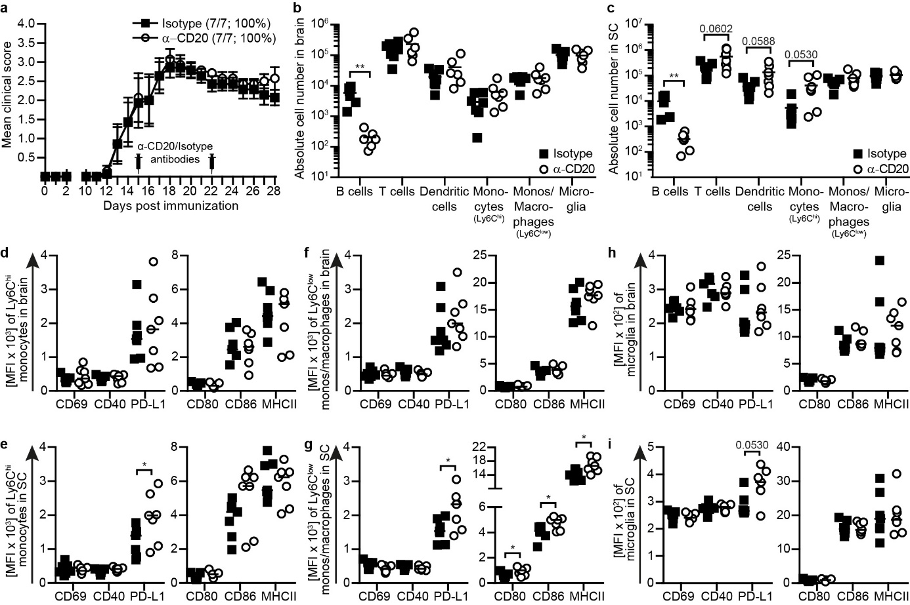
Supplementary data Fig. 5: Depletion of B cells during the acute phase of the disease is associated with increased spinal cord infiltration, enhanced activation and expression of molecules involved in antigen presentation on myeloid cells. C57BL/6 mice were treated with 0.2 mg anti-CD20 (α-CD20) or isotype antibodies on day 15 and 22 post immunization with MOG peptide 35-55. a) Group EAE score and disease incidence indicated in brackets (n = 7). Composition of CNS-infiltrating cells (B cells: CD19⁺CD20⁺, T cells: CD3⁺, dendritic cells: CD11c⁺, monocytes (monos; Ly6C^{hi}): CD11b⁺CD45^{hi}Ly6C^{hi}, monos/macrophages (Ly6C^{low}): CD11b⁺CD45^{hi}Ly6C⁻, microglia: CD11b⁺CD45^{low}Ly6C⁻) was analysed by flow cytometry in b) brain and c) spinal cord (SC) by flow cytometry (n = 6-7). d, e) Monocytes (Ly6C^{hi}; CD11b⁺CD45^{hi}Ly6C^{hi}), f, g) monos/macrophages (Ly6C^{low}; CD11b⁺CD45^{hi}Ly6C⁻) and h, i) microglia (CD11b⁺CD45^{low}Ly6C⁻) were isolated from d, f, h) brain or e, g, i) spinal cord (SC). Activation and expression of molecules involved in antigen presentation were analysed by flow cytometry are shown as mean fluorescence intensity (MFI; n = 7). In the graphs, a) mean ± standard error of the mean or b-i) median are indicated. Data sets are representative of two independent experiments. Asterisks indicate significant difference calculated using the unpaired two-tailed Mann Whitney U-test (*P ≤ 0.05, **P ≤ 0.01).
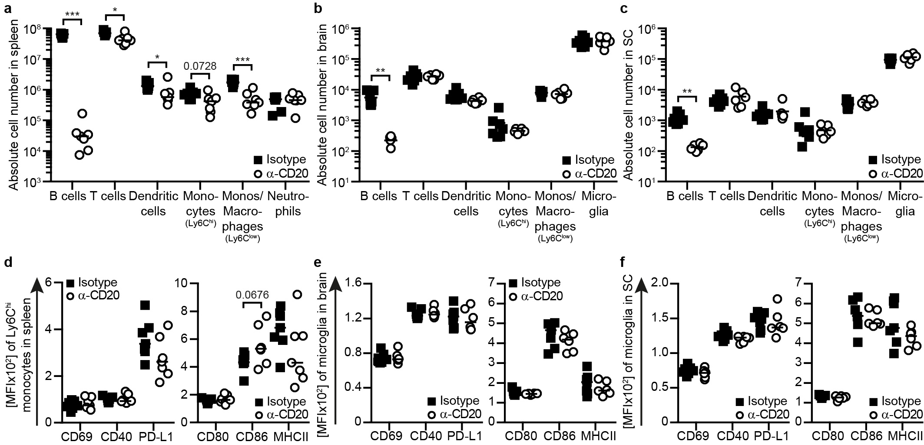
Supplementary Fig. 6: B cell depletion has no effect on microglia cells in naïve mice. Mice were treated weekly with 0.2 mg anti-CD20 (α-CD20) or isotype control antibodies for five consecutive weeks. Composition of immune cells in a) spleen (B cells: CD19⁺CD20⁺, T cells: CD3⁺, dendritic cells: CD11c⁺, monocytes (monos; Ly6C^{hi}): CD11b⁺CD45^{hi}Ly6C^{hi}, monos/macrophages (Ly6C^{low}): CD11b⁺CD45^{hi}Ly6C⁻ , neutrophils: CD11b⁺CD45^{hi}Ly6G⁺Ly6C^{int}), b) brain and c) spinal cord (SC; B cells: CD19⁺CD20⁺, T cells: CD3⁺, dendritic cells: CD11c⁺, monocytes (monos; Ly6C^{hi}): CD11b⁺CD45^{hi}Ly6C^{hi}, monos/macrophages (Ly6C^{low}): CD11b⁺CD45^{hi}Ly6C⁻, microglia: CD11b⁺CD45^{low}Ly6C⁻) were analysed by flow cytometry (n = 6-7). d) Ly6C^{hi} monocytes were isolated from spleen and microglia (CD11b⁺CD45^{low}Ly6C⁻) were isolated from e) brain and f) spinal cord (SC). Activation and expression of molecules involved in antigen presentation were analysed by flow cytometry and are shown mean fluorescence intensity (MFI; n = 6-7). The median is indicated in all graphs. Data sets are representative of two independent experiments. Asterisks indicate significant difference calculated using the unpaired two-tailed Mann Whitney U-test (*P ≤ 0.05, **P ≤ 0.01, ***P ≤ 0.001).

Supplementary table 1: Characteristics of subjects enrolled in studies on B cells
 | HC (Fig. 1a, b) | MS vs. HC (Extended data fig. 1b-d)
 | HC (n = 11) | HC (n = 8) | MS (n = 8)
Age Mean ± SD | 27 ± 5.73 | 45 ± 15.09 | 45 ± 16.87
Female/male | 10/1 | 4/4 | 4/4
Time since diagnosis [months]; mean ± SD | n.a. | n.a. | 77.14 ± 75.71
EDSS, mean ± SD | n.a. | n.a. | 2.86 ± 1.49
Clinical course of MS [number]
RR-MS | n.a. | n.a. | 5
SP-MS | n.a. | n.a. | 1
PP-MS | n.a. | n.a. | 2
Treatment
Corticosteroids (within last 2 months) | n.a. | n.a. | RR-MS: 2
Glatiramer acetate (> 7 days, within last 2 months) | n.a. | n.a. | RR-MS: 2
no treatment for > 1 year | n.a. | n.a. | RR-MS:1  SP-MS: 1  PP-MS: 2
HC = healthy control; MS = multiple sclerosis; SD = standard deviation; n. a. = not applicable; EDSS = Expanded Disability Status Scale; RR = relapsing-remitting; SP = secondary progressive; PP = primary progressive; DMD = disease modifying drug

Supplementary table 2: Characteristics of patients enrolled in studies on CD14⁺ cells (Figure 1c-e)
 | Flow cytometry (n = 14) | ELISpot (n = 17)
Age [years]; mean ± SD | 34.71 ± 8.30 | 36.00 ± 10.20
Time since diagnosis [years]; mean ± SD | 8.86 ± 7.77 | 10.57 ± 9.15
Female/male | 7/7 | 9/8
EDSS; mean ± SD | 3.3 ± 2.01 | 3.5 ± 1.85
Clinical course of MS [number]
RR-MS | 12 | 14
SP-MS | 1 | 2
CIS | 1 | 1
Last treatment before rituximab
Azathioprine | RR-MS: 1 | RR-MS: 1
Dimethyl fumarate | RR-MS: 2 | RR-MS: 2
Fingolimod | RR-MS: 6 | RR-MS: 6
Glatiramer acetate | RR-MS: 1 | RR-MS: 1
Natalizumab | RR-MS: 1  SP-MS: 1 | RR-MS: 1  SP-MS: 1
no treatment | RR-MS: 1  CIS: 1 | RR-MS: 3  SP-MS: 1  CIS: 1
SD = standard deviation; EDSS = Expanded Disability Status Scale; MS = multiple sclerosis; RR = relapsing-remitting; SP = secondary progressive; CIS = clinically isolated syndrome

