Supplementary Information S1: Guide RNA targeting MBP

Supplementary Information S2: Pyrosequencing primer list
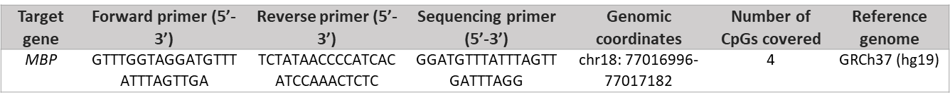

Supplementary Information S3: qPCR primer list
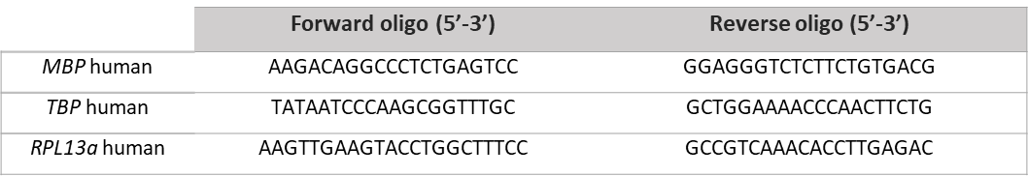

Supplementary Information S4: Antibody list
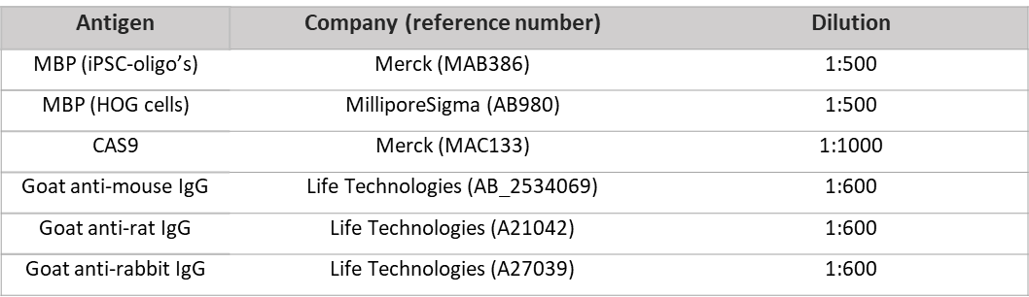

Supplementary Information S5: Predicted off-target sites of the sgRNA
