Last BMI
Status (n) | <18.5 | 18.5-24.9 | 25.0-29.9 | 30.0-34.9 | 35.0-39.9 | M | SD
CON (9) | 2 | 6 | 1 | 0 | 0 | 21.5 | 3.4
MCI Sparse (10) | 0 | 4 | 6 | 1 | 0 | 25.3 | 3.9
MCI High (12) | 2 | 5 | 4 | 1 | 0 | 23.5 | 3.9

Diagnosis Age
Status (n) | 70-74 | 75-79 | 80-84 | 85-89 | ≥90 | M | SD
CON (0)
MCI Sparse (3) | 0 | 0 | 2 | 1 | 0 | 84.0 | 3.0
MCI High (8) | 1 | 0 | 0 | 3 | 4 | 86.3 | 6.1

Years Since Diagnosis
Status (n) | 1 | 2 | 3 | 4 | 5 | M | SD
CON (0)
MCI Sparse (5) | 3 | 2 | 0 | 0 | 0 | 1.4 | 0.5
MCI High (10) | 3 | 2 | 2 | 1 | 2 | 2.7 | 1.6

 | Expired Age
Status (n) |  | 50-69 | 70-74 | 75-79 | 80-84 | 85-89 | ≥90 | M | SD
CON (10) |  | 1 | 1 | 2 | 4 | 1 | 1
MCI Sparse (10) |  | 0 | 0 | 1 | 3 | 2 | 4
MCI High (12) |  | 0 | 0 | 1 | 1 | 1 | 6

Postmortem Interval (hours)
Status (n) | 1-3 | 4-6 | 7-9 | M | SD
CON (10) | 8 | 2 | 0 | 3.2 | 0.7
MCI Sparse (10) | 6 | 4 | 0 | 3.2 | 1.1
MCI High (12) | 5 | 6 | 1 | 4.1 | 1.2

Final MMSE |  |  |  |  |  |  |  |  | Months Since Last MMSE
Status (n) | >25 | 20-24 | 15-19 | 10-14 | 5-9 | 0-4 | M | SD | M | SD
CON (7) | 7 | 0 | 0 | 0 | 0 | 0 | 28.3 | 1.8 | 19.6 | 19.3
MCI Sparse (10) | 9 | 1 | 0 | 0 | 0 | 0 | 27.0 | 3.2 | 16.1 | 8.5
MCI High (12) | 10 | 2 | 0 | 0 | 0 | 0 | 26.6 | 2.4 | 16.4 | 13.4

APOE Status
Status (n) | 2/2 | 2/3 | 3/3 | 3/4 | 4/4
CON (9) | 0 | 0 | 8 | 1 | 0
MCI Sparse (10) | 1 | 2 | 3 | 3 | 0
MCI High (12) | 0 | 3 | 7 | 2 | 0

Braak staging
Status (n) | I | II | III | IV | V
CON (10) | 2 | 3 | 5 | 0 | 0
MCI Sparse (10) | 0 | 4 | 6 | 0 | 0
MCI High (12) | 0 | 0 | 0 | 11 | 1

CERAD neuritic plaque density
Status (n) | Zero | Sparse | Moderate | Frequent
CON (10) | 4 | 6 | 0 | 0
MCI Sparse (10) | 4 | 4 | 2 | 0
MCI High (12) | 0 | 0 | 0 | 12

Cerebral Amyloid Angiopathy (CAA) Status
Status (n) | Yes | No
CON (10) | 4 | 6
MCI Sparse (10) | 6 | 4
MCI High (12) | 9 | 3

Cerebral white matter rarefaction (CWMR)
Status (n) | Yes | No
CON (10) | 5 | 5
MCI Sparse (10) | 4 | 6
MCI High (12) | 11 | 1

TDP-43 Pathology
Status (n) | Yes | No | Undiagnosed
CON (5) | 0 | 3 | 2
MCI Sparse (8) | 6 | 2 | 0
MCI High (10) | 2 | 3 | 5

Brain Weight (grams)
Status (n) | M | SEM | Range
CON (10) | 1210 | 29.4 | 1002-1456
MCI Sparse (10) | 1186 | 92.9 | 1060-1360
MCI High (12) | 1155 | 112.4 | 928-1340

NIA-Reagan Diagnosis
Status (n) | No AD | Low | Intermediate | High
CON (10) | 10 | 0 | 0 | 0
MCI Sparse (10) | 10 | 0 | 0 | 0
MCI High (12) | 9 | 0 | 3 | 0

Supplementary Table 1: MCI Human characteristic profiles.

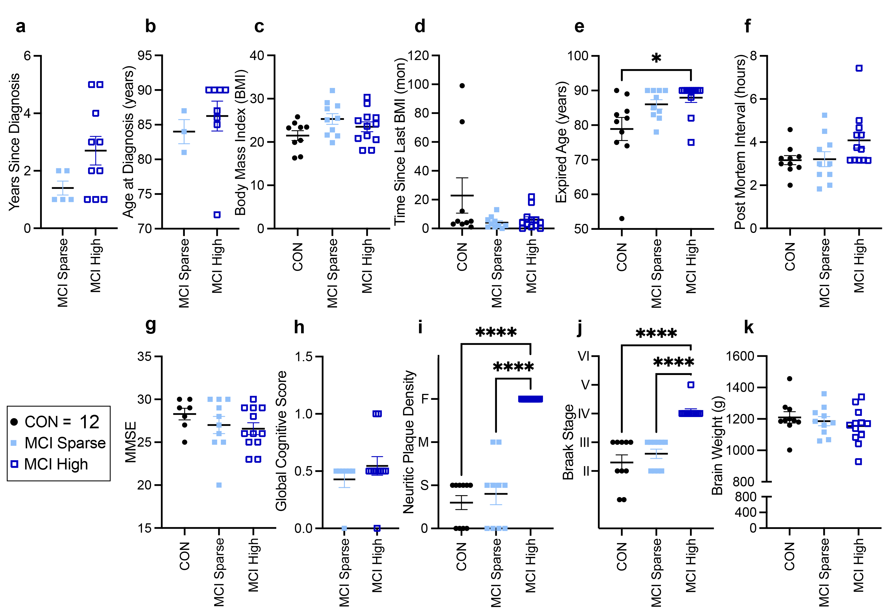
Supplemental Figure 1: Graphical representation of human MCI subject profiles. Healthy controls (n = 10), MCI with sparse pathology (MCI Sparse; sparse CERAD neuritic plaque density and Braak stage = II - III; n = 10), MCI with high pathology (MCI High; frequent CERAD neuritic plaque density and Braak stage = IV - V; n = 12). Comparison of the groups (a) years since diagnosis, (b) age at diagnosis, (c) BMI, (d) time since last BMI measurement, (e) expired age, (f) PMI, and (g) MMSE, and (h) Global cognitive score. Subjects differed from each other according to diagnosis on (i) neuritic plaque density. 0=Zero, S=Sparse, M=Moderate, F=Frequent, and (j) Braak stage, but not (k) brain weight. Data are reported as means ± SEM. *p<0.05, ****p<0.0001.

Last BMI
Status (n) | <18.5 | 18.5-24.9 | 25.0-29.9 | 30.0-34.9 | 35.0-39.9 | >40 | M | SD
CON (8) | 0 | 7 | 2 | 1 | 0 | 0 | 23.62 | 4.05
AD Mod (10) | 2 | 3 | 2 | 1 | 1 | 1 | 26.25 | 8.79
AD Sev (11) | 1 | 7 | 2 | 1 | 0 | 0 | 24.23 | 3.45

Diagnosis Age
Status (n) | 65-69 | 70-74 | 75-79 | 80-84 | 85-89 | ≥90 | M | SD
CON (1)* | 0 | 0 | 0 | 1 | 0 | 0
AD Mod (12) | 1 | 2 | 2 | 1 | 6 | 1 | 80.83 | 8.01
AD Sev (12) | 1 | 3 | 4 | 3 | 1 | 0 | 77.17 | 1.61

Years Since Diagnosis
Status (n) | 1-2 | 3-5 | 6-8 | 9-11 | 12-14 | 15-17 | M | SD
CON (1)* | 1 | 0 | 0 | 0 | 0 | 0
AD Mod (12) | 1 | 5 | 4 | 0 | 1 | 1 | 6.5 | 4.36
AD Sev (12) | 1 | 1 | 6 | 2 | 0 | 2 | 8.25 | 3.81

Expired Age
Status (n) | 70-74 | 75-79 | 80-84 | 85-89 | ≥90 |  | M | SD
CON (12) | 1 | 1 | 2 | 3 | 5 |  | 85 | 6.61
AD Mod (12) | 0 | 2 | 1 | 4 | 5 |  | 86.17 | 4.97
AD Sev (12) | 0 | 2 | 3 | 5 | 2 |  | 84.75 | 4.21

Postmortem Interval (hours)
Status (n) | 1-3 | 4-6 | 7-9 | 10-12 | 13-15 | 16-18 | M | SD
CON (12) | 10 | 2 | 0 | 0 | 0 | 0 | 2.87 | 1.26
AD Mod (12) | 9 | 0 | 2 | 0 | 1 | 0 | 4.56 | 3.7
AD Sev (12) | 9 | 2 | 0 | 0 | 0 | 1 | 3.92 | 4.04

Final MMSE |  |  |  |  |  |  |  |  | Months Since Last MMSE
Status (n) | >25 | 20-24 | 15-19 | 10-14 | 5-9 | 0-4 | M | SD | M | SD
CON (8) | 8 | 0 | 0 | 0 | 0 | 0 | 28.5 | 1.6 | 20.4 | 17.3
AD Mod (11) | 3 | 2 | 4 | 1 | 0 | 0 | 21.37 | 5.87 | 19.6 | 13.7
AD Sev (11) | 1 | 1 | 1 | 3 | 1 | 3 | 11.8 | 3.45 | 29.9 | 35.1

APOE Status
Status (n) | 2/2 | 2/3 | 3/3 | 3/4 | 4/4
CON (12) | 1 | 2 | 6 | 2 | 1
AD Mod (12) | 0 | 2 | 6 | 4 | 0
AD Sev (11) | 0 | 1 | 4 | 4 | 2

Braak staging
Status (n) | <II | III | IV | V | VI
CON (12) | 6 | 6 | 0 | 0 | 0
AD Mod (12) | 0 | 0 | 12 | 0 | 0
AD Sev (12) | 0 | 0 | 0 | 0 | 12

CERAD neuritic plaque density
Status (n) | Zero | Sparse | Moderate | Frequent
CON (12) | 5 | 7 | 0 | 0
AD Mod (12) | 0 | 0 | 5 | 7
AD Sev (12) | 0 | 0 | 0 | 12

Cerebral Amyloid Angiopathy (CAA) Status
Status (n) | Yes | No
CON (12) | 3 | 9
AD Mod (12) | 7 | 5
AD Sev (12) | 11 | 1

Cerebral white matter rarefaction (CWMR)
Status (n) | Yes | No
CON (12) | 6 | 6
AD Mod (12) | 6 | 6
AD Sev (12) | 10 | 2

TDP-43 Pathology
Status (n) | Yes | No | Undiagnosed
CON (6) | 3 | 3 | 0
AD Mod (11) | 2 | 7 | 2
AD Sev (9) | 1 | 6 | 2

Brain Weight
Status (n) | M | SEM | Range
CON (12) | 1194.75 | 30.25 | 1055-1440
AD Mod (12) | 1103 | 34.97 | 960-1300
AD Sev (12) | 1026.33 | 24.18 | 900-1150

NIA-Reagan Diagnosis
Status (n) | No AD | Low | Intermediate | High
CON (12) | 12 | 0 | 0 | 0
AD Mod (12) | 0 | 0 | 12 | 0
AD Sev (12) | 0 | 0 | 0 | 12
*Mild Cognitive Impairment Diagnosis

Supplementary Table 2: AD Human characteristic profiles.

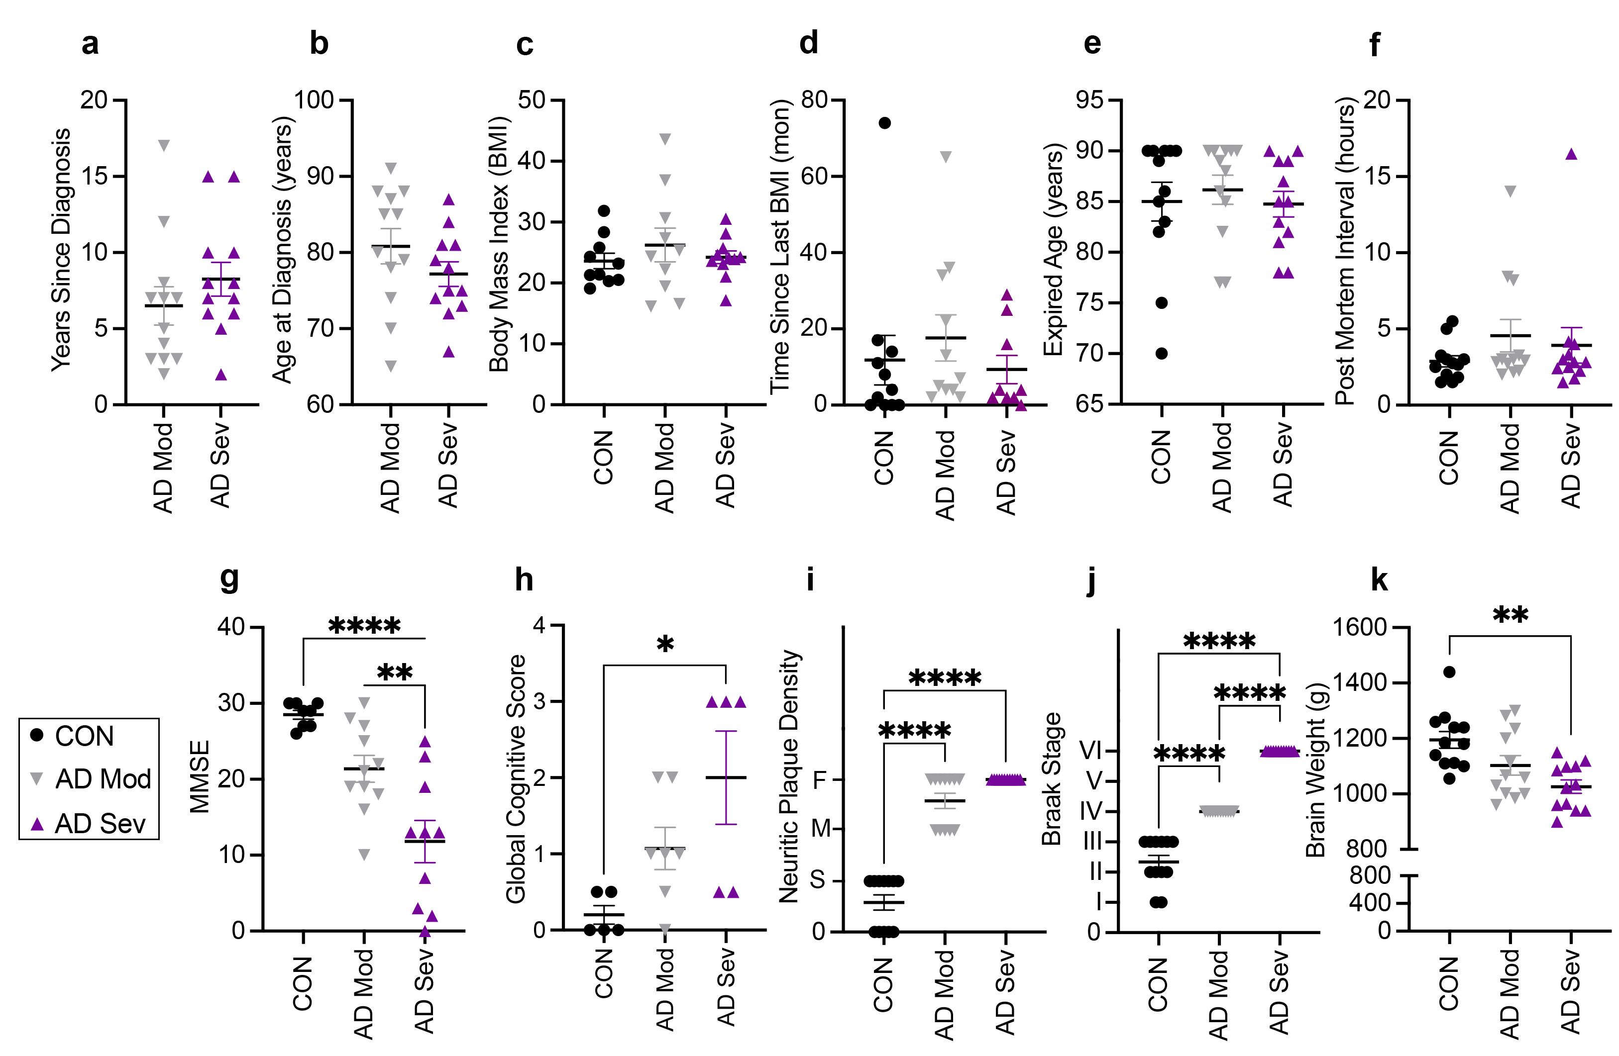

Supplemental Figure 2: Graphical representation of human AD subject profiles. Healthy controls with Braak stage ≤ III (CON, n = 12), moderate AD with Braak stage = IV and moderate to frequent CERAD neuritic plaques (AD Mod, n = 12), and severe AD with Braak stage = VI and frequent CERAD neuritic plaques (AD Sev, n = 12). Subjects were matched on (a) years since diagnosis, (b) age at diagnosis, (c) BMI, (d) time since last BMI measurement, (e) expired age, and (f) PMI. Subjects differed from each other according to diagnosis on (g) MMSE, (h) Global cognitive score, (i) neuritic plaque density. 0=Zero, S=Sparse, M=Moderate, F=Frequent, (j) Braak stage, (k) brain weight. Data are reported as means ± SEM. *p<0.05, **p<0.01, ****p<0.0001.

