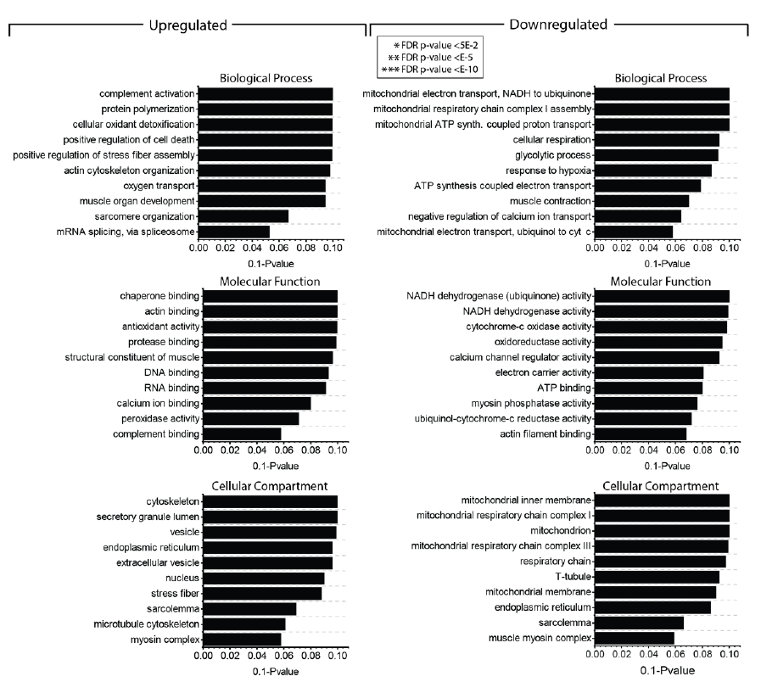

Supplemental Fig 1 GO-Term analysis of differentially abundant proteins in DM2 muscle biopsy samples studied by unbiased proteomic analysis.

