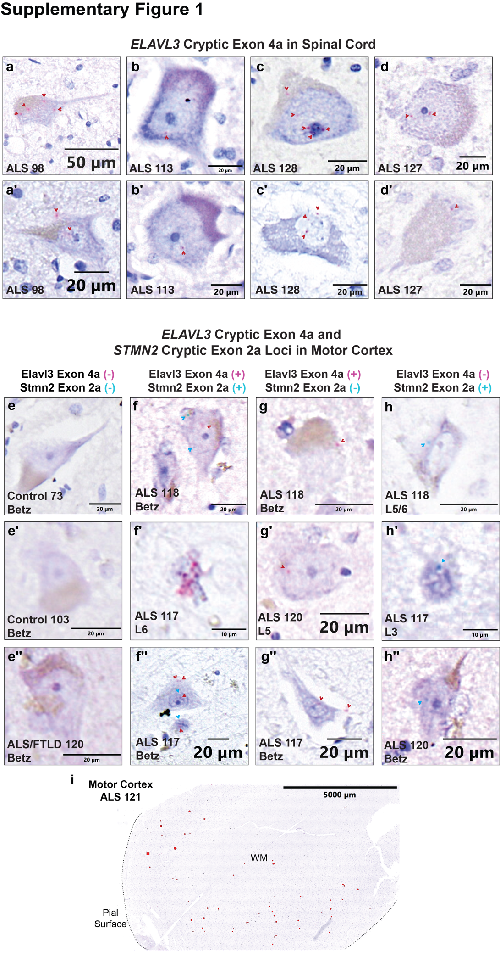
Supplementary Fig 1 Additional representative images of ELAVL3 cryptic exon 4a and STMN2 cryptic exon 2a expression by in situ hybridization
(a-d') Additional representative images of ELAVL3 CE 4a expression in anterior horn motor neurons of ALS spinal cord using in situ hybridization using a single channel chromogenic BaseScope assay. Signal in red, counterstain in purple. (d-h''') Additional representative images of ELAVL3 CE 4a (red) and/or STMN2 CE 2a (blue) expression in ALS motor cortex using a duplex chromogenic BaseScope assay. Counterstain in purple. (i) Representative snapshot of the frequency of ELAVL3 CE 4a and/or STMN2 CE 2a expression events in ALS motor cortex. Red-filled shapes drawn over cells for visualization.
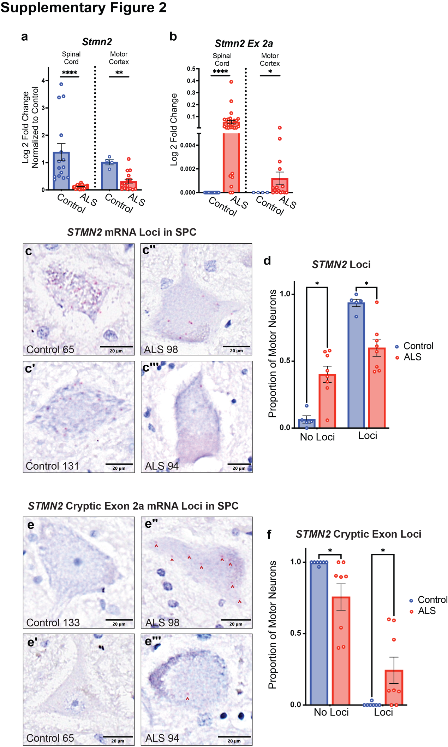
Supplementary Fig 2 STMN2 mRNA is reduced and STMN2 cryptic exon 2a is expressed in spinal cord in ALS
(a) qPCR in spinal cord and motor cortex using primers amplifying a small segment of STMN2 3´UTR. Control spinal cord and motor cortex showed higher expression of STMN2 compared to ALS (P<0.0001, P=0.004). (b) qPCR in spinal cord and motor cortex using primers amplifying a small segment from STMN2 Exon 1 to Exon 2a shows no expression in the controls and significantly more expression in spinal cord and motor cortex (P<0.0001, P=0.01). (c-d) Chromogenic in situ hybridization (CISH) captures expression reduction of STMN2 mRNA and expression of STMN2 cryptic exon 2a in ALS spinal cord motor neurons. Signal in red, counterstain in purple. (c-c''') Representative images of STMN2 3´UTR mRNA in control and ALS spinal cord (d) The proportion of motor neurons with measured STMN2 loci was significantly higher in controls compared to ALS (mean = 0.9) compared to ALS (mean=0.60, *P=0.0124). (e-f) CISH probing for a segment of STMN2 mRNA containing the junction of exon 1 and cryptic exon 2a in control and ALS spinal cord. Signal in red, counterstain in purple. (e-e''') Representative images of STMN2 exon 2a loci in control (e-e') and ALS (e''-e''') motor neurons. (f) ALS spinal cord had significantly more motor neurons positive for cryptic exon 2a (mean=0.2437) compared to controls (mean=0.005, *P=0.02). All graphs plotted as mean +/- SEM.

