Differences in the Cerebral Amyloid Angiopathy Proteome in Alzheimer’s Disease and Mild Cognitive Impairment

Dominique Leitner^{1,2,3}, Tomas Kavanagh⁴, Evgeny Kanshin^{5,6}, Kaleah Balcomb⁴, Geoffrey Pires^{1,3}, Manon Thierry^{1,3}, Jianina I. Suazo^{1,3}, Julie Schneider^{7,8.9}, Beatrix Ueberheide^{5,6}, Eleanor Drummond^{4*}, Thomas Wisniewski^{1,3,10,11*}

Supplemental Materials

Supplemental Figure 1. Collagen proteins. a-m) All detected collagen proteins are depicted. Significant pairwise comparisons are indicated for those analyses that were performed, * p < 0.05, ** p < 0.01, *** p < 0.0001.
Supplemental Figure 2. Proteins important for blood brain barrier function. a) Occludin (OCLN) and b) TJP1 (ZO-1) were decreased or not detected (N.D.) in CAA(+) vessels when compared to CAA(-) vessels. c) SLC2A1 (GLUT1), important to the function of the BBB, was decreased in AD CAA(+) vessels, with a similar trend seen in MCI. Significant pairwise comparisons are indicated for those analyses that were performed, * p < 0.05, ** p < 0.01, *** p < 0.0001.

Supplemental Table 1. Detailed Case History
Supplemental Table 2. Multiple Linear Regression of PCA for Group and Tissue Type
Supplemental Table 3. LFQ Normalized Data, CAA(+) vs CAA(-) Paired T-tests, CAA(-) Unpaired T-tests
Supplemental Table 4. GO Cell Component Terms for MCI CAA(+) vs CAA(-)
Supplemental Table 5. GO Cell Component Terms for AD CAA(+) vs CAA(-)
Supplemental Table 6. GO Cell Component Terms for MCI vs. Control non-CAA
Supplemental Table 7. GO Cell Component Terms for AD vs. Control non-CAA
Supplemental Table 8. CAA and Amyloid Plaque Proteome Comparison

Supplemental Figure 1.
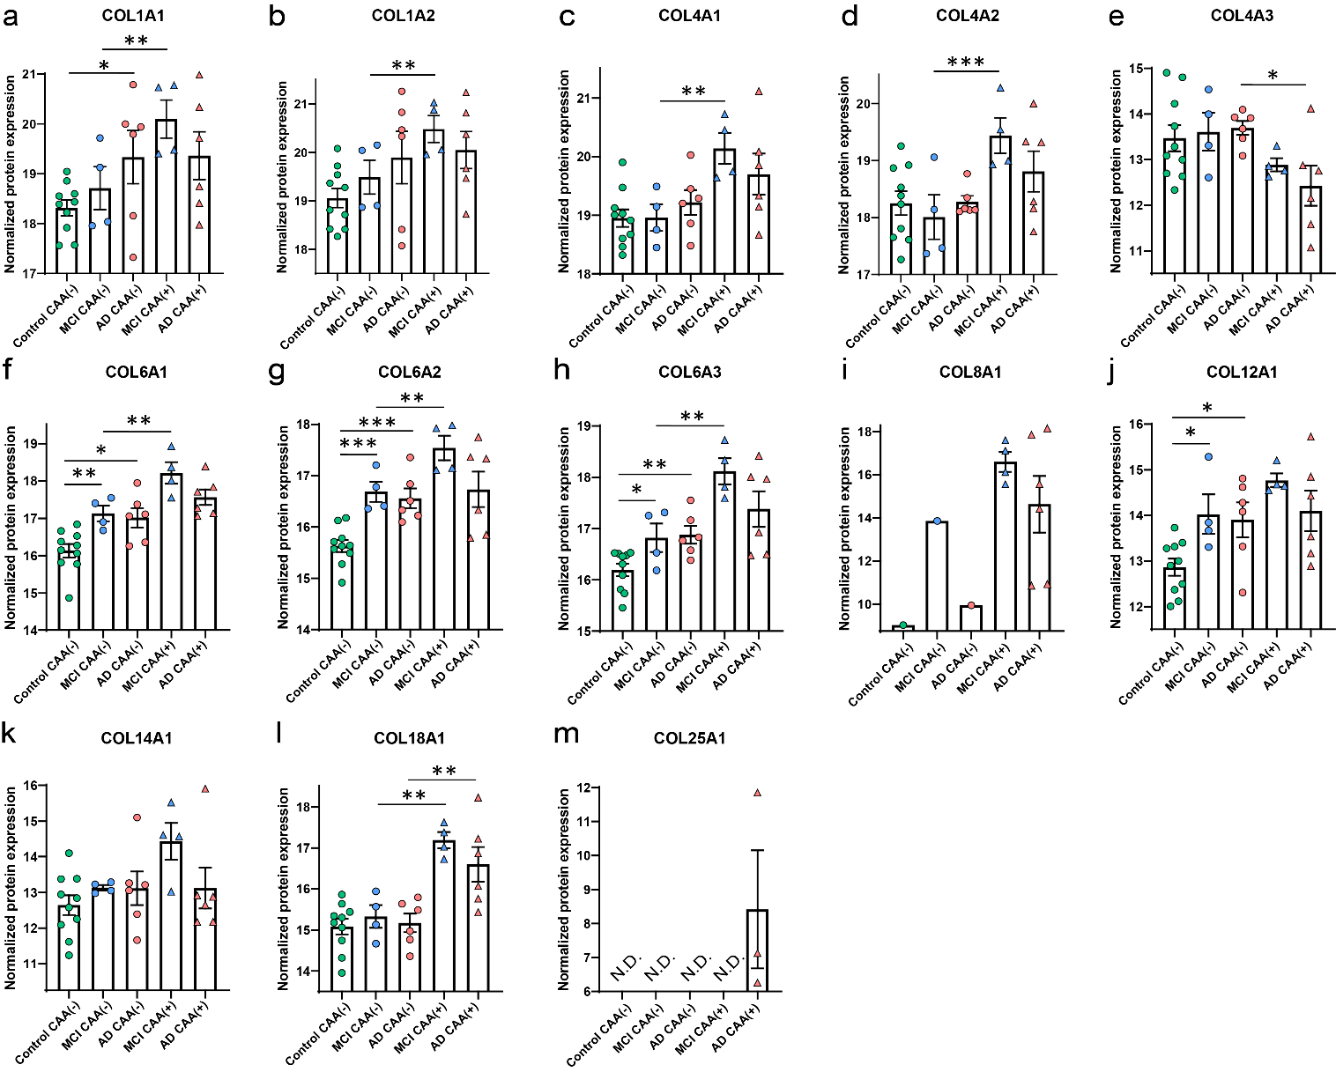

Supplemental Figure 2.
