SUPPORTING INFORMATION

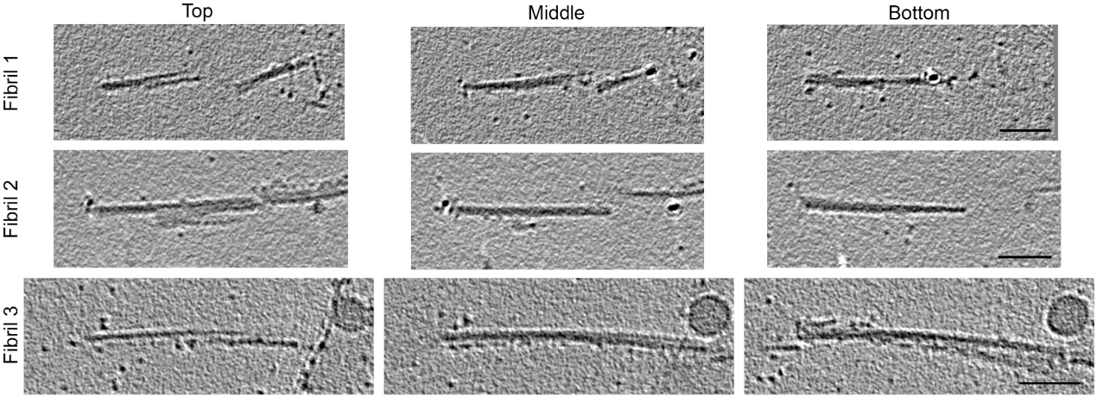

Fig. S1 Cryo-EM tomography of CWD fibrils. Representative images of three fibrils showing top, middle and bottom slices through the tomograms, indicating left-handed twist in each fibril. Scale bars: 50 nm.

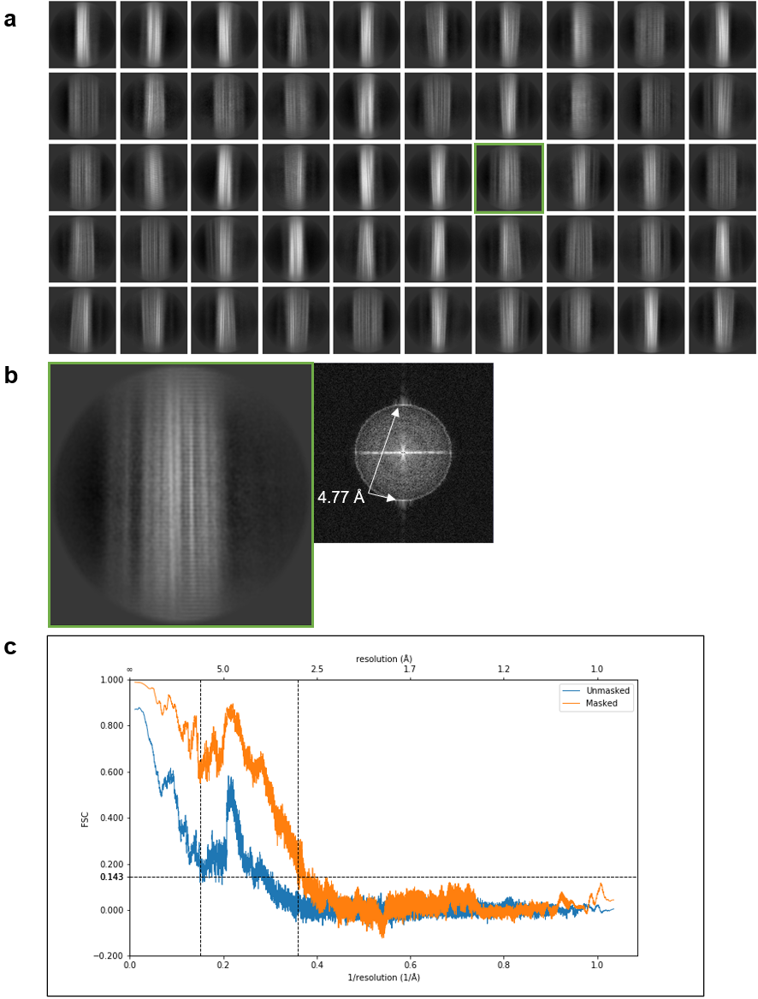

Fig. S2 a Representative 2D class averages showing lateral views of CWD fibril segments. b An enlargement of the class average boxed in green in a allows easier visualization of the fine horizontal bands running perpendicular to the fibril axis. Right panel: fast Fourier transform of 2D class average boxed in green indicating signals at ~4.77 Å that correspond to the spacing between the bands. c Fourier shell correlation plots of masked and unmasked models indicating, from the masked trace, a maximal resolution of 2.8 Å.

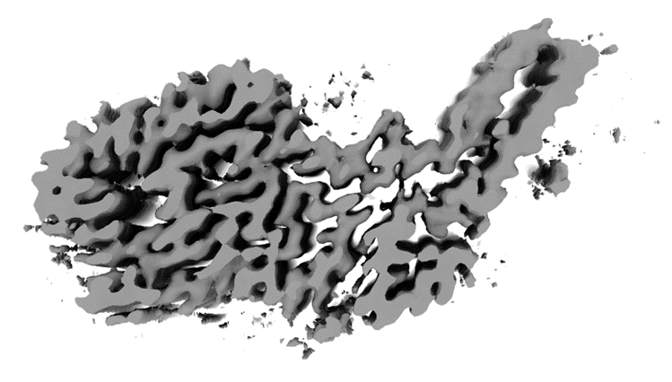

Fig. S3 Cross-section of the unsharpened 3D map from auto-refinement in Relion. Peripheral densities can be clearly identified in association with the prion core.

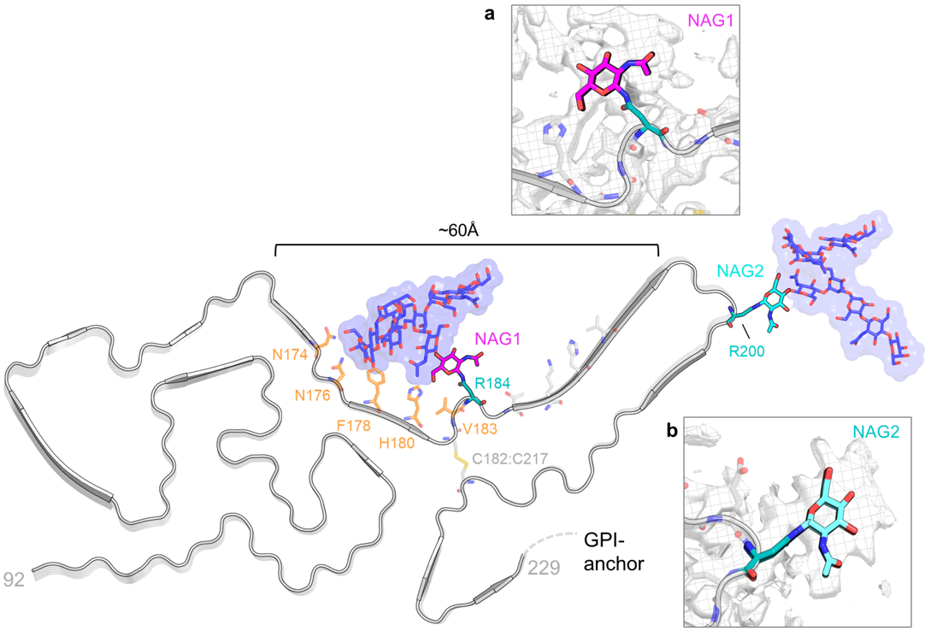
Fig. S4 Glycosylation of CWD PrP^{Sc}. Overview of the CWD structure with the two resolved N-acetylglucosamine residues NAG1 (magenta) and NAG2 (cyan). Representative tri-antennary glycans were modeled onto the NAG1 and NAG2 residues with CHARMM-GUI [22] and are depicted in dark blue (carbons) with red (oxygens). Residues forming potential interactions with the N-linked glycan attached to R184 are colored in orange. Width of the cleft between the N- and C-lobes is ~60 Å. Inset (a): structure of NAG1 (magenta) on R184 (teal) against a mesh/surface plot of the cryo-EM density (grey). Inset (b): structure of NAG2 (cyan) on R200 (teal) against cryo-EM density.

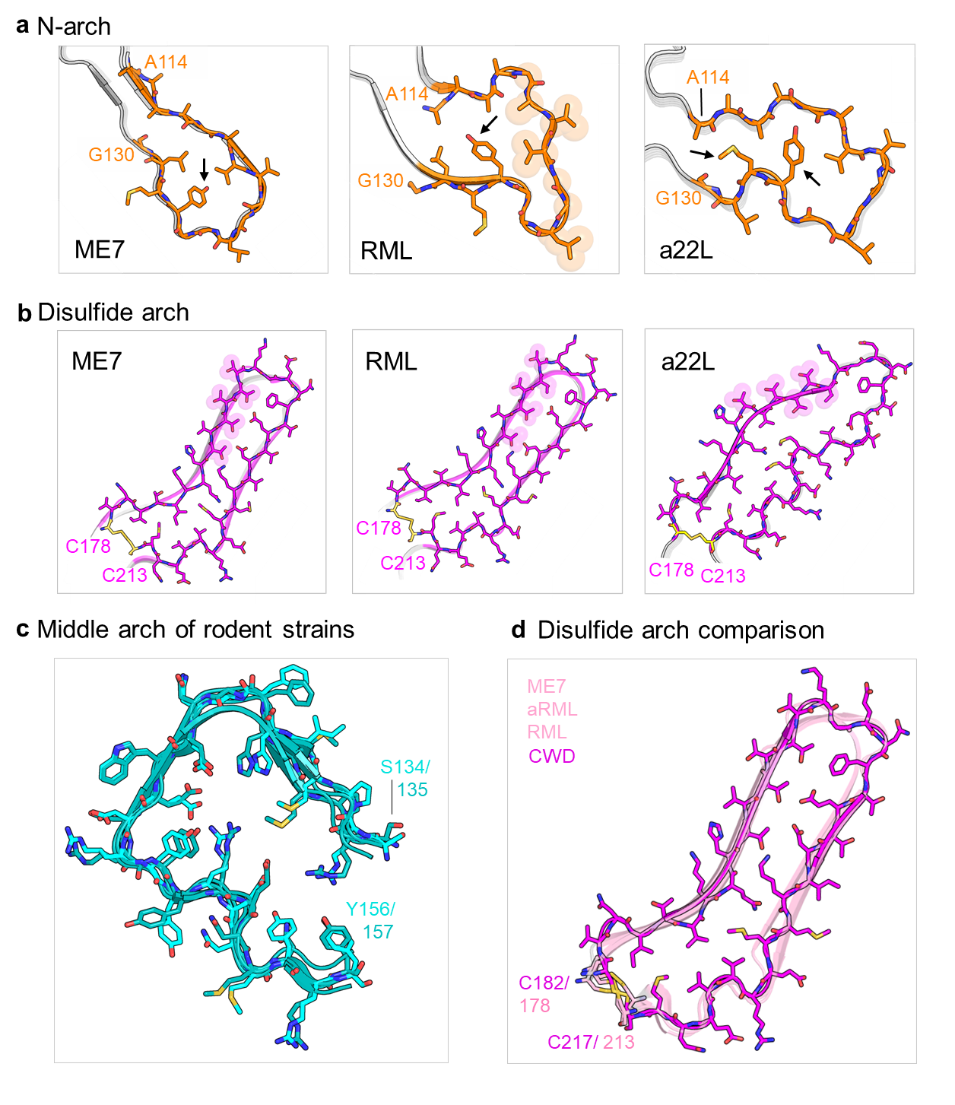
Fig. S5 Rodent-adapted prion strain comparison of major PrP^{Sc} structural motifs. a Residues 114-130, which comprise the N-arch in mouse strains ME7, RML and a22L. Highlighted residues span 119-124 and arrow marks Y120. b Disulfide arches of three mouse strains (ME7, RML and a22L), which begin at the disulfide bond formed by residues C178 and C213. The prominent stretches of 5 closely spaced threonine residues are highlighted. c Overlay of middle arches from five rodent strains (ME7, aRML, RML, a22L and 263K). Hamster residues are colored in teal and mouse residues are colored in cyan. d Comparison of CWD disulfide arch (magenta) with the disulfide arches of three mouse strains (pink; ME7, aRML and RML)

Table S1 Excel file with a summary of cryo-EM tomography twist results from all fibrils analyzed.
Tomograph |  | Twist
CWD81K | 1 | L
 | 2 | L
 | 3 | L
CWD81K_30 | 1 | L
CWD81K_31 | 1 | L
 | 2 | L
CWD81K_37 | 1 | L
 | 2 | L
 | 3 | L
CWD81K_39 | 1 | L
CWD81K_41 | 1 | L
 | 2 | L
CWD81K_42 | 1 | L
 | 2 | L
CWD81K_15 | 1 | L
 | 2 | L
CWD81K_19 | 1 | L
CWD81K_1 | 1 | L
CWD81K_24 | 1 | L
 | 2 | L
CWD81K_27 | 1 | L
CWD81K_40 | 1 | L
CWD81K_4 | 1 | L
 | 2 | L

