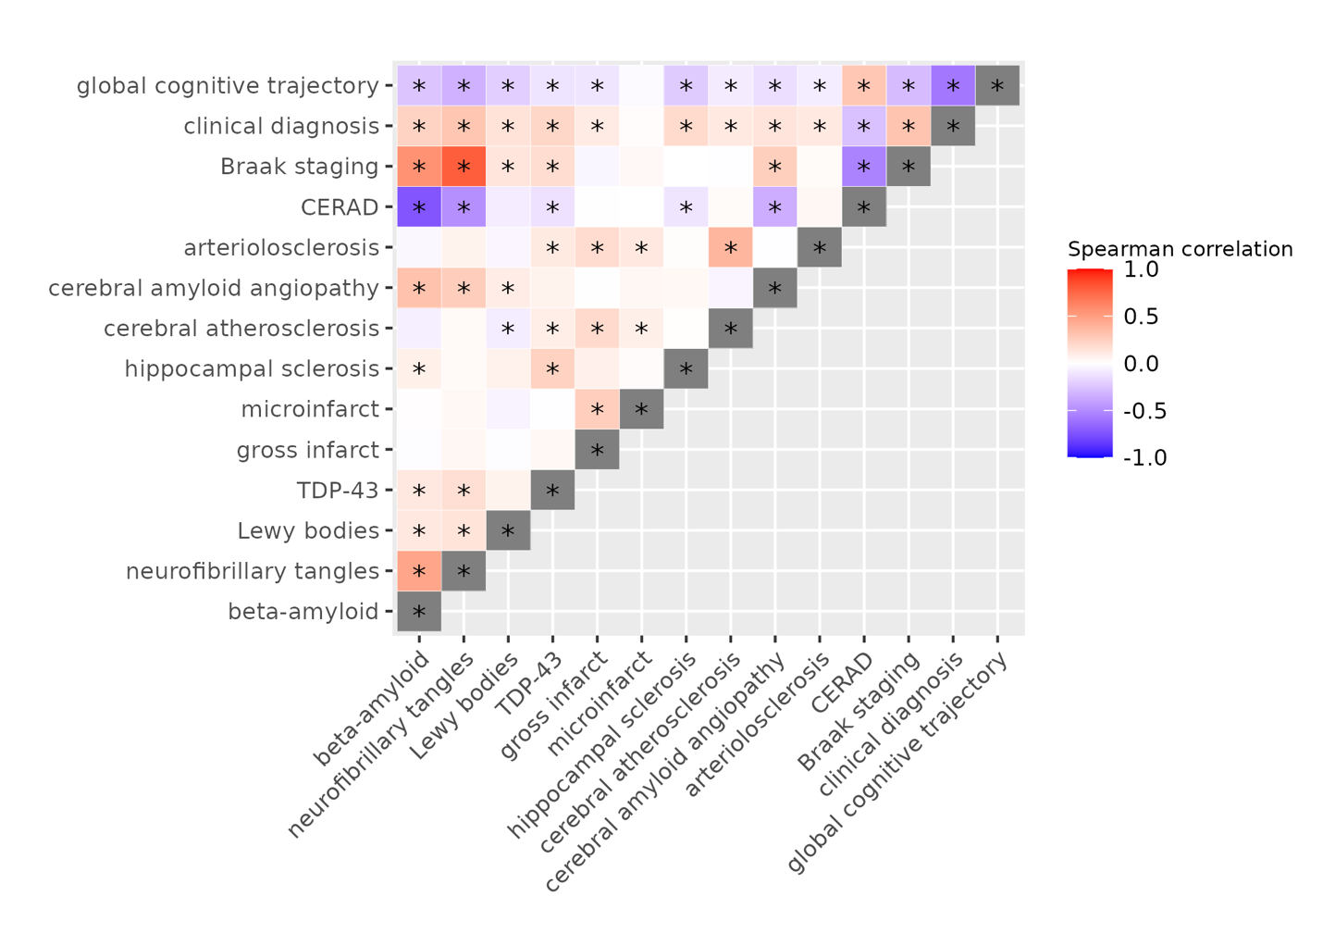

Supplementary Figure 1. Pairwise correlation among global cognitive trajectory, clinical diagnosis, and pathologies. Asterisks indicate Spearman p-value < 0.05. In our analysis we used beta-amyloid and neurofibrillary tangle measures as derived on the ROS/MAP participants, but we include Braak staging or CERAD to provide context for the outcomes.

