SUPPLEMENTARY

Supplementary Table 1. Antibodies

Application | Target | Dilution | Company | Catalogue #
Western blot | TH | 1:5000 | CST | 2792S
Western blot | pTH | 1:1000 | Abcam | ab51206
Western blot | α-synuclein | 1:5000 | BD Biosciences | 610786
Western blot | DJ1 | 1:1000 | Abcam | ab76008
Western blot | MAO-A | 1:1000 | Abcam | ab126751
Western blot | MAO-B | 1:1000 | Abcam | ab175136
IHC | TH | 1:1000 | Millipore | AB152
IHC | α-synuclein | 1:5000 | Abcam | ab138501

Supplementary Table 2. Donor characteristics

 | Age | Sex | PMD  (hours) | Cause of Death | Tissue pH
PD | 84 | M | 5 | Cholangiocarcinoma | 6.4
PD | 82 | M | 19 | Cardiorespiratory failure | 6.4
PD | 81 | F | 29 | Cardiorespiratory failure | 6.4
PD | 71 | M | 25 | Hypertensive heart disease | 6.5
PD | 82 | F | 9 | Pneumonia | 6.1
PD | 92 | M | 46 | Cardiorespiratory failure | 6.1
PD | 93 | F | 9 | Cardiorespiratory failure | 6.1
PD | 78 | M | 26 | Cardiorespiratory failure | 5.6
PD | 80 | F | 21 | Cardiorespiratory failure | 6.0
PD | 88 | F | 21 | Cardiorespiratory failure | 6.3
NC | 79 | M | 8 | Pulmonary embolism | 7.5
NC | 89 | F | 23 | Metastatic adenocarcinoma | 6.0
NC | 88 | F | 31 | Congestive cardiac failure | 6.2
NC | 84 | M | 22 | Cardiorespiratory failure | 5.8
NC | 84 | M | 36 | Severe pulmonary hypertension | 6.4
NC | 80 | F | 29 | Cardiorespiratory failure | 6.3
NC | 73 | M | 39 | Cardiorespiratory failure | 6.3
NC | 88 | M | 9 | Cardiorespiratory failure | 6.4
NC | 85 | F | 10 | Cardiorespiratory failure | 6.6
NC | 86 | F | 4 | Cardiorespiratory failure | 6.4
F, female; NC, neurological control; M, male; PD, Parkinson’s disease; PMD, post-mortem delay.

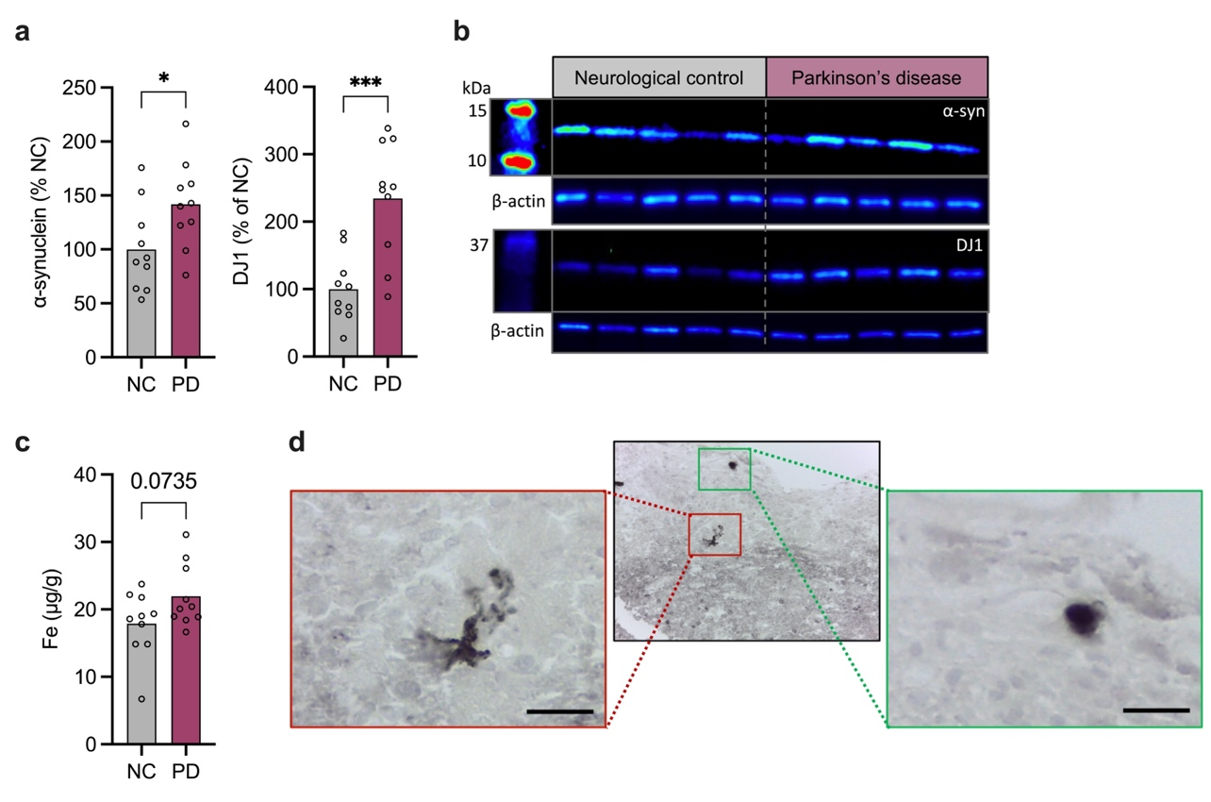

S Fig 1 Parkinson’s disease pathology in the olfactory bulb a Quantification of α-synuclein and DJ1 immunoblot densitometry presented as percentage of neurological control, a-syn increased by 41.8±17.9%, DJ1 increased by 134.7±31.4%. b Representative immunoblots of olfactory bulb lysates. c Iron (Fe) ICP-MS analysis, Fe increased by 4.1±2.1 μg/g. d Representative images of the α-synuclein pathology found within the PD olfactory bulb; scale bar represents 40 μm. NC (n=10) and PD (n=10). Analyses performed by Students’ T Test; *P<0.05, ***P<0.001

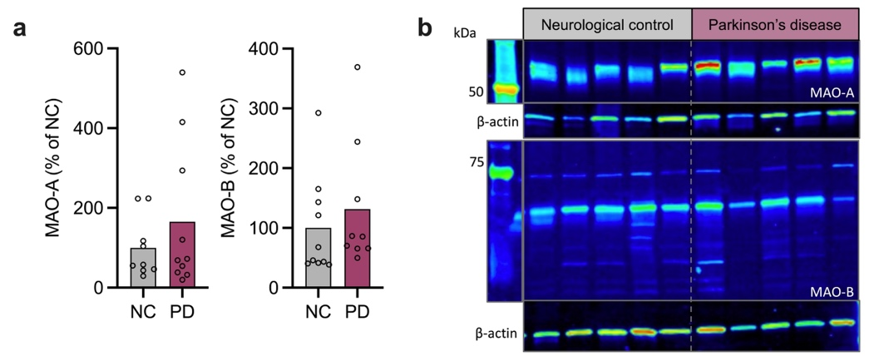

S Fig 2 Monoamine oxidase is not altered in Parkinson’s disease. a Quantification of MAO-A and MAO-B immunoblot densitometry presented as % of neurological control. b Representative immunoblots of olfactory bulb lysates stained for MAO-A, MAO-B and β-actin.

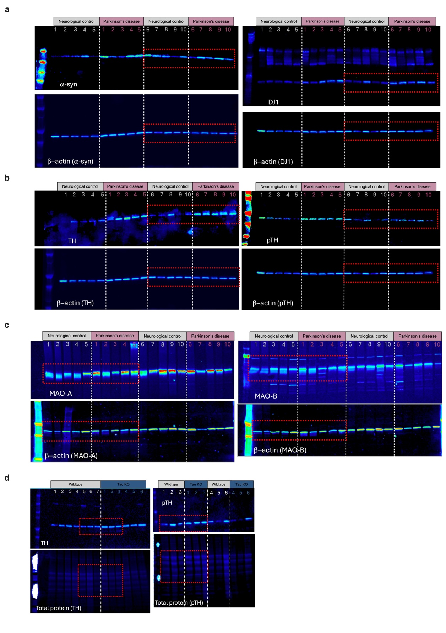

S Fig 3 Full Western blot images a Alpha-synuclein and DJ1 in neurological control and Parkinson’s disease olfactory bulb lysate; Supplementary Figure 1. b Tyrosine hydroxylase and phosphor-Ser40 tyrosine hydroxylase in neurological control and Parkinson’s disease olfactory bulb lysate; Figure 1. c Monoamine-A and monoamine-B in neurological control and Parkinson’s disease olfactory bulb lysate; Supplementary Figure 2. d Tyrosine hydroxylase and phosphor-Ser40 tyrosine hydroxylase in wildtype and tau knockout mouse olfactory bulb lysate; Figure 3. Red box indicates cropped samples presented in manuscript figures.
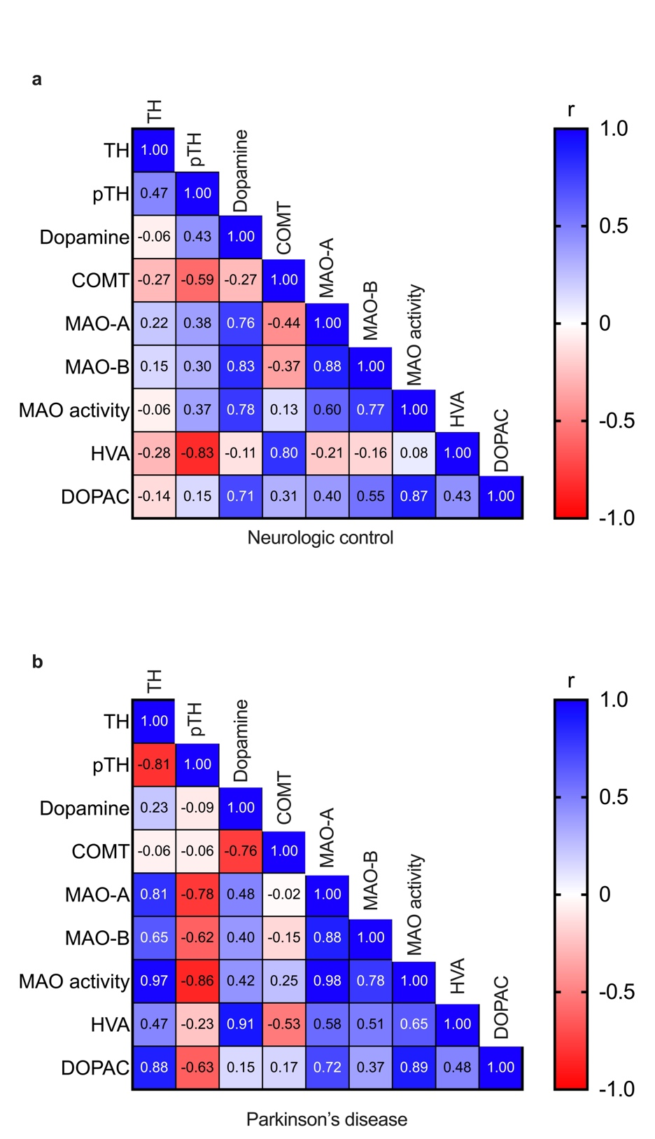

S Fig 4 Correlation analysis between dopamine synthesis and metabolism in the olfactory bulb. a Correlation matrix assessing the relation between key dopamine synthesis and metabolism enzymes, dopamine, and dopamine metabolites in neurological control and b Parkinson’s disease. The color scale depicts the strength of the Pearson correlation coefficient (r), which is superimposed as text on the matrix.

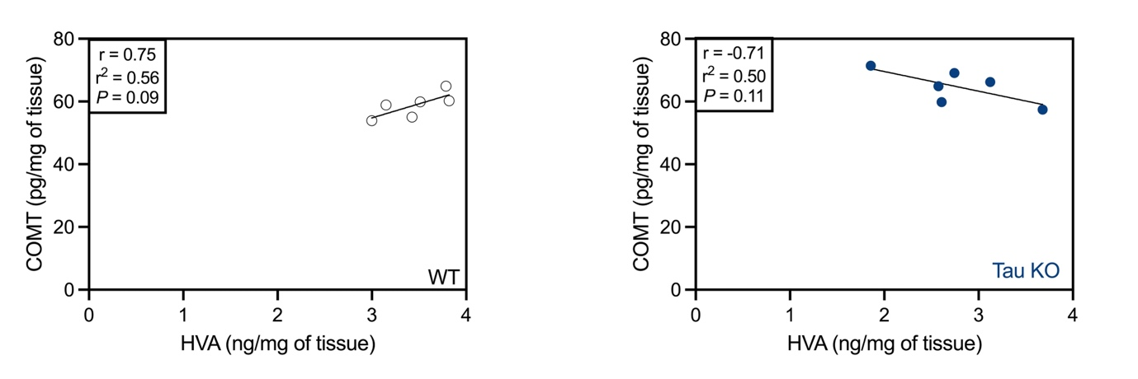

S Fig 5 Correlation of catechol-O-methyltransferase (COMT) and homovanillic acid (HVA) in wildtype (left) and tau knockout (right) olfactory bulb lysate.

