Supplemental figures

Role of CSF flow and meningeal barriers in the development of inflammatory lesions at the CNS-PNS transition zone of cranial nerves in autoimmune demyelinating diseases

Li Xin^{1*}, Hideaki Nishihara², Adrian Madarasz¹, Petr Pleskac¹, Linh Tran¹, Daniela C. Ivan¹, Fumitaka Shimizu², Simone Aleandri³, Giuseppe Locatelli ¹, Paola Luciani³, Steven T. Proulx^{1*}

¹Theodor Kocher Institute, University of Bern, Bern, Switzerland
² Department of Neurology and Clinical Neuroscience, Yamaguchi University, Yamaguchi, Japan
³ Department of Chemistry, Biochemistry and Pharmaceutical Sciences, University of Bern, Bern, Switzerland.

*Corresponding authors:

Li Xin, PhD
Theodor Kocher Institute
University of Bern
CH-3012 Bern, Switzerland
Email: li.xin@unibe.ch

Steven T. Proulx, PhD
Theodor Kocher Institute
University of Bern
CH-3012 Bern, Switzerland
Email: steven.proulx@tki.unibe.chs

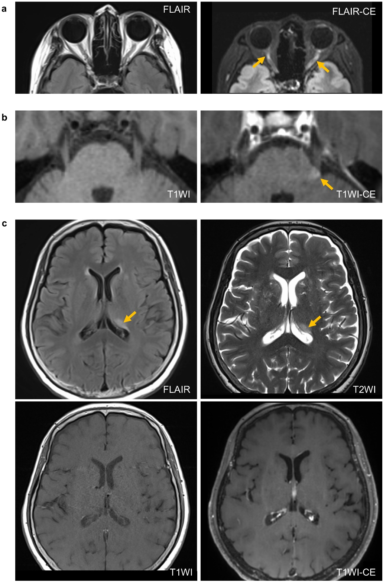
Supplemental Fig. 1 Additional MRI imaging of case 1 (patient with an inflammatory demyelinating disease of undefined type) at acute phase. Axial fluid-attenuated inversion recovery (FLAIR) and T1-weighted images (T2WI) revealed bilateral optic nerve lesions (a) and lesion in the left intramedullary trigeminal tract at REZ (b) exhibited contrast enhancement (T1W1-CE). In contrast, the periventricular hyperintense lesion seen on FLAIR and T2W1 in the acute phase did not show contrast enhancement. Yellow arrows indicate lesions.

Supplemental Fig. 2 Decalcified tissues marking the relevant anatomical landmarks. a A sagittal section of the decalcified cranium showing the four cranial nerves assessed in this study and other brain structures indicated by the arrows. b A coronal section of the decalcified rostral cranium with GFAP staining showing the olfactory bulbs, olfactory nerve fiber layer (NFL) and intra-orbital segment of the optic nerve (right). The optic nerve transition area (from intra-orbital to intra-ocular) is indicated on the left, near the retina.
Supplemental Fig. 3 CX3CR1⁺ cell distribution between the CNS and PNS segments of the trigeminal and cochlear nerve. a CX3CR1⁺ microglia were abundant within the CNS segment of the trigeminal nerve and largely associated with the dome-shaped TZ marked by GFAP⁺ astrocyte foot processes. CX3CR1⁺ cells were scarce on the PNS side of the trigeminal nerve. b Cx3CR1⁺ cells were abundant on the CNS segment of the cochlear nerve and scarce on the PNS side, but their distribution pattern did not clearly reveal the TZ marked by GFAP⁺ astrocyte foot processes.
Supplemental Fig. 4 CCR2⁺ cells and liposomes are accumulated within the SAS cisterns. a Representative images showing that in the naïve mouse, liposomes were visible in the SAS cisterns, but CCR2⁺ cells were nearly visible. ACi, ambient cistern; AMV, anterior medullary velum. b In EAE peak stage, accumulation of CCR2⁺ cells and liposomes were seen in multiple SAS cisterns including the ACi, AMV, the CiOT (cistern of the optic tract), and the CiLT (cistern of the lamina terminalis).
Supplemental Fig. 5 Arachnoid cul-de-sac of the trigeminal nerve. a The arachnoid cul-de-sac (arrow) of the trigeminal nerve (Tri) is revealed on a lateral sagittal section of the Prox1-GFP mouse i.c.v-infused with liposomes.

Supplemental Fig. 6 E-cadherin staining did not reveal obvious differences between the naïve and EAE condition for trigeminal and cochlear nerves. a E-cadherin staining did not reveal morphological differences around the trigeminal nerve (Tri) between the naïve and the EAE mouse ((n= 3 mice in each group). b Discontinuous E-cadherin⁺ signal (between the colored arrows) when nerve bundles merge into the trunk of cochlear nerve (Coc) was seen in both naïve and EAE peak. ST, scala tympani.
Supplemental Fig. 7 E-cadherin staining did not reveal obvious differences between the naïve and EAE mouse for optic and olfactory nerves. a E-cadherin staining on sagittal sections (left and middle panels) of the optic tract (OT) and the cranial segment of the optic nerve (Opt). Right panels, E-cadherin staining on coronal sections showing the optic nerve (Opt) near the retina. CCR2⁺ cells were visible inside the optic nerve parenchyma, as well as in the intra-orbital connective tissue. b The discontinuous E-cadherin staining looks similar around the olfactory nerve bundles between the naïve and EAE mouse. c Representative confocal images showing the indifferentiable E-cadherin staining pattern between the naïve and the EAE condition.
Supplemental Fig. 8 Immune cells were found inside the cribriform plate lymphatic vessels in naïve and EAE mouse. a Iba1⁺ macrophages containing liposomes observed inside the lymphatic vessel in a naïve Prox1-GFP mouse. Right panel, the 3D view of a confocal image from the yellow box area. b During EAE, CCR2⁺ cells were located within the lumen of the Lyve-1⁺ cribriform plate lymphatic vessels. Right panel, the 3D view of a confocal image from the yellow box area.

