Supplementary Table a: Demographic, Clinical, Genetic, and Neuropathological Characteristics for AD cohort

Characteristics |  | AD (n=51)
Sex (Male/Female) |  | 26/25
Age median (IQR), |  | 90 (10)
RHI years median (IQR) |  | 9.5 (7.25)
Age of First Contact Sports Exposure median (IQR) |  | 11.0 (6.0)
Sport | Football | 11 (26.2%)
Sport | Hockey | 2 (4.9%)
Sport | Other | 2 (4.9%)
TMEM106B (CC/G+)- |  | 16 (31.4%)
APOE E4 status % (Y/N) |  | 27 (47.1%)
TDP-43 % (Y/N) |  | 5 (45.5%)
Dementia status % (Y/N) |  | 6 (25.0%)
Brainstem Lewy Body pathology %Y (Y/N) |  | 6 (54.5%)
Alzheimer disease neuropathologic change
Braak Stage | 0 | 0 (0%)
Braak Stage | I-II | 0 (0%)
Braak Stage | III-IV | 17 (36.2%)
Braak Stage | V-VI | 30 (63.8%)
CERAD Score | C0 | 0 (0%)
CERAD Score | C1 | 22 (46.8%)
CERAD Score | C2 | 22 (46.8%)
CERAD Score | C3 | 3 (6.4%)
Remote microinfarcts % (Y/N) |  | 22 (53.2%)
Cerebral Amyloid Angiopathy (moderate-severe) |  | 19 (40.4%)
Supplementary Table a: Not all cases had available data for each variable; denominators vary by measure.)
b.
COMPUTE LL_full = -285.722 / 2. /* Final model */
COMPUTE LL_null = -310.068 / 2. /* Intercept-only model */
COMPUTE N = 110. /* Sample size */

* --- Compute Cox & Snell R² ---.
COMPUTE R2_CoxSnell = 1 - EXP((-2 * (LL_full - LL_null)) / N).

* --- Compute Nagelkerke R² ---.
COMPUTE R2_Nagelkerke = R2_CoxSnell / (1 - EXP((2 * LL_null) / N)).

* --- Compute Cohen's f² ---.
COMPUTE f2 = R2_Nagelkerke / (1 - R2_Nagelkerke).

* --- Format numbers for readability ---.
FORMATS R2_CoxSnell R2_Nagelkerke f2 (F8.3).

* --- Display the results in the output window ---.
DISPLAY R2_CoxSnell R2_Nagelkerke f2.
EXECUTE.
Supplementary figure b: SPSS code demonstrating the calculation for effect size that was used for Power analysis in G*Power (version 3.1.9.7).

c.
CTE
IFNg | N | CD68C | N | IBA1C | N | TREM2
GG, CG | 38 | .283 (.169) | 31 | .345 | 46 | .218
CC | 19 | .122 | 16 | .540 | 23 | .049 (-.423) ▲
IL10
GG, CG | 37 | .013 (.387) ● | 31 | .914 | 45 | .553
CC | 20 | .441 | 17 | .250 | 24 | .003 (-.562) ●
IL13
GG, CG | 37 | .871 | 30 | .042 (-.377) ▲ | 45 | .805
CC | 20 | .200 | 17 | .057 (-.486) | 24 | .911
IL1B
GG, CG | 37 | .003 (.476) ● | 30 | .038 (.387) ● | 45 | .803
CC | 20 | .318 | 17 | .626 | 24 | .087 (-.366)
IL4
GG, CG | 37 | .008 (.412) ● | 31 | .469 | 45 | .065 (.266)
CC | 20 | .322 | 17 | .049 (-.501) ▲ | 24 | .003 (-.593) ●
IL8
GG, CG | 38 | .031 (.350) ● | 31 | .018 (.411) ● | 46 | .003 (.416) ●
CC | 20 | .976 | 17 | .052 (.495) | 24 | .898
TNF-α
GG, CG | 37 | .025 (.357) ● | 30 | .179 | 45 | .052 (.279)
CC | 20 | .955 | 17 | .436 | 24 | .004 (-.575) ●
TNF-Β
GG, CG | 38 | .080 (.281) ■ | 31 | .461 | 46 | .931
CC | 20 | .163 | 17 | .846 | 24 | .018 (-.483) ▲
IL1A
GG, CG | 38 | .327 (.166) ■ | 31 | .276 | 46 | .989
CC | 19 | .126 | 17 | .735 | 23 | .551
IL6
GG, CG | 38 | .003 (.468) ● | 31 | .075 (.325) ■ | 46 | .007 (.394) ●
CC | 20 | .117 | 17 | .021 (.528) ● | 24 | .848
Supplementary table c: Effect of TMEM106B gene variation on cytokine association with microglial levels in CTE in a Caucasian-only subgroup. Cytokine associations with microglia subtypes vary by TMEM106B risk in CTE. Multiple linear regression analyses adjusted for age tested associations between inflammatory cytokines and microglial markers within the protective genotype and the risk genotype. Values are presented as p value (β value). Legend: ■ Lost significance; ● Maintained significance; ▲ Became newly significant.

d.
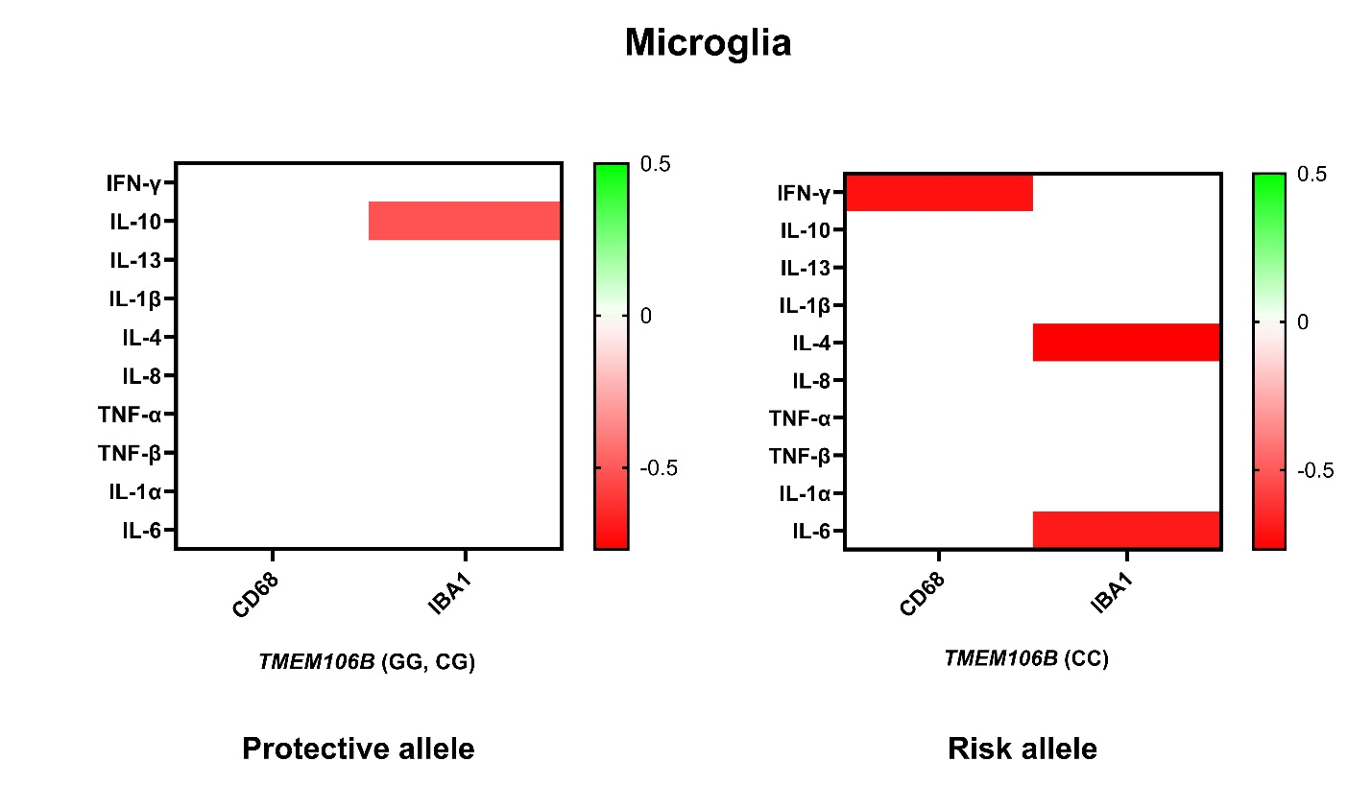
Supplementary figure d: Effect of TMEM106B gene variation on microglial levels in AD. Cytokine associations with microglia subtypes vary by TMEM106B risk in CTE. Multiple linear regression analyses adjusted for age, gender and APOE ε4 tested associations between inflammatory cytokines and microglial markers within the protective genotype (a) and the risk genotype (b). Heatmaps show β values with p<0.05 (red to green shading indicated by key). *p<0.05 after FDR adjustment.

e.
CTE
IFNg | N | AT8 Cort | N | Ptau181 | N | Ptau202 | N | Ptau231 | N | Ptau396 | N | Ptau202/Ptau396
GG, CG | 56 | .097 | 60 | .980 | 57 | .099 | 60 | .550 | 59 | .266 | 58 | .726
CC | 33 | .407 | 35 | .706 | 33 | .193 | 34 | .314 | 35 | .517 | 33 | .063
IL10
GG, CG | 56 | .917 | 59 | .772 | 56 | .869 | 59 | .066 (-.241)■ | 58 | .973 | 57 | .426
CC | 34 | .180 | 36 | .980 | 34 | .306 | 35 | .101 | 36 | .116 | 33 | .569
IL13
GG, CG | 55 | .110 | 59 | .091 | 56 | .460 | 59 | .003 (-.378)● | 58 | .778 | 57 | .629
CC | 34 | .786 | 36 | .097 | 34 | .259 | 35 | .053 | 36 | .208 | 33 | .080
IL1B
GG, CG | 55 | .494 | 59 | .741 | 56 | .874 | 59 | .555 | 58 | .776 | 57 | .554
CC | 34 | .906 | 36 | .659 | 34 | .232 | 35 | .494 | 35 | .851 | 33 | .419
IL4
GG, CG | 56 | .935 | 59 | .297 | 56 | .161 | 59 | .006 (-.348)● | 58 | .537 | 57 | .472
CC | 34 | .083 | 36 | .585 | 34 | .179 | 35 | .004 (-.476)● | 36 | .036 (-.433)▲ | 33 | .062
IL8
GG, CG | 56 | .005 (.417)● | 60 | .449 | 57 | .273 | 60 | .925 | 59 | .112 (.207)■ | 58 | .473
CC | 34 | .158 | 36 | .255 | 34 | .856 | 35 | .567 | 36 | .066 | 33 | .069 (-.320)■
TNF-α
GG, CG | 55 | .933 | 59 | .524 | 56 | .970 | 59 | .178 (-.174) ■ | 58 | .737 | 57 | .647
CC | 34 | .003 (-.580)● | 36 | .770 | 34 | .962 | 35 | .019 (-.403)● | 36 | .036 (-.437)▲ | 33 | .593
TNF-Β
GG, CG | 56 | .266 | 60 | .236 | 57 | .759 | 60 | <.001 (-.448)● | 59 | .632 | 58 | .312
CC | 34 | .369 | 36 | .594 | 34 | .035 (.402)● | 35 | .014 (-.423)● | 36 | .106 | 33 | .014 (.430)●
IL1A
GG, CG | 56 | .143 | 60 | .707 | 57 | .415 | 60 | .089 (-.224)■ | 59 | .307 | 58 | .360
CC | 33 | .466 | 35 | .251 | 33 | .893 | 34 | .090 (-.297)■ | 35 | .038 (-.429)● | 32 | .639
IL6
GG, CG | 56 | .020 (.351)● | 60 | .168 | 57 | .109 | 60 | .338 | 59 | .231 | 58 | .345
CC | 34 | .173 | 36 | .316 | 34 | .415 | 35 | .169 | 36 | .091 | 33 | .300

Supplementary table e: Effect of TMEM106B gene variation on cytokine interaction on tau pathology in CTE in a Caucasian-only subgroup. Cytokine associations with tau vary by TMEM106B risk in CTE. Multiple linear regression analyses adjusted for age tested associations between inflammatory cytokines and microglial markers within the protective genotype and the risk genotype. Values are presented as p value (β value). Legend: ■ Lost significance; ● Maintained significance; ▲ Became newly significant.

f.
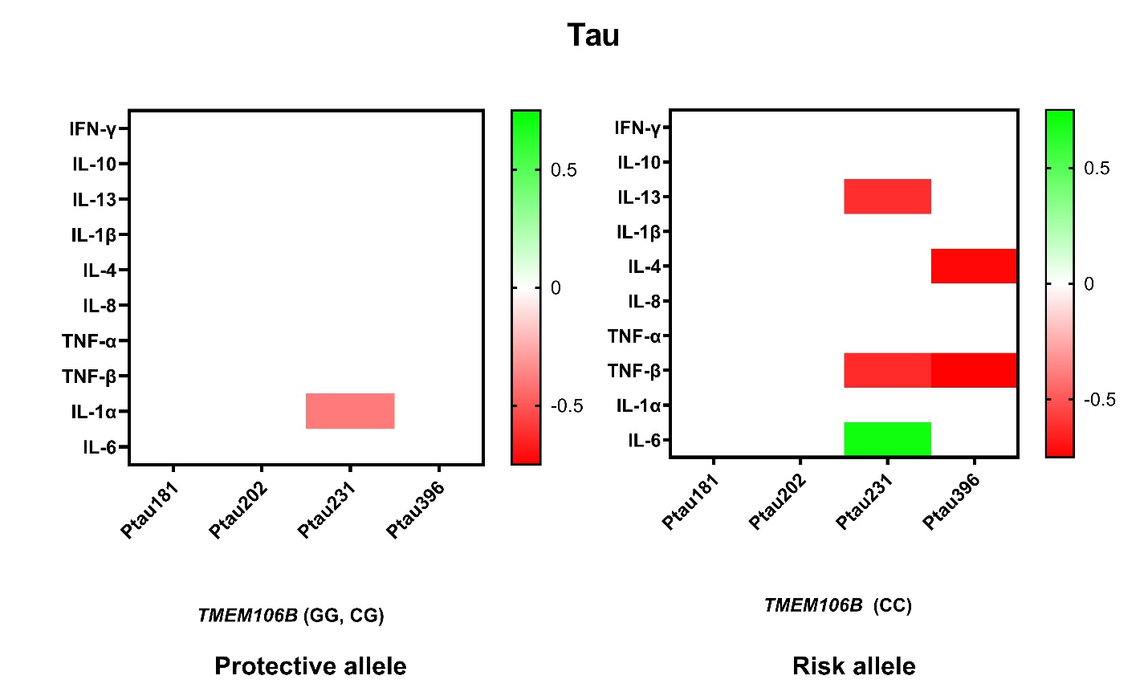
Supplementary figure f: Cytokine associations with tau pathology vary by TMEM106B risk in AD. Multiple linear regression analyses adjusted for age, gender and APOE ε4 tested associations between inflammatory cytokines and measures of tau pathology including tau inclusions (AT8) levels of various phosphorylated tau species within the protective genotype (a) and the risk genotype (b). Heatmaps show β values with p<0.05 (red to green shading indicated by key). *p<0.05 after FDR adjustment.

g.
CTE
IFNg | N | AB38 | N | AB40 | N | AB42
GG, CG | 60 | .337 | 60 | .390 | 59 | .146
CC | 34 | .564 | 34 | .220 | 35 | .949
IL10
GG, CG | 59 | .865 | 59 | .623 | 58 | .532
CC | 35 | .320 | 35 | .045 (-.349)▲ | 36 | .706
IL13
GG, CG | 59 | .630 | 59 | .346 | 58 | .897
CC | 35 | .586 | 35 | .325 | 36 | .838
IL1B
GG, CG | 59 | .460 | 59 | .942 | 58 | .966
CC | 35 | .933 | 35 | .358 | 36 | .564
IL4
GG, CG | 59 | .411 | 59 | .805 | 58 | .235
CC | 35 | .572 | 35 | .018 (-.402)● | 36 | .423
IL8
GG, CG | 60 | .554 | 60 | .228 | 59 | .443
CC | 35 | .154 | 35 | .488 | 36 | .792
TNF-α
GG, CG | 59 | .833 | 59 | .534 | 58 | .989
CC | 35 | .622 | 35 | .075 | 36 | .285
TNF-Β
GG, CG | 60 | .818 | 60 | .116 (-.208)■ | 59 | .379
CC | 35 | .176 | 35 | .001 (-.529)● | 36 | .229
IL1A
GG, CG | 60 | .295 | 60 | .135 (-.203)■ | 59 | .714
CC | 34 | .189 | 34 | .096 | 35 | .955
IL6
GG, CG | 60 | .572 | 60 | .110 (.217)■ | 59 | .147 (.203)■
CC | 35 | .709 | 35 | .723 | 36 | .434

Supplementary table g: Effect of TMEM106B gene variation on Cytokine interaction on beta amyloid levels in CTE in a Caucasian-only subgroup. Cytokine associations with beta amyloid vary by TMEM106B risk in CTE. Multiple linear regression analyses adjusted for age tested associations between inflammatory cytokines and microglial markers within the protective genotype and the risk genotype. Values are presented as p value (β value). Legend: ■ Lost significance; ● Maintained significance; ▲ Became newly significant.

h.
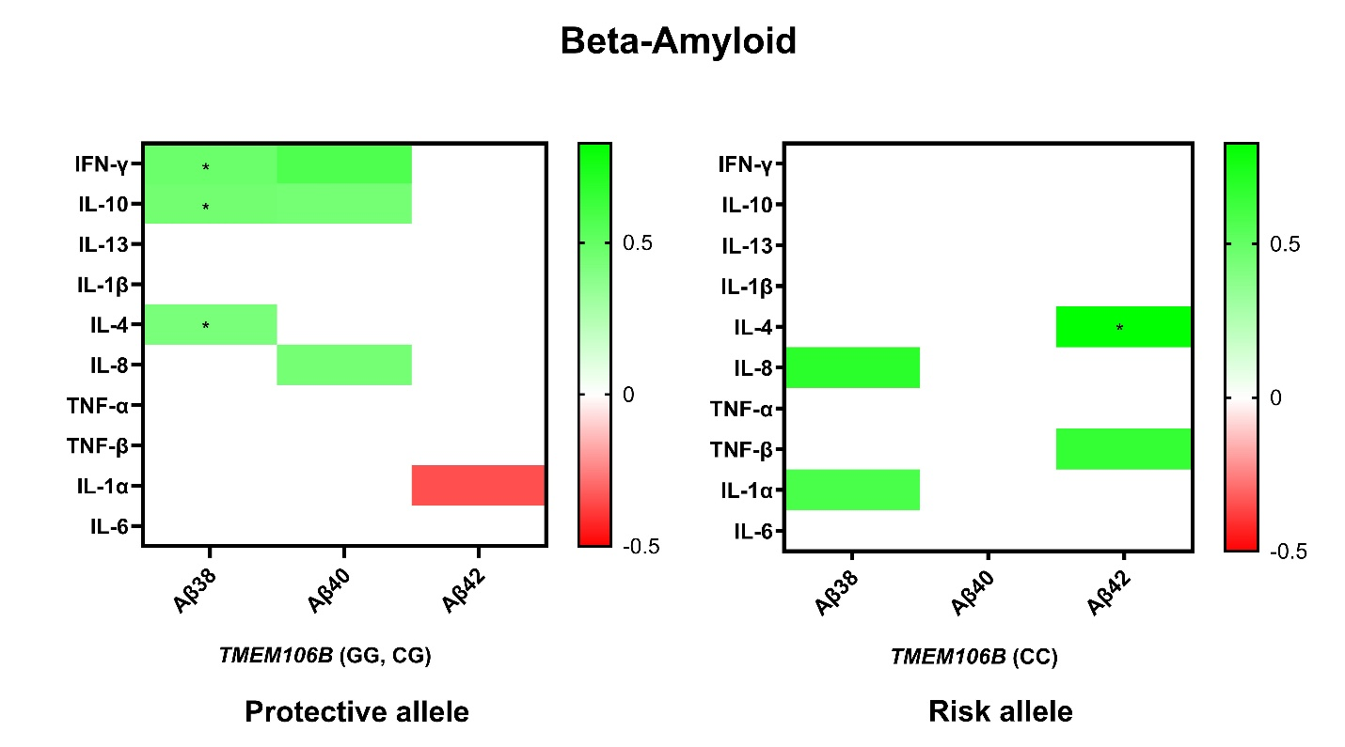
Supplementary figure h: Effect of TMEM106B gene variation on the cytokine interaction beta-amyloid. Cytokine associations with beta-amyloid pathology vary by TMEM106B risk in CTE. Multiple linear regression analyses adjusted for age and APOE ε4 tested associations between inflammatory cytokines and beta-amyloid levels within the protective genotype (a) and the risk genotype (b). Heatmaps show β values with p<0.05 (red to green shading indicated by key). *p<0.05 after FDR adjustment.

