Distinct cerebrovascular pathways underlying Alzheimer’s disease-related neurodegeneration

Rosaleena Mohanty, PhD^{1,2}, Sophia Wheatley, MSc¹, Konstantinos Chiotis, MD, PhD¹, Anna Marseglia, PhD¹, Eric Westman, PhD^{1,2}, for the Alzheimer’s Disease Neuroimaging Initiative cohort*

¹ Division of Clinical Geriatrics, Center for Alzheimer Research, Department of Neurobiology, Care Sciences and Society, Karolinska Institutet, Stockholm, Sweden
² The Ageing Epidemiology Research Unit, School of Public Health, Imperial College London, London, UK

Supplementary Material

Supplementary Table 1. Comparison of infarcts observed on the in vivo MRI and postmortem neuropathologic assessment
Number of infarcts on in vivo MRI | Presence of infracts in neuropathologic exam
Number of infarcts on in vivo MRI | Old  infarcts | Old hemorrhages | Old microinfarcts
1 | 1 | 0 | 1
1 | 0 | 0 | 0
1 | 0 | 0 | 0
1 | 0 | 0 | 0
1 | 0 | 1 | 0
1 | 0 | 0 | 0
1 | 0 | 0 | 1
1 | 0 | 0 | 0
3 | 0 | 0 | 0
1 | 1 | 0 | 1
1 | 0 | 0 | 1
3 | 0 | 0 | 0
1 | 0 | 0 | 0
2 | 0 | 0 | 1
1 | 0 | 0 | 1

Supplementary Figure 1. Scree plot showing eigenvalues of multiple correspondence analysis applied to eight cerebrovascular markers
Scree plot shows that the inflection point or “elbow” after component 1 and an incremental gain in going from component 2 to component 3 indicating that the first two dimensions capture the structure in the data while also maintaining the model parsimonious for easier interpretation of the results. Cumulative variance accounted for are 12.2% by dimension 1 and 21.8% by dimensions 1-2.
Supplementary Table 2. Ordinal logistic regression showing interaction of white matter hypointensity volume and hippocampal atrophy to explain arteriolosclerosis
Outcome: arteriolosclerosis | β | 95% confidence interval | p-value
White matter hypointensity ×  hippocampal atrophy | 143.2 | [63.9, 230.1] | 0.0003
History of hypertension | -1.2 | [-2.6, 0.05] | 0.06
Age difference (MRI to postmortem) | 0.1 | [-0.006, 0.26] | 0.06
Akaike information criterion | 161.3

Supplementary Table 3. Ordinal logistic regression showing fractional anisotropy and AD pathology to explain cerebral amyloid angiopathy
Outcome: cerebral amyloid angiopathy | β | 95% confidence interval | p-value
Mean fractional anisotropy | -20 | [-41.5, -3.1] | 0.02
AD neuropathologic change | -0.2 | [-3.0, 2.5] | 0.85
APOE ɛ4 carriership | 2.3 | [0.2, 4.9] | 0.03
Age difference (DTI to postmortem) | 0.4 | [-0.2, 1.1] | 0.22
Akaike information criterion | 48.5

Supplementary Table 4. Ordinal logistic regression model showing interaction of cortical atrophy and AD pathology to explain cerebral amyloid angiopathy
Outcome: cerebral amyloid angiopathy | β | 95% confidence interval | p-value
Cortical atrophy ×  AD neuropathologic change | 0.6 | [0.2, 1.2] | 0.007
APOE ɛ4 carriership | 1.2 | [0.4, 2.1] | 0.004
Age at death | -0.002 | [-0.05, 0.05] | 0.93
Akaike information criterion | 227.8

Supplementary Table 5. Multiple linear regression model showing interaction of cerebral amyloid angiopathy and AD neuropathologic change to explain memory scores
Outcome: memory composite score | β | 95% Confidence interval | p-value
Intercept | -0.7 | [-1.6, 0.2] | 0.12
Cerebral amyloid angiopathy ×  AD neuropathologic change | -0.2 | [-0.3, -0.09] | 0.0009
APOE ɛ4 carriership | -0.3 | [-0.7, 0.01] | 0.05
Age difference (cognition to postmortem) | 0.01 | [-0.03, 0.06] | 0.66
Education | 0.02 | [-0.03, 0.07] | 0.4
R² (p-value) | 0.23 (<0.0001)

Supplementary Figure 2. In vivo neuroimaging correlates based on MRI, FDG PET and ASL of postmortem arteriolosclerosis and cerebral amyloid angiopathy
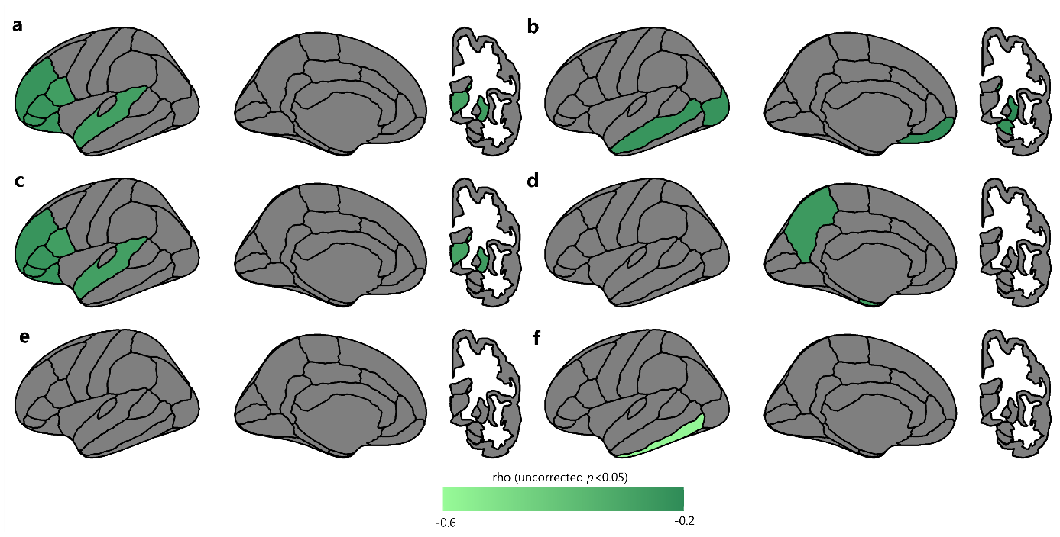
Uncorrected regional associations between postmortem arteriolosclerosis and in vivo (a) MRI-based cortical thickness and subcortical volume, (c) FDG PET-based standardized uptake value ratio and (e) ASL-based cerebral blood flow. Regional association between postmortem cerebral amyloid angiopathy and in vivo (b) MRI-based cortical thickness and subcortical volume, (d) FDG PET-based standardized uptake value ratio and (f) ASL-based cerebral blood flow. Regional values were averaged across left and right hemispheres. Partial correlations were adjusted for neuroimaging-to-postmortem interval and represented by rho for uncorrected p < 0.05.

