Supplementary Information
Title: Neuropathological measures of increased tau phosphorylation across the Down syndrome lifespan
Journal: Acta Neuropathologica
Authors: Jesse R Pascual¹, Isabel Rivera¹, Halyma Nguyen¹, Phong T Ngo¹, Alan Hoang¹, Elizabeth J Andrews¹, Jeremy Rouanet¹, Sierra T Wright¹, Lorena Sordo¹, Julia Kofler^{2,4}, Milos D Ikonomovic^{2,3,4,5}, Florence Lai⁶, Mark Mapstone⁷, Bradley T Christian⁸, Benjamin L Handen⁹, Ira T Lott¹⁰, Eric Doran¹⁰, Christy L Hom¹¹, Jordan Harp¹², Frederick Schmitt^{12,13}, Dana L Tudorascu⁹, Beau M Ances¹⁴, Michael Phelan¹, Lei Liu¹⁵, Lisi Flores-Aguilar¹, Elizabeth Head*¹, for the Alzheimer’s Biomarkers Consortium–Down Syndrome (ABC-DS) Investigators
*Corresponding Author:
Elizabeth Head, MA, PhD.
Department of Pathology and Laboratory Medicine, University of California, 1111 Gillespie Neuroscience Research Facility, Irvine, CA 92697, USA.
Email: heade@uci.edu

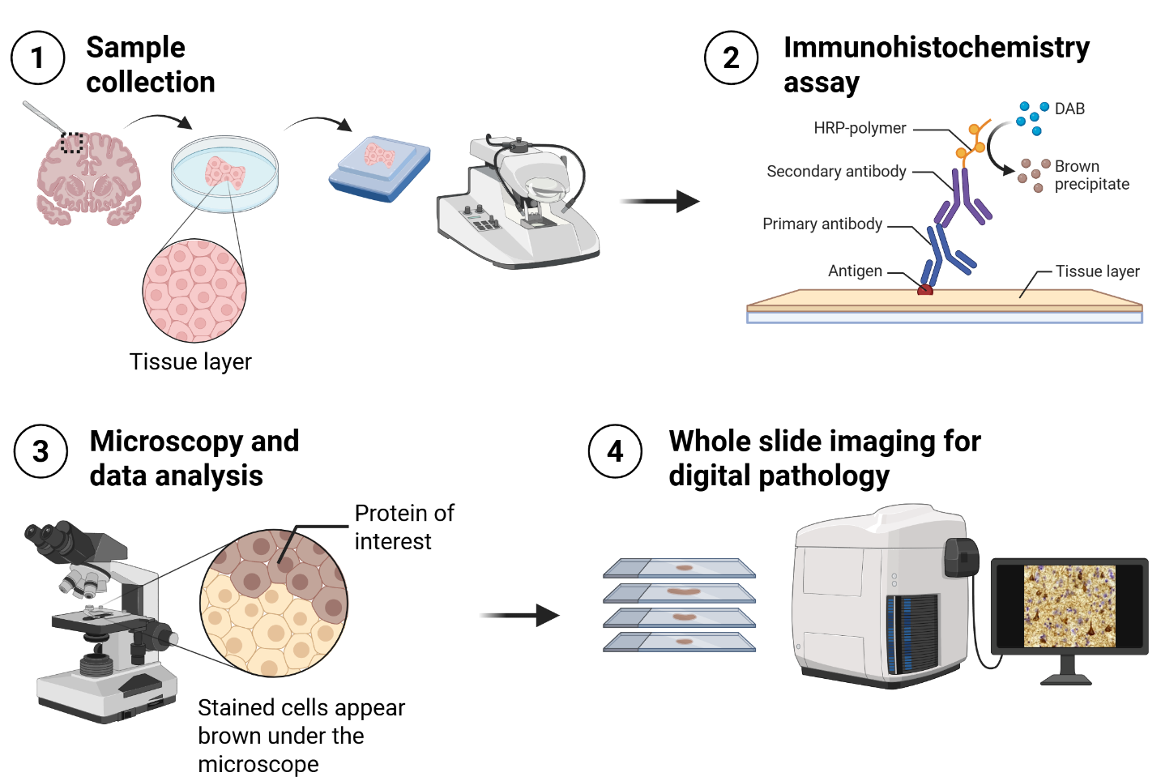
Figure S1 Overview of study design workflow. Study workflow for assessing p-tau epitope burdens in the human postmortem brain. Illustration created in BioRender. Rivera, I. (2025) https://BioRender.com/m040e04
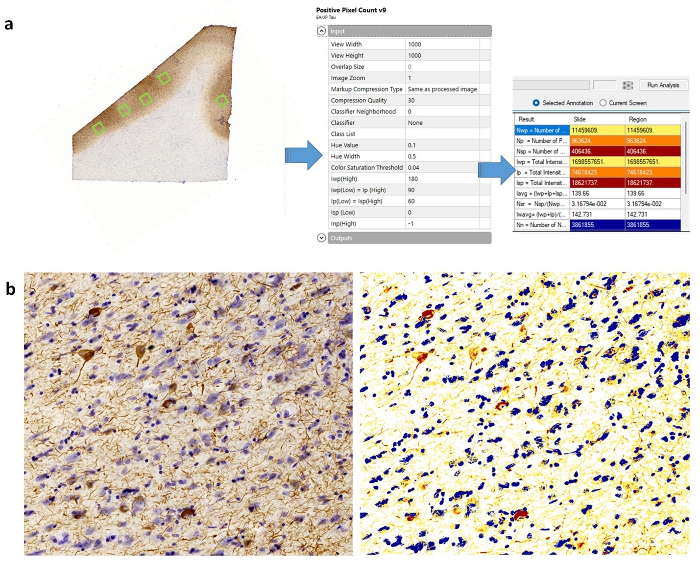
Figure S2 Analysis workflow. (a) The annotation process includes selecting ROIs and detecting positive pixel counts, illustrating input design and output signal positivity in Qupath. (b) The resulting IHC stain (left) and the overlay (right) illustrate how the positive pixel algorithm determines positive p-tau signal (in red/yellow) in relation to the cresyl violet, depicting nuclear staining of cells (in blue), which represents the negative pixels

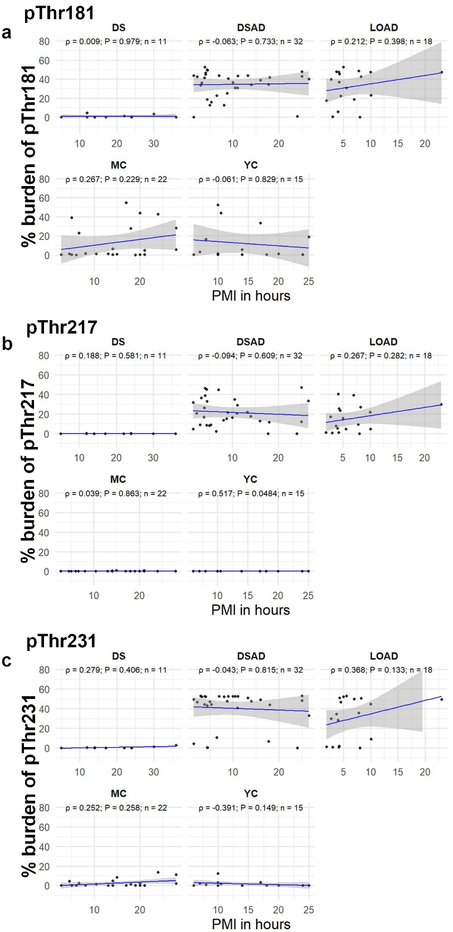
Figure S3 PMI to p-tau burden outcome measures. Spearman correlation plots for PMI to %burden of (a) pThr181, (b) pThr217, and (c) pThr231. Stratified by diagnostic group. Note: For YC, MC, and DS cases, the % burden of all p-tau values was low and represented noise. YC = young controls; MC = middle age controls; DS = young Down syndrome; DSAD = DS with AD neuropathology; LOAD = Late-onset AD; PMI = postmortem interval
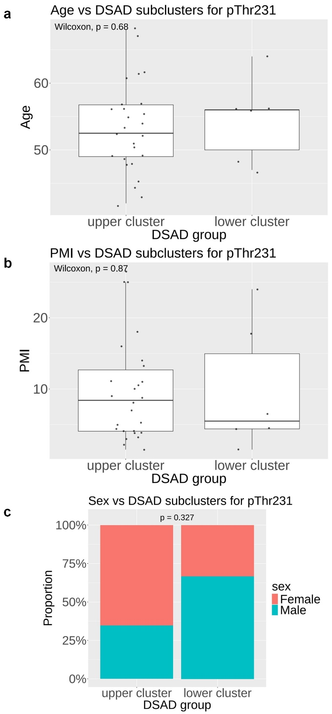
Figure S4 pThr231 burden in DSAD stratified into two clusters, independent of (a) age, (b) PMI, or (c) sex. Two subclusters identified: high pThr231 burden (upper cluster, n = 26) and low pThr231 burden (lower cluster, n = 6). Statistical comparisons were performed using the Mann-Whitney U (Wilcoxon) test for age and PMI, and a Pearson’s Chi-square test of independence for sex. DSAD = DS with AD neuropathology; PMI = postmortem interval
DSAD | pThr181 | pThr217 | pThr231
pThr181 | 1
pThr217 | .73 (p < .001) | 1
pThr231 | .38 (p = .04) | .49 (p = .004) | 1
LOAD | pThr181 | pThr217 | pThr231
pThr181 | 1
pThr217 | .57 (p = .02) | 1
pThr231 | .55 (p = .02) | .50 (p = .04) | 1

Table S1 Associations between pThr181, pThr217, and pThr231 within DSAD and LOAD. Partial Spearman correlations (r_{s}) are reported with p-values after adjusting for age in DSAD (n = 32) and LOAD (n = 18) groups. DSAD = DS with AD neuropathology. LOAD = Late-onset AD.

