Tau Oligomerization Induces Nuclear Lamina Invagination and Chromatin Remodeling in Alzheimer’s Disease
Shuo Yuan ^{1, 2#}, Nicholas Essepian ^{1#}, Rebecca Roberts ³, Eliana Sherman ^{1, 2}, Qingbo Wang ^{1, 2}, Alev Erisir ³, Lulu Jiang ^{1, 2, 4*}
¹ Department of Neuroscience, ² Center for Brain Immunology and Glia (BIG), University of Virginia School of Medicine, VA, USA 22908
³ Department of Psychology, University of Virginia, Charlottesville, VA, USA 22904
⁴Neuroscience Graduate Program, University of Virginia, Charlottesville, Virginia, USA
* Correspondence should be addressed to: jiang.lulu@virginia.edu
# These authors contributed equally.

Supplementary Materials

Supplementary Material-1:
Supplemental video-1: Live cell imaging of 30 minutes of blue light activation shows that mCherry particles move about randomly within the cell.

Supplementary Material-2
Supplemental video-2: Live cell imaging of 30 minutes of blue light activation shows that OptoTau granules quickly aggregated toward the nuclear envelope, leading to nuclear deformation.

Supplementary Material-3
Supplementary Figure 1. Additional statistical analyses of Lamin B and Lamin B Receptor levels in human brain samples.
a) Logarithmic regression analysis corresponding to Figure 1e. Logarithmic fitting was performed to evaluate the potential non-linear relationship between MC1 and Lamin B Receptor.
b) Quantification of Lamin B Receptor levels stratified into three age groups (59-74, 75-90, and >90 years old). One-way ANOVA showed no significant differences among groups (p = 0.5710, n≥7).
c) Comparison of LBR levels among control, control/asymptomatic AD, and AD cases. One-way ANOVA revealed a significant reduction in LBR levels in AD compared with controls (p = 0.0019, n≥7).
d) Scatter plot showing LBR levels plotted against age for all cases. Linear regression analysis revealed no significant correlation between LBR levels and age (p = 0.5710, n≥7).
e-f) Correlation between Lamin B2 levels and Tau5 or AT8. Lamin B2 levels were significantly negatively correlated with both AT8 and Tau5.
g-h) Correlation between Lamin B receptor levels and Tau5 or AT8. Although no statistically significant correlations were observed, Lamin B receptor levels exhibited a decreasing trend with increasing tau levels.

Supplementary Material-4
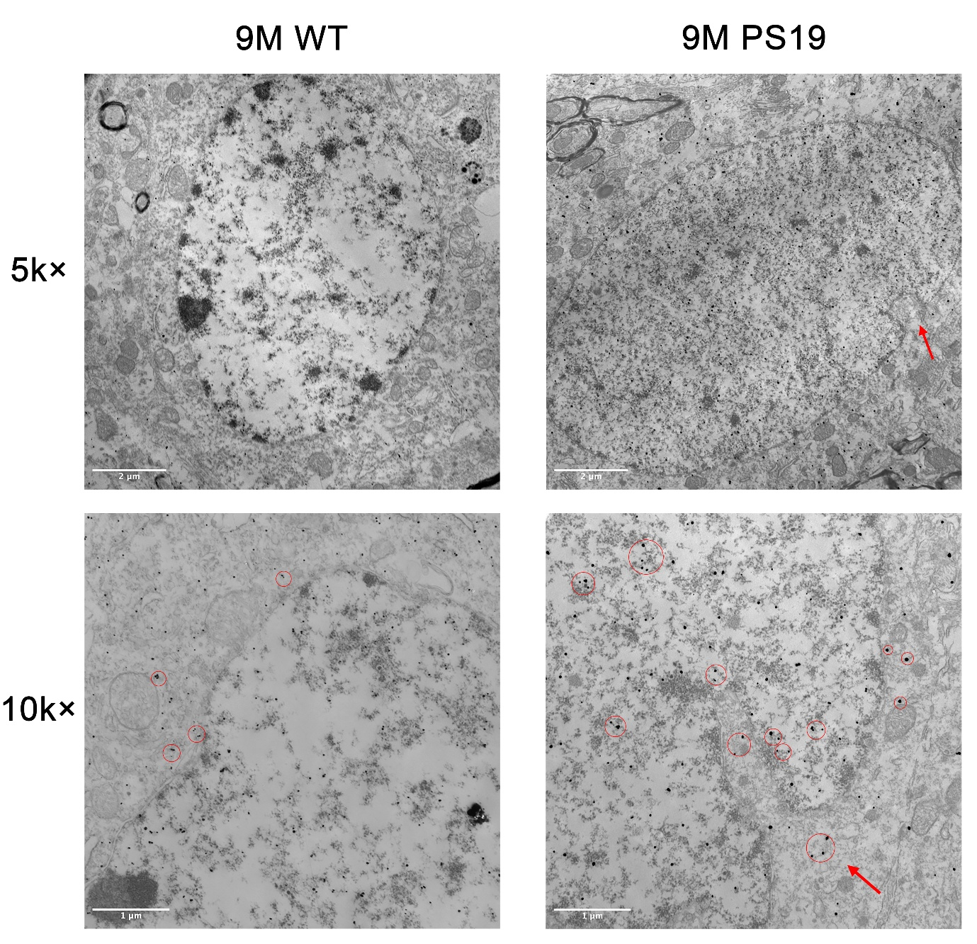
Supplemental Fig. 2. Representative micrographs showing MC1 immunostaining in WT and PS19 mice brain sections processed with gold-silver staining to visualize pathological Tau conformers. Images acquired at 5k× and 10k× magnifications highlight the distribution and morphology of silver-positive neuronal structures. Arrows indicate positive gold labeling with silver-enhanced immuno-EM signal corresponding to MC-1-positive tau aggregates.

Supplementary Material-5
Supplemental Fig. 3. OptoTau expressing neurons show pathological tau accumulation following prolonged 488λ blue light activation examined by Tau 5 antibody. Representative confocal images for co-localization of mCherry with Tau5 positive total tau level in iPSC induced Neuron. (63× magnifications, Cyan: DAPI; Red: mCherry; Green: Tau5; Magenta: TUJ1). The scale bar=50 µm.

Supplementary Material-6

Supplemental Fig. 4. OptoTau oligomerization drives sustained accumulation of pathological tau bound to the nuclear membrane in iPSC-derived neurons.
a) Quantification for the TUJ1 fluorescence intensity normalized by DAPI fluorescence intensity in Fig.2b.
b) Quantification for the TUJ1 fluorescence intensity normalized by DAPI fluorescence intensity in Fig.2c.
c) Quantification of pTau217–DAPI colocalization in Fig.2b. Bar graph shows the percentage of DAPI-positive nuclei exhibiting pTau217 signal.
d) Quantification of MC1–DAPI colocalization in Fig.2c. Bar graph shows the percentage of DAPI-positive nuclei exhibiting MC1 signal. N=5.

Supplementary Material-7
Supplemental Fig. 5. Tau phosphorylation induced by optogenetic oligomerization in human induced iPSCs.
a) Representative Western blot analysis of pTau217, AT8 and TOMA2 in human iPSC-derived neurons across experimental groups. Total cell lysates were collected from iPSC-derived neurons under control and optogenetic induction conditions. GAPDH was used as a loading control.
b-d) Quantification of Western blot results shown in panel a. Band intensities were quantified using ImageJ and normalized to the corresponding GAPDH loading control. Data are presented as fold-change relative to the mean of the control group (set to 1.0).
e) Immunoprecipitation of the optogenetically-induced tau complex with a 20-minute illumination paradigm. Lysates from iPSC-induced neurons expressing the optogenetic tau construct (fused to mCherry) were subjected to immunoprecipitation by ChromoTek RFP-Trap® Agarose. The presence of pTau217 and AT8 positive tau phosphorylation in the immunoprecipitated complex was assessed by Western blot.
f-g) Quantification of IP results shown in panel e. The pTau217 and AT8 enrichment in the mCherry immunoprecipitate. The band intensity for each protein in the co-IP lane was quantified for pulldown efficiency.

Supplementary Material-8
Table S1. Summary of Human Subject Metadata and Neuropathology. Clinical and pathological information for all human tissue samples, including diagnosis, Braak staging, age-related metrics, disease duration, APOE status, and demographic variables (race and sex).
Primary Neuropathologic Diagnosis | Braak Stage | Age at Onset | Age at Death/ Biopsy | Duration (years) | APOE | Race | Sex
Control | I |  | 59 |  | E2/3 | b | m
Control | I |  | 70 |  | E3/3 | b | m
Control | I |  | 72 |  | E3/3 | w | m
Control | II |  | 78 |  | E3/3 | w | f
Control | IV |  | 84 |  | E2/3 | b | f
Control | III |  | 91 |  | E3/3 | w | f
Control | III |  | 92 |  | E3/3 | w | f
Control | II |  | 94 |  | E3/3 | w | m
Control/asymptomatic AD | II |  | 64 |  | E4/4 | w | f
Control/asymptomatic AD | IV |  | 80 |  | E3/4 | w | m
Control/asymptomatic AD | II |  | 81 |  | E3/3 | w | m
Control/asymptomatic AD | I |  | 87 |  | E3/4 | w | m
Control/asymptomatic AD | III |  | 87 |  | E2/3 | w | f
Control/asymptomatic AD | IV |  | 89 |  | E3/3 | w | m
Control/asymptomatic AD | IV |  | 91 |  | E3/3 | w | m
AD | VI | 49 | 59 | 10 | E3/3 | w | m
AD | VI | 59 | 69 | 10 | E3/4 | w | m
AD | VI | 53 | 71 | 18 | E3/4 | w | m
AD | VI | 65 | 80 | 15 | E3/4 | b | f
AD | V | 77 | 83 | 6 | NA | w | f
AD | V | 86 | 92 | 6 | E3/4 | w | f
AD | V | 82 | 92 | 10 | E3/3 | w | m
AD | VI | 80 | 93 | 13 | E3/4 | w | f

Supplementary Material-9
Table S2. Antibodies and Reagents. Comprehensive list of antibodies employed for detection. (a) Primary antibodies categorized by target, source, and experimental concentration. (b) Secondary antibodies used for signal visualization, including host species and conjugation details.
(a) Primary Antibody Information
Name | Host | Target | Dilution Factor | Storage | Source | Catalog
LBR Rabbit PolyAb | Rabbit | Lamin B Receptor | 1:500 IHC; 1:1000 ICC | -20°C | Proteintech | 12398-1-AP
AT8 Phosphotau Monoclonal Ab | Mouse | Phosphorylated tau | 1:1000 WB; 1:500 IHC; 1:500 ICC | -20°C | Invitrogen | MN1020
GAPDH Mouse McAb | Mouse | GAPDH (Control) | 1:1000 WB | -20°C | Proteintech | 60004-1-Ig
Lamin B2 Rabbit mAb | Rabbit | LaminB2 | 1:1000 WB | -20°C | Cell Signaling Tech | E1S1Q
Lamin B2 | Mouse | LaminB2 | 1:400 IHC; 1:500 ICC | -20°C | Invitrogen | 33-2100
Tau5 | Mouse | Phosphorylated tau | 1:400 IHC; 1:400 ICC | -20°C | Millipore | MAB361
PTau 217 Polyclonal Ab | Rabbit | Phosphorylated tau | 1:400 IHC; 1:500 ICC | -20°C | Invitrogen | 44-744
TOMA2 | Mouse | Phosphorylated oligomeric tau | 1:500 IHC | -20°C | Collaborator Dr. Rakez Kayed lab
Tuj1 Beta Tubulin III | Chicken | Neurons | 1:500 ICC | 4°C | Aves | TUJ
MAP-2 | Chicken | Neuronal processes | 1:400 IHC | 4°C | Aves | MAP
mCherry mAb (16D7) | Rat | mCherry | 1:500 ICC | -20°C | Invitrogen | M11217
DAPI | Stain | Nuclei | 1:5000 IHC; 1:10000 ICC | -20°C | Thermo Fisher Scientific | 62248
MC1 | Mouse | misfolded tau | 1:500 WB; 1:300 IHC | -20°C, -80°C | The Feinstein Institutes for Medical Research | NA
PHF-1 | Mouse | anti-tau pS396 (late); insoluble paired helical filaments (PHFs) | 1:500 WB; 1:300 IHC | -20°C, -80°C | The Feinstein Institutes for Medical Research | NA

(b) Secondary Antibody Information
Name | Host | Type | Dilution Factor | Storage | Source | Catalog
Goat anti-Rabbit IgG (H+L) | Rabbit | Alexa Fluor 488 | 2mg/mL | 4°C | Invitrogen | A11008
Goat anti-Rabbit IgG (H+L) | Rabbit | Alexa Fluor 594 | 2mg/mL | 4°C | Invitrogen | A11012
Goat anti-Rabbit IgG (H+L) | Rabbit | hRPC | 1:5000 WB | -20°C | Invitrogen | G21234
Goat anti-rat IgG (H+L) | Rat | Alexa Fluor 488 | 2mg/mL | 4°C | Invitrogen | A11006
Goat anti-Rat IgG (H+L) | Rat | Alexa Fluor 594 | 2mg/mL | 4°C | Invitrogen | A11008
Goat anti-rat IgG (H+L) | Rat | hRPC | 1:5000 WB | -20°C | Invitrogen | A10549
Goat anti-Mouse IgG (H+L) | Mouse | Alexa Fluor 405 | 2mg/mL | 4°C | Invitrogen | A48255
Goat anti-Mouse IgG (H+L) | Mouse | Alexa Fluor 488 | 1mg/mL | 4°C | Invitrogen | A28175
Goat anti-Mouse IgG (H+L) | Mouse | Alexa Fluor 594 | 2mg/mL | 4°C | Invitrogen | A11032
Goat anti-Mouse IgG (H+L) | Mouse | hRPC | 1:5000 WB | -20°C | Invitrogen | G21040
Goat anti-Chicken IgG (H+L) | Chicken | Alexa Fluor 488 | 2mg/mL | 4°C | Invitrogen | A11039
Goat anti-Chicken IgG (H+L) | Chicken | Alexa Fluor 594 | 2mg/mL | 4°C | Invitrogen | A11007
Goat anti-Chicken IgG (H+L) | Chicken | Alexa Fluor Plus 647 | 2mg/mL | 4°C | Invitrogen | A32933
Goat anti-Chicken IgY (H+L) | Chicken | hRPC | 1:5000 WB | -20°C | Invitrogen | A16054

