Supplementary Table 1. Demographic characteristics of the brain samples from UCSD
AGE at visit | SEX | APOE ε4 | MMSE | BRAAK | THAL | Pathology Diagnosis
92 | F | 33 | 27 | 5 | 4 | Alzheimer’s disease
83 | F | 33 | 14 | 4 | NA | Alzheimer's disease; Diffuse Lewy body disease
93 | M | 33 | 25 | 1 | 0 | Lewy body disease- limbic (transitional) type; Microinfarcts, old
59 | F | 33 | 9 | 1 | 1 | Frontotemporal dementia; Hippocampal sclerosis
71 | F | 44 | 13 | 6 | 5 | Alzheimer's disease; Amyloid angiopathy; Lewy body pathology, limbic (transitional) type; TDP-43 proteinopathy
70 | F | 34 | 22 | 2 | NA | Diffuse Lewy body disease; Alzheimer's changes
76 | M | 33 | 16 | 6 | 5 | Alzheimer's disease; Amyloid angiopathy; Lewy body pathology, neocortical (diffuse) type
89 | M | 33 | 23 | 2 | 5 | Lewy body disease- brain stem predominant type; Alzheimer's changes; Microinfarcts, old.
83 | M | 34 | 30 | 6 | 5 | Alzheimer’s disease
81 | M | 44 | 26 | 4 | 5 | Lewy body disease- neocortical (diffuse) type; Alzheimer's disease
77 | M | 34 | 12 | 3 | 4 | Lewy body pathology, neocortical (diffuse); Alzheimer's disease; TDP-43 proteinopathy
83 | F | 33 | 25 | 3 | 4 | Alzheimer's disease; Lewy body disease- neocortical (diffuse) type
70 | M | 34 | 24 | 3 | 4 | Alzheimer's disease; Lewy body disease- neocortical (diffuse) type
71 | M | 34 | 12 | 5 | 5 | Alzheimer’s disease; Amyloid angiopathy; Lewy body pathology, amygdala predominant type; TDP-43 proteinopathy
89 | F | 33 | 26 | 2 | 5 | Alzheimer’s changes
79 | M | 23 | 29 | 2 | 0 | Normal Control
Abbreviations: Apolipoprotein E (APOE); Tau classification according to Braak staging (BRAAK)
mini-mental state examination(MMSE); TAR-DNA binding protein 43 (TDP-43)

Supplementary Table 2. Demographic characteristics of the amyloid-negative biomarker subcohort
 | FTLDtau | FTLDTDP | αSyn | Normal | p | Missing
n | 24 | 29 | 12 | 41
Age at Onset (years) | 65.0 [59.0, 70.0] | 60.0 [55.0, 64.5] | 61.5 [57.0, 66.0] | -- | 0.152 | 42
Age at CSF (years) | 69.5 [62.5, 72.0] | 63.0 [58.0, 68.0] | 71.0 [67.2, 78.2] | 66.0 [61.0, 70.0] | 0.019 | --
Age at Death (years) | 72.0 [66.0, 76.5] | 66.0 [60.5, 73.0] | 78.5 [73.2, 81.0] | 76.0 [76.0, 76.0] | 0.014 | 43
CSF to Death (years) | 4.0 [2.0, 5.5] | 4.0 [2.5, 5.0] | 4.5 [1.8, 6.2] | 6.0 [6.0, 6.0] | 0.711 | 43
Sex = Male (%) | 13 (54.2%) | 16 (55.2%) | 11 (91.7%) | 13 (31.7%) | 0.003 | --
Self-reported Race (%) |  |  |  |  | 0.045 | --
Asian | 0 | 1 (3.4%) | 0 | 0
Black or African American | 0 | 1 (3.4%) | 0 | 9 (22.0%)
More than one Race | 0 | 1 (3.4%) | 0 | 2 (4.9%)
White | 24 (100.0%) | 26 (89.7%) | 12 (100.0%) | 30 (73.2%)
ClinicalDx (%) |  |  |  |  | <0.001 | --
Normal | 0 | 0 | 0 | 41 (100.0%)
Amnestic | 2 (8.3%) | 0 | 1 (8.3%) | 0
CBS | 5 (20.8%) | 1 (3.4%) | 0 | 0
lvPPA | 2 (8.3%) | 0 | 0 | 0
naPPA | 2 (8.3%) | 2 (6.9%) | 0 | 0
svPPA | 0 | 1 (3.4%) | 0 | 0
bvFTD | 10 (41.7%) | 16 (55.2%) | 0 | 0
ALS | 0 | 5 (17.2%) | 0 | 0
PSP | 3 (12.5%) | 0 | 0 | 0
PD/PDD | 0 | 0 | 10 (83.3%) | 0
DLB | 0 | 0 | 1 (8.3%) | 0
Vascular | 0 | 1 (3.4%) | 0 | 0
Dementia NOS | 0 | 3 (10.3%) | 0 | 0
Mutation (%) |  |  |  |  | <0.001 | --
None | 18 (75.0%) | 13 (44.8%) | 12 (100.0%) | 41 (100.0%)
C9orf72 | 0 | 10 (34.5%) | 0 | 0
GRN | 0 | 5 (17.2%) | 0 | 0
MAPT | 6 (25.0%) | 0 | 0 | 0
TARDBP | 0 | 1 (3.4%) | 0 | 0
ADNC = Low (%) | 15 (71.4%) | 10 (50.0%) | 9 (75.0%) | -- | -- | 53
Thal Phase (%) |  |  |  |  | -- | 52
0 | 6 (27.3%) | 10 (50.0%) | 3 (25.0%) | --
1 | 12 (54.5%) | 7 (35.0%) | 5 (41.7%) | --
2 | 4 (18.2%) | 3 (15.0%) | 4 (33.3%) | --
Brain tau burden | 2.0 [1.8, 2.4] | 0.5 [0.2, 1.0] | 0.7 [0.6, 1.1] | -- | <0.001 | 55
CSF p-tau181 | 40.5 [30.8, 47.1] | 28.9 [22.9, 32.3] | 25.8 [21.9, 31.6] | 28.2 [23.1, 32.8] | 0.004 | 18
CSF t-tau | 56.0 [45.8, 79.2] | 58.0 [44.0, 83.0] | 36.0 [26.5, 49.0] | 44.0 [37.0, 57.7] | 0.001 | --
CSF p-tau212 | 7.6 [5.1, 12.9] | 3.6 [2.1, 4.8] | 3.8 [3.0, 4.6] | 4.4 [3.1, 7.0] | <0.001 | 2
CSF tau368 | 15.7 [13.4, 20.3] | 16.2 [13.8, 21.5] | 13.8 [10.3, 17.7] | 17.6 [14.8, 19.8] | 0.441 | 4
CSF p-tau212/tau368 | 0.6 [0.3, 0.8] | 0.2 [0.2, 0.3] | 0.3 [0.2, 0.4] | 0.3 [0.2, 0.4] | <0.001 | 6
CSF p-tau181/tau368 | 2.5 [2.1, 2.8] | 1.8 [1.6, 1.9] | 2.1 [1.3, 2.5] | 1.5 [1.3, 2.0] | <0.001 | 22
CSF Aβ42/Aβ40 | 0.091 [0.081, 0.095] | 0.090 [0.078, 0.097] | 0.094 [0.088, 0.100] | 0.098 [0.094, 0.103] | 0.006 | 18
CSF tau368/t-tau | 0.287 [0.216, 0.366] | 0.285 [0.236, 0.330] | 0.381 [0.314, 0.581] | 0.378 [0.327, 0.466] | <0.001 | 4
CSF p-tau212/t-tau | 0.160 [0.097, 0.218] | 0.061 [0.043, 0.076] | 0.117 [0.089, 0.159] | 0.104 [0.084, 0.135] | <0.001 | 2
CSF p-tau181/t-tau | 0.605 [0.568, 0.810] | 0.468 [0.377, 0.601] | 0.708 [0.592, 0.971] | 0.614 [0.532, 0.680] | 0.002 | 18
Abbreviations: Amyloid-β (Aβ); Amyotrophic Lateral Sclerosis (ALS); Alzheimer’s Disease (AD); Alzheimer’s Disease neuropathologic change (ADNC); Behavioural variant of Frontotemporal lobar degeneration (bvFTD); Cerebrospinal Fluid (CSF); chromosome 9 open reading frame 72 (C9orf72); clinically healthy individuals without cognitive impairment (normal); Corticobasal Syndrome (CBS); Frontotemporal Lobar Degeneration type tau (FTLD-Tau), Frontotemporal Lobar Degeneration type TDP (FTLD-TDP): Granulin (GRN); Lewy body disease (LBD); Lewy body disease with alpha-synuclein/Parkinson’s Disease (NSD; αSyn) and Lewy body disease with alpha-synuclein/Parkinson’s Disease with concominant AD co-pathology (NSD+AD; αSyn+AD); Microtubule-associated protein Tau (MAPT); Mild-Cognitive Impairment (MCI); Parkinson’s Disease (PD); Phosphorylated-tauX (p-tauX); Presenilin1 (PSEN); Primary Progressive Aphasia (PPA); Progressive Supranuclear Palsy (PSP); total-tau (t-tau).
Supplementary Table 3. Receiver operating characteristic curves (ROC) to discriminate Alzheimer’s Disease (AD) from other participants.
AD vs. Not | AUC | AUC 95% CI | Threshold | Threshold 95% CI | Sensitivity | Specificity | Accuracy
ptau212/tau368 | 0.94 | 0.90 – 0.97 | 0.95 | 0.65 – 1.16 | 0.81 | 0.90 | 0.84
ptau181/tau368 | 0.94 | 0.89 – 0.99 | 3.15 | 2.82 – 3.40 | 0.90 | 0.93 | 0.91
ptau212 | 0.92 | 0.87 – 0.96 | 16.29 | 11.37 – 21.37 | 0.80 | 0.90 | 0.84
ptau181 | 0.91 | 0.85 – 0.97 | 54.72 | 46.18 – 61.33 | 0.82 | 0.92 | 0.87
p-tau212/t-tau | 0.89 | 0.83 – 0.95 | 0.22 | 0.18 – 0.25 | 0.81 | 0.88 | 0.84
p-tau181/t-tau | 0.83 | 0.74 – 0.92 | 0.75 | 0.68 – 0.85 | 0.84 | 0.75 | 0.80
tau368/t-tau | 0.79 | 0.70 – 0.87 | 0.26 | 0.21 – 0.30 | 0.74 | 0.66 | 0.70
t-tau | 0.78 | 0.70 – 0.85 | 66.93 | 58.06 – 88.94 | 0.71 | 0.70 | 0.71
tau368 | 0.60 | 0.48 – 0.70 | 18.58 | 14.36 – 23.87 | 0.40 | 0.64 | 0.50

Supplementary Table 4. Areas under the curve to discriminate FTLD-tau from FTLD-TDP in amyloid-negative subcohort. A. FTLD-tau excluding PSP (n=102), and B. FTLD-tau including PSP (n=106).

A.  FTLD-Tau vs. FTLD-TDP | AUC | AUC 95% CI | Threshold | Threshold 95% CI | Sensitivity | Specificity | Accuracy
p-tau212/t-tau | 0.88 | 0.76 – 0.97 | 0.11 | 0.08 – 0.15 | 0.76 | 0.90 | 0.83
p-tau212/tau368 | 0.86 | 0.72 – 0.96 | 0.36 | 0.24 – 0.54 | 0.74 | 0.85 | 0.79
p-tau212 | 0.85 | 0.71 – 0.95 | 6.13 | 4.59 – 8.86 | 0.76 | 0.85 | 0.80
p-tau181/tau368 | 0.84 | 0.68 – 0.97 | 2.06 | 1.93 – 2.28 | 0.78 | 0.82 | 0.80
p-tau181 | 0.81 | 0.66 – 0.94 | 32.21 | 28.05 – 37.18 | 0.70 | 0.76 | 0.73
p-tau181/t-tau | 0.75 | 0.57 – 0.90 | 0.57 | 0.49 – 0.68 | 0.70 | 0.65 | 0.68
tau368 | 0.53 | 0.35 – 0.72 | 15.21 | 12.52 – 18.93 | 0.60 | 0.55 | 0.58
t-tau | 0.51 | 0.33 – 0.68 | 75.85 | 50.96 – 106.92 | 0.68 | 0.35 | 0.52
tau368/t-tau | 0.50 | 0.32 – 0.68 | 0.33 | 0.21 – 0.42 | 0.35 | 0.60 | 0.48

B.  FTLD-Tau vs. FTLD-TDP  (Including PSP) | AUC | AUC 95% CI | Threshold | Threshold 95% CI | Sensitivity | Specificity | Accuracy
p-tau212/t-tau | 0.96 | 0.89 – 1.00 | 0.11 | 0.08 – 0.15 | 0.88 | 0.90 | 0.89
p-tau212/tau368 | 0.95 | 0.87 – 1.00 | 0.37 | 0.26 – 0.54 | 0.88 | 0.85 | 0.86
p-tau212 | 0.94 | 0.86 – 0.99 | 5.94 | 4.63 – 8.65 | 0.88 | 0.85 | 0.86
p-tau181/tau368 | 0.93 | 0.81 – 1.00 | 2.06 | 1.92 – 2.30 | 0.87 | 0.82 | 0.84
p-tau181 | 0.80 | 0.63 – 0.94 | 34.10 | 28.79 – 39.13 | 0.62 | 0.82 | 0.73
p-tau181/t-tau | 0.72 | 0.54 – 0.88 | 0.57 | 0.46 – 0.73 | 0.62 | 0.65 | 0.64
tau368/t-tau | 0.56 | 0.37 – 0.75 | 0.28 | 0.22 – 0.35 | 0.53 | 0.55 | 0.54
tau368 | 0.50 | 0.31 – 0.69 | 14.97 | 11.70 – 18.92 | 0.65 | 0.55 | 0.59
t-tau | 0.48 | 0.30 – 0.67 | 75.26 | 44.20 – 110.12 | 0.61 | 0.35 | 0.47

Supplementary Table 5. Areas under the curve to discriminate FTLD-tau from other participants in amyloid-negative subcohort. A. FTLD-tau excluding PSP (n=102), and B. FTLD-tau including PSP (n=106).
A.  FTLD-Tau vs. Not | AUC | AUC 95% CI | Threshold | Threshold 95% CI | Sensitivity | Specificity | Accuracy
p-tau181/tau368 | 0.88 | 0.80 – 0.95 | 2.12 | 1.95 – 2.35 | 0.87 | 0.74 | 0.77
p-tau212/tau368 | 0.87 | 0.79 – 0.94 | 0.42 | 0.28 – 0.58 | 0.78 | 0.81 | 0.80
p-tau212 | 0.84 | 0.74 – 0.92 | 6.41 | 4.63 – 9.36 | 0.74 | 0.75 | 0.75
p-tau212/t-tau | 0.80 | 0.68 – 0.90 | 0.13 | 0.10 – 0.16 | 0.68 | 0.79 | 0.77
p-tau181 | 0.77 | 0.63 – 0.90 | 36.32 | 30.80 – 42.17 | 0.62 | 0.84 | 0.80
tau368/t-tau | 0.70 | 0.55 – 0.84 | 0.28 | 0.23 – 0.33 | 0.53 | 0.75 | 0.71
t-tau | 0.63 | 0.49 – 0.76 | 55.96 | 45.13 – 72.85 | 0.65 | 0.62 | 0.63
p-tau181/t-tau | 0.58 | 0.42 – 0.74 | 0.69 | 0.52 – 0.90 | 0.38 | 0.75 | 0.68
tau368 | 0.55 | 0.40 – 0.70 | 14.85 | 10.42 – 19.35 | 0.42 | 0.62 | 0.59

B.  FTLD-Tau vs. Not (Including PSP) | AUC | AUC 95% CI | Threshold | Threshold 95% CI | Sensitivity | Specificity | Accuracy
p-tau181/tau368 | 0.83 | 0.73 – 0.91 | 2.06 | 1.83 – 2.32 | 0.78 | 0.73 | 0.74
p-tau212/tau368 | 0.78 | 0.64 – 0.89 | 0.44 | 0.30 – 0.60 | 0.62 | 0.84 | 0.79
p-tau212 | 0.76 | 0.64 – 0.88 | 6.52 | 4.74 – 9.52 | 0.61 | 0.79 | 0.75
p-tau181 | 0.76 | 0.64 – 0.88 | 33.53 | 28.81 – 39.34 | 0.65 | 0.78 | 0.75
p-tau212/t-tau | 0.72 | 0.59 – 0.84 | 0.13 | 0.11 – 0.16 | 0.57 | 0.80 | 0.75
tau368/t-tau | 0.66 | 0.52 – 0.79 | 0.29 | 0.23 – 0.37 | 0.55 | 0.70 | 0.67
t-tau | 0.62 | 0.48 – 0.74 | 51.25 | 42.44 – 66.84 | 0.67 | 0.59 | 0.60
p-tau181/t-tau | 0.61 | 0.47 – 0.74 | 0.64 | 0.54 – 0.78 | 0.45 | 0.63 | 0.59
tau368 | 0.52 | 0.38 – 0.66 | 15.18 | 10.59 – 20.98 | 0.50 | 0.60 | 0.58

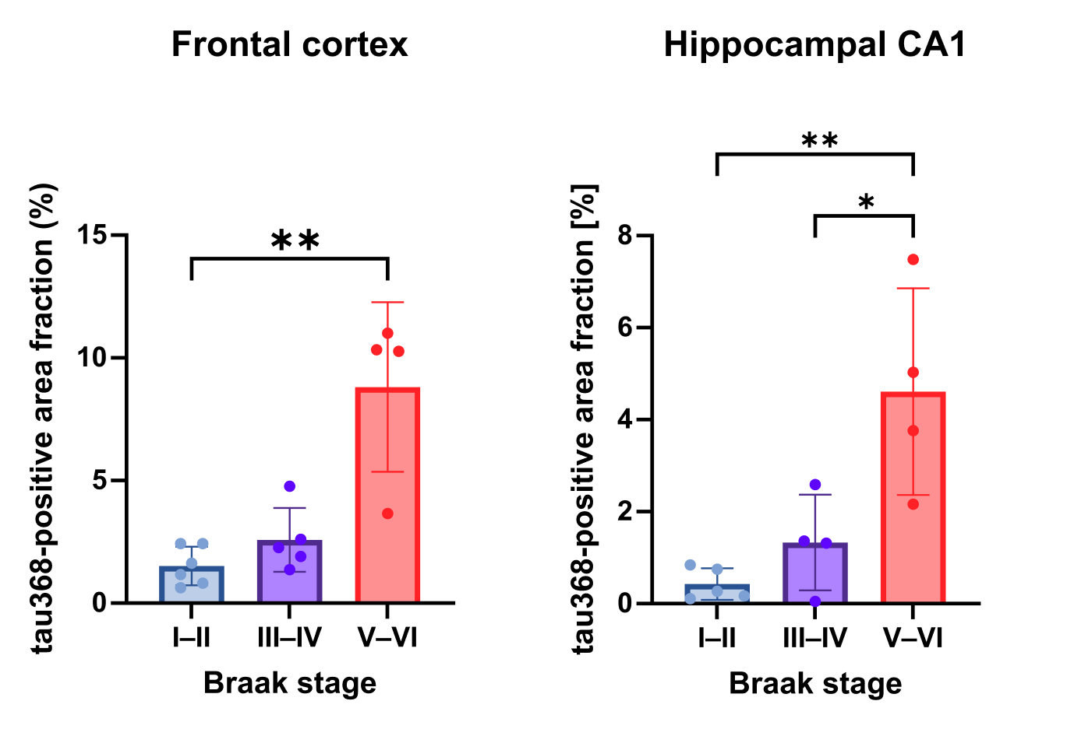

Supplementary Figure 1. Quantification of tau368-positive area fraction across Braak stage groups in frontal cortex and hippocampal CA1.
Tau368-positive area fraction was quantified in post-mortem brain sections from the frontal cortex and hippocampal CA1 and grouped by Braak stage as I–II, III–IV, and V–VI. Bars represent group mean ± SD, and dots represent individual cases. In the frontal cortex, tau368-positive area fraction was higher in Braak V–VI than in Braak I–II. In hippocampal CA1, tau368-positive area fraction was higher in Braak V–VI than in both Braak I–II and Braak III–IV. Statistical comparisons are indicated on the graph: * p < 0.05; ** p < 0.01.

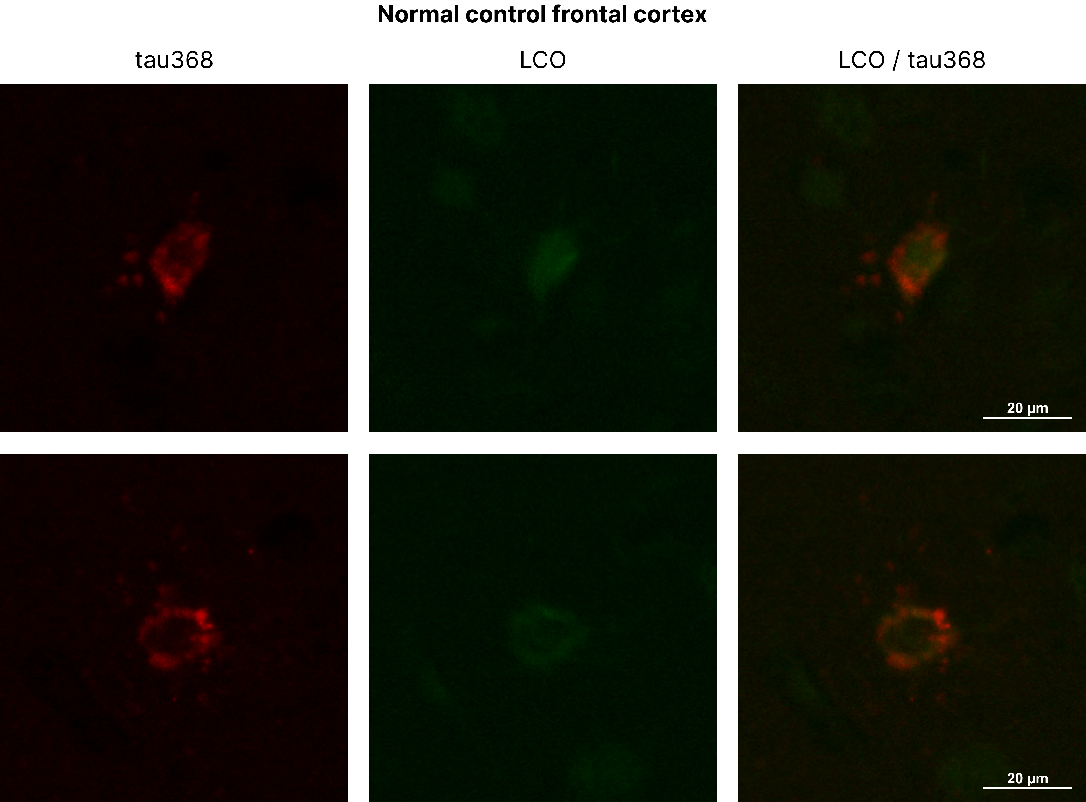Supplementary Figure 2. Tau368 and LCO staining in the normal control frontal cortex.
Representative immunofluorescence images from normal control frontal cortex showing rare tau368-positive cells with faint staining and no detectable LCO signal. This finding supports the interpretation that sparse tau368 immunoreactivity may be present at low levels in control tissue without a corresponding LCO-positive fibrillar tau signal. Scale bars: 20 µm.

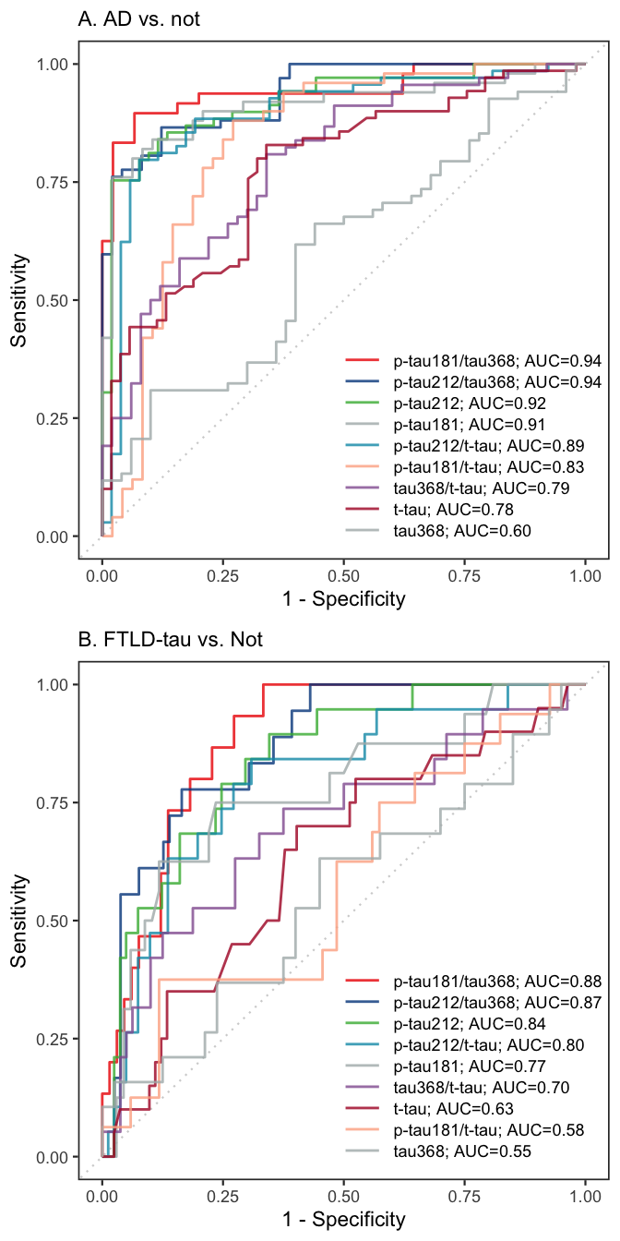
Supplementary Figure 3. Receiver operating characteristic curves (ROC) to discriminate (a) Alzheimer’s disease (AD) from other participants (b) discriminate FTLD-Tau from non-Tau participants.

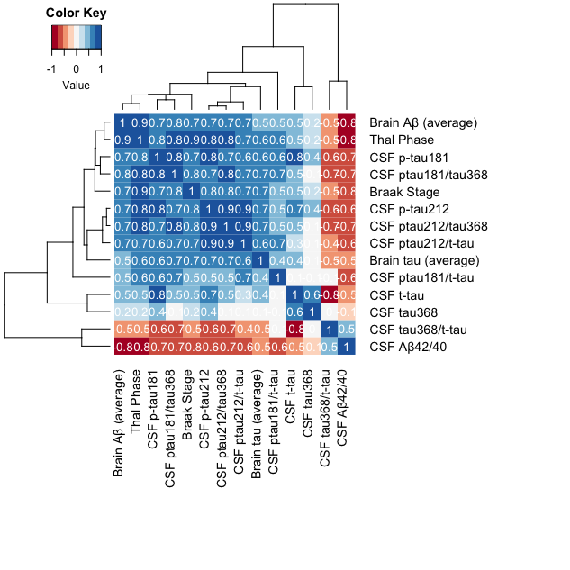
Supplementary Figure 4. Correlation of tau biomarkers with ADNC and CSF Aβ42/40 ratio in the whole cohort. The matrix presents Spearman correlations of tau biomarkers with Thal Phase, Braak Stage, Brain Tau (averaged over sampled regions), Brain Amyloid (averaged over sampled regions), and CSF Aβ42/40 ratio. Spearman’s rho is reported. White cells indicate p>0.05.

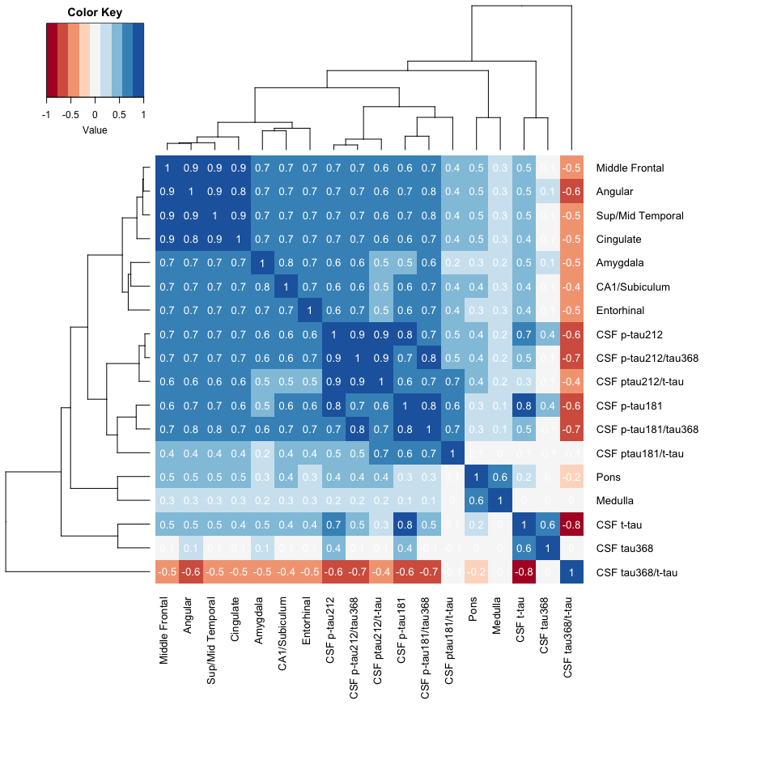
Supplementary Figure 5. Correlations with regional brain tau burden in the whole cohort. Spearman correlations tested associations between tau biomarkers and tau burden across the brain regions. Spearman’s rho is reported. White cells indicate p>0.05.

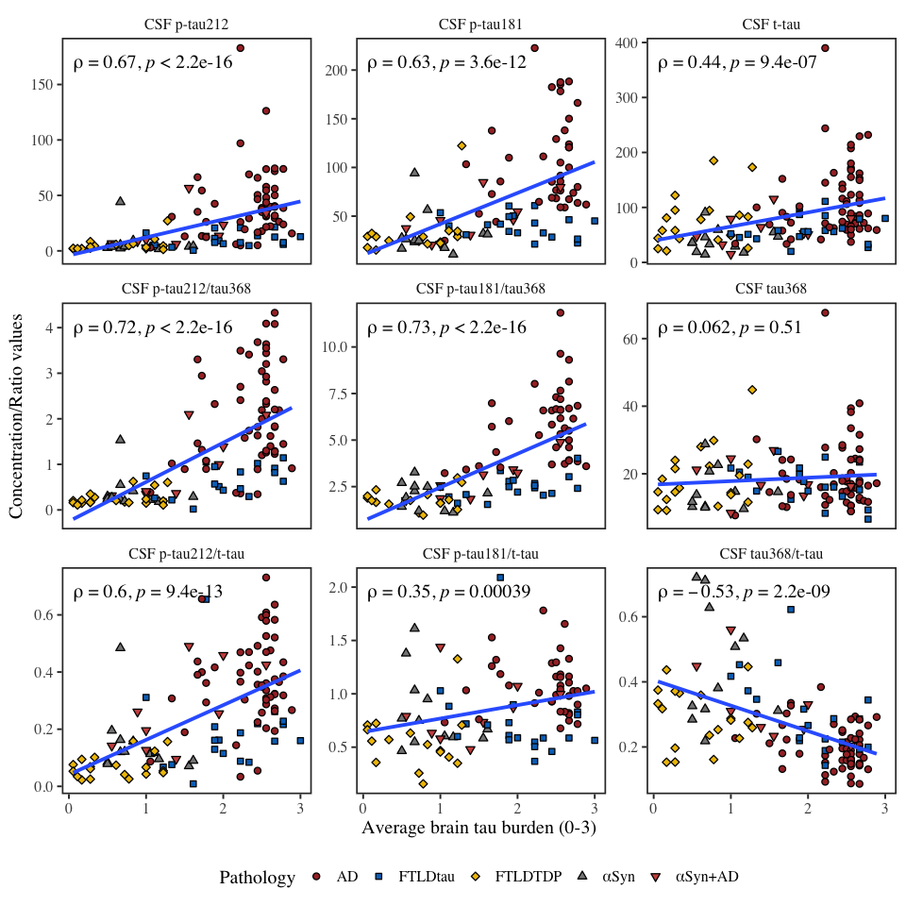
Supplementary Figure 6. Average correlations of tau biomarkers with brain tau burden in whole cohort. The Figure shows Spearman correlations between CSF biomarkers and average brain tau burden.

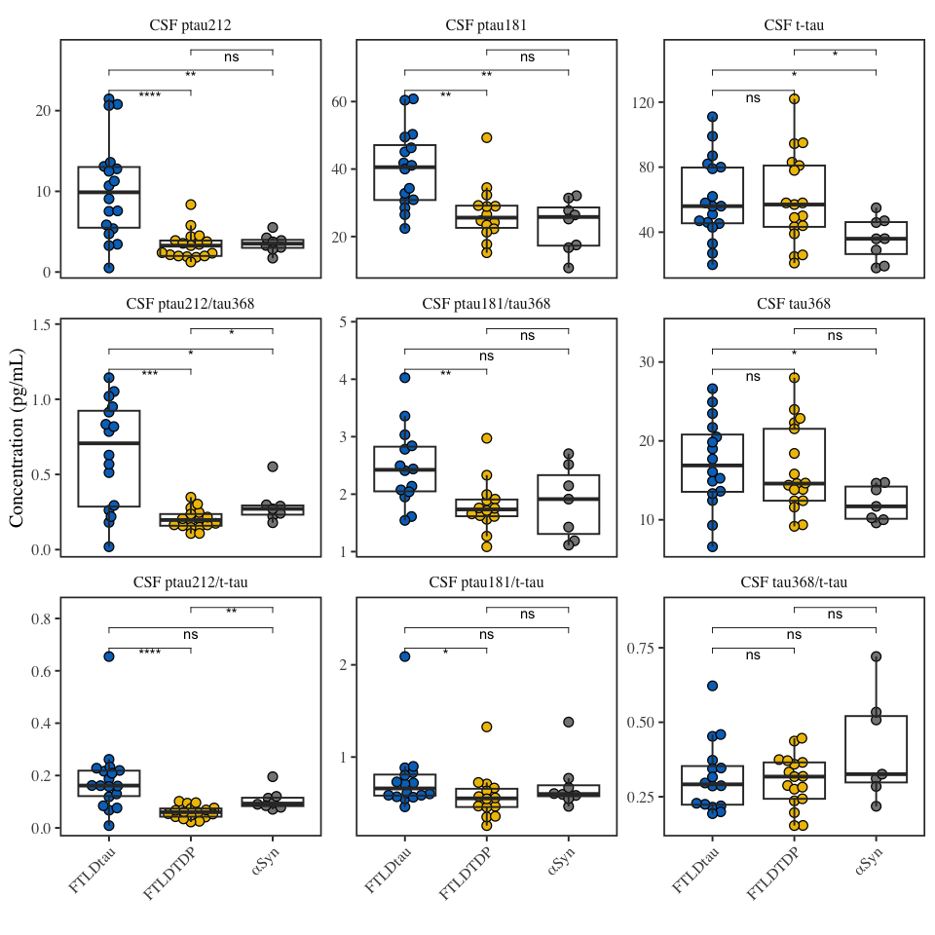
Supplementary Fig 7. CSF tau biomarkers levels in ADNC-negative & Thal Phase < 2 neurodegenerative diseases. The figure shows levels of tau biomarkers in FTLD-tau (n=18), FTLD-TDP (n=17) and αSyn (n=8) when intermediate and high ADNC and Thal Phases 2≥ are excluded. *; **; ***;**** represent p<0.05; p<0.01; p<0.001; p<0.0001 respectively.

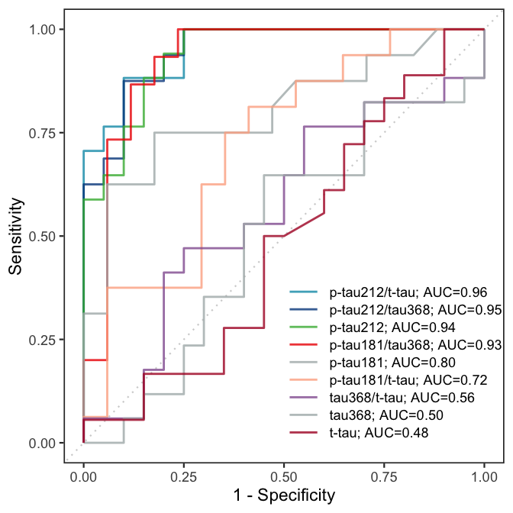
Supplementary Fig. 8. Receiver operating characteristic curves (ROC) to discriminate FTLD-tau from other participants in ADNC-negative subcohort. Excluding PSP (n=102).

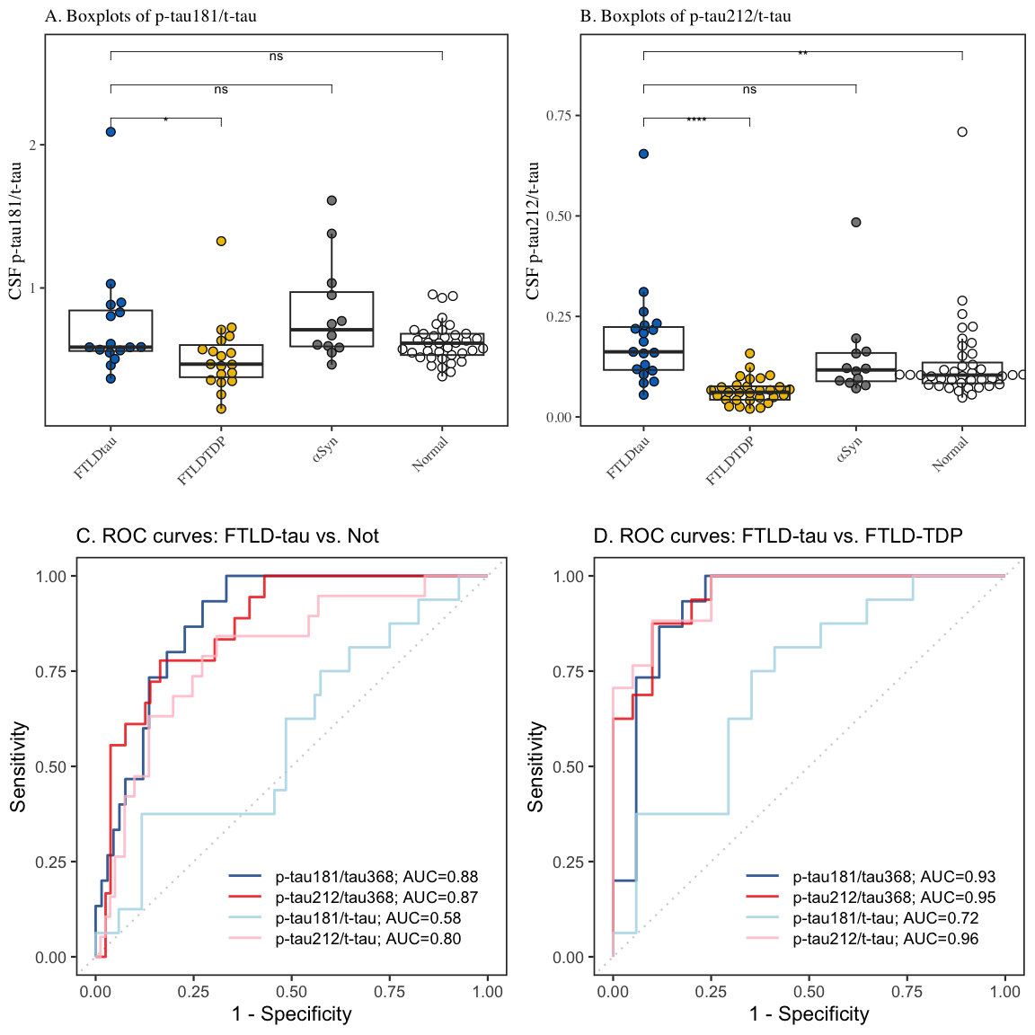
Supplementary Fig. 9. Boxplots and receiver operating characteristic curves (ROC) of CSF p-tau181/t-tau and p-tau212/t-tau in ADNC-negative subcohort. Excluding PSP (n=102).

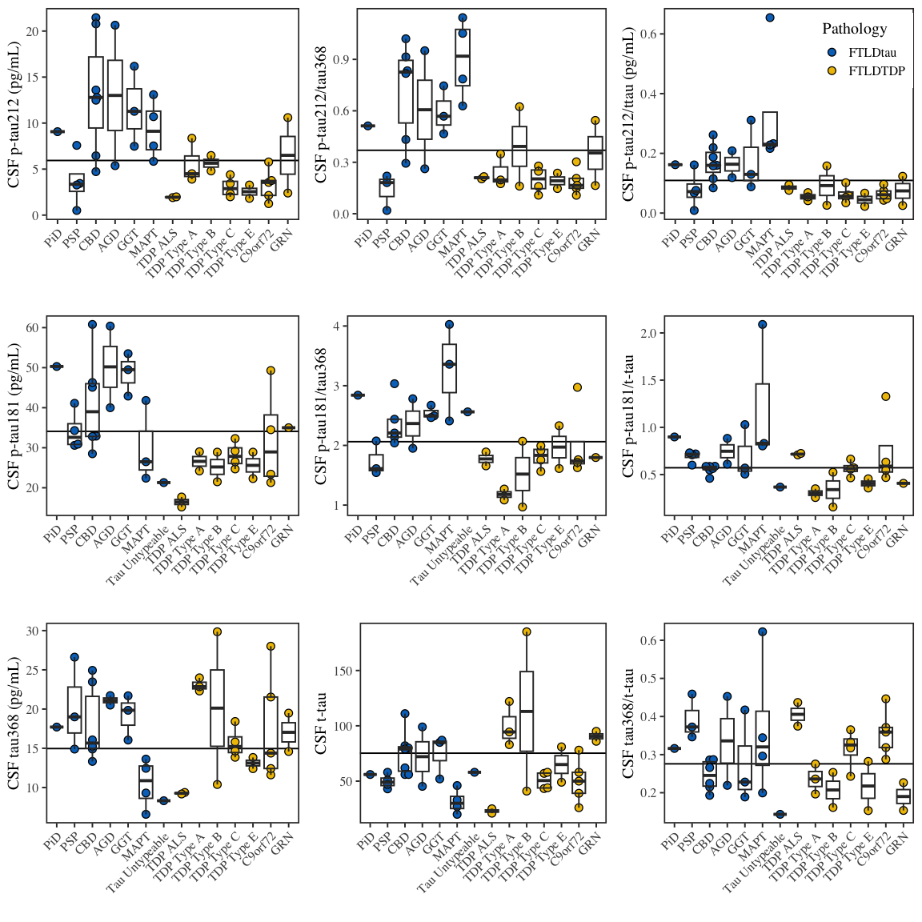
Supplementary Figure 10. Levels of biomarkers in subtypes of FTLD-tau and FTLD-TDP. The figure shows levels of p-tau212, p-tau212/tau368, p-tau181, p-tau181/tau368, p-tau212/t-tau, p-tau181/t-tau, tau368, and tau368/t-tau in FTLD-Tau (blue) neurodegenerative diseases: Pick’s Disease (PiD, n=1), progressive supranuclear palsy (PSP, n=4), corticobasal degeneration (CBD, n=7), argyrophilic grain disease (AGD, n=2), globular glial tauopathy (GGT, n=3), genetic tau mutations (MAPT, n=6) or untypeable tau pathology (n=1) and FTLD-TDP (yellow) neurodegenerative diseases: amyotrophic lateral sclerosis (ALS, n=2), FTLD-TDP type A (n=3), FTLD-TDP type B (n=2) FTLD-TDP type C (n=4), FTLD-TDP type E (n=2), participants with genetic mutation of C9orf72 (n=10), and participants with granulin mutation (GRN, n=5). Box plots represent median and interquartile range (IQR), and boundaries of the whiskers are minimum to maximum values. Horizontal lines indicate threshold to discriminate FTLD-tau from FTLD-TDP based on maximum Youden’s index, for p-tau212, p-tau212/tau368, p-tau181 and p-tau181/tau368.

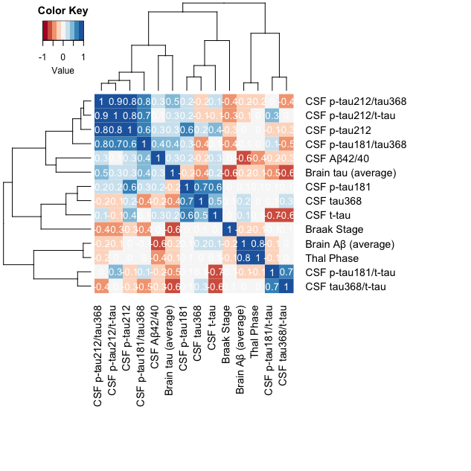
Supplementary Figure 11. Correlation of tau biomarkers with ADNC and CSF Aβ42/40 ratio in ADNC-negative subcohort. The matrix presents Spearman correlations of tau biomarkers with Thal Phase, Braak Stage, Brain Tau (averaged over sampled regions), Brain Amyloid (averaged over sampled regions), and CSF Aβ42/40 ratio. Spearman’s rho is reported.

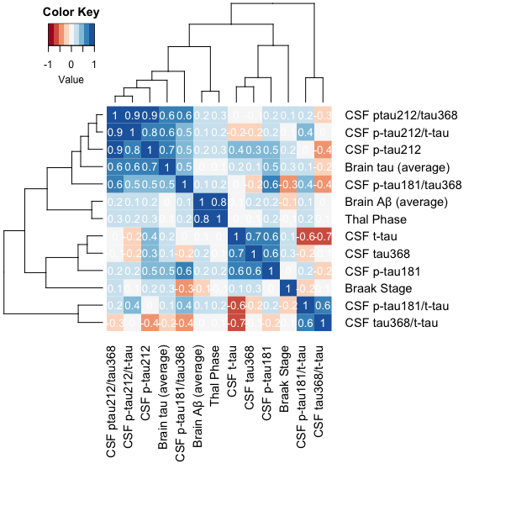

Supplementary Figure 12. Correlation of biomarkers in ADNC-negative and Thal Phase<2 subcohort. The matrix presents spearman correlations of tau biomarkers with ADNC. Spearman rho is reported.

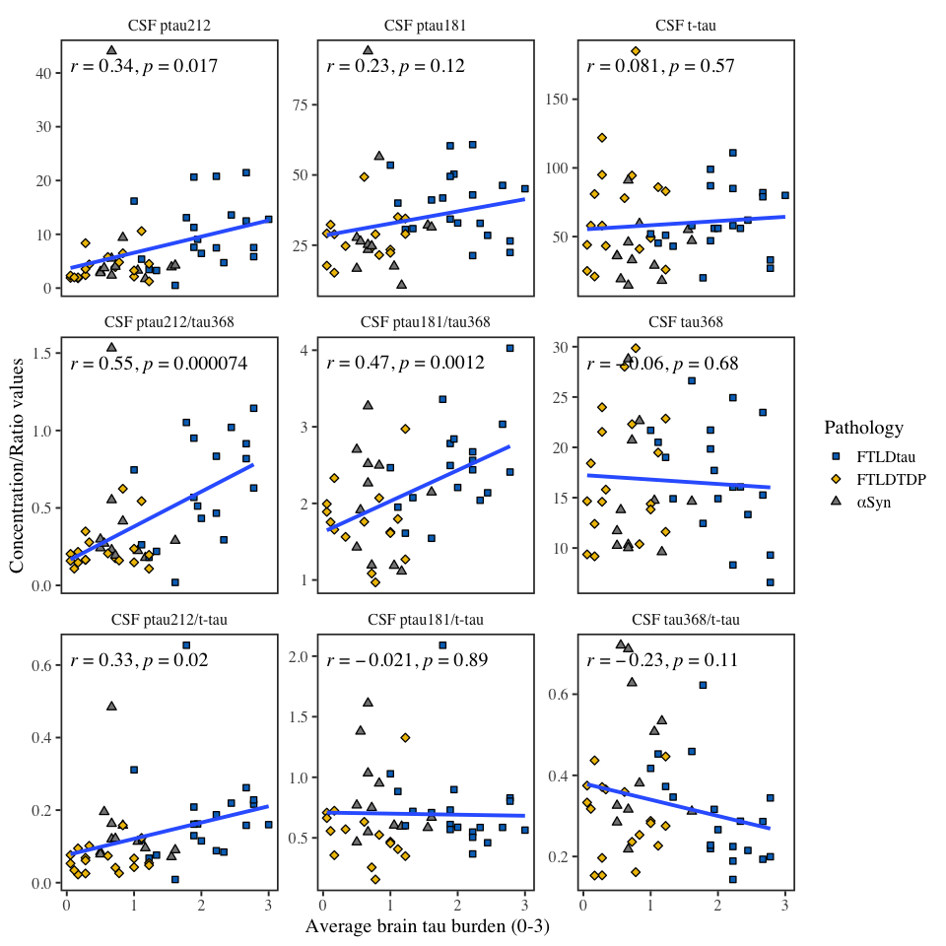
Supplementary Figure 13. Average correlations of tau biomarkers with brain tau burden in ADNC-negative subcohort. The figure shows Pearson’s correlations between CSF biomarkers and average brain tau burden.
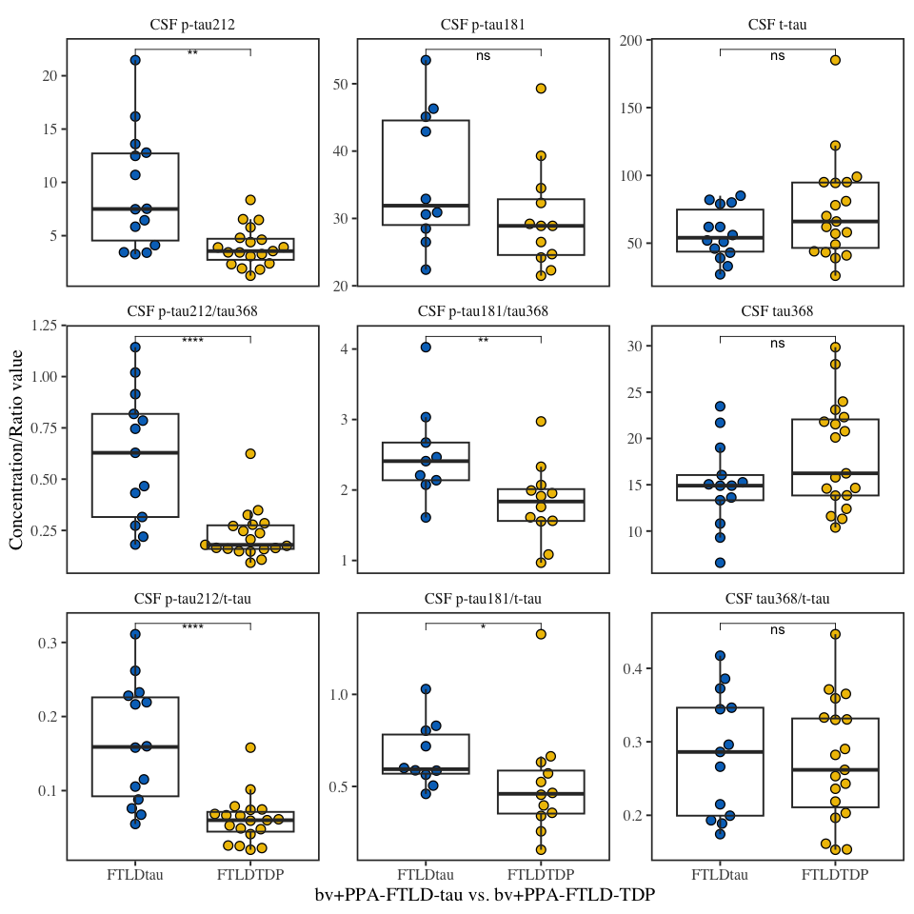
Supplementary Figure 14. Levels of biomarkers in FTLD clinical variants, bvFTD and PPA. The figure shows levels of tau biomarkers in clinically characterized behavioural variants of FTLD (bvFTD) and primary progressive aphasia (PPA) (bv+PPA-FTLD-tau (n=14); bv+PPA-FTLD-TDP (n=19). *; ** ; *** ; represent p<0.05; p<0.01; and p<0.001 respectively.

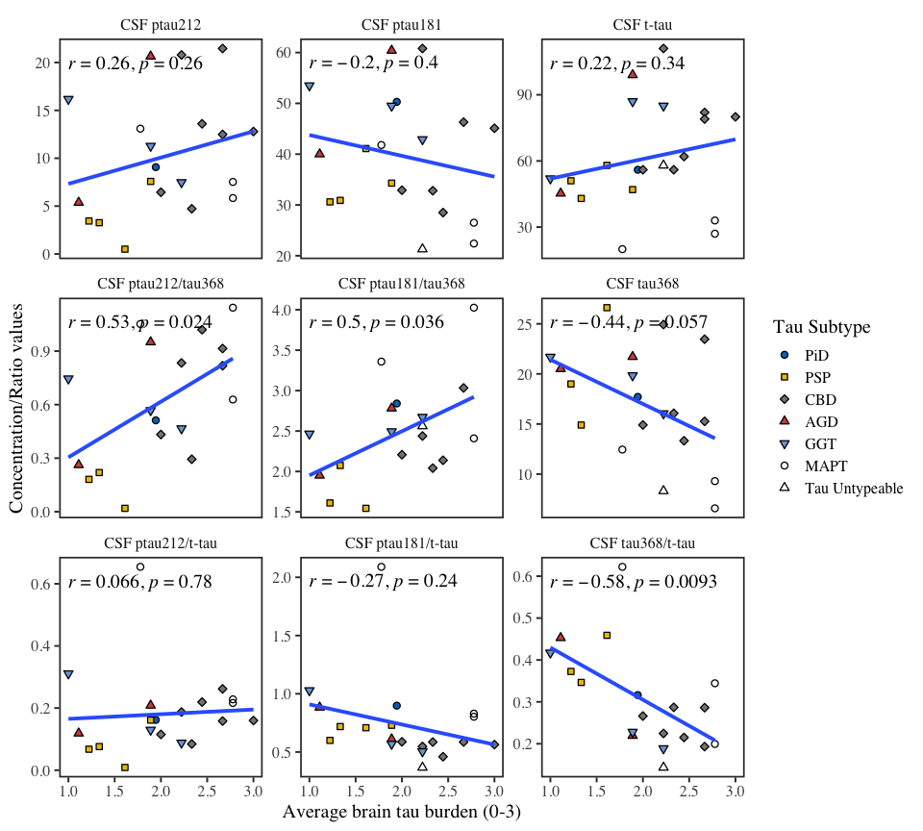

Supplementary Figure 15. Average correlations of tau biomarkers with brain tau burden in ADNC-negative FTLD-tau group. The Figure shows Pearson’s correlations between CSF biomarkers and average brain tau burden. Color indicates FTLD-tau molecular subtype.

