Supplemental Digital Content 1. The 2018 version of the AO/OTA fracture classification for 31A1 fractures.
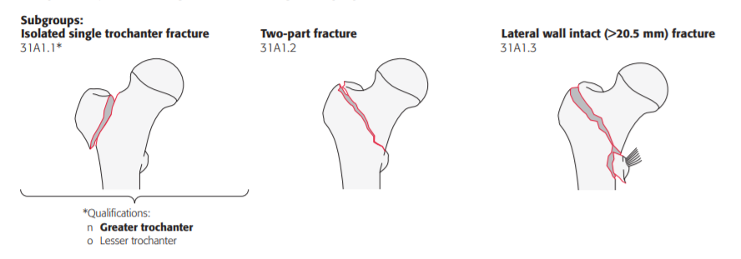
Reference: Fracture and Dislocation Classification Compendium—2018.

