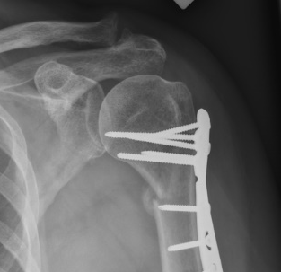
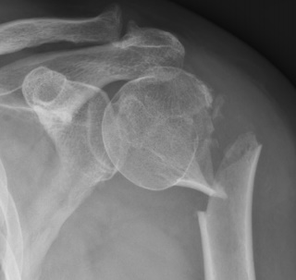
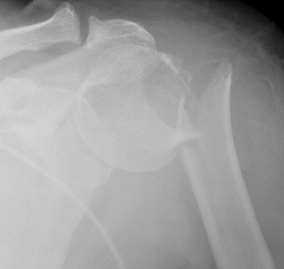

Eligible follow-up radiographs
Trauma
Day 8
Callus on radiograph

Supplement 1 Outline of eligible follow-up radiographs. This example covers the follow-up of a type C fracture. follow-up radiographs must have been taken between day 8 post trauma and start of radiographically visible callus or surgical fixation.

 | Supplement 2 Comparison between in- and excluded patients for MMG, MLG and NSA
 |  | A | B | C
 | MMG incl. | 11.3 ± 7.6 | 29.1 ± 10.2 | 13.6 ± 8.7
 | MMG excl. | 9.1 ± 5.4 | 23.1 ± 10.0 | 16.0 ± 8.7
 | p-value | 0.31 | 0.21 | 0.30
 | MLG incl. | 13.5 ± 5.8 | 22.9 ± 8.7 | 8.5 ± 5.4
 | MLG excl. | 15.8 ± 6.1 | 23.3 ± 8.5 | 9.8 ± 6.4
 | p-value | 0.24 | 0.92 | 0.40
 | NSA incl. | 161.1 ± 11.3 | 134.8 ± 15.8 | 111.7 ± 15.4
 | NSA excl. | 159.0 ± 12.5 | 136.7 ± 13.7 | 114.4 ± 14.8
 | p-value | 0.60 | 0.78 | 0.49
 | MMG and MLG (millimeters) are presented in means ± standard deviation and NSA (degrees) in means ± standard deviation. Abbreviations: incl., included patients; excl., excluded patients; MMG, maximal medial gap; MLG, maximal lateral gap; NSA, neck-shaft angle

