Supplementary information

Supplementary Fig. 1 Forest plot of coronal component alignment (both femoral and tibial) outliers >3 degrees

Supplementary Fig. 2 Forest plot for coronal femoral component outliers >3 degrees

Supplementary Fig. 3 Forest plot for coronal tibial component outliers >3 degrees

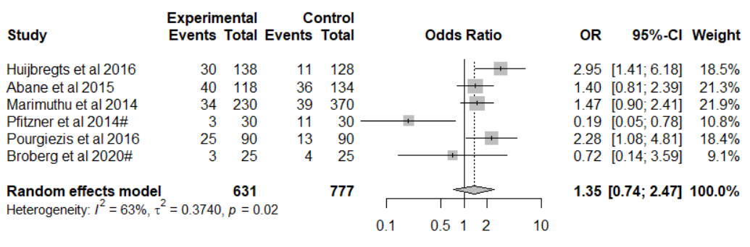
# = study only had data for sagittal tibial component alignment

Supplementary Fig. 4 Forest plot of sagittal component alignment (both femoral and tibial) outliers >3 degrees

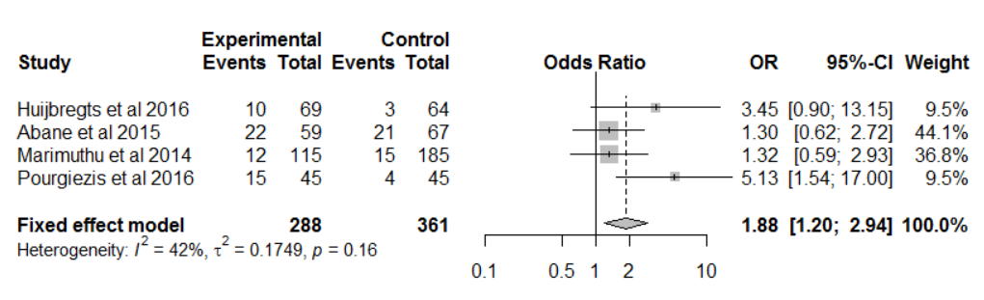
Supplementary Fig. 5 Forest plot of femoral flexion (sagittal femoral component) outliers >3 degrees

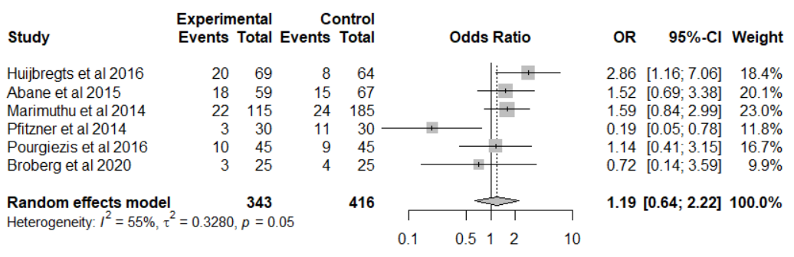
Supplementary Fig. 6 Forest plot for posterior slope (sagittal tibial component) outliers >3 degrees

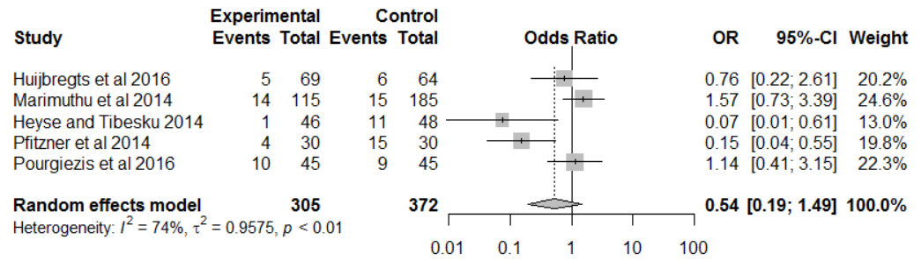
Supplementary Fig. 7 Forest plot for femoral component rotation outliers >3 degrees

