Appendix 1
1a: Patellofemoral and tibiofemoral joint regions
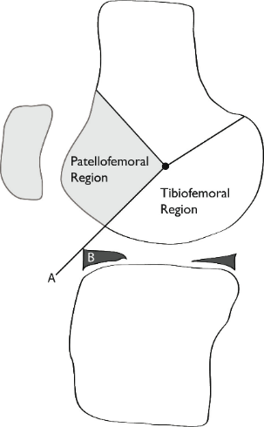
Diagram illustrating the division between the patella-femoral and tibiofemoral joint regions (line A) using the anterior margin of the meniscus in the sagittal plane as a landmark (B).

1b: The “mouse ear” osteophyte
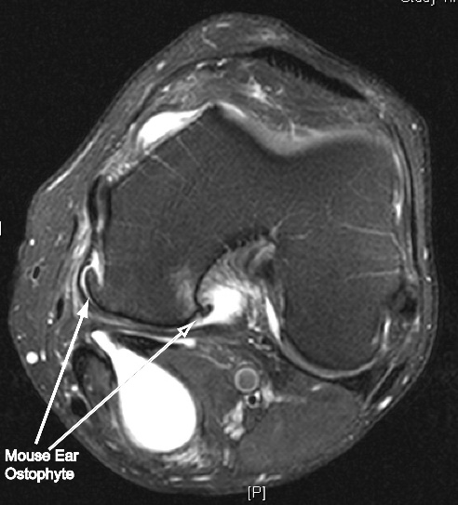
The ‘”mouse ear”osteophyte is found at the medial and lateral margins of each posterior femoral condyle

1c: Osteophyte severity
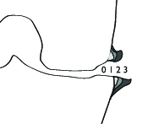

Illustration of osteophyte severity scoring; 1 = a minor deviation, 2 = moderate deviation, 3= large irregularity

1d: Meniscal extrusion
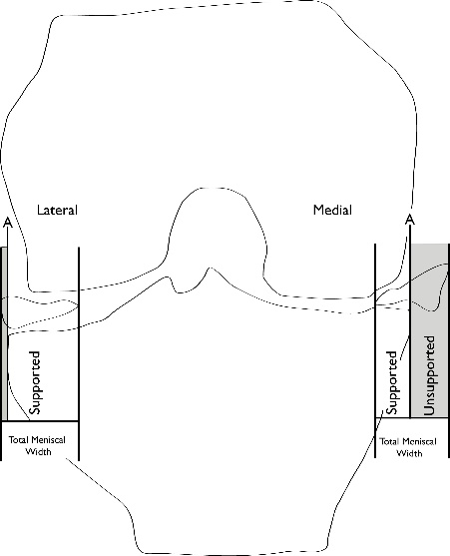

Illustration of meniscal extrusion; extrusion was defined as more than 30% of the meniscal width lying outside a vertical line up from the tibial rim

1e: ACL scoring system
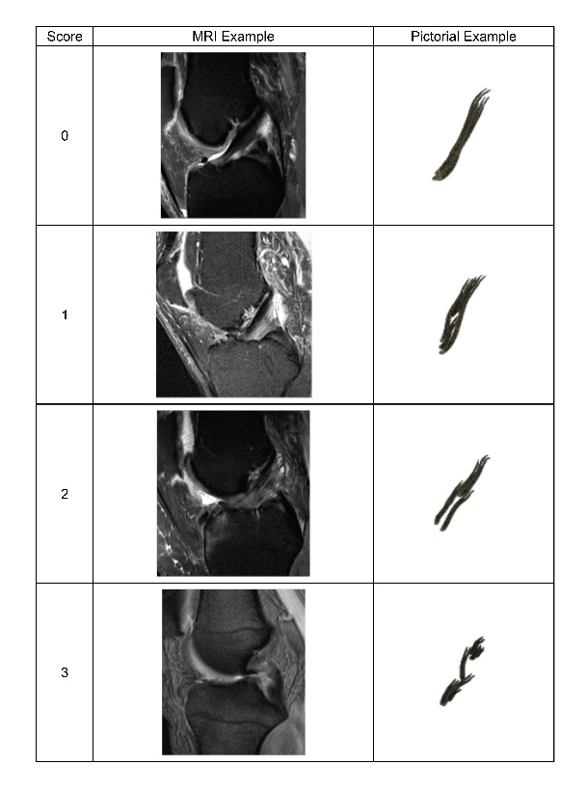
Illustration of ACL scoring system; 0= normal, 1= minor signal changes present in an intact ligament, 2 = more significant splaying, kinking or ganglion formation but with preserved orientation of fibres, 3= rupture

