Supplementary Figures and Tables
Variable | Included knees (n = 253) | Excluded knees (n = 58) | P value
Age at surgery (years) | 68.3 ± 10.5 | 70.4 ± 9.1 | 0.29
Body mass index (kg/m2) | 28.6 ± 5.0 | 27.6 ± 5.0 | 0.21
ASA score | 2.2 ± 0.4 | 2.3 ± 0.5 | 0.07
Female sex | 143 (56.5%) | 35 (61.1%) | 0.73
Lateral UKA | 32 (12.5%) | 6 (11.1%) | 1
Right sided procedure | 109 (43.1%) | 32 (55.6%) | 0.22
Table S1. Dropout analysis comparing baseline characteristics between included and excluded knees
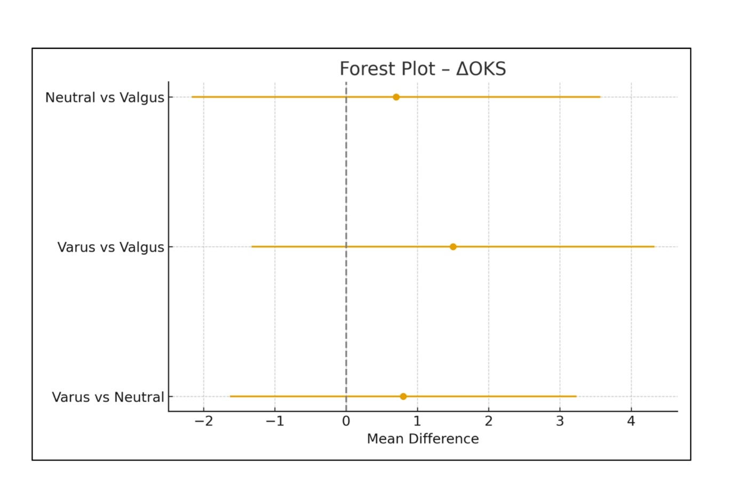
Figure S1: forest plot comparing varus vs. neutral, varus vs. valgus, and neutral vs. valgus in ΔOKS
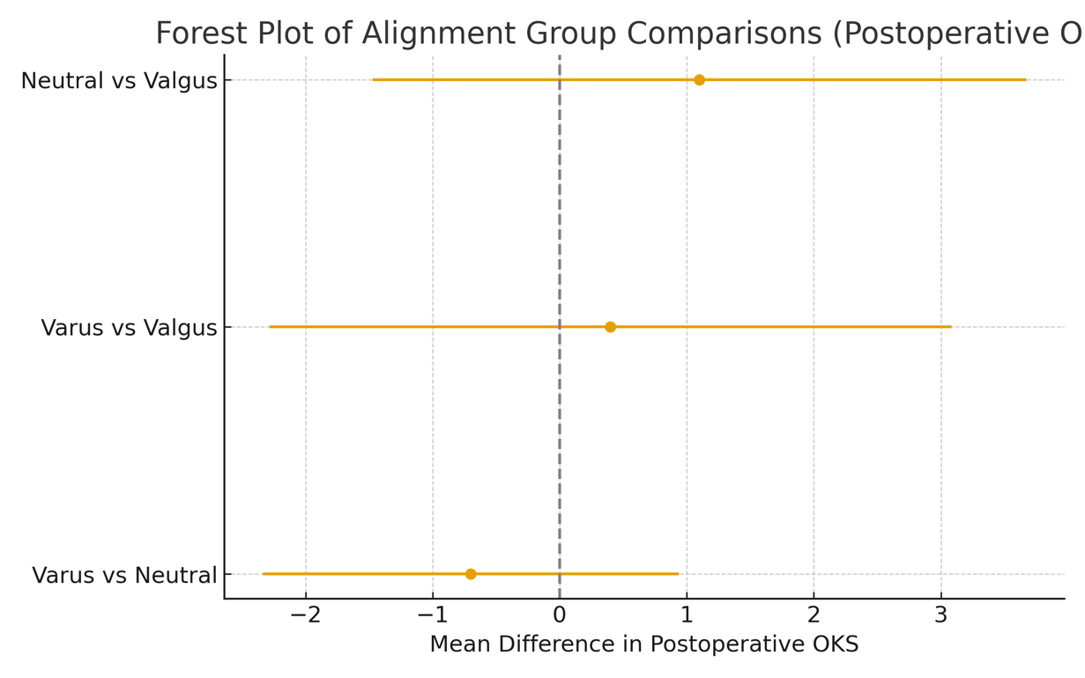

Figure S2: forest plot comparing varus vs. neutral, varus vs. valgus, and neutral vs. valgus in postoperative OKS
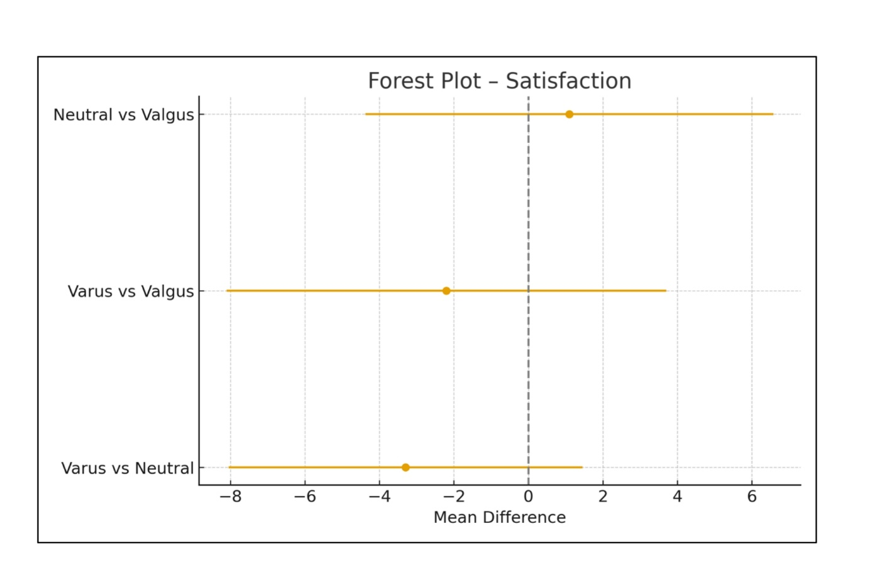
Figure S3: forest plot comparing varus vs. neutral, varus vs. valgus, and neutral vs. valgus in satisfaction

