Supplementary materials

Supplementary Table 1
Sensitivity analyses using alternative thresholds to define a tight extension gap (<0.4 mm and <0.3 mm) yielded similar results, with the association between preoperative alignment and tight extension gap remaining statistically significant. However, these findings should be interpreted cautiously due to the very small sample size of the >10° varus subgroup.
Threshold for tight gap | 0–3° n/N (%) | 3–10° n/N (%) | >10° n/N (%) | p-value
<0.5 mm | 16 / 47 (34.0%) | 48 / 202 (23.8%) | 4 / 5 (80.0%) | 0.011*
<0.4 mm | 16 / 47 (34.0%) | 47 / 202 (23.3%) | 4 / 5 (80.0%) | 0.007
<0.3 mm | 14 / 47 (29.8%) | 39 / 202 (19.3%) | 3 / 5 (60.0%) | 0.035
*Fisher’s exact test used due to small sample size in the >10° group.

Supplementary Table 2
Sensitivity analysis of the association between sex and tight intraoperative flexion gap (F90) using alternative thresholds, Pearson chi-square test. The observed associations remained consistent across thresholds.
Threshold for tight gap | Women tight n/N (%) | Men tight n/N (%) | p-value
<0.5 mm | 95 / 155 (61.3%) | 45 / 99 (45.5%) | 0.019
<0.4 mm | 90 / 155 (58.1%) | 44 / 99 (44.4%) | 0.046
<0.3 mm | 85 / 155 (54.8%) | 40 / 99 (40.4%) | 0.034

Supplementary Table 3 and Figure 1

Summary of diagnostic test for multivariate linear regression and multinomial logistic regression.

Diagnostic test | Model | Result | Interpretation
Residuals vs fitted plot | Linear regression | No systematic pattern | Linearity satisfied
Q–Q plot of residuals | Linear regression | Points close to reference line | Residual normality acceptable
Scale–location plot | Linear regression | No funnel pattern | Homoscedasticity satisfied
Residuals vs leverage | Linear regression | No high Cook’s distance values | No influential observations
Variance inflation factor (VIF) | All regression models | VIF < 2 | No multicollinearity
Likelihood ratio test | Multinomial logistic regression | G² = 29.65 | Model improves fit vs null model
McFadden pseudo-R² | Multinomial logistic regression | 0.076 | Acceptable explanatory power
Cross-tabulation check | Multinomial logistic regression | Sparse cells due to small >10° group | Addressed with sensitivity analysis

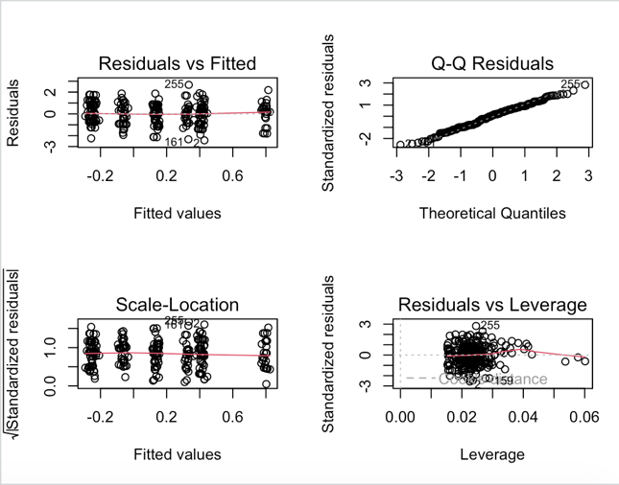

Supplementary Table 4(a-d)

4a - Sensitivity analysis in multivariate linear regression for gap size in extension excluding knees with varus >10°
Variable | Sensitivity model β (SE) | p-value | Interpretation
Sex (male vs female) | 0.17 (0.11) | 0.126 | Effect unchanged
Surgeon 2 | −0.03 (0.14) | 0.812 | Similar direction
Surgeon 3 | −0.37 (0.14) | 0.009 | Similar direction
Surgeon 4 | −0.46 (0.15) | 0.002 | Similar direction
Preoperative varus | 0.02 (0.02) | 0.265 | No association

4b - Sensitivity analysis in multivariate linear regression in F90 excluding knees with varus >10°

Variable | Main model β (SE) | p-value | Sensitivity model β (SE) | p-value | Interpretation
Sex (male vs female) | 0.38 (0.12) | 0.002 | 0.39 (0.13) | 0.002 | Effect unchanged
Surgeon 2 | −0.18 (0.17) | 0.28 | −0.48 (0.17) | 0.004 | Similar direction
Surgeon 3 | −0.18 (0.17) | 0.30 | −0.65 (0.16) | <0.001 | Similar direction
Surgeon 4 | −0.19 (0.18) | 0.30 | −0.68 (0.18) | <0.001 | Similar direction
Preoperative varus | 0.005 (0.02) | 0.82 | 0.001 (0.02) | 0.96 | No association

4c - Sensitivity analysis in multinomial logistic regression in extension excluding knees with varus >10°
Outcome vs B | Variable | OR | p-value | Interpretation
L vs B | Sex (male vs female) | 0.93 | 0.901 | No association
 | Surgeon 2 vs 1 | 0.82 | 0.751 | No association
 | Surgeon 3 vs 1 | 0.20 | 0.135 | Trend toward lower odds of loose balance
 | Surgeon 4 vs 1 | ~0.00 | 0.885 | Unstable estimate due to small cell counts
 | Preoperative varus | 1.10 | 0.423 | No association
T vs B | Sex (male vs female) | 0.76 | 0.384 | No association
 | Surgeon 2 vs 1 | 0.76 | 0.556 | No association
 | Surgeon 3 vs 1 | 2.13 | 0.055 | Trend toward higher odds of tight balance
 | Surgeon 4 vs 1 | 1.53 | 0.322 | No association
 | Preoperative varus | 0.96 | 0.443 | No association

4d - Sensitivity analysis in multinomial logistic regression in flexion excluding knees with varus >10°
Outcome vs B | Variable | OR | p-value* | Interpretation
L vs B | Sex (male vs female) | 1.93 | ≈0.50 | Not significant
 | Surgeon 2 vs 1 | 0.43 | ≈0.46 | Not significant
 | Surgeon 3 vs 1 | ~0.00 | ≈0.87 | Unstable estimate
 | Surgeon 4 vs 1 | ~0.00 | ≈0.88 | Unstable estimate
 | Preoperative varus | 1.37 | ≈0.19 | Not significant
T vs B | Sex (male vs female) | 0.46 | ≈0.06 | Trend toward lower odds of tight balance
 | Surgeon 2 vs 1 | 2.35 | ≈0.02–0.03 | Higher odds of tight balance
 | Surgeon 3 vs 1 | 2.40 | ≈0.02 | Higher odds of tight balance
 | Surgeon 4 vs 1 | 2.28 | ≈0.03 | Higher odds of tight balance
 | Preoperative varus | 0.99 | ≈0.91 | No association

Sensitivity analyses excluding knees with preoperative varus >10° were also performed for the multinomial logistic regression models evaluating extension and flexion balance. Using “balanced” as the reference category and adjusting for sex, surgeon group, and preoperative varus, the results were consistent with the primary analyses. No meaningful associations were observed for sex or preoperative varus. Surgeon group showed a trend toward differences in flexion balance, while estimates for the “loose” category were unstable due to the small number of cases.

