Online Resource 1
STROBE-compliant patient selection flow diagram

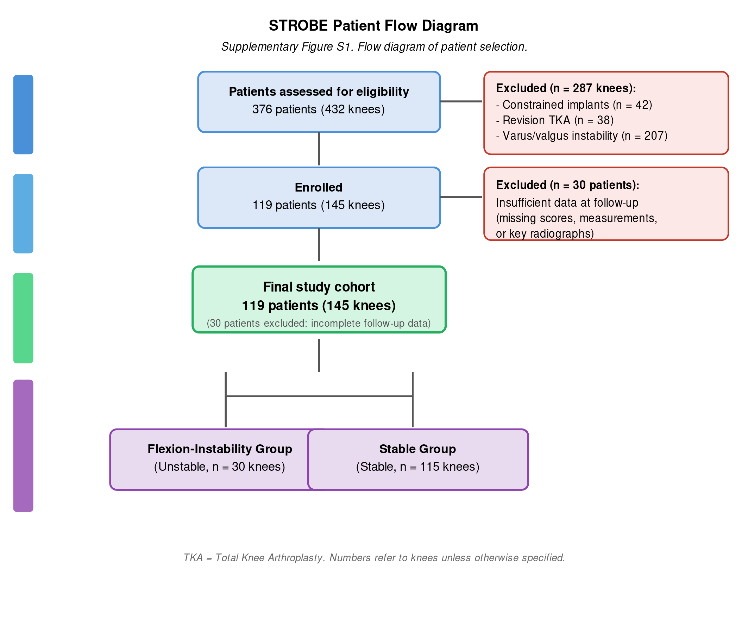

Fig. S1. Flowchart of patient selection. TKA, total knee arthroplasty.

