Supplementary Material
eTable 1. Full Multivariable Logistic Regression Model for the Primary Outcome (Non-home Discharge)
Variable | Adjusted OR | 95% CI | P Value
RSA (vs hemiarthroplasty) | 1.20 | 0.93–1.55 | .153
Age (per year) | 1.08 | 1.07–1.09 | < .001
Female sex | 1.07 | 0.87–1.31 | .518
Injury Severity Score | 1.24 | 1.19–1.31 | < .001
Comorbidity count | 1.82 | 1.32–2.51 | < .001
Polytrauma | 0.45 | 0.30–0.67 | < .001
Fall mechanism | 1.00 | 0.81–1.23 | .986
COVID-era admission | 1.29 | 1.08–1.54 | .006
Hypertension | 0.53 | 0.37–0.78 | .001
Diabetes mellitus | 0.73 | 0.51–1.05 | .088
COPD | 0.76 | 0.50–1.17 | .216
Congestive heart failure | 0.68 | 0.40–1.14 | .146
Anticoagulant therapy | 0.77 | 0.51–1.16 | .205
Dementia | 0.74 | 0.40–1.35 | .322
Chronic renal failure | 0.64 | 0.27–1.51 | .311
Functional dependence | 1.16 | 0.74–1.82 | .521
Current smoking | 0.64 | 0.40–1.01 | .055
Note. Adjusted odds ratios from a single multivariable logistic regression model (n = 3085). Reference category for procedure is hemiarthroplasty.
eTable 2. Inverse Probability of Treatment–Weighted Estimates
Outcome | IPTW OR | 95% CI | P Value
Non-home discharge | 1.02 | 0.79–1.33 | .857
Any complication | 1.22 | 0.65–2.29 | .539
Extended LOS (> 7 d) | 1.38 | 1.06–1.81 | .019
ICU admission | 0.92 | 0.63–1.34 | .668
Note. OR from weighted logistic regression with HC0 robust standard errors; stabilized weights truncated at the 1st and 99th percentiles.
eTable 3. Sensitivity Analyses: Adjusted Odds Ratios Across Cohorts
Outcome | Primary (full cohort, n = 3085) | Excluding interfacility transfers (n = 2405) | Excluding COVID-era (n = 1924)
Non-home discharge | 1.20 (0.93–1.55); P=.153 | 1.13 (0.84–1.52); P=.419 | 1.17 (0.86–1.60); P=.325
Any complication | 1.01 (0.58–1.77); P=.962 | 1.27 (0.64–2.53); P=.489 | 0.80 (0.40–1.60); P=.529
Extended LOS (> 7 d) | 1.27 (0.99–1.62); P=.058 | 1.32 (1.00–1.76); P=.054 | 1.19 (0.88–1.60); P=.263
ICU admission | 1.05 (0.74–1.50); P=.786 | 1.03 (0.69–1.55); P=.871 | 1.02 (0.67–1.55); P=.942
Note. Each cell reports the adjusted odds ratio (95% CI) for RSA vs hemiarthroplasty from a multivariable model fitted within the indicated cohort.
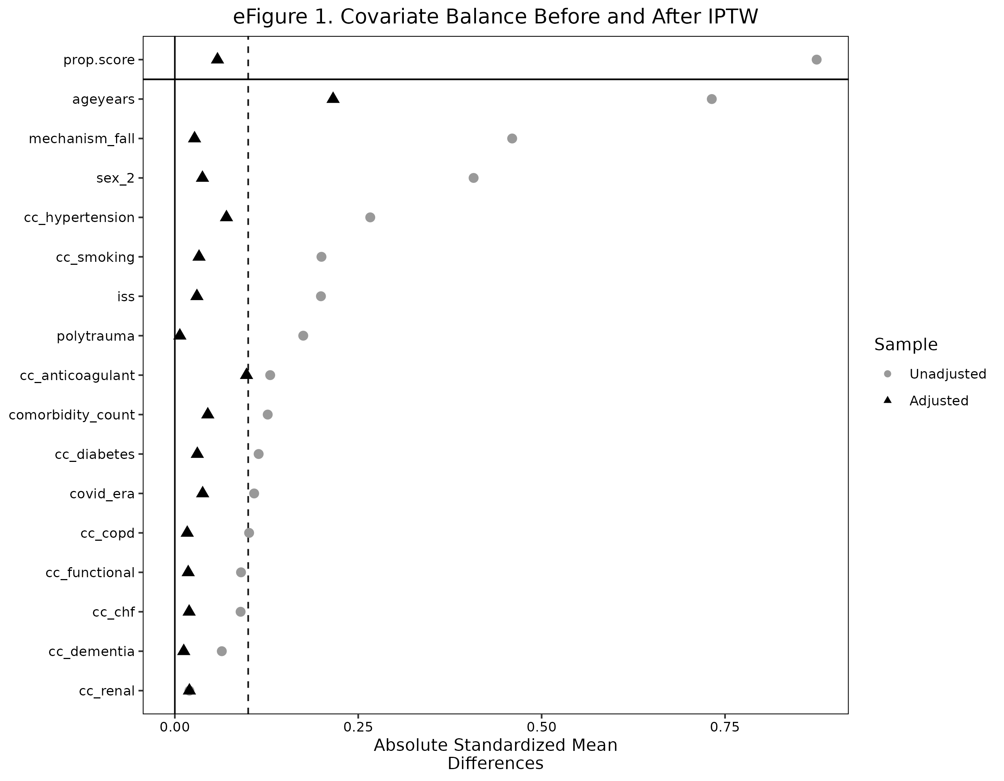
eFigure 1. Absolute standardized mean differences for all covariates before (unadjusted) and after (adjusted) IPTW. Dashed line indicates the 0.10 balance threshold.
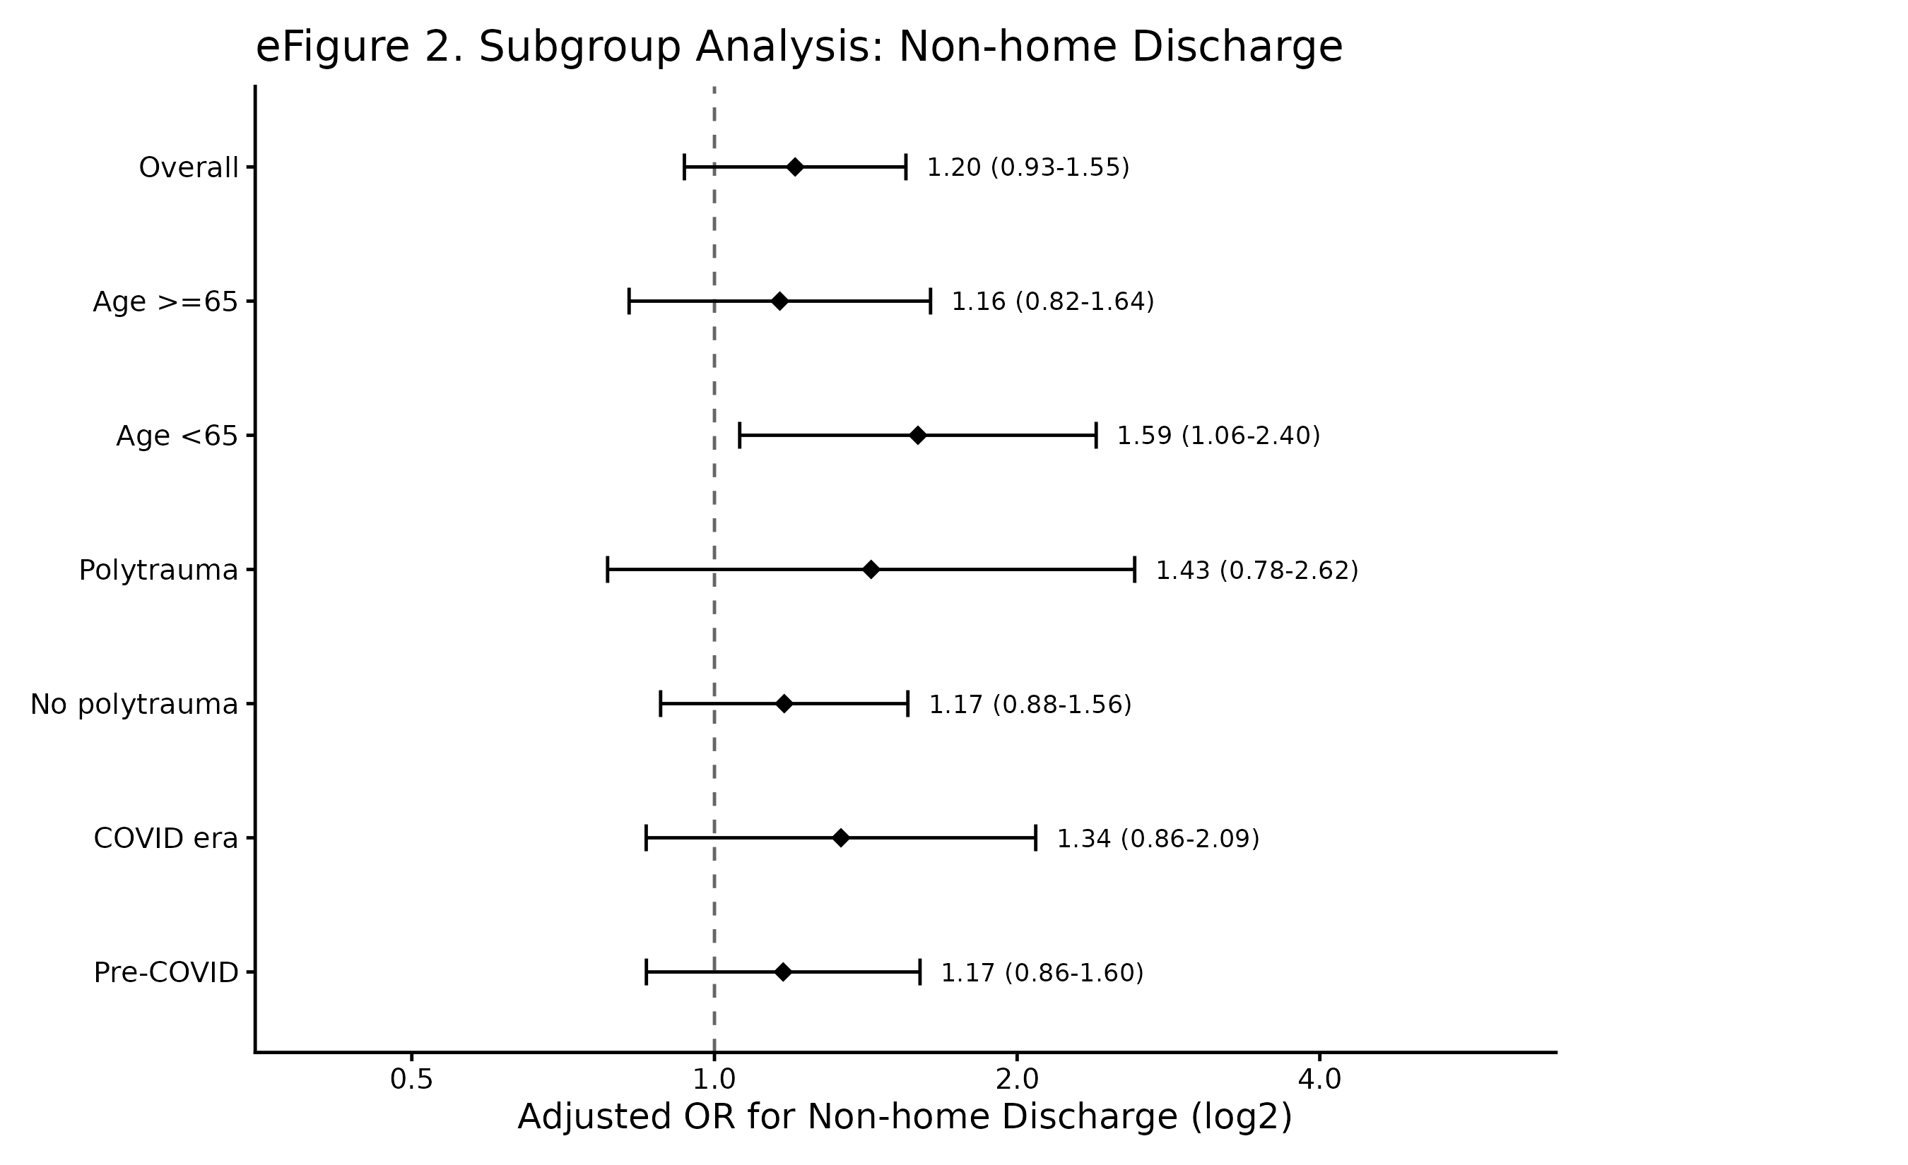
eFigure 2. Adjusted odds ratios for non-home discharge within pre-specified subgroups. Reference, hemiarthroplasty.

