Figure Legends
Supplementary Figure S1. Egger’s test for type 2 diabetes.
Supplementary Figure S2. Begg’s test for type 2 diabetes.
Supplementary Figure S3. Funnel plot following trim-and-fill method for type 2 diabetes.
Supplementary Figure S4. Egger’s test for sex.
Supplementary Figure S5. Begg’s test for sex.
Supplementary Figure S6. Sensitivity analysis for the duration of postoperative drain placement.
Supplementary Figure S7. Sensitivity analysis for ASA score.
Supplementary Figure S8. Sensitivity analysis for operative blood loss.
Supplementary Figure S9. Sensitivity analysis for postoperative urinary tract infection.
Supplementary Figure S10. Sensitivity analysis for operating time > 90 minutes.
Supplementary Figure S11. Sensitivity analysis for BMI≥30 kg/m².
Supplementary Figure S12. Subgroup analysis for rheumatoid arthritis.
Supplementary Figure S13. Subgroup analysis for operating time > 90 minutes.
Supplementary Figure S14. Subgroup analysis for postoperative drainage tube placement duration ≥ 24 hours.
Supplementary Figure S15. Forest plot for history of hormone therapy.
Supplementary Figure S16. Forest plot for combined pulmonary diseases.
Supplementary Figure S17. Forest plot for ASA score ≥ 3 points.
Supplementary Figure S18. Forest plot for operating time ≥ 3 hours.
Supplementary Figure S19. Forest plot for operating time ≥ 2 hours.
Supplementary Figure S20. Forest plot for operating time > 90 minutes.
Supplementary Figure S21. Forest plot for rheumatoid arthritis.
Supplementary Figure S22. Forest plot for postoperative urinary tract infection.
Supplementary Figure S23. Forest plot for BMI≥30 kg/m².
Supplementary Figure S24. Forest plot for postoperative drainage tube placement duration ≥ 24 hours.
Supplementary Figure S25. Forest plot for operative blood loss > 200 ml.

Appendix
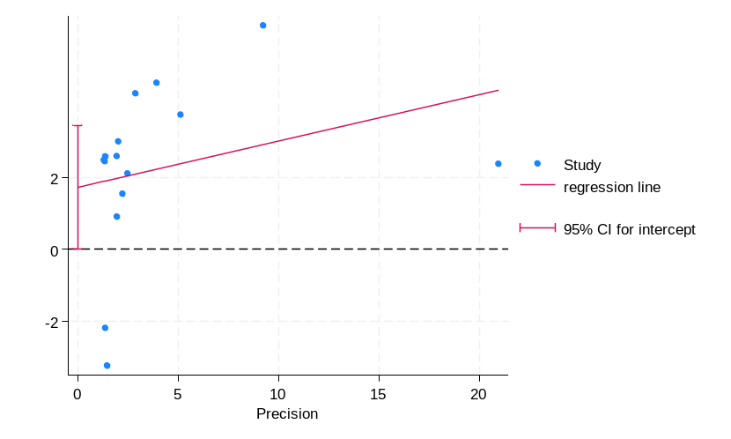
Supplementary Figure S1. Egger’s test for type 2 diabetes.
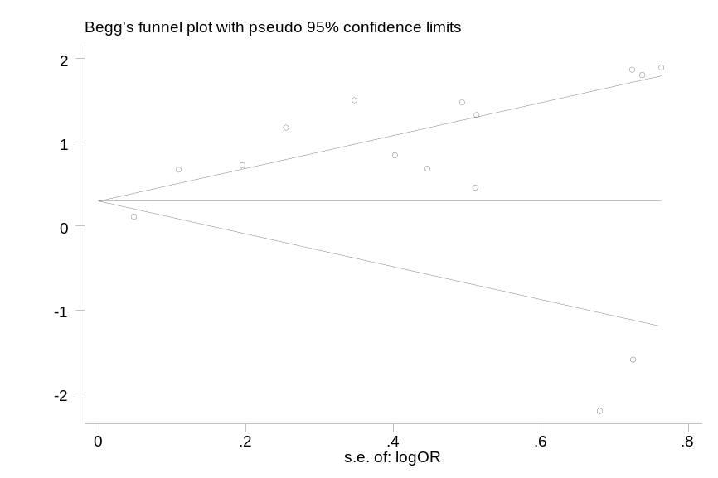
Supplementary Figure S2. Begg’s test for type 2 diabetes.
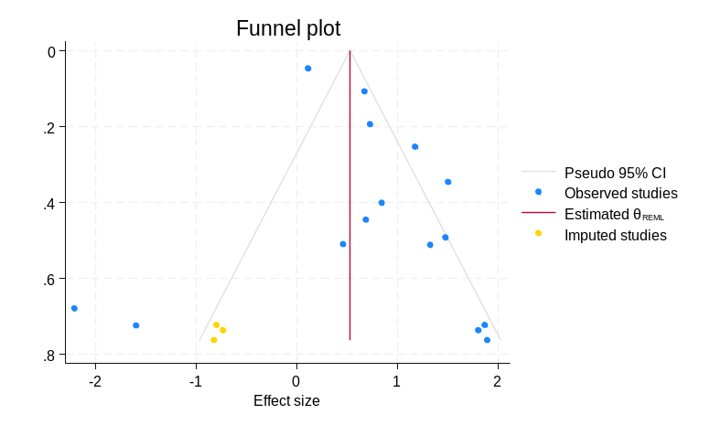
Supplementary Figure S3. Funnel plot following trim-and-fill method for type 2 diabetes.
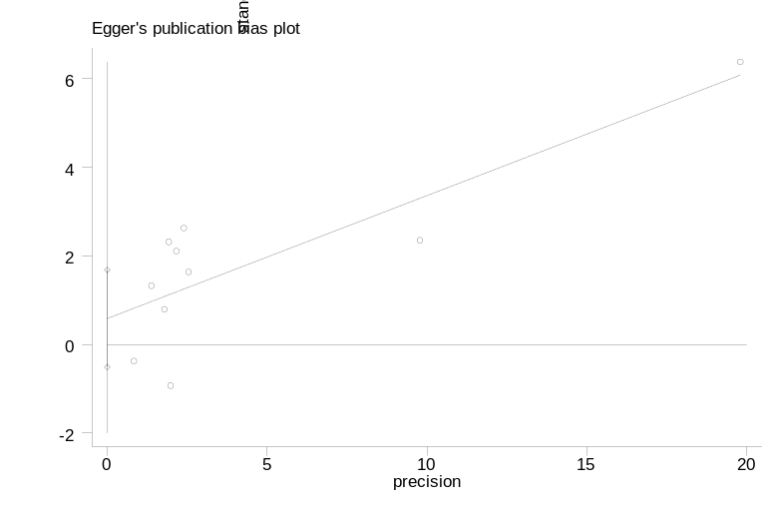
Supplementary Figure S4. Egger’s test for sex.
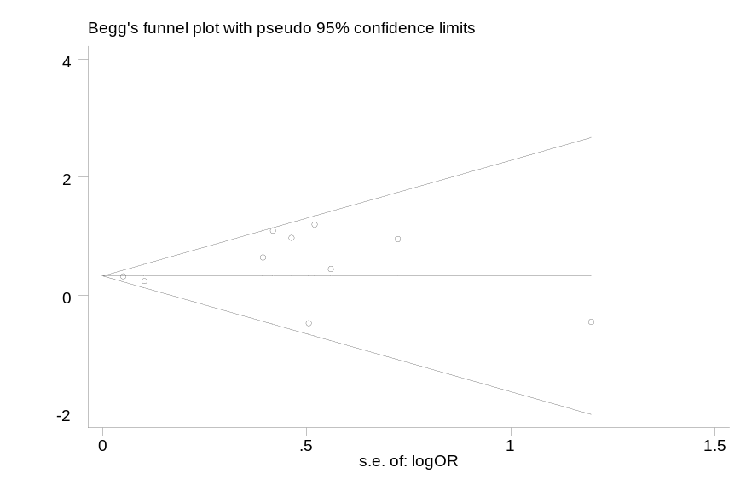
Supplementary Figure S5. Begg’s test for sex.
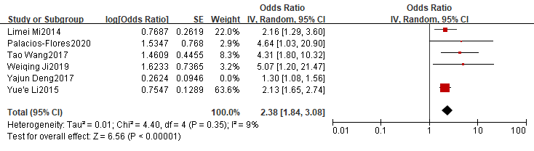
Supplementary Figure S6. Sensitivity analysis for the duration of postoperative drain placement.
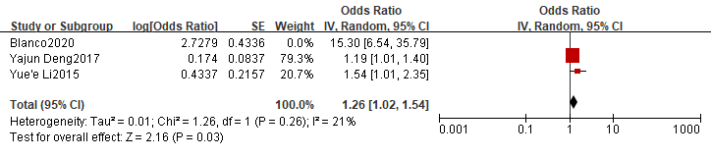
Supplementary Figure S7. Sensitivity analysis for ASA score.
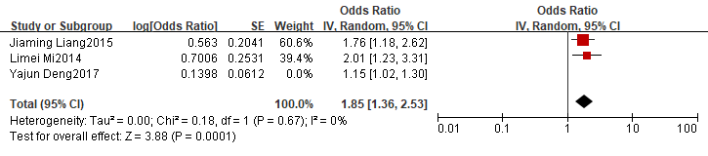
Supplementary Figure S8. Sensitivity analysis for operative blood loss.
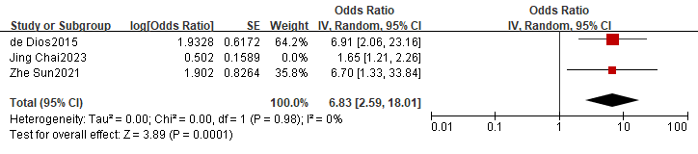
Supplementary Figure S9. Sensitivity analysis for postoperative urinary tract infection.
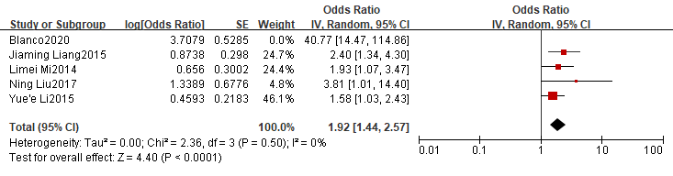
Supplementary Figure S10. Sensitivity analysis for operating time > 90 minutes.
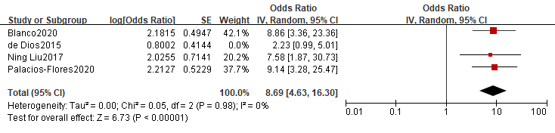
Supplementary Figure S11. Sensitivity analysis for BMI≥30 kg/m².
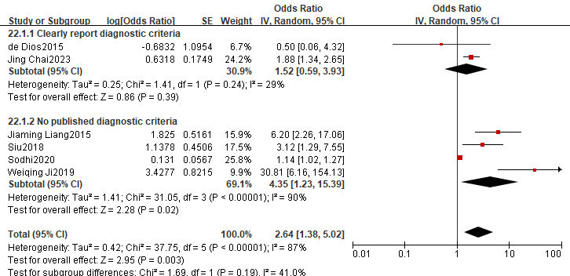
Supplementary Figure S12. Subgroup analysis for rheumatoid arthritis.
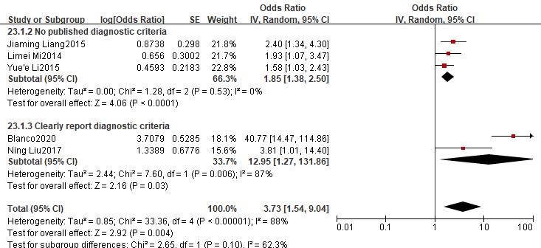
Supplementary Figure S13. Subgroup analysis for operating time > 90 minutes.
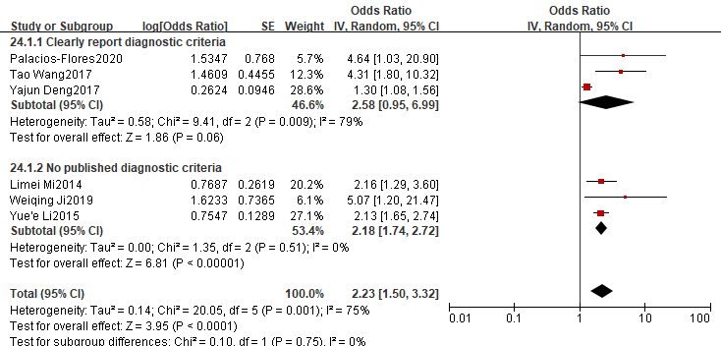
Supplementary Figure S14. Subgroup analysis for postoperative drainage tube placement duration ≥ 24 hours.
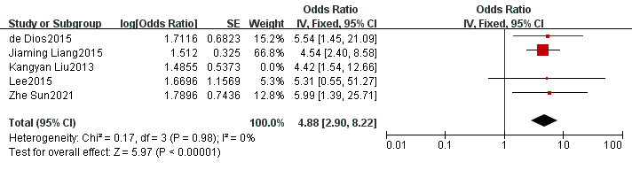
Supplementary Figure S15. Forest plot for history of hormone therapy.
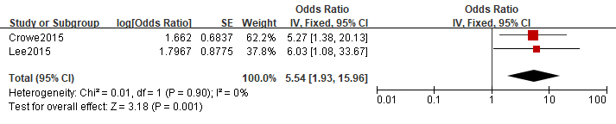
Supplementary Figure S16. Forest plot for combined pulmonary diseases.
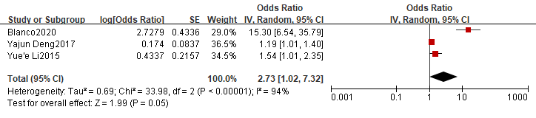
Supplementary Figure S17. Forest plot for ASA score ≥ 3 points.
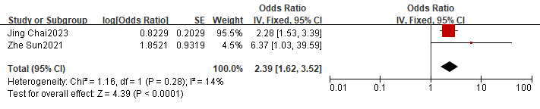
Supplementary Figure S18. Forest plot for operating time ≥ 3 hours.
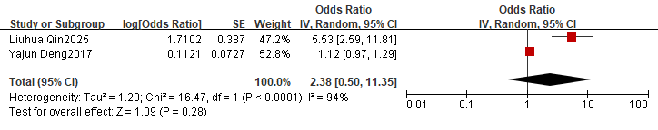
Supplementary Figure S19. Forest plot for operating time ≥ 2 hours.
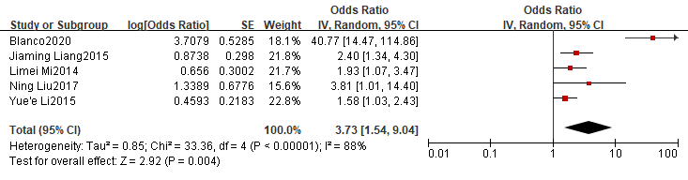
Supplementary Figure S20. Forest plot for operating time > 90 minutes.
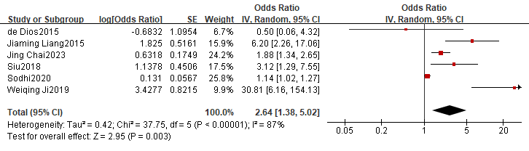
Supplementary Figure S21. Forest plot for rheumatoid arthritis.

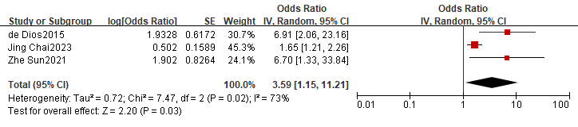
Supplementary Figure S22. Forest plot for postoperative urinary tract infection.
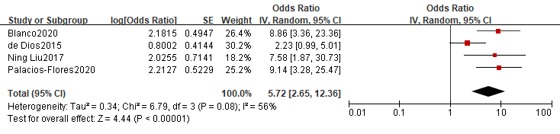
Supplementary Figure S23. Forest plot for BMI≥30 kg/m².
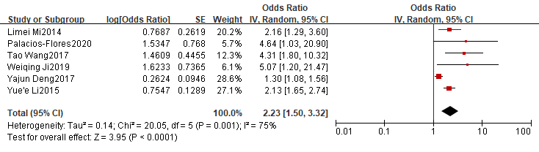
Supplementary Figure S24. Forest plot for postoperative drainage tube placement duration ≥ 24 hours.
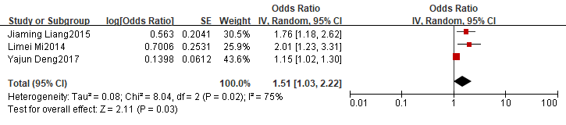
Supplementary Figure S25. Forest plot for operative blood loss > 200 ml.

