Appendices
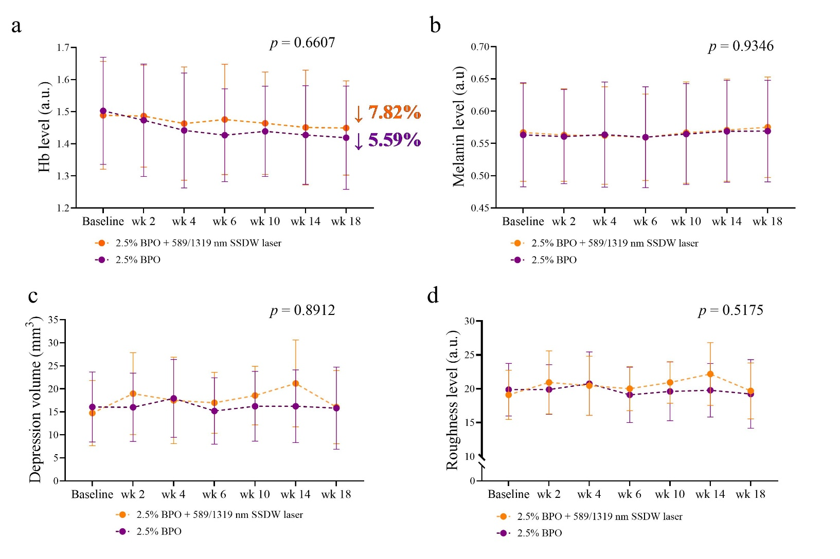
Figure S1 Acne-related skin parameters
The average level of (a) hemoglobin, (b) melanin, (c) depression volume, and (d) roughness level. The graphs depicted the mean and standard deviation. The differences between groups were analyzed using repeated-measures ANOVA. n = 18 in each group.
a.u., arbitrary unit; BPO, benzoyl peroxide; Hb, hemoglobin; nm, nanometer; SSDW, solid-state dual wavelength; wk, week.

