Supplemental: Medline (Ovid) Session results

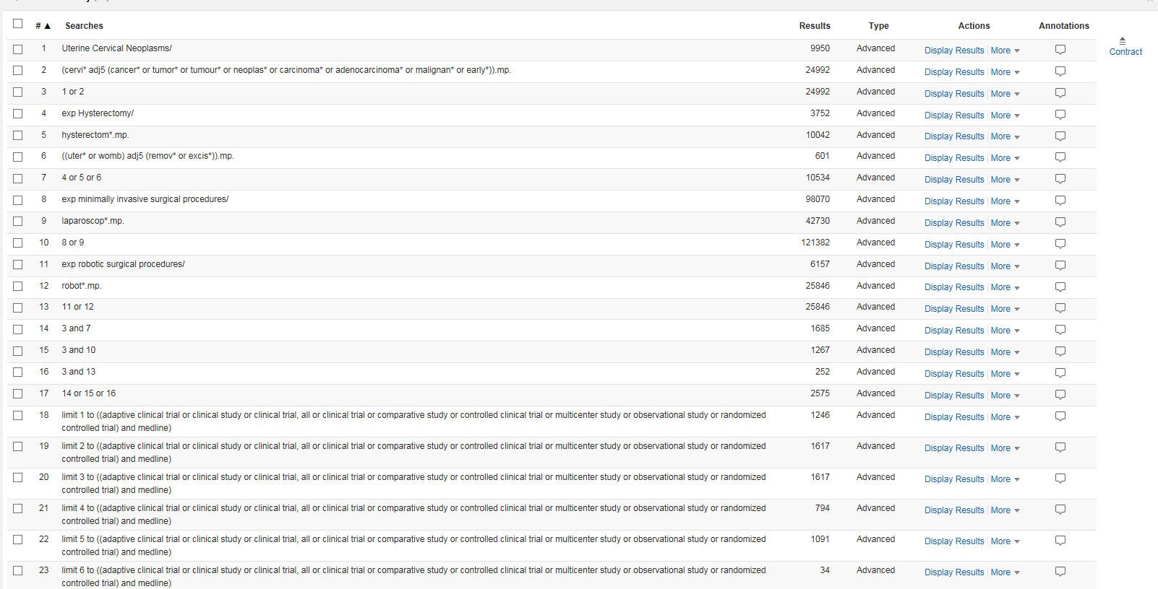

Supplemental: Embase Session results

