SUPPLEMENTARY MATERIAL
The Use of LNG-IUS-19.5mg in Daily Gynecological Routine Practice in Germany: Data from the Kyleena™ Satisfaction Study (KYSS)
Thomas Römer,¹ Ann-Kathrin Frenz,² Susanne Dietrich-Ott,³ Anja Fiedler⁴
Affiliations: ¹Obstetrics and Gynecology Department, Academic Hospital Weyertal, University of Cologne, Cologne, Germany; ²Medical Affairs, Bayer AG, Berlin, Germany; ³Jenapharm GmbH & Co. KG, Jena, Germany; ⁴Medical Practice of Obstetrics and Gynecology, Gera/Jena, Germany
Correspondence to: Thomas Römer, Thomas.Roemer@evk-koeln.de

Table S1 Satisfaction of German participants with their bleeding profile during LNG-IUS-19.5mg use at 12 months/end of observation (FAS) by previous contraceptive method, by presence of amenorrhea and by dysmenorrhea severity
Satisfaction with bleeding profile, n (%) |  | German participants, n | Very satisfied | Somewhat satisfied | Neither satisfied nor dissatisfied | Dissatisfied | Very dissatisfied
Previous contraceptive method^{a,b} | None | 102 | 43 (42.2) | 24 (23.5) | 19 (18.6) | 12 (11.8) | 4 (3.9)
Previous contraceptive method^{a,b} | Oral contraception | 118 | 64 (54.2) | 27 (22.9) | 14 (11.9) | 9 (7.6) | 4 (3.4)
Previous contraceptive method^{a,b} | Barrier method | 78 | 33 (42.3) | 17 (21.8) | 11 (14.1) | 15 (19.2) | 2 (2.6)
Previous contraceptive method^{a,b} | IUS | 75 | 51 (68.0) | 14 (18.7) | 6 (8.0) | 3 (4.0) | 1 (1.3)
Previous contraceptive method^{a,b} | IUD | 11 | 6 (54.5) | 3 (27.3) | 1 (9.1) | 1 (9.1) | 0
Previous contraceptive method^{a,b} | Vaginal contraception | 10 | 5 (50.0) | 2 (20.0) | 2 (20.0) | 1 (10.0) | 0
Presence of amenorrhea^{b} | Yes | 120 | 64 (53.3) | 25 (20.8) | 14 (11.7) | 13 (10.8) | 4 (3.3)
Presence of amenorrhea^{b} | No | 272 | 140 (51.5) | 60 (22.1) | 39 (14.3) | 26 (9.6) | 7 (2.6)
Dysmenorrhea severity^{c} | No dysmenorrhea | 161 | 93 (57.8) | 30 (18.6) | 20 (12.4) | 14 (8.7) | 4 (2.5)
Dysmenorrhea severity^{c} | Mild | 111 | 57 (51.4) | 25 (22.5) | 17 (15.3) | 9 (8.1) | 3 (2.7)
Dysmenorrhea severity^{c} | Moderate | 88 | 41 (46.6) | 18 (20.5) | 15 (17.0) | 12 (13.6) | 2 (2.3)
Dysmenorrhea severity^{c} | Severe | 33 | 14 (42.4) | 11 (33.3) | 3 (9.1) | 4 (12.1) | 1 (3.0)
FAS: full analysis set; IUD: intrauterine device; IUS: intrauterine system; LNG-IUS: levonorgestrel-releasing intrauterine system.
ªGroups with fewer than 10 participants with available bleeding satisfaction outcome data have been excluded from the table.
^{b}Data missing for 114 participants.
^{c}Data missing for 113 participants.
Table S2 Summary of the LNG-IUS-19.5mg–related TEAEs at 12 months/premature discontinuation for the German population and overall population in KYSS (safety analysis set)^{a,b}
TEAE, n (%) | German participants (n=508)
Any LNG-IUS-19.5mg–related TEAE | 47 (9.3)
Reproductive system and breast disorders  Cervical dysplasia  Dysmenorrhea  Genital hemorrhage  Hypomenorrhea  Menorrhagia  Menstrual disorder  Metrorrhagia  Ovarian cyst  Ovarian cyst ruptured  Pelvic pain  Uterine hemorrhage  Vaginal hemorrhage  Vulvovaginal burning sensation | 26 (5.1)  1 (0.2)  3 (0.6)  1 (0.2)  1 (0.2)  6 (1.2)  2 (0.4)  4 (0.8)  4 (0.8)  1 (0.2)  1 (0.2)  3 (0.6)  4 (0.8)  1 (0.2)
Gastrointestinal disorders  Abdominal pain  Abdominal pain lower  Abdominal pain upper  Flatulence | 17 (3.3)  1 (0.2)  16 (3.1)  1 (0.2)  1 (0.2)
Skin and subcutaneous tissue disorders  Acne  Alopecia  Skin disorder | 5 (1.0)  2 (0.4)  1 (0.2)  2 (0.4)
Psychiatric disorders  Depressed mood  Depression  Listless  Panic attack | 4 (0.8)  1 (0.2)  1 (0.2)  1 (0.2)  1 (0.2)
Cardiac disorders  Cardiovascular disorder | 2 (0.4)  2 (0.4)
Infections  Endometritis  Salpingo-oophoritis | 2 (0.4)  1 (0.2)  1 (0.2)
Nervous system disorders  Headache  Migraine | 2 (0.4)  1 (0.2)  1 (0.2)
Product issues  Device dislocation | 2 (0.4)  2 (0.4)
Ear and labyrinth disorders  Vertigo | 1 (0.2)  1 (0.2)
Musculoskeletal and connective tissue disorders  Back pain | 1 (0.2)  1 (0.2)
Vascular disorders  Hypotension | 1 (0.2)  1 (0.2)
KYSS: KyleenaTM Satisfaction Study; LNG-IUS: levonorgestrel-releasing intrauterine system; TEAE: treatment-emergent adverse event.
ªKYSS was conducted in Belgium, Canada, Germany, Mexico, Norway, Sweden, Spain, and the United States.
^{b}Note that the adverse events of particular interest in this publication are highlighted in bold.

Fig. S1 Flow chart of German participants in KYSS
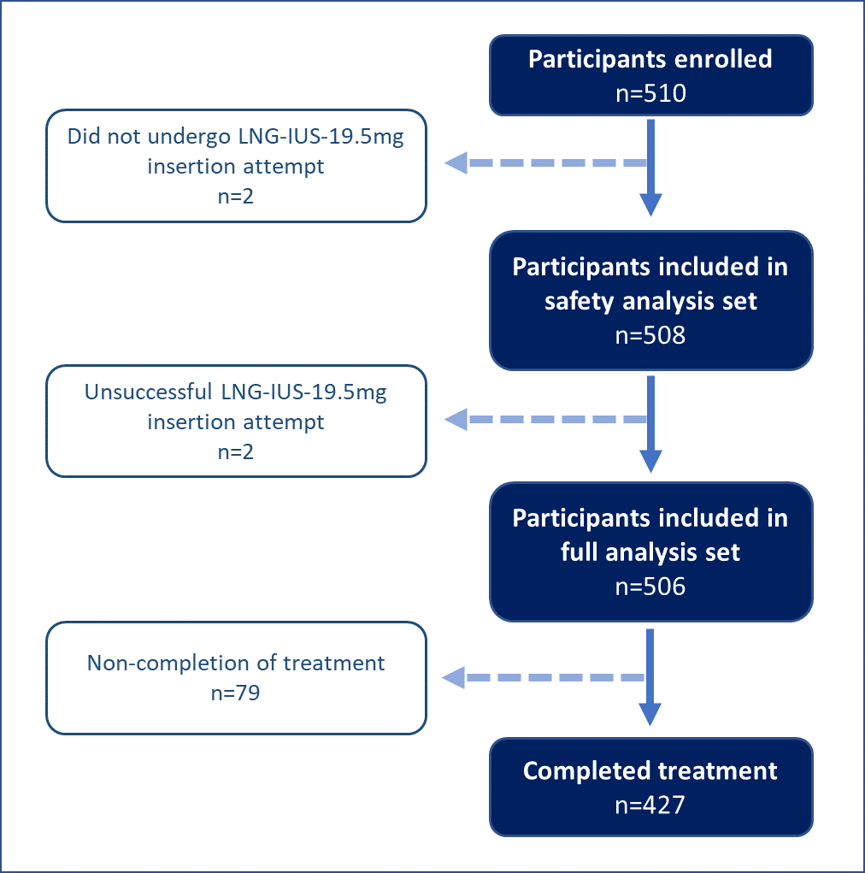
KYSS: KyleenaTM Satisfaction Study.

Fig. S2 Prior method of contraception in the German population (safety analysis set)

IUD: intrauterine device; IUS: intrauterine system.

Fig. S3 Motivation for choosing LNG-IUS-19.5mg in the German population (safety analysis set)ª

ªMore than one reason could be given.
LNG-IUS: levonorgestrel-releasing intrauterine system.

Fig. S4 Ease of placement (a), pain during placement (b), and additional measures used during placement (c) of LNG-IUS-19.5mg in the German population (safety analysis set), stratified by parity and age

LNG-IUS: levonorgestrel-releasing intrauterine system.

