Prediction of spontaneous preterm birth in pregnant women using machine learning
Archives of Gynecology and Obstetrics
Xiaoxue Yang, Xuewu Song, Kun Yang, Peng Gao, Shuai Wang, Simin Zhang, Rong Qiang, Zhibin Li, and Xinru Gao^{1*}
¹Ultrasonic Diagnosis Center, Northwest Women's and Children's Hospital, Xi'an, Shaanxi, China
*Corresponding author: Xinru Gao, xin_ru_gao@163.com

Supplementary Figures and Tables

Supplementary Figures

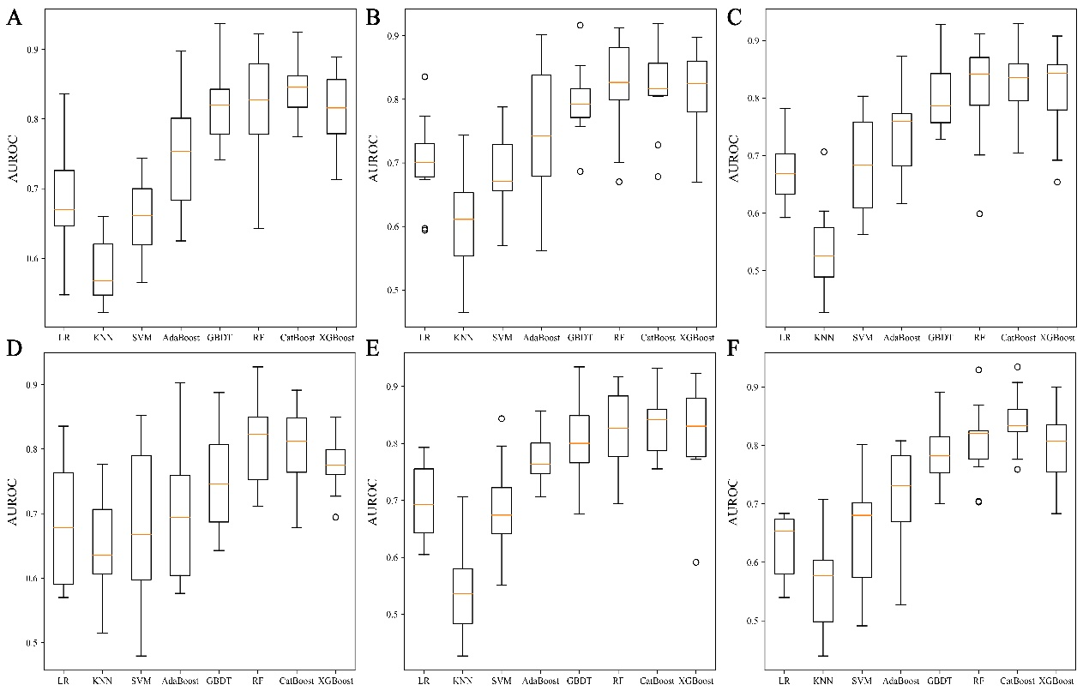
Fig. S1 The AUROC of different machine learning models developed by 6 variable selection methods on the training set. (A) Backward elimination; (B) Forward selection; (C) Lasso regression; (D) Ridge regression; (E) Elastic net regression; (F) All features. AUROC, area under the receiver operating characteristic curve; LR, logistic regression; KNN, k-nearest neighbor; SVM, support vector machine; AdaBoost, adaptive boosting; GBDT, gradient boosting decision tree; RF, random forest; CatBoost, categorical boosting; XGBoost, extreme gradient boosting.
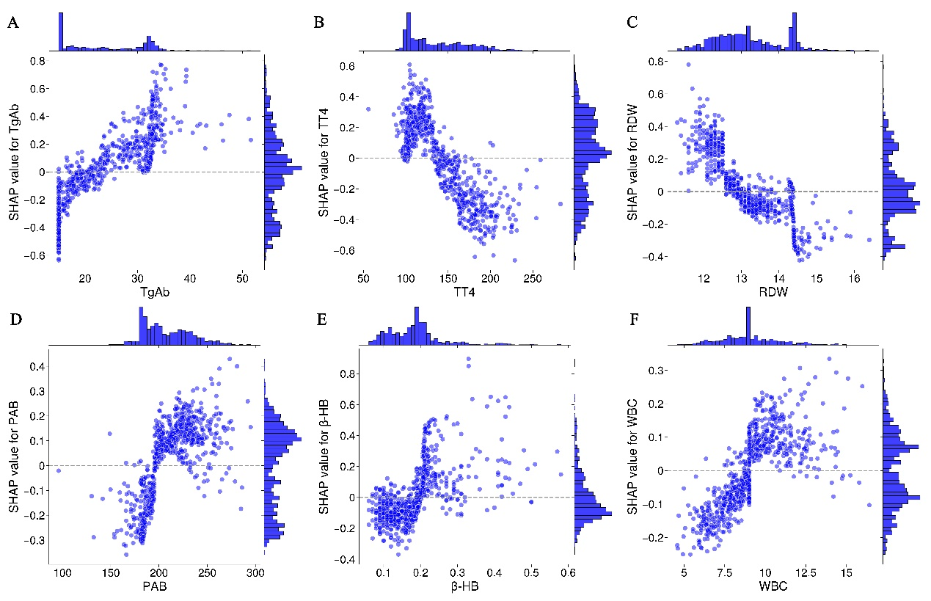
Fig. S2 Further examples of the relationship between SHAP value and variable value in predicting spontaneous preterm birth. (A) TgAb; (B) TT4; (C) RDW; (D) PAB; (E) β-HB; (F) WBC. SHAP, Shapley additive explanations; TgAb, thyroglobulin antibody; TT4, total thyroxine; RDW, red cell volume distribution width; PAB, prealbumin; β-HB, β-hydroxybutyric acid; WBC, white blood cell.

Supplementary Tables
Table S1 The results of different variable selection methods
Methods | Variables | Number
Backward elimination | Pre-pregnancy weight, white blood cell, neutrophil, monocyte, basophil, RDW, prothrombin time, PT-INR, TT4, FT3, TgAb, TSH, ALT, AST, direct bilirubin, AST/ALT, globulin, CKMB, A/G, prealbumin, β-HB | 21
Forward selection | FT3, TgAb, RDW, neutrophil, basophil, uric acid, monocyte, white blood cell, CKMB, TT4, TT3, β-HB, TSH, age, direct bilirubin, total protein | 16
Lasso regression | Age, pre-pregnancy weight, pre-pregnancy height, number of deliveries before this birth, white blood cell, lymphocyte, monocyte, basophil, MCHC, RDW, MPV, D-dimer, TT4, FT3, TgAb, TSH, creatine kinase, total protein, direct bilirubin, uric acid, AST/ALT, CO₂CP, α-HB, CKMB, prealbumin, β-HB | 26
Ridge regression | β-HB, PT-INR, D-dimer, lymphocyte, cystatin C, eosinophil, glucose, TSH, number of deliveries before this birth, neutrophil, white blood cell, MPV, direct bilirubin, AST/ALT, RDW, PCT, A/G, FT3, monocyte, basophil | 20
Elastic Net regression | Age, pre-pregnancy weight, pre-pregnancy height, number of deliveries before this birth, white blood cell, neutrophil, lymphocyte, monocyte, basophil, MCHC, RDW, MPV, PT-INR, D-dimer, TT4, FT3, FT4, TgAb, TSH, creatine kinase, total protein, albumin, direct bilirubin, glucose, uric acid; AST/ALT, CO₂CP, α-HB, CKMB, prealbumin, β-HB | 31
All | Age, pre-pregnancy weight, pre-pregnancy height, number of deliveries before this birth, the MVP of AF, white blood cell, neutrophil, lymphocyte, monocyte, eosinophil, basophil, hemoglobin, red blood cell, hematocrit, MCV, MCH, MCHC, RDW, blood platelet, PDW, MPV, PCT, P-LCR, prothrombin time, PT-INR, APTT, fibrinogen, thrombin time, D-dimer, TT3, TT4, FT3, FT4, TgAb, TPOAb, TSH, thyroglobulin, ALT, AST, creatine kinase, lactate dehydrogenase, total protein, albumin , GGT, alkaline phosphatase, total bilirubin, direct bilirubin, urea, creatinine, glucose, uric acid, AST/ALT, globulin, indirect bilirubin, CO₂CP, α-HB, CKMB, A/G, cystatin C, α-L-fucosidase, prealbumin, β-HB | 62
Abbreviations: A/G, albumin/globulin; ALT, alanine aminotransferase; APTT, activated partial thromboplastin time; AST, aspartate transaminase; CKMB, creatine kinase isozyme MB; CO₂CP, carbondioxide combining power; FT3, free triiodothyronine; FT4, free thyroxine; GGT, γ-glutamyl transpeptidase; MCH, mean corpuscular hemoglobin; MCHC, mean corpuscular hemoglobin concentration; MCV, mean corpuscular volume; MPV, mean platelet volume; PCT, platelet hematocrit; PDW, platelet distribution width; P-LCR, platelet-large-cell ratio; PT-INR, prothrombin time-international normalized ratio; RDW, red cell volume distribution width; TgAb, thyroglobulin antibody; the MVP of AF, the maximum vertical pocket of amniotic fluid; TPOAb, thyroid peroxidase antibody; TSH, thyroid stimulating hormone; TT3, total triiodothyronine; TT4, total thyroxine; α-HB, α-hydroxybutyric acid; β-HB, β-hydroxybutyric acid.
Table S2 Models Performance
Methods | Algorithms | Accuracy | Sensitivity | F1-Score | PPV | NPV | Brier score
Backward elimination | LR | 0.82 | 0.03 | 0.06 | 0.40 | 0.83 | 0.18
Backward elimination | KNN | 0.81 | 0.12 | 0.18 | 0.35 | 0.84 | 0.19
Backward elimination | SVM | 0.83 | 0.02 | 0.03 | 0.50 | 0.83 | 0.17
Backward elimination | AdaBoost | 0.85 | 0.36 | 0.46 | 0.62 | 0.88 | 0.15
Backward elimination | GBDT | 0.88 | 0.41 | 0.54 | 0.77 | 0.89 | 0.12
Backward elimination | RF | 0.87 | 0.26 | 0.41 | 0.94 | 0.87 | 0.13
Backward elimination | CatBoost | 0.88 | 0.31 | 0.47 | 0.95 | 0.87 | 0.12
Backward elimination | XGBoost | 0.89 | 0.45 | 0.58 | 0.81 | 0.90 | 0.11
Forward selection | LR | 0.83 | 0.10 | 0.17 | 0.55 | 0.84 | 0.17
Forward selection | KNN | 0.85 | 0.14 | 0.24 | 0.80 | 0.85 | 0.15
Forward selection | SVM | 0.83 | 0.02 | 0.03 | 0.50 | 0.83 | 0.17
Forward selection | AdaBoost | 0.84 | 0.33 | 0.42 | 0.58 | 0.87 | 0.16
Forward selection | GBDT | 0.85 | 0.43 | 0.51 | 0.61 | 0.89 | 0.15
Forward selection | RF | 0.87 | 0.28 | 0.43 | 0.94 | 0.87 | 0.13
Forward selection | CatBoost | 0.88 | 0.36 | 0.51 | 0.84 | 0.88 | 0.12
Forward selection | XGBoost | 0.88 | 0.50 | 0.60 | 0.74 | 0.90 | 0.12
Lasso regression | LR | 0.83 | 0.03 | 0.07 | 0.67 | 0.83 | 0.17
Lasso regression | KNN | 0.82 | 0.09 | 0.14 | 0.42 | 0.84 | 0.18
Lasso regression | SVM | 0.83 | 0.02 | 0.03 | 0.50 | 0.83 | 0.17
Lasso regression | AdaBoost | 0.85 | 0.41 | 0.48 | 0.59 | 0.89 | 0.15
Lasso regression | GBDT | 0.85 | 0.36 | 0.46 | 0.62 | 0.88 | 0.15
Lasso regression | RF | 0.87 | 0.24 | 0.38 | 0.93 | 0.86 | 0.13
Lasso regression | CatBoost | 0.88 | 0.29 | 0.45 | 0.94 | 0.87 | 0.12
Lasso regression | XGBoost | 0.85 | 0.33 | 0.43 | 0.63 | 0.87 | 0.15
Ridge regression | LR | 0.83 | 0.07 | 0.13 | 0.67 | 0.84 | 0.17
Ridge regression | KNN | 0.85 | 0.17 | 0.28 | 0.77 | 0.85 | 0.15
Ridge regression | SVM | 0.83 | 0.02 | 0.03 | 0.50 | 0.83 | 0.17
Ridge regression | AdaBoost | 0.82 | 0.21 | 0.29 | 0.48 | 0.85 | 0.18
Ridge regression | GBDT | 0.85 | 0.28 | 0.39 | 0.67 | 0.87 | 0.15
Ridge regression | RF | 0.87 | 0.26 | 0.41 | 0.94 | 0.87 | 0.13
Ridge regression | CatBoost | 0.88 | 0.33 | 0.49 | 0.95 | 0.88 | 0.12
Ridge regression | XGBoost | 0.86 | 0.33 | 0.45 | 0.73 | 0.87 | 0.14
Elastic Net regression | LR | 0.84 | 0.07 | 0.13 | 0.80 | 0.84 | 0.16
Elastic Net regression | KNN | 0.82 | 0.09 | 0.14 | 0.42 | 0.84 | 0.18
Elastic Net regression | SVM | 0.83 | 0.02 | 0.03 | 0.50 | 0.83 | 0.17
Elastic Net regression | AdaBoost | 0.87 | 0.41 | 0.52 | 0.69 | 0.89 | 0.13
Elastic Net regression | GBDT | 0.85 | 0.34 | 0.44 | 0.63 | 0.88 | 0.15
Elastic Net regression | RF | 0.87 | 0.28 | 0.43 | 0.94 | 0.87 | 0.13
Elastic Net regression | CatBoost | 0.88 | 0.33 | 0.49 | 0.95 | 0.88 | 0.12
Elastic Net regression | XGBoost | 0.87 | 0.33 | 0.46 | 0.76 | 0.88 | 0.13
All variables | LR | 0.82 | 0.02 | 0.03 | 0.20 | 0.83 | 0.18
All variables | KNN | 0.84 | 0.10 | 0.18 | 0.67 | 0.84 | 0.16
All variables | SVM | 0.83 | 0.02 | 0.03 | 0.50 | 0.83 | 0.17
All variables | AdaBoost | 0.87 | 0.52 | 0.58 | 0.65 | 0.90 | 0.13
All variables | GBDT | 0.86 | 0.33 | 0.45 | 0.70 | 0.87 | 0.14
All variables | RF | 0.87 | 0.26 | 0.41 | 0.94 | 0.87 | 0.13
All variables | CatBoost | 0.88 | 0.29 | 0.45 | 0.94 | 0.87 | 0.12
All variables | XGBoost | 0.88 | 0.36 | 0.51 | 0.84 | 0.88 | 0.12
Abbreviations: AdaBoost, adaptive boosting; CatBoost, categorical boosting; GBDT, gradient boosting decision tree; KNN, k-nearest neighbor; LR, logistic regression; NPV, negative predictive value; PPV, positive predictive value; RF, random forest; SVM, support vector machine; XGBoost, extreme gradient boosting.

