Table S1 search strategy
(("Reproductive Techniques, Assisted"[Mesh]) OR ((((((((((((((((((Reproductive Techniques, Assisted[Title/Abstract]) OR (Assisted Reproductive Technique[Title/Abstract])) OR (Reproductive Technique, Assisted[Title/Abstract])) OR (Technique, Assisted Reproductive[Title/Abstract])) OR (Techniques, Assisted Reproductive[Title/Abstract])) OR (Assisted Reproductive Technics[Title/Abstract])) OR (Assisted Reproductive Technic[Title/Abstract])) OR (Reproductive Technic, Assisted[Title/Abstract])) OR (Reproductive Technics, Assisted[Title/Abstract])) OR (Technic, Assisted Reproductive[Title/Abstract])) OR (Technics, Assisted Reproductive[Title/Abstract])) OR (Assisted Reproductive Techniques[Title/Abstract])) OR (Reproductive Technology, Assisted[Title/Abstract])) OR (Assisted Reproductive Technologies[Title/Abstract])) OR (Assisted Reproductive Technology[Title/Abstract])) OR (Reproductive Technologies, Assisted[Title/Abstract])) OR (Technologies, Assisted Reproductive[Title/Abstract])) OR (Technology, Assisted Reproductive[Title/Abstract]))) AND (("Sleep"[Mesh]) OR (((((((((((Sleep[MeSH Terms]) OR (Sleeping Habits[Title/Abstract])) OR (Sleep Habits[Title/Abstract])) OR (Habit, Sleep[Title/Abstract])) OR (Habits, Sleep[Title/Abstract])) OR (Sleep Habit[Title/Abstract])) OR (Sleeping Habit[Title/Abstract])) OR (Habit, Sleeping[Title/Abstract])) OR (Habits, Sleeping[Title/Abstract])) OR (Sleep Quality[Title/Abstract])) OR (Sleep Qualities[Title/Abstract])))

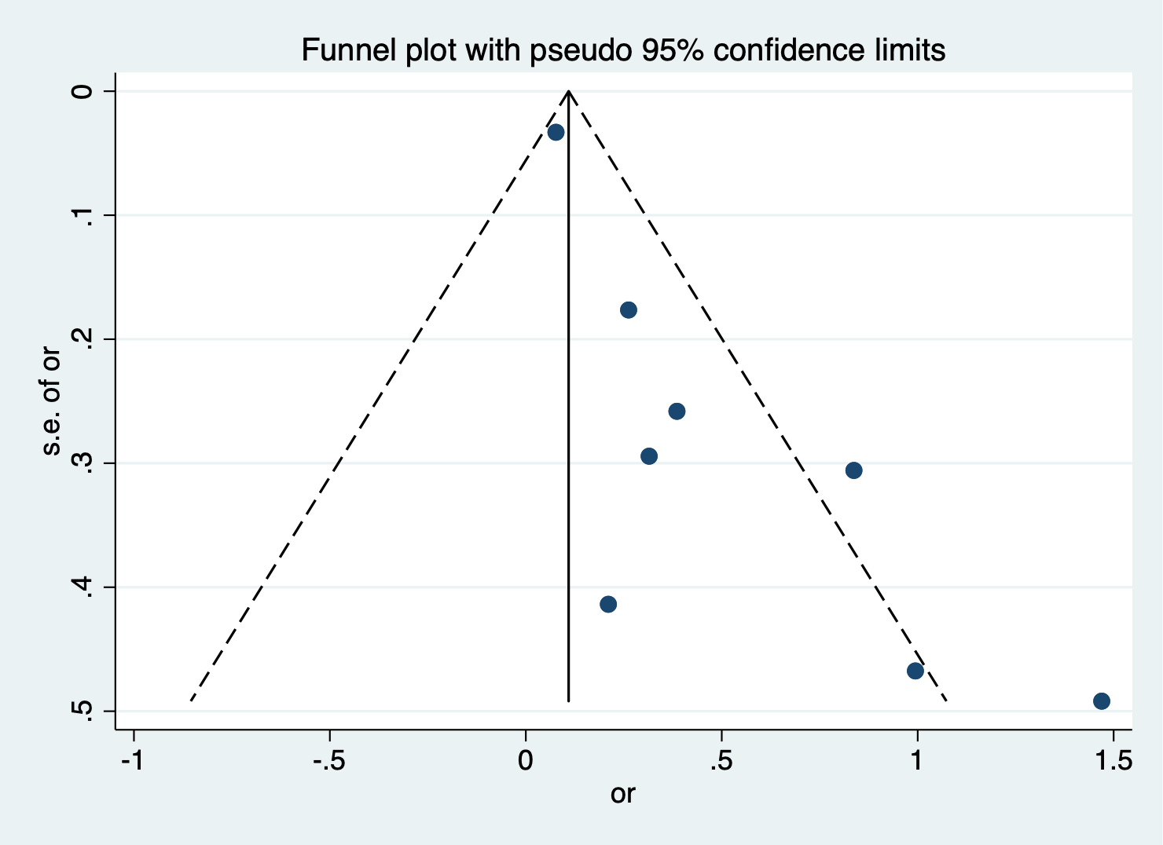
Figure S1 Funnel plot of the association between good sleep and clinical pregnancy by meta-analysis

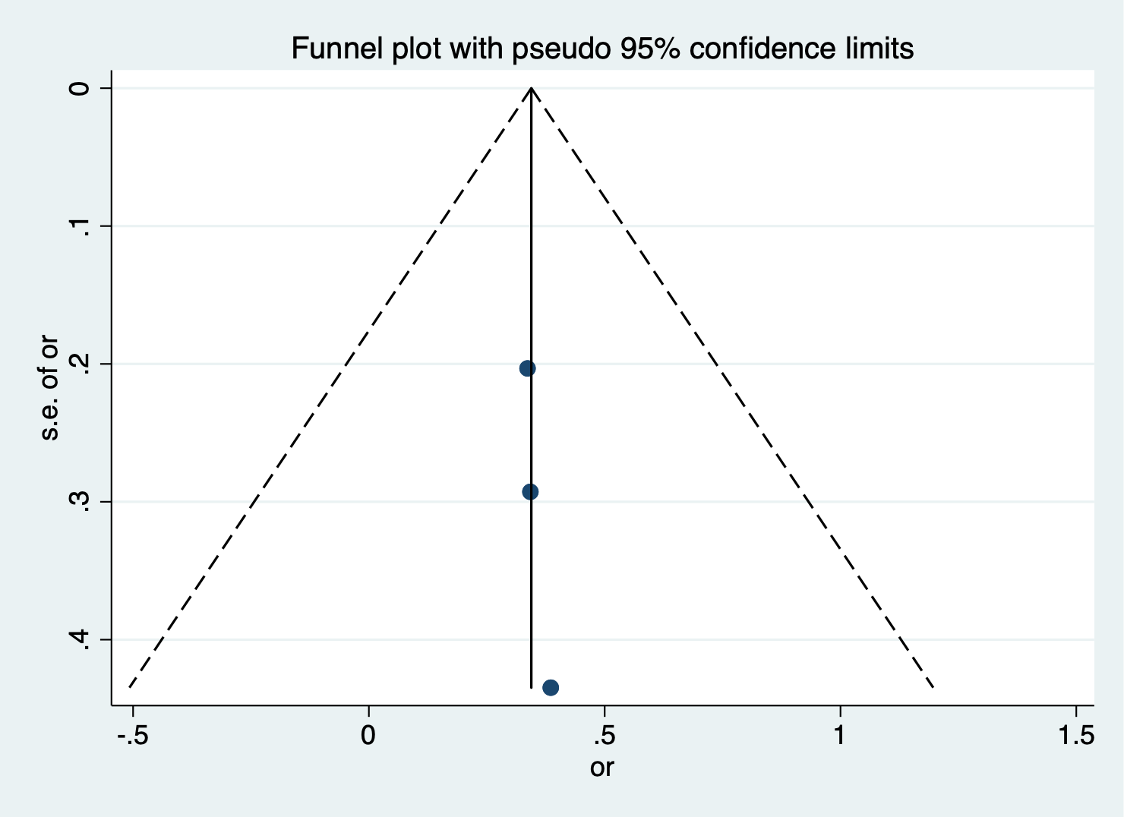
Figure S2 Funnel plot of the association between good sleep and implants by meta-analysis

