Supplementary Materials

Supplementary FigureS1. Stratified Analysis of the Association Between SIRI and Female Infertility Risk Across Subgroups
Forest plot illustrating the odds ratios (ORs) and 95% confidence intervals (CIs) for the association between estimated glucose disposal rate (eGDR) and the odds of prediabetes or diabetes, stratified by demographic, clinical, and behavioral subgroups. All models are adjusted for age, race/ethnicity, marital status, education, smoking status, alcohol consumption, BMI, hyperlipidemia, hypertension, and CKD. Subgroups include age (<30 vs. ≥30), race/ethnicity, BMI (≥25 vs. <25), hypertension, hyperlipidemia, smoking, and alcohol consumption.

SupplementaryFigureS2. Correlation Heatmap of eGDR and Clinical, Metabolic, and Inflammatory Biomarkers
Spearman correlation matrix showing pairwise correlations among variables including age, BMI, waist circumference, blood pressure, lipid profiles, glucose metabolism indices (e.g., insulin, HOMA-IR), inflammatory markers (e.g., SIRI), and eGDR. Color scale indicates direction and magnitude of correlation (blue = negative; red = positive).

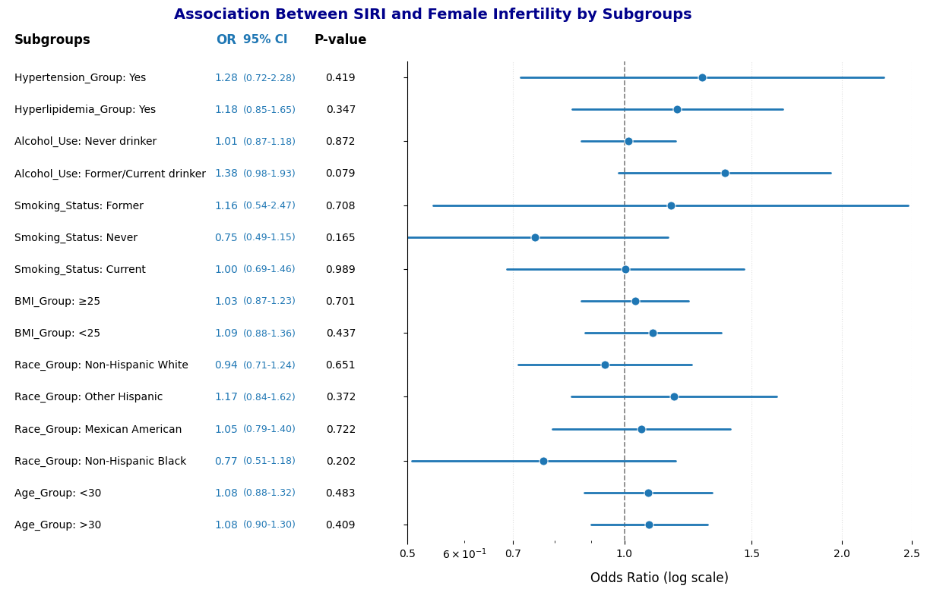

Supplementary FigureS1. Stratified Analysis of the Association Between SIRI and Female Infertility Risk Across Subgroups
Forest plot illustrating the odds ratios (ORs) and 95% confidence intervals (CIs) for the association between estimated glucose disposal rate (eGDR) and the odds of prediabetes or diabetes, stratified by demographic, clinical, and behavioral subgroups. All models are adjusted for age, race/ethnicity, marital status, education, smoking status, alcohol consumption, BMI, hyperlipidemia, hypertension, and CKD. Subgroups include age (<30 vs. ≥30), race/ethnicity, BMI (≥25 vs. <25), hypertension, hyperlipidemia, smoking, and alcohol consumption.

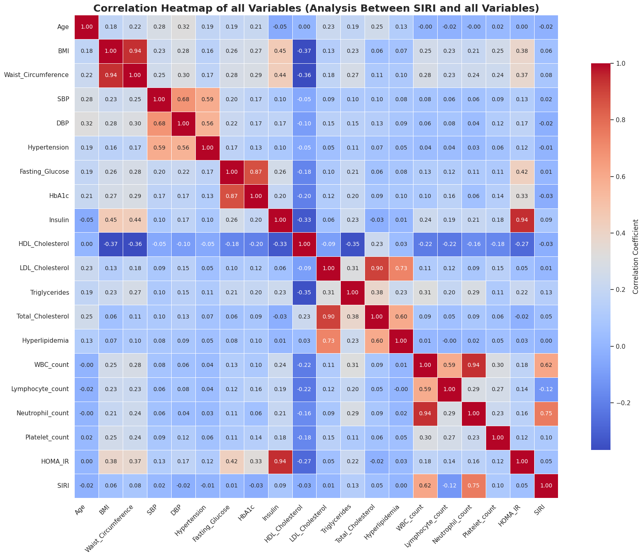
SupplementaryFigureS2. Correlation Heatmap of eGDR and Clinical, Metabolic, and Inflammatory Biomarkers
Spearman correlation matrix showing pairwise correlations among variables including age, BMI, waist circumference, blood pressure, lipid profiles, glucose metabolism indices (e.g., insulin, HOMA-IR), inflammatory markers (e.g., SIRI), and eGDR. Color scale indicates direction and magnitude of correlation (blue = negative; red = positive).

