Supplementary Materials

Supplemental Table 1. Definition of spontaneous miscarriage 2
Supplemental Table 2. List covariates, their definition, and functional form. 3
Supplemental Table 3. Missing data for key covariates. 4
Supplemental Table 4. Adjusted hazard ratios for risk of all-cause premature mortality, according to the history of spontaneous miscarriage. 5
Supplemental Table 5. Adjusted hazard ratios for risk of all-cause premature mortality after further adjusted for hypertension, diabetes, hyperlipidemia, CVD and cancer at baseline 6
Supplemental Table 6. Adjusted hazard ratios for risk of all-cause premature mortality after excluding participants with diabetes,CVD or cancer at baseline 7
Supplemental Table 7. Adjusted hazard ratios for risk of all-cause premature mortality after excluding death due to complications of pregnancy, childbirth, and the puerperium 8
Supplemental Table 8. Adjusted hazard ratios for risk of all-cause premature mortality (<70 years), according to the number of spontaneous miscarriages 9
Supplemental Table 9. Association between number of spontaneous miscarriages and premature mortality: sensitivity analysis using attained age as the time scale with delayed entry 10
Supplemental Table 10. Adjusted HR (95% CI) for the number of spontaneous miscarriages and all-cause premature mortality stratified by traditional risk factors 11
Supplemental Table 11. The association between the number of spontaneous miscarriages and hazard of cause-specific premature mortality 13
Supplemental Figure 1. Flow chart of study participants in UK Biobank 14
Supplemental Figure 2. Directed acyclic graph (DAG) illustrating the assumed causal relationships. 15

Supplemental Table 1. Definition of spontaneous miscarriage.
 | Source and definition | UK Biobank field code
History of spontaneous miscarriage at enrollment | ICD 9: 6340-6349;  ICD 10: O030-O039 (if time of diagnosis <=Date of attending assessment centre);  Self-reported by touchscreen questionnaire at enrollment;  Self-reported by a verbal interview at enrollment: 1559; | 41271  41270,41280,53  2774,3839  20002

Supplemental Table 2. List covariates, their definition, and functional form.
Covariates | Definition and functional form in models
Age, years | Continuous
Race/ethnicity | Categorical: White (reference); Mixed; Asian or Asian British; Black or Black British; Chinese; Other ethnic group; Do not know or prefer not to answer
Education | Categorical: College or university degree (reference); Non-college; Prefer not to answer
Average household income | Categorical: <£18000; £18000-30999 (reference); £31000-51999; £52000- 10000; ≥£100000; Do not know or prefer not to answer
Townsend deprivation index at recruitment | Continuous
Early menopause | Categorical: No (reference); Yes
Hormone treatment | Categorical: No (reference); Yes
Hypertension disorders in pregnancy | Categorical: No (reference); Yes
Gestational diabetes | Categorical: No (reference); Yes
Number of live births | Continuous
Alcohol intake frequency | Categorical: Daily or almost daily (reference); Three or four times a week; Once or twice a week; One to three times a month; Specical occasions only; Never; Prefer not to answer
Body mass index, kg/m² | Categorical: Underweight (<18.5 kg/m²); Normal weight (18.5–24.9 kg/m²) (reference); Overweight (25–29.9 kg/m²) ; Obese (≥30 kg/m²)
Diet score | Continuous
Physical activity | Categorical: Regular physical activity; Irregular physical activity (reference)
Smoking status | Categorical: Never (reference) ; Previous; Current

Supplemental Table 3. Missing data for key covariates.
Covariates | Missing N | Missing %
Age, years | 0 | 0%
Race/ethnicity | 0 | 0%
Education | 1735 | 0.75%
Average household income | 2274 | 0.98%
Townsend deprivation index at recruitment | 273 | 0.12%
Early menopause | 0 | 0%
Hormone treatment | 1 | 0%
Hypertension disorders in pregnancy | 0 | 0%
Gestational diabetes | 0 | 0%
Number of live births | 0 | 0%
Alcohol intake frequency | 0 | 0%
Body mass index, kg/m² | 1045 | 0.45%
Diet score | 29 | 0.01%
Physical activity | 16682 | 7.22%
Smoking status | 0 | 0%

Supplemental Table 4. Adjusted hazard ratios for risk of all-cause premature mortality, according to the history of spontaneous miscarriage.
Premature all-cause mortality | History of spontaneous miscarriage |  | P value
Premature all-cause mortality | None | Yes | P value
Cases, n | 8890 | 2782
Crude incidence per 1000 Person-Years | 4.20 | 4.10
Age- adjusted | 1 [Reference] | 1.05 (1.00-1.10) | 0.05
Model 1 | 1 [Reference] | 1.06 (1.01-1.11) | 0.01
Model 2 | 1 [Reference] | 1.06 (1.01-1.11) | 0.01
Model 3 | 1 [Reference] | 1.04 (1.00-1.09) | 0.08
Model 1: Results were adjusted for age, ethnicity, education level, average household income, Townsend deprivation index.
Model 2: Model 1 +number of live births, gestational diabetes mellitus, hypertensive disorder in pregnancy, early menopause, and hormone treatment.
Model 3: Model 2+ BMI, alcohol intake frequency, diet score, physical activity, and smoking status.

Supplemental Table 5. Adjusted hazard ratios for risk of all-cause premature mortality after further adjusted for hypertension, diabetes, hyperlipidemia, CVD and cancer at baseline.
 | History of spontaneous miscarriage |  |  |  | P-trend
 | None | 1 | 2 | ≥3 | P-trend
Model 3+HP,DM and hyperlipidemia | 1 [Reference] | 0.98 (0.93-1.03) | 1.15(1.05-1.26) | 1.20(1.07-1.35) | 0.002
Model 3+HP,DM, hyperlipidemia and CVD | 1 [Reference] | 0.98 (0.93-1.03) | 1.14(1.04-1.25) | 1.19(1.06-1.33) | 0.005
Model 3+HP,DM, hyperlipidemia,CVD and cancer | 1 [Reference] | 0.97 (0.92-1.03) | 1.14(1.04-1.24) | 1.15(1.03-1.29) | 0.02
Model 3: Results were adjusted for age, ethnicity, education level, average household income, Townsend deprivation index, number of live births, gestational diabetes mellitus, hypertensive disorder in pregnancy, early menopause, hormone treatment, BMI, alcohol intake frequency, diet score, physical activity, and smoking status.
Abbreviation: HP, hypertension; DM, diabetes; CVD, cardiovascular disease.

Supplemental Table 6. Adjusted hazard ratios for risk of all-cause premature mortality after excluding participants with diabetes, CVD or cancer at baseline.
 | History of spontaneous miscarriage |  |  |  | P-trend
 | None | 1 | 2 | ≥3 | P-trend
Cases, n | 5538/144770 | 1181/33122 | 334/8295 | 196/4489
Age- adjusted | 1 [Reference] | 1.00 (0.94-1.07) | 1.16(1.03-1.30) | 1.35(1.17-1.57) | <0.001
Model 1 | 1 [Reference] | 1.02 (0.95-1.09) | 1.17(1.04-1.32) | 1.37(1.18-1.58) | <0.001
Model 2 | 1 [Reference] | 1.02 (0.95-1.09) | 1.17(1.04-1.32) | 1.36(1.17-1.58) | <0.001
Model 3 | 1 [Reference] | 1.01 (0.95-1.08) | 1.14(1.02-1.29) | 1.28(1.10-1.48) | 0.001
Model 3+HP and hyperlipidemia | 1 [Reference] | 1.01 (0.95-1.08) | 1.14(1.01-1.28) | 1.27(1.10-1.48) | 0.002
Model 1: Results were adjusted for age, ethnicity, education level, average household income, Townsend deprivation index.
Model 2: Model 1+number of live births, gestational diabetes mellitus, hypertensive disorder in pregnancy, early menopause, and hormone treatment.
Model 3: Model 2+ BMI, alcohol intake frequency, diet score, physical activity, and smoking status.
Abbreviation: HP, hypertension.

Supplemental Table 7. Adjusted hazard ratios for risk of all-cause premature mortality after excluding death due to complications of pregnancy, childbirth, and the puerperium.
 | History of spontaneous miscarriage |  |  |  | P-trend
 | None | 1 | 2 | ≥3 | P-trend
Cases, n | 8889/175209 | 1877/40051 | 559/10221 | 346/5666
Age- adjusted | 1 [Reference] | 0.97 (0.92-1.03) | 1.18(1.08-1.29) | 1.35(1.20-1.51) | <0.001
Model 1 | 1 [Reference] | 0.99 (0.94-1.04) | 1.19(1.09-1.31) | 1.35(1.20-1.51) | <0.001
Model 2 | 1 [Reference] | 0.99 (0.94-1.04) | 1.19(1.09-1.31) | 1.34(1.19-1.50) | <0.001
Model 3 | 1 [Reference] | 0.98 (0.93-1.04) | 1.16(1.06-1.27) | 1.24(1.10-1.39) | <0.001
Model 1: Results were adjusted for age, ethnicity, education level, average household income, Townsend deprivation index.
Model 2: Model 1 +number of live births, gestational diabetes mellitus, hypertensive disorder in pregnancy, early menopause, and hormone treatment.
Model 3: Model 2+ BMI, alcohol intake frequency, diet score, physical activity, and smoking status.

Supplemental Table 8. Adjusted hazard ratios for risk of all-cause premature mortality (<70 years), according to the number of spontaneous miscarriages
 | History of spontaneous miscarriage |  |  |  | P-trend
 | None | 1 | 2 | ≥3 | P-trend
Cases, n | 4180 | 942 | 301 | 182
Age- adjusted | 1 [Reference] | 0.98 (0.91-1.06) | 1.24 (1.09-1.40) | 1.39 (1.19-1.62) | <0.001
Model 1 | 1 [Reference] | 0.99 (0.92-1.07) | 1.25 (1.10-1.41) | 1.38 (1.18-1.61) | <0.001
Model 2 | 1 [Reference] | 0.99 (0.92-1.07) | 1.25 (1.10-1.41) | 1.36 (1.16-1.59) | <0.001
Model 3 | 1 [Reference] | 0.99 (0.92-1.06) | 1.21 (1.07-1.37) | 1.26 (1.07-1.47) | 0.003
Model 1: Results were adjusted for age, ethnicity, education level, average household income, Townsend deprivation index.
Model 2: Model 1 +number of live births, gestational diabetes mellitus, hypertensive disorder in pregnancy, early menopause, and hormone treatment.
Model 3: Model 2+ BMI, alcohol intake frequency, diet score, physical activity, and smoking status.

Supplemental Table 9. Association between number of spontaneous miscarriages and premature mortality: sensitivity analysis using attained age as the time scale with delayed entry
 | History of spontaneous miscarriage |  |  |  | P-trend
 | None | 1 | 2 | ≥3 | P-trend
Model | 1 [Reference] | 0.99 (0.93-1.04) | 1.16 (1.06-1.27) | 1.23 (1.10-1.38) | <0.001
Model: Results were adjusted for ethnicity, education level, average household income, Townsend deprivation index, number of live births, gestational diabetes mellitus, hypertensive disorder in pregnancy, early menopause, and hormone treatment, BMI, alcohol intake frequency, diet score, physical activity, and smoking status.

Supplemental Table 10. Adjusted HR (95% CI) for number of spontaneous miscarriage and all-cause premature mortality stratified by traditional risk factors.
 | History of spontaneous miscarriage |  |  |  |  | P-interaction
 | None | 1 | 2 | ≥3 | P-trend | P-interaction
Age, years |  |  |  |  |  | 0.40
<57 | 1[Reference] | 1.01(0.90-1.13) | 1.19(0.98-1.44) | 1.46(1.17-1.82) | 0.003
≥57 | 1[Reference] | 0.98(0.92-1.04) | 1.15(1.04-1.28) | 1.16(1.02-1.33) | 0.02
Ethnicity |  |  |  |  |  | 0.82
White | 1[Reference] | 0.98(0.92-1.03) | 1.16(1.06-1.28) | 1.21(1.08-1.36) | 0.002
Non-white | 1[Reference] | 1.19(0.91-1.54) | 1.01(0.63-1.61) | 1.72(1.12-2.64) | 0.05
Education level |  |  |  |  |  | 0.56
College or university degree | 1[Reference] | 1.03(0.92-1.14) | 1.02(0.84-1.24) | 1.18(0.93-1.48) | 0.24
Non-college | 1[Reference] | 0.97(0.91-1.03) | 1.20(1.08-1.33) | 1.25(1.10-1.43) | <0.001
Average household income |  |  |  |  |  | 0.98
<£18000 | 1[Reference] | 0.97(0.89-1.07) | 1.08(0.91-1.27) | 1.28(1.05-1.55) | 0.07
£18000-30999 | 1[Reference] | 1.02(0.91-1.14) | 1.29(1.07-1.56) | 1.17(0.90-1.52) | 0.03
≥£31000 | 1[Reference] | 1.00(0.90-1.11) | 1.19(1.00-1.43) | 1.31(1.04-1.64) | 0.02
Townsend deprivation index |  |  |  |  |  | 0.15
<median | 1[Reference] | 0.95(0.88-1.03) | 1.24(1.08-1.41) | 1.12(0.93-1.35) | 0.10
≥median | 1[Reference] | 1.01(0.94-1.09) | 1.09(0.96-1.24) | 1.31(1.13-1.52) | 0.002
Number of live births |  |  |  |  |  | 0.44
0 | 1[Reference] | 0.92(0.74-1.16) | 1.27(0.89-1.80) | 1.00(0.66-1.50) | 0.73
1 | 1[Reference] | 0.98(0.84-1.13) | 1.26(1.00-1.58) | 1.53(1.19-1.97) | 0.002
≥ 2 | 1[Reference] | 0.98(0.93-1.04) | 1.12(1.01-1.24) | 1.17(1.02-1.35) | 0.04
History of GDM |  |  |  |  |  | 0.44
No | 1[Reference] | 0.99(0.94-1.04) | 1.17(1.06-1.28) | 1.24(1.10-1.39) | <0.001
Yes | 1[Reference] | 0.52(0.24-1.13) | 0.22(0.03-1.72) | 0.85(0.28-2.53) | 0.17
History of HDP |  |  |  |  |  | 0.37
No | 1[Reference] | 0.99(0.93-1.04) | 1.16(1.06-1.27) | 1.22(1.09-1.37) | <0.001
Yes | 1[Reference] | 0.80(0.44-1.43) | 1.00(0.39-2.55) | 2.24(1.00-5.04) | 0.32
Early menopause |  |  |  |  |  | 0.47
No | 1[Reference] | 1.01(0.95-1.08) | 1.19(1.07-1.33) | 1.22(1.06-1.41) | <0.001
Yes | 1[Reference] | 1.12(0.85-1.46) | 1.35(0.87-2.09) | 1.37(0.87-2.17) | 0.06
Hormone treatment |  |  |  |  |  | 0.90
No | 1[Reference] | 1.00(0.93-1.08) | 1.26(1.11-1.43) | 1.20(1.01-1.43) | 0.003
Yes | 1[Reference] | 0.97(0.90-1.05) | 1.08(0.95-1.23) | 1.26(1.08-1.47) | 0.04
BMI, kg/m2 |  |  |  |  |  | 0.13
BMI≤24.9 | 1[Reference] | 0.91(0.82-1.00) | 1.25(1.08-1.46) | 1.10(0.89-1.36) | 0.28
25≤BMI≤29.9 | 1[Reference] | 1.10(1.01-1.20) | 1.09(0.93-1.27) | 1.26(1.03-1.54) | 0.005
Obese ≥30 | 1[Reference] | 0.94(0.85-1.04) | 1.11(0.93-1.31) | 1.33(1.10-1.60) | 0.05
Alcohol intake frequency |  |  |  |  |  | 0.97
Daily or almost daily | 1[Reference] | 1.08(0.95-1.22) | 1.21(0.97-1.53) | 1.24(0.92-1.66) | 0.03
Less than 3-4 times a week | 1[Reference] | 0.95(0.89-1.01) | 1.14(1.03-1.28) | 1.23(1.06-1.41) | 0.03
Never | 1[Reference] | 1.06(0.92-1.23) | 1.17(0.92-1.48) | 1.28(0.98-1.66) | 0.04
Diet score |  |  |  |  |  | 0.25
<2 | 1[Reference] | 1.03(0.91-1.17) | 0.97(0.77-1.22) | 1.19(0.91-1.56) | 0.39
≥2 | 1[Reference] | 0.97(0.92-1.03) | 1.20(1.09-1.33) | 1.25(1.10-1.42) | <0.001
Physical activity |  |  |  |  |  | 0.41
Regular physical activity | 1[Reference] | 0.93(0.87-1.01) | 1.11(0.98-1.27) | 1.18(1.00-1.39) | 0.27
Irregular physical activity | 1[Reference] | 1.04(0.96-1.12) | 1.20(1.06-1.36) | 1.29(1.10-1.51) | <0.001
Smoking status |  |  |  |  |  | 0.87
Never | 1[Reference] | 0.98(0.91-1.06) | 1.14(0.99-1.31) | 1.34(1.13-1.60) | 0.006
Previous | 1[Reference] | 0.99(0.91-1.08) | 1.21(1.05-1.40) | 1.01(0.81-1.25) | 0.23
Current | 1[Reference] | 0.96(0.84-1.10) | 1.09(0.88-1.35) | 1.34(1.06-1.68) | 0.07
Results were adjusted for age, ethnicity, education level, average household income, townsend deprivation index, number of live births, gestational diabetes mellitus, hypertensive disorder in pregnancy, early menopause, and hormone treatment, BMI, alcohol intake frequency, diet score, physical activity, and smoking status.

Supplemental Table 11. The association between the number of spontaneous miscarriages and hazard of cause-specific premature mortality.
 | History of spontaneous miscarriage |  |  |  | P-trend
 | None | 1 | 2 | ≥3 | P-trend
Total CVD mortality
Cases, n | 1272 | 268 | 77 | 60
Age- adjusted | 1 [Reference] | 0.98 (0.85-1.13) | 1.13(0.88-1.46) | 1.81(1.38-2.38) | 0.003
Model 1 | 1 [Reference] | 1.01 (0.87-1.17) | 1.14(0.89-1.47) | 1.81(1.38-2.38) | 0.001
Model 2 | 1 [Reference] | 1.01 (0.87-1.17) | 1.15(0.89-1.48) | 1.79(1.36-2.35) | 0.002
Model 3 | 1 [Reference] | 1.01 (0.87-1.16) | 1.10(0.86-1.42) | 1.59(1.21-2.08) | 0.01
Model 3+CVD at baseline | 1 [Reference] | 0.99 (0.86-1.15) | 1.08(0.83-1.39) | 1.48(1.13-1.95) | 0.04
Cancer mortality
Cases, n | 5275 | 1101 | 345 | 188
Age- adjusted | 1 [Reference] | 0.96 (0.90-1.03) | 1.24(1.10-1.39) | 1.21(1.04-1.41) | 0.005
Model 1 | 1 [Reference] | 0.97 (0.91-1.04) | 1.25(1.11-1.40) | 1.21(1.04-1.41) | 0.003
Model 2 | 1 [Reference] | 0.97 (0.91-1.04) | 1.25(1.11-1.40) | 1.20(1.03-1.40) | 0.004
Model 3 | 1 [Reference] | 0.96 (0.90-1.03) | 1.21(1.08-1.36) | 1.13(0.97-1.32) | 0.03
Model 3+cancer at baseline | 1 [Reference] | 0.96 (0.90-1.03) | 1.20(1.07-1.35) | 1.10(0.94-1.28) | 0.07
All other causes of mortality
Cases, n | 2343 | 508 | 137 | 98
Age- adjusted | 1 [Reference] | 1.00 (0.90-1.11) | 1.07(0.88-1.29) | 1.44(1.15-1.79) | 0.03
Model 1 | 1 [Reference] | 1.03 (0.93-1.14) | 1.08(0.90-1.31) | 1.44(1.15-1.79) | 0.01
Model 2 | 1 [Reference] | 1.03 (0.92-1.14) | 1.08(0.90-1.31) | 1.41(1.13-1.76) | 0.01
Model 3 | 1 [Reference] | 1.02 (0.92-1.14) | 1.05(0.86-1.27) | 1.28(1.03-1.60) | 0.08
Model 1: Results were adjusted for age, ethnicity, education level, average household income, Townsend deprivation index.
Model 2: Model 1 +number of live births, gestational diabetes mellitus, hypertensive disorder in pregnancy, early menopause, and hormone treatment.
Model 3: Model 2+ BMI, alcohol intake frequency, diet score, physical activity, and smoking status.
ss
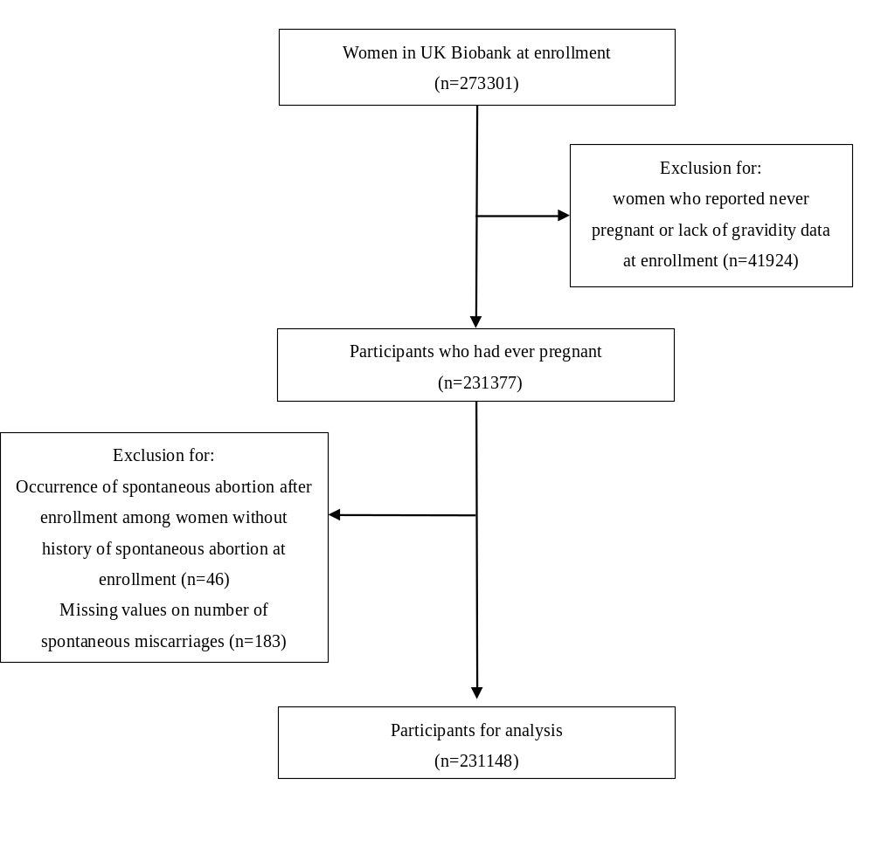
Supplemental Figure 1. Flow chart of study participants in UK Biobank.

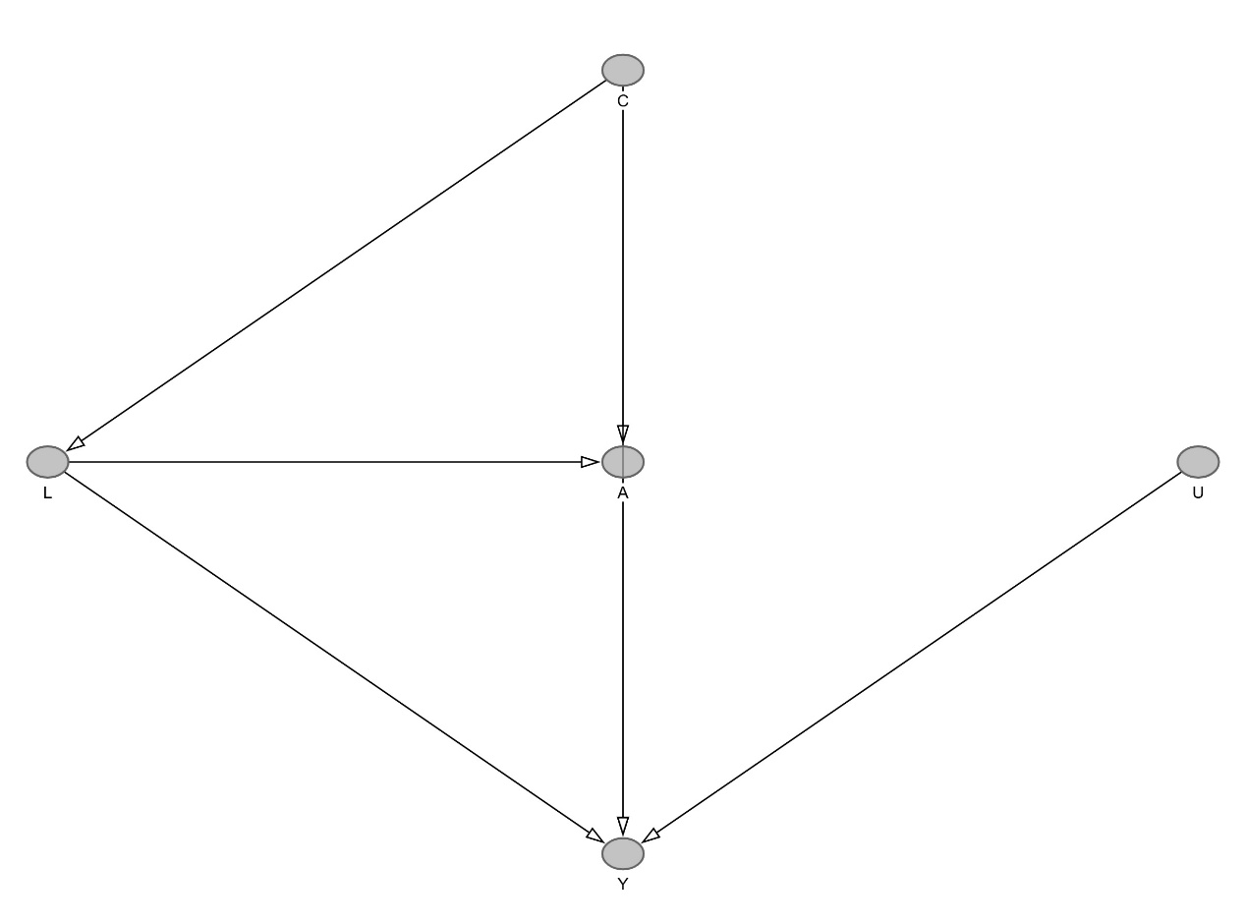
Supplementary Figure 2. Directed acyclic graph (DAG) illustrating the assumed causal relationships.
A: spontaneous miscarriage; Y: premature mortality; L: lifestyle factors; C: sociodemographic and reproductive confounders. Lifestyle (L) is conceptualized as a confounder (influencing both A and Y). The additive interaction between A and L on Y (A × L → Y) was assessed separately using interaction models and is not explicitly represented by an arrow in this DAG; however, a significant additive interaction was observed (P for interaction = 0.03), indicating that the effect of A on Y varies by level of L.

