Supplementary Information

Low skeletal muscle mass assessed directly from the 3rd cervical vertebra can predict pharyngocutaneous fistula risk after total laryngectomy in the male population
European Archives of Oto-Rhino-Laryngology and Head and Neck

Maria Casasayas,ª Jacinto García-Lorenzo, Beatriz Gómez-Ansón, Victoria Medina, Alejandro Fernández, Miquel Quer, Xavier León
ª Servicio de Otorrinolaringología. Hospital de la Santa Creu i Sant Pau, Universitat Autònoma de Barcelona, Barcelona, Spain
E-mail: mcasasayas@santpau.cat

Fig. S1 Dot plots showing correlation between measurements of the cross-sectional muscle area (CSMA) at the 3rd cervical vertebra (C3) for 10 computed tomography images. A. Obtained by the same researcher on 2 different occasions (intraobserver reproducibility). B. Obtained by 2 different researchers (interobserver reproducibility). All measurements are expressed in cm2

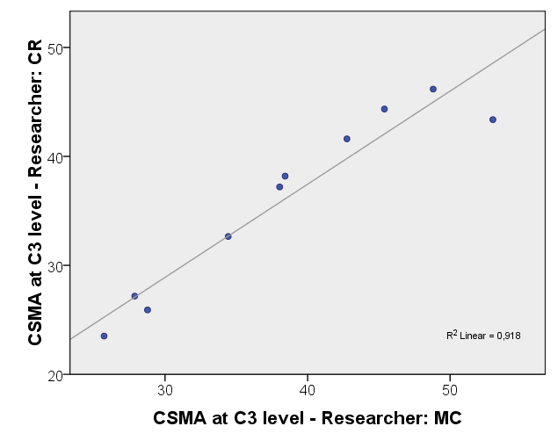
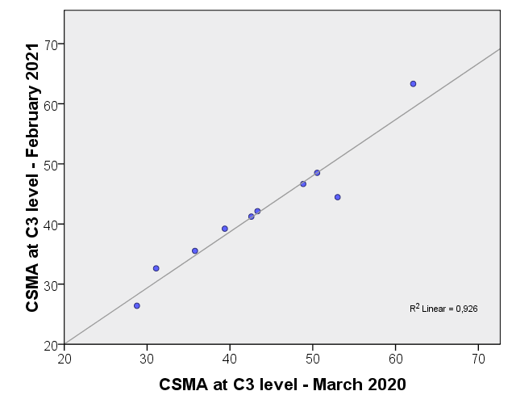
P=0.0001
P=0.0001

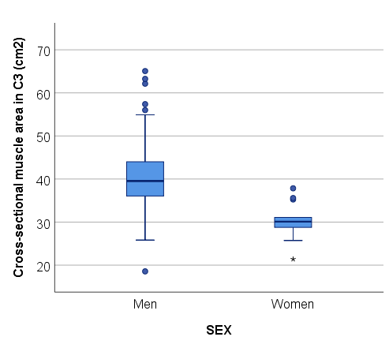
Fig. S2 Box plot showing cross sectional muscle area (cm2) mean and distribution according to sex. Mean area for men was 41.02cm2 (SD 7.9cm2), while mean area for women was 30.22cm2 (SD 4.3cm2) (p=0.000)

B
A
Table S1. Pharyngocutaneous fistula risk: multivariate analysis including the skeletal muscle mass index estimated at the 3rd lumbar vertebra.
Characteristic |  |  | PCF HR (CI 95%) | p-value
Age | (Continuous variable) |  | 0.95 (0.87-1.03) | 0.218
Tobacco/alcohol use | Moderate |  | 1 | 0.051
Tobacco/alcohol use | Heavy |  | 0.15 (0.02-1.01) | 0.051
ASA physical status | I-II |  | 1 | 0.838
ASA physical status | III-IV |  | 0.86 (0.20-3.73) | 0.838
Diabetes mellitus | No |  | 1 | 0.169
Diabetes mellitus | Yes |  | 3.04 (0.62-14.90) | 0.169
Body mass index, kg/m2 | (Continuous variable) |  | 1.13 (0.94-1.36) | 0.182
SMMI at L3  (Low SMM = ≤47.7 cm2/m2) | >47.7cm2/m2 |  | 1 | 0.031*
SMMI at L3  (Low SMM = ≤47.7 cm2/m2) | ≤47.7 cm2/m2 |  | 8.50 (1.22-47.04) | 0.031*
Subsite location | Supraglottis |  | 1
Subsite location | Glottis |  | 1.558 (0.25-9.80) | 0.625
Subsite location | Hypopharynx |  | 1.29 (0.11-14.86) | 0.839
Tumour stage (pT) | pT2 |  | 1
Tumour stage (pT) | pT3 |  | 1.13 (0.11-11.87) | 0.919
Tumour stage (pT) | pT4 |  | 1.22 (0.16-9.28) | 0.846
Previous radiotherapy | No |  | 1 | 0.594
Previous radiotherapy | Yes |  | 0.67 (0.15-2.97) | 0.594
Surgery type | Simple TL |  | 1 | 0.096
Surgery type | Extended TL +/- reconstruction |  | 7.93 (0.69-90.95) | 0.096
Automatic suture | No |  | 1 | 0.195
Automatic suture | Yes |  | 0.31 (0.05-1.84) | 0.195
Neck dissection | No |  | 1
Neck dissection | Unilateral |  | 0.96 (0.08-11.73) | 0.972
Neck dissection | Bilateral |  | 1.08 (0.15-8.02) | 0.938
Voice prosthesis | No |  | 1 | 0.497
Voice prosthesis | Yes |  | 0.38 (0.02-6.20) | 0.497
Preoperative anaemia | No |  | 1 | 0.831
Preoperative anaemia | Yes |  | 0.84 (0.17-4.09) | 0.831
Postoperative anaemia | No |  | 1 | 0.424
Postoperative anaemia | Yes |  | 3.05 (0.20-47.04) | 0.424
*Statistical significance p<0.05. ASA, American Society of Anesthesiologists; HR, hazard ratio; L3, 3rd lumbar vertebra; PCF, pharyngocutaneous fistula; SMMI, skeletal muscle mass index; TL, total laryngectomy.

Table S2. Cross-sectional muscle area at the 3rd cervical vertebra according to different variables.
Characteristic |  |  | Mean (SD) CSMA  at C3, cm² |  | p-value
Age, years |  | Pearson correlation |  | -0.138 | 0.207
Tobacco/alcohol use |  | Moderate |  | 39.66 (3.7) | 0.249
 |  | Heavy |  | 41.28 (8.4) | 0.249
ASA physical status |  | I-II |  | 40.78 (6.8) | 0.809
 |  | III-IV |  | 41.20 (8.8) | 0.809
Diabetes mellitus |  | No |  | 39.95 (7.3) | 0.047*
 |  | Yes |  | 43.70 (8.8) | 0.047*
Height (m) |  | Pearson correlation |  | 0.130 | 0.233
Weight (kg) |  | Pearson correlation |  | 0.480 | 0.0001*
Body mass index, kg/m2 |  | Pearson correlation |  | 0.469 | 0.0001*
Subsite location |  | Supraglottis |  | 39.22 (8.2) | 0.043*
 |  | Glottis |  | 42.67 (8.0) | 0.043*
 |  | Hypopharynx |  | 37.12 (3.7) | 0.043*
Tumour stage (pT) |  | pT2 |  | 42.00 (7.3) | 0.422
 |  | pT3 |  | 42.76 (10.4) | 0.422
 |  | pT4 |  | 40.17 (7.0) | 0.422
Previous radiotherapy |  | No |  | 39.95 (7.8) | 0.219
 |  | Yes |  | 42.05 (7.9) | 0.219
Surgery type |  | Simple TL |  | 42.02 (8.4) | 0.001*
 |  | Extended TL +/- reconstruction |  | 37.38 (3.6) | 0.001*
Automatic suture |  | No |  | 40.13 (8.6) | 0.166
 |  | Yes |  | 42.61 (6.0) | 0.166
Neck dissection |  | No |  | 43.16 (9.3) | 0.243
 |  | Unilateral |  | 43.44 (9.4) | 0.243
 |  | Bilateral |  | 40.14 (7.2) | 0.243
Voice prosthesis |  | No |  | 40.56 (7.9) | 0.158
 |  | Yes |  | 44.32 (6.9) | 0.158
Preoperative protein, g/L † |  | Pearson correlation |  | -0.181 | 0.240
Preoperative albumin, g/L ‡ |  | Pearson correlation |  | 0.093 | 0.537
Preoperative haemoglobin, g/L |  | Pearson correlation |  | -0.007 | 0.948
Postoperative haemoglobin, g/L |  | Pearson correlation |  | -0.010 | 0.929
*Statistical significance p<0.05. † Data available from 44 patients. ‡ Data available from 46 patients.
ASA, American Society of Anesthesiologists; C3, 3rd cervical vertebra; CSMA, cross-sectional muscle area; PCF, pharyngocutaneous fistula; TL, total laryngectomy.

