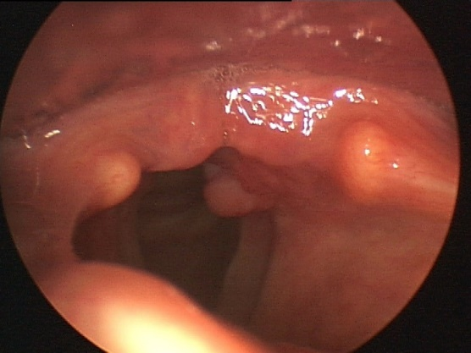
a
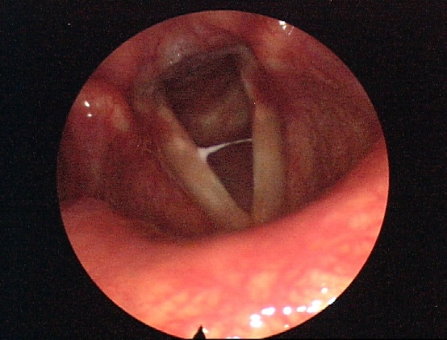
b
Fig. 6. Videolaryngoscopic images of LPR patients (RFS > 7).
Fig. 6 (a): Moderate vocal fold edema, vocal process granuloma, posterior commissure hypertrophy and diffuse laryngeal hyperemia
Fig. 6 (b): Thick endolaryngeal mucus, mild vocal fold edema, posterior commissure hypertrophy and diffuse laryngeal hyperemia

